EXPT NO:2 | Implementation of data visualization techniques
DATE: 06.01.2026 | Implementation of data visualization techniques

PRE-LAB QUESTIONS (PROVIDE BRIEF ANSWERS TO THE FOLLOWING QUESTIONS)
- Why is exploratory data analysis critical before model building?
Exploratory Data Analysis is essential as it helps identify missing values, detect outliers, and understand data patterns before applying machine learning models. Skipping EDA can cause models to learn noise instead of meaningful relationships.
- How do distributions influence algorithm selection in ML?
Data distribution plays a key role in choosing algorithms. Methods such as Linear Regression and Gaussian Naive Bayes assume normally distributed data. When data is skewed or non-linear, non-parametric models like Decision Trees or data transformations are more suitable.
- What insights can outliers provide in business data?
Outliers reveal unusual patterns that may indicate fraud, system errors, or exceptional customer behavior. Identifying these deviations helps businesses take corrective or strategic actions.
- Why are visual summaries preferred over raw tables?
Visual summaries enable quick identification of trends, patterns, and relationships that are difficult to interpret from raw numerical tables. They reduce analysis time and improve understanding.
- How does visualization improve business intelligence?
Visualization converts complex data into intuitive insights. It allows decision-makers to quickly recognize changes and opportunities, supporting faster and more informed business decisions.

IN-LAB EXERCISE:
OBJECTIVE:

To explore data distribution and variability using advanced visualization techniques.

SCENARIO:

A startup analyzes e-commerce transaction data to understand customer spending behavior and detect abnormal purchase patterns.

IN-LAB TASKS (Using R Language)
- Plot histogram of transaction amounts
- Use boxplot to detect outliers
- Create heatmap of monthly sales intensity

(CODE: CONATAINS STUDENT ROLL NOS
SCREENSHOT OF CODE
SCREENSHOT OF OUTPUT)

CODE:

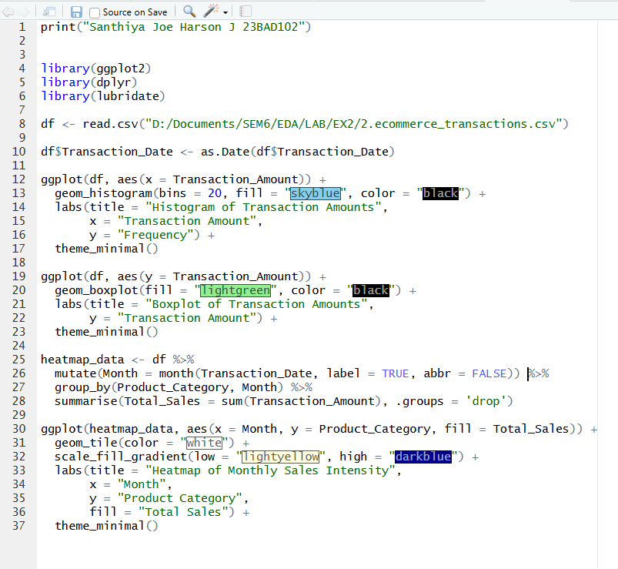

OUTPUT:
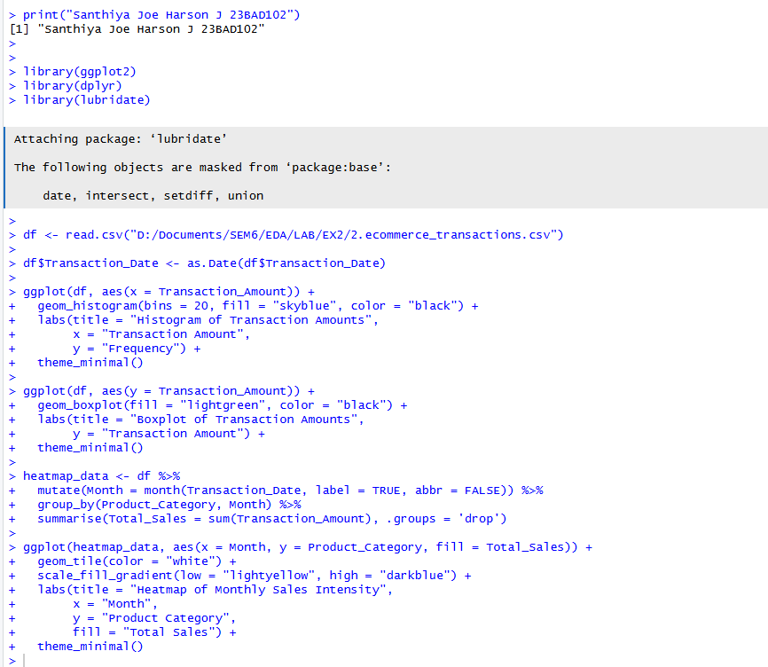

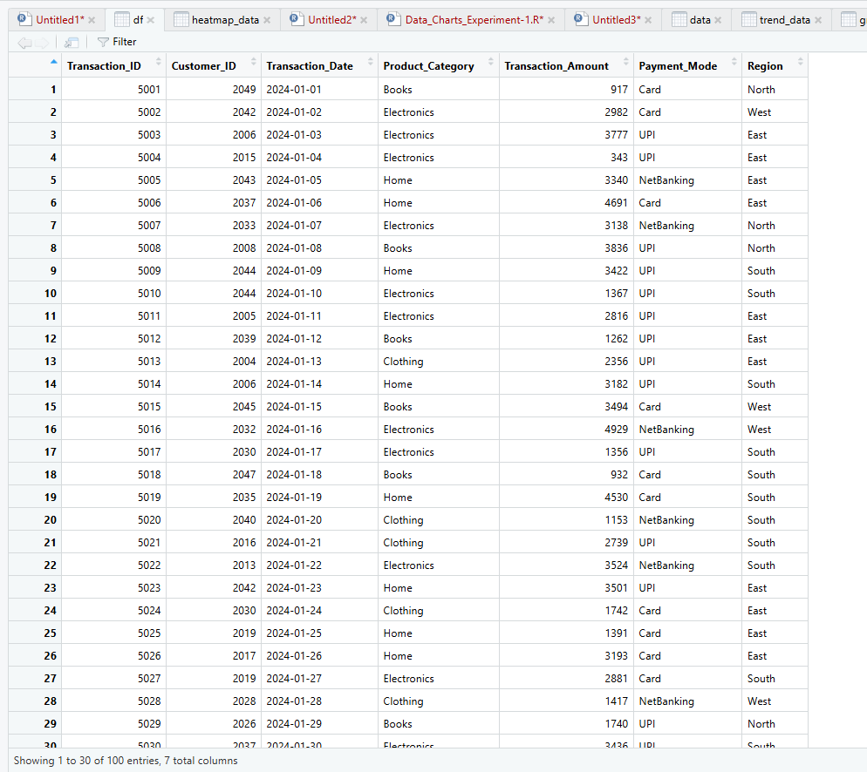

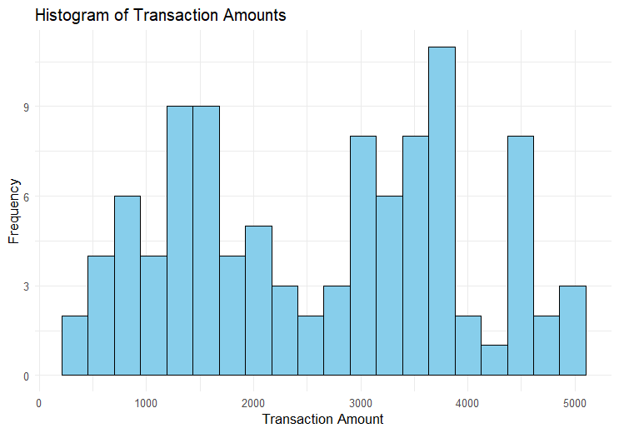

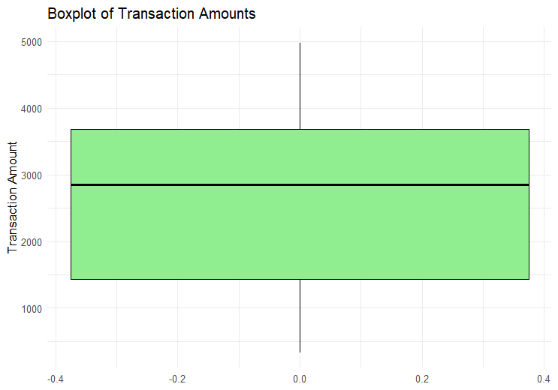

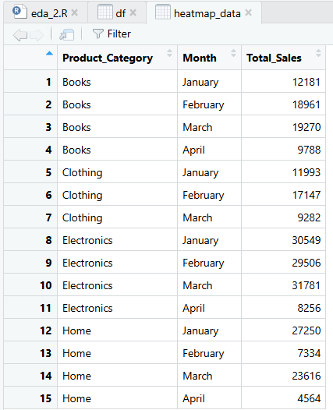

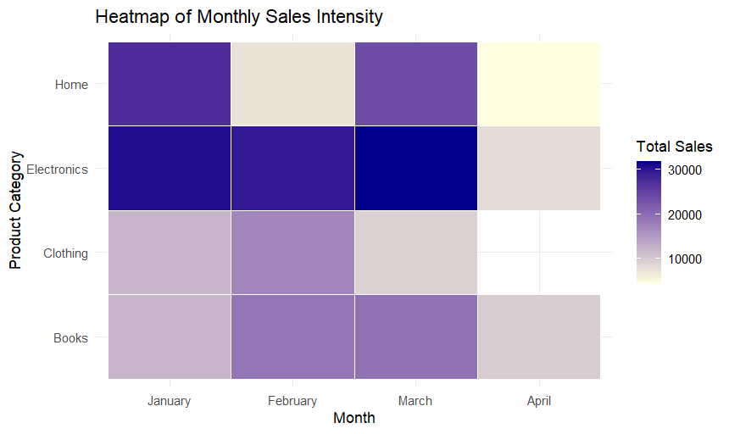
POST-LAB QUESTIONS (PROVIDE BRIEF ANSWERS TO THE FOLLOWING QUESTIONS)
- What does a right-skewed distribution indicate about customer behavior?
A right-skewed distribution shows that most customers make low to moderate purchases, while a small number of customers account for very high-value transactions.

- How can detected outliers impact business decisions?
Outliers influence whether extreme values should be removed or analyzed separately. Excluding them prevents distorted predictions, while examining them can reveal premium customer segments or critical issues such as fraud or system failures.

- Which visualization best supports anomaly detection?
Box plots are highly effective for detecting anomalies. They define normal data using the interquartile range and clearly display outliers as points beyond the whiskers.

- How does EDA improve AI model accuracy?
EDA improves model accuracy by uncovering data issues such as imbalance, noise, or correlated features. Addressing these problems before training helps models learn valid patterns rather than misleading relationships.

- How can visualization guide feature engineering?
Visualizations expose hidden patterns and relationships in data. Observing non-linear trends may suggest creating transformed features, while visible clusters can guide the creation of meaningful categorical variables.

ASSESSMENT
Description | Max Marks | Marks Awarded
Pre Lab Exercise | 5
In Lab Exercise | 10
Post Lab Exercise | 5
Viva | 10
Total | 30
Faculty Signature

