EXPT NO:3 | Designing Multivariate Patterns
DATE: 12.01.2026

PRE-LAB QUESTIONS (PROVIDE BRIEF ANSWERS TO THE FOLLOWING QUESTIONS)
- Why is multivariate analysis essential in real-world AI problems?
Multivariate analysis is essential because real-world AI problems rarely depend on a single factor. Most systems involve multiple interacting variables that jointly influence outcomes. By analyzing these variables together, multivariate methods capture complex relationships, improve predictive accuracy, reduce bias, and enable AI models to make decisions that reflect real-world conditions more reliably.
- What challenges arise when visualizing high-dimensional data?
Visualizing high-dimensional data is challenging because human perception is limited to two or three dimensions. As dimensionality increases, visualizations can become cluttered, misleading, or difficult to interpret. Key challenges include loss of information during dimensionality reduction, overlapping data points, increased cognitive load, and the risk of oversimplifying important relationships.
- How does correlation analysis support feature selection?
Correlation analysis helps feature selection by identifying redundant or irrelevant variables. Features that are highly correlated with each other may provide duplicate information, while weakly correlated features may contribute little to the target variable. Removing such features simplifies the model, reduces overfitting, improves interpretability, and enhances computational efficiency.
- What are ethical concerns in healthcare data visualization?
Ethical concerns in healthcare data visualization include patient privacy breaches, misrepresentation of medical data, and biased interpretations that can affect clinical decisions. Poorly designed visualizations may exaggerate trends, hide uncertainties, or lead to incorrect conclusions, potentially resulting in harmful medical outcomes. Ensuring data anonymization, accuracy, transparency, and fairness is critical.
- Give examples of multivariate data in AI systems.
Examples of multivariate data in AI systems include:
- Healthcare AI: patient age, blood pressure, glucose level, medical history, and genetic data
- Autonomous vehicles: speed, GPS coordinates, sensor readings, camera inputs, and weather conditions
- Recommendation systems: user preferences, browsing history, ratings, time spent, and demographic data
- Financial AI: income, transaction history, credit score, spending patterns, and market indicators

IN-LAB EXERCISE:
OBJECTIVE:
To discover relationships among multiple variables using multivariate visualization.
SCENARIO:
A hospital analytics team studies patient health records to identify relationships between age, BMI, glucose levels, and blood pressure for early disease prediction.

IN-LAB TASKS (Using R Language)
- Generate scatter plot matrix
- Apply color encoding for age groups
- Identify correlated health indicators

CODE:

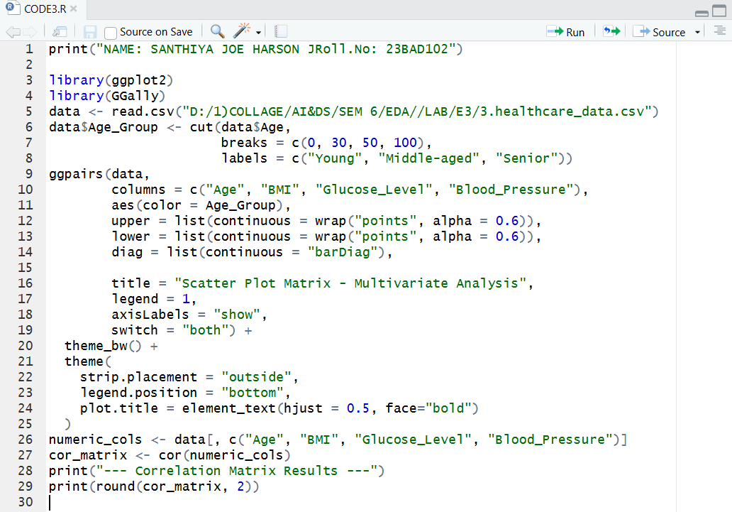

OUTPUT:

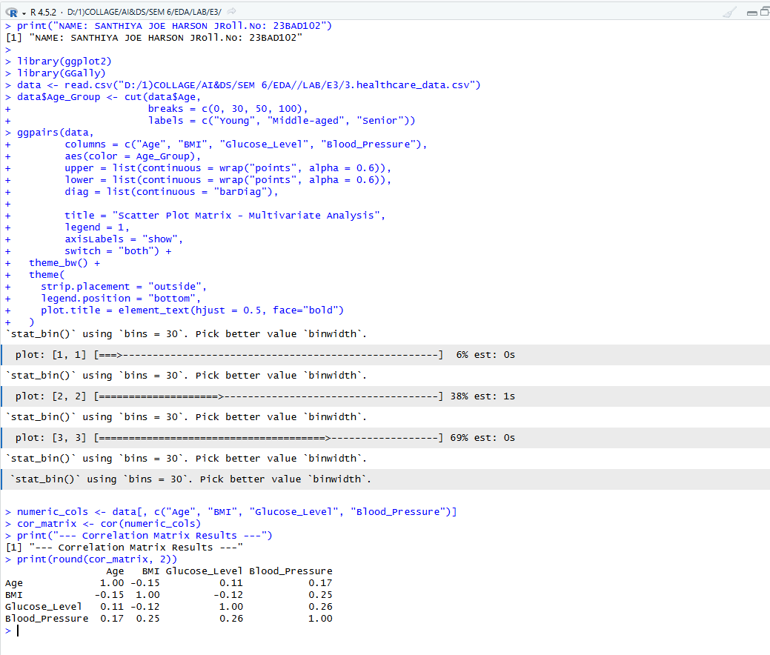

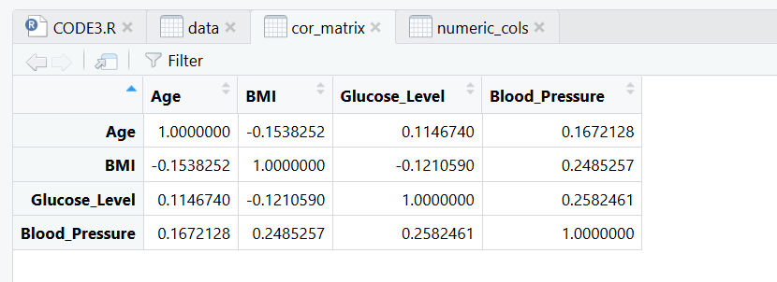

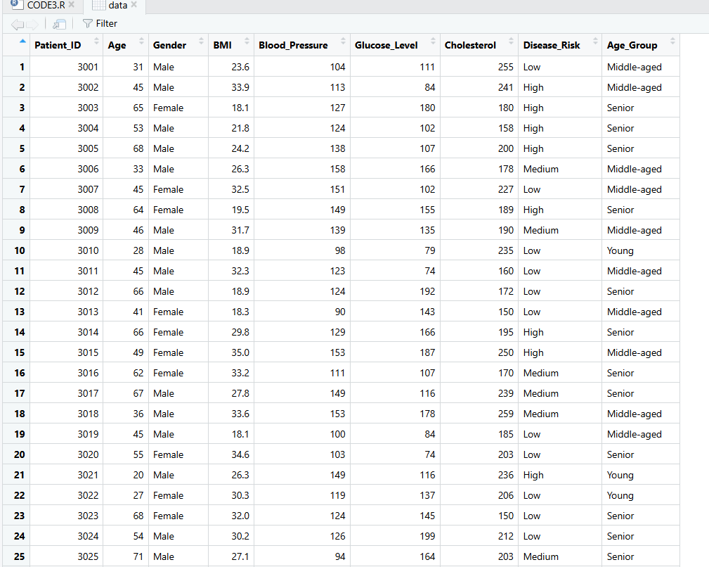

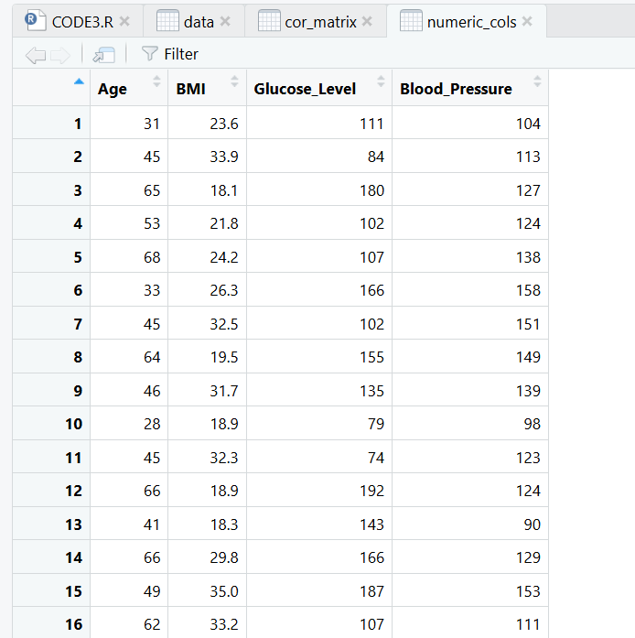
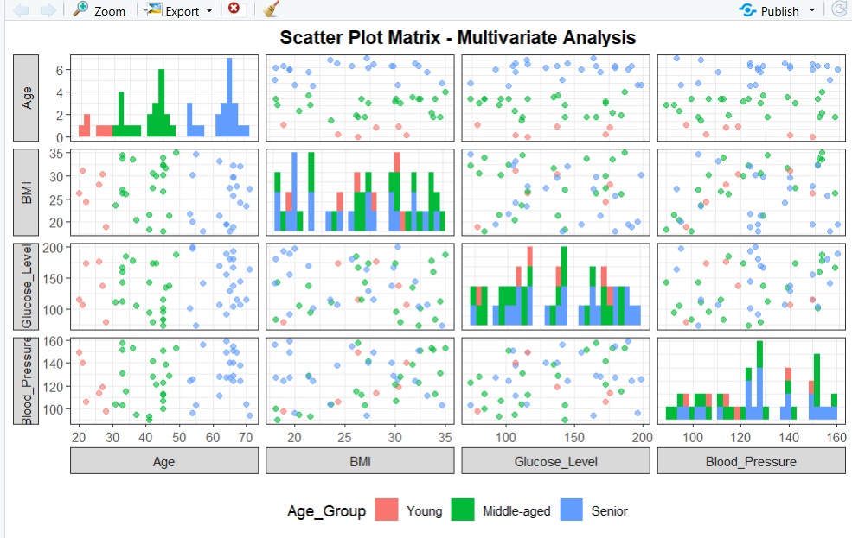

POST-LAB QUESTIONS (PROVIDE BRIEF ANSWERS TO THE FOLLOWING QUESTIONS)

- Which health parameters show strong correlation?
Based on the correlation matrix, Glucose Level and Blood Pressure (≈ 0.26) and BMI and Blood Pressure (≈ 0.25) exhibit the strongest positive correlations among the variables analyzed. However, these values remain in the moderate-to-weak range, indicating the absence of strong linear dependence between the health parameters.

- Why correlation does not imply causation in medical data?
Correlation reflects a statistical association rather than a direct cause-and-effect relationship. In medical datasets, observed correlations may arise due to confounding factors such as lifestyle habits, genetic predispositions, medications, or environmental influences. Therefore, an increase in one health parameter does not necessarily cause a change in another.

- How can these patterns assist predictive healthcare AI?
Recognizing correlation patterns enables healthcare AI systems to identify meaningful features, uncover early risk indicators, and model interactions among variables. This supports more accurate disease prediction, particularly for conditions like diabetes and hypertension, where multiple health factors contribute simultaneously.

- What visualization limitations exist for high-dimensional data?
High-dimensional data presents visualization challenges because increasing the number of variables leads to overlapping plots, visual clutter, and reduced interpretability. This makes it difficult to clearly identify relationships, trends, or interactions across multiple features at once.

- How can dimensionality reduction improve visualization?
Dimensionality reduction techniques such as Principal Component Analysis (PCA) condense multiple variables into a smaller set of informative components. This approach preserves the most important patterns in the data while enabling clearer 2D or 3D visual representations, improving interpretability and analytical insight.

ASSESSMENT
Description | Max Marks | Marks Awarded
Pre Lab Exercise | 5
In Lab Exercise | 10
Post Lab Exercise | 5
Viva | 10
Total | 30
Faculty Signature

