EXPT NO:4 | Visual encoding of data
DATE: 20.01.2026

PRE-LAB QUESTIONS
- How does the human visual system process visual variables?
The human visual system processes visual variables such as color, size, shape, and position by rapidly identifying patterns, contrasts, and differences. This enables users to understand complex information quickly, with particular efficiency in perceiving spatial relationships and variations in color and size.

- Why is improper encoding misleading in analytics?
Improper encoding can mislead analysis by distorting, hiding, or overstating data patterns. Inappropriate use of visual variables may cause viewers to misinterpret trends, comparisons, or relative importance, resulting in flawed conclusions and decisions.

- What are perceptual limitations in visualization?
Perceptual limitations include challenges in distinguishing subtle color differences, small variations in size, and complex shapes—especially when multiple variables are presented simultaneously. Excessive visual complexity can also lead to cognitive overload and reduced comprehension.

- How does color choice affect interpretation?
Color selection plays a critical role in interpretation, as colors affect attention, readability, and emotional response. Poor contrast or unsuitable color schemes can confuse users and obscure important insights.

- Why should AI dashboards be perceptually optimized?
Perceptual optimization ensures that AI dashboards communicate information clearly, accurately, and efficiently. Well-designed visuals reduce cognitive effort, minimize interpretation errors, and support effective human–AI decision-making.

OBJECTIVE: To apply effective visual encoding principles for meaningful data communication.

SCENARIO: A city traffic department analyzes accident data to identify high-risk zones and accident severity patterns.

IN-LAB TASKS (Using R Language) • Encode severity using color gradients • Represent accident frequency using size • Use shape to indicate accident type

CODE:
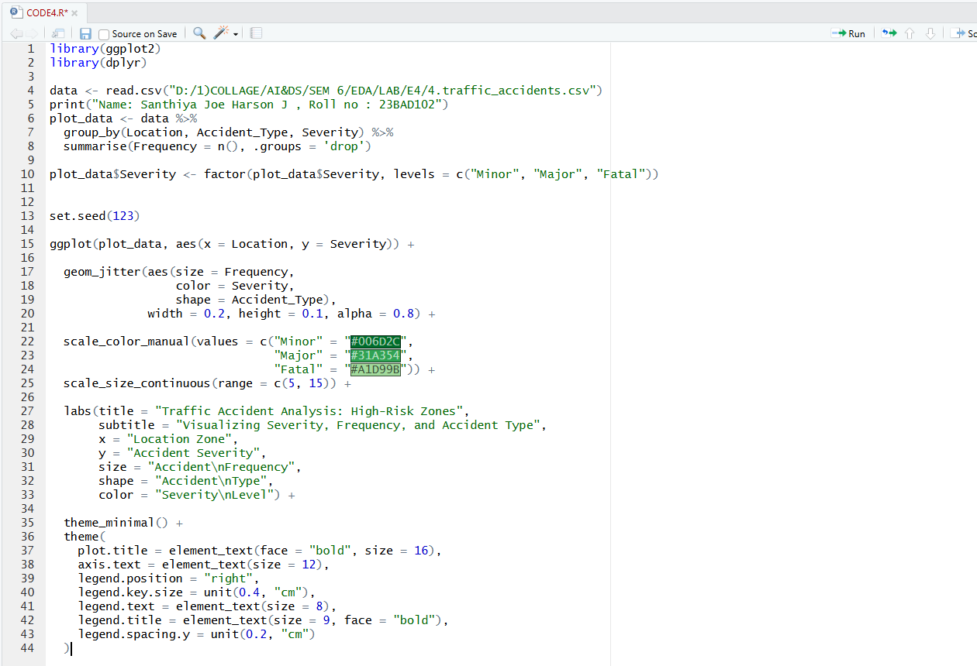

OUTPUT:

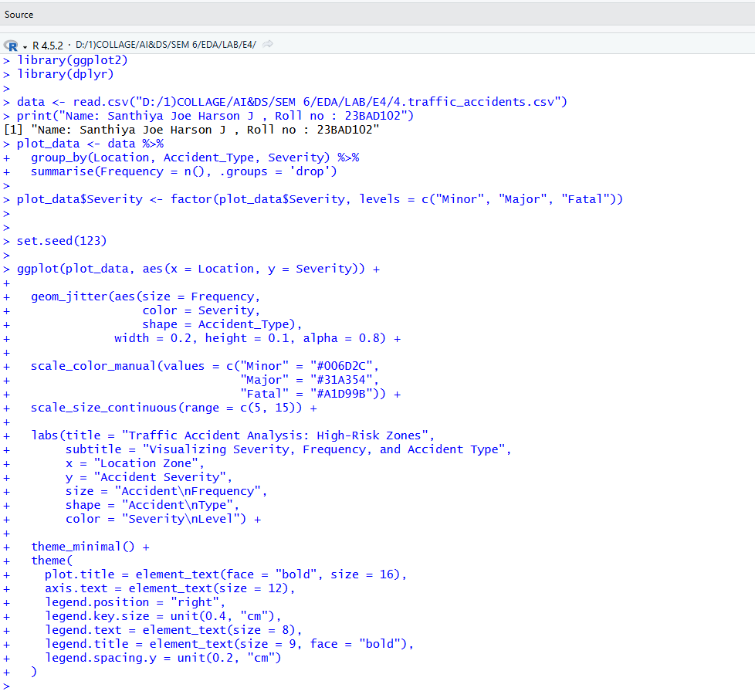

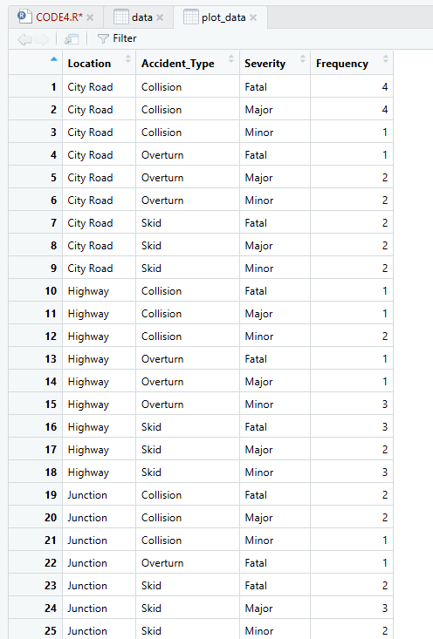

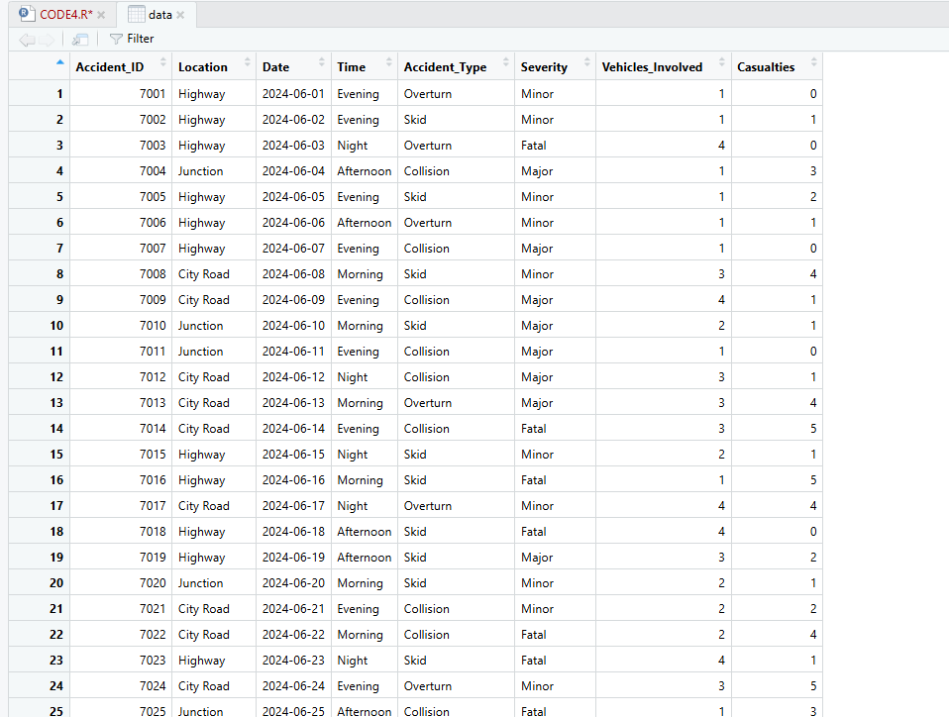
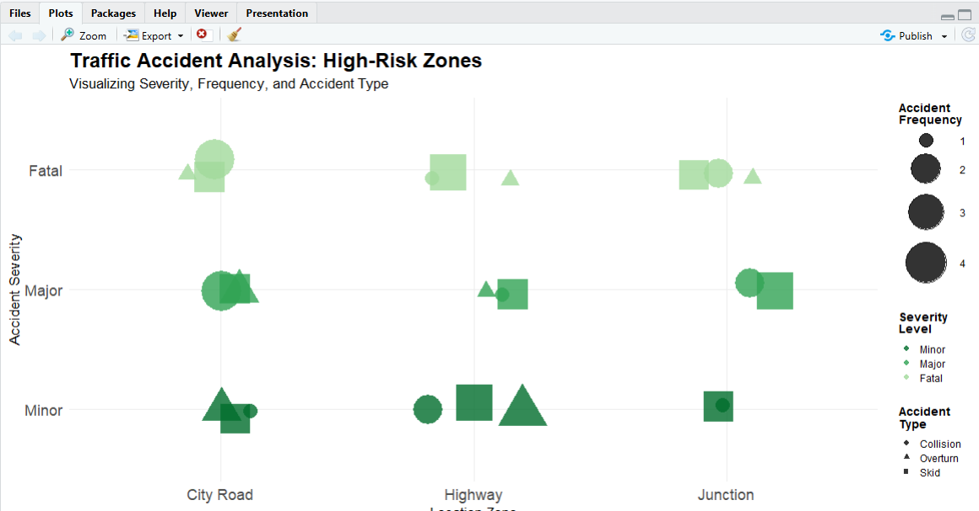

POST-LAB QUESTIONS
- Which visual variable best conveys severity and why?
Color encoding is the most effective way to represent severity because it enables fast and intuitive distinction between categories such as Minor, Major, and Fatal accidents. Human visual perception processes color differences more quickly than variations in shape or size, allowing severity to be recognized instantly across different locations.

- How can poor encoding mislead policy decisions?
Inappropriate encoding—such as using similar colors for different severity levels or inconsistent scaling—can obscure important trends, including the true impact of fatal accidents. This may cause policymakers to underestimate risks and allocate resources inefficiently.

- What precautions should be taken for color-blind users?
Designs should use color-blind–friendly palettes with adequate contrast and should not rely solely on color. Supplementing color with additional cues like shapes or spatial positioning enhances accessibility and ensures accurate interpretation.

- How does visual encoding affect AI explainability?
Effective visual encoding clarifies how patterns and features contribute to outcomes, improving transparency in AI-driven insights. Poorly designed or cluttered visuals can reduce trust and make it difficult to justify AI-based decisions to stakeholders.

- Suggest improvements for large-scale public dashboards.
Incorporating interactive filters, informative tooltips, scalable legends, and responsive layouts can significantly improve usability. Consistent encoding, simplified visuals, and drill-down capabilities help accommodate a wide range of users and analytical needs.

LEARNING OUTCOME: Students learn perceptually effective visual communication for AI systems.

ASSESSMENT
Description | Max Marks | Marks Awarded
Pre Lab Exercise | 5
In Lab Exercise | 10
Post Lab Exercise | 5
Viva | 10
Total | 30
Faculty Signature

