EXPT NO:6 | IMPLEMENTATION OF MULTIVARIATE DISPLAYS
DATE: 24.01.2026

PRE-LAB QUESTIONS
- Why are multivariate displays important in AI analytics?
Multivariate displays enable analysts to view and analyze relationships among many variables at the same time, instead of focusing on only one or two. In AI analytics, models rely on multiple features, and these visualizations help uncover patterns, correlations, clusters, and anomalies in high-dimensional data. They also assist in feature selection, identifying multicollinearity, and understanding complex interactions, leading to better model performance.

- How do parallel coordinates differ from scatter plots?
A scatter plot shows the relationship between two variables using x and y axes. In contrast, parallel coordinates visualize multiple variables simultaneously by representing each variable as a parallel vertical axis and connecting values with lines. Scatter plots are ideal for simple pairwise analysis, while parallel coordinates are more effective for exploring high-dimensional datasets.

- What challenges exist in interpreting multivariate plots?
Interpreting multivariate plots can be difficult when large datasets cause visual clutter. Overlapping points or lines may obscure important patterns. Additionally, analyzing many variables at once increases cognitive load, and poor color schemes or improper scaling can be misleading. Techniques such as normalization, filtering, and interactive visualization help reduce these challenges.

- Where are trellis displays commonly used?
Trellis displays, also known as small multiples, are widely used in statistical analysis, machine learning, and time-series studies. They present repeated plots for different data subsets, allowing easy comparison across categories, classes, or time intervals. This approach helps reveal similarities, trends, and differences more clearly.

- How does multivariate visualization aid model evaluation?
Multivariate visualization supports model evaluation by showing how features relate to predictions and errors across multiple dimensions. It helps identify bias, detect outliers, compare predicted and actual values, and understand feature influence. These insights are valuable for model tuning, debugging, and validation.

OBJECTIVE : To implement advanced multivariate displays for complex data analysis.

SCENARIO A retail analytics firm studies sales, profit, customer segment, and region to optimize business strategy.

IN-LAB TASKS (Using R Language) • Create parallel coordinate plots • Generate bubble charts • Implement trellis displays by region

CODE:
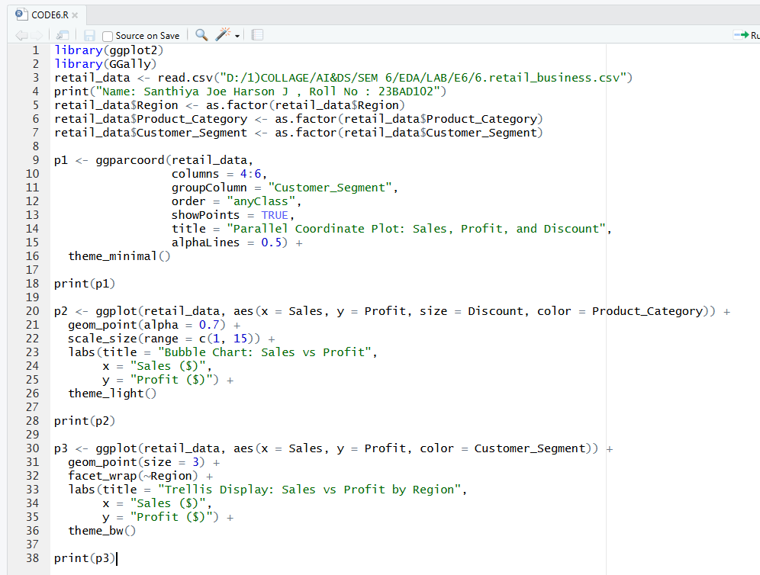

OUTPUT:

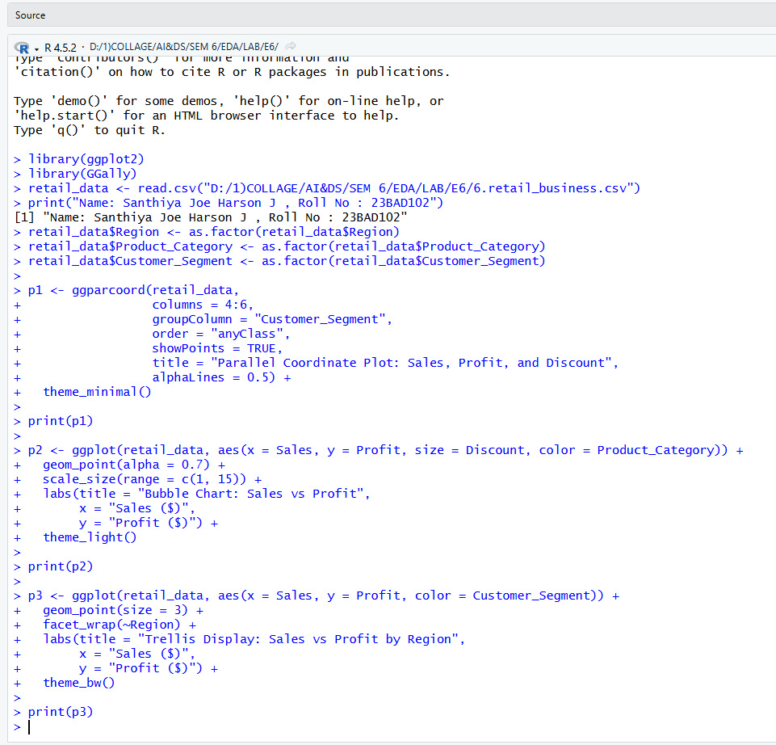

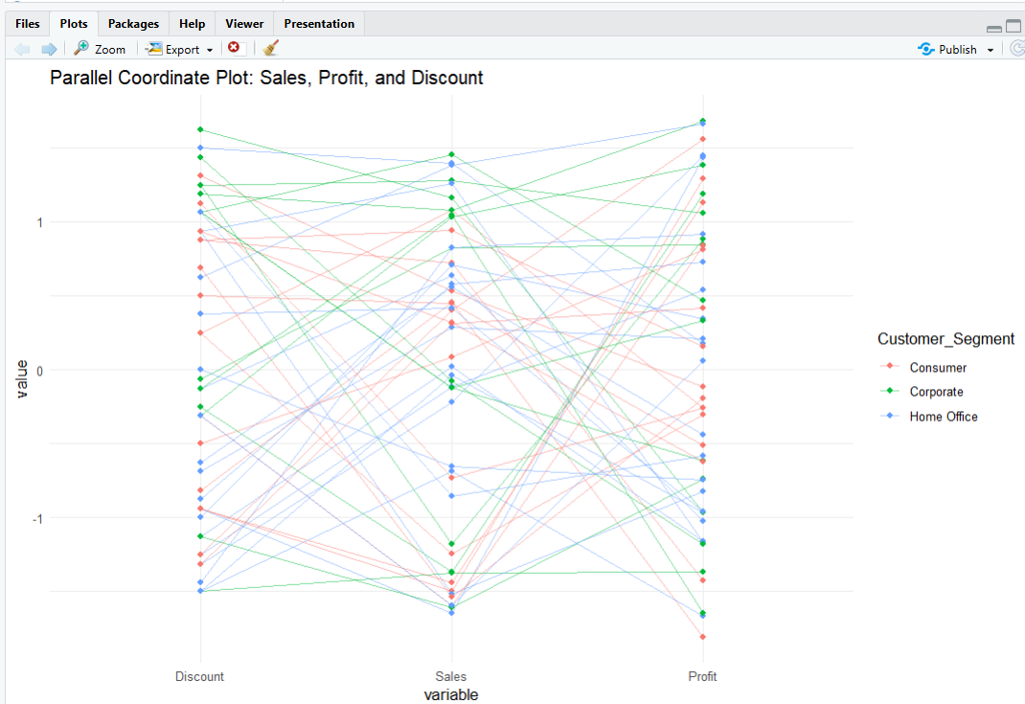

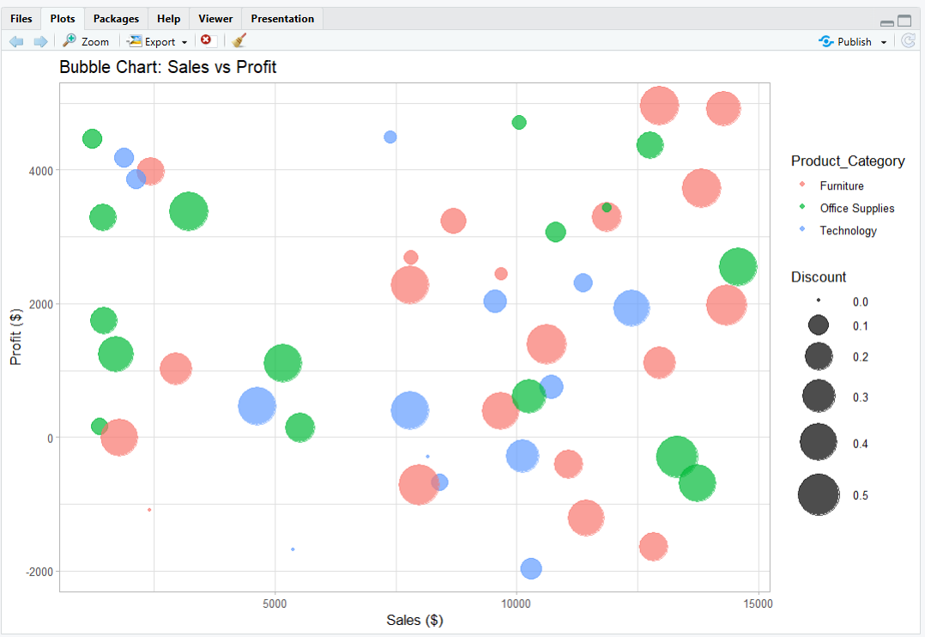
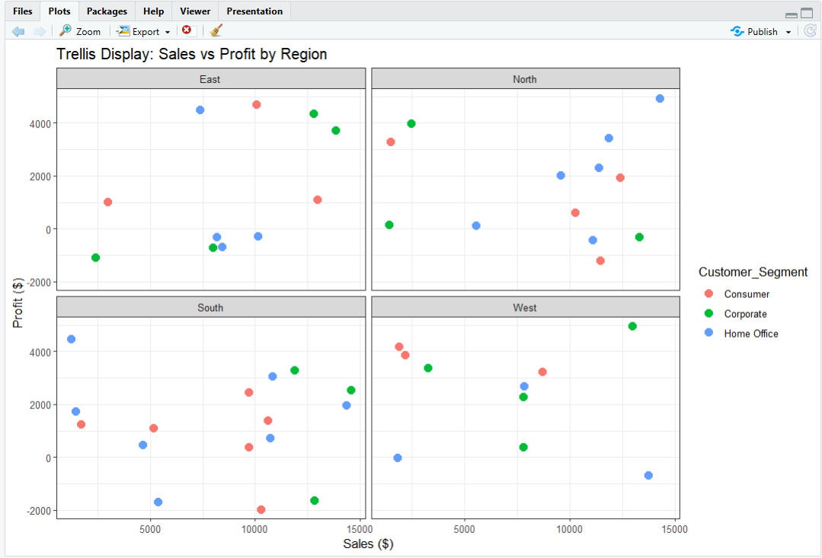

POST-LAB QUESTIONS
- What insights are gained from parallel coordinates?
Parallel coordinate plots illustrate how variables such as Discount, Sales, and Profit change together across different customer segments. The visualization shows that higher discounts do not always result in higher profits; in some cases, increased discounts correspond to reduced profit. It also highlights differences in sales and profit behavior among Consumer, Corporate, and Home Office segments, helping identify combinations of values linked to profitable or unprofitable outcomes.

- How does faceting simplify complex data?
Faceting splits the dataset into smaller groups based on Region (East, North, South, and West) and displays each group in a separate panel. This approach reduces visual clutter and makes it easier to compare sales and profit trends across regions. Regional patterns, such as consistently high profits or frequent losses, become more noticeable than in a single combined chart.

- What limitations exist in bubble charts?
Bubble charts can be challenging to interpret when many bubbles overlap. Comparing bubble sizes that represent values like discounts may not be precise. Additionally, encoding multiple variables through position, size, and color at the same time can overwhelm viewers and reduce clarity.

- How can these displays support AI-driven recommendations?
These visualizations help uncover patterns such as profitable product categories at specific sales levels and customer segments that are sensitive to discounts. AI systems can use these insights to recommend optimal discount strategies, focus on high-profit categories, and design region- or segment-specific marketing actions.

- Suggest improvements for large multivariate datasets.
• Use interactive dashboards with filtering and zoom features
• Apply dimensionality reduction techniques such as PCA
• Use sampling or data aggregation to minimize clutter
• Enable brushing and linking across multiple plots
• Ensure consistent normalization and scaling of variables
LEARNING OUTCOME: Students apply multivariate visualization for business intelligence.

ASSESSMENT
Description | Max Marks | Marks Awarded
Pre Lab Exercise | 5
In Lab Exercise | 10
Post Lab Exercise | 5
Viva | 10
Total | 30
Faculty Signature

