EXPT NO:1 | Implementation of data charts
DATE: 06.01.2026 | Implementation of data charts

PRE-LAB QUESTIONS (PROVIDE BRIEF ANSWERS TO THE FOLLOWING QUESTIONS)

- How can visualization help an academic institution improve student outcomes?
Visualization enables institutions to quickly identify performance trends and patterns. It highlights weak subjects and struggling students at a glance. Faculty can track progress over time and across departments, allowing timely intervention and improved academic outcomes.

- Which chart types are suitable for comparing subject-wise performance?
Bar charts are effective for comparing scores across subjects. Grouped bar charts support comparison among multiple students or classes. Box plots display score distribution and detect outliers, making subject-wise comparisons clearer and more informative.

- What type of data scale is used for student marks?
Student marks follow an interval scale of measurement. The differences between scores are meaningful and uniform. However, since there is no true zero value indicating absence of performance, ratio comparisons are not valid.

- Why should raw academic data be cleaned before visualization?
Raw academic data may include missing entries, duplicates, or errors that distort analysis. Cleaning the data improves accuracy and consistency, ensuring that visualizations correctly represent student performance.

- How does visualization support evidence-based decision making?
Visualization converts complex academic data into easily interpretable formats. It helps in quickly recognizing trends, patterns, and anomalies, enabling decisions to be based on factual data rather than assumptions.

IN-LAB EXERCISE:
OBJECTIVE:
To design appropriate data charts to analyze and compare academic performance indicators.
SCENARIO:
An autonomous engineering college wants to analyze internal assessment performance of first-year students across five subjects to identify difficult courses and improve teaching strategies.
IN-LAB TASKS (Using R Language)
- Load required R libraries (ggplot2, dplyr)
- Import dataset using read.csv()
- Perform basic data preprocessing
- Create bar chart for subject-wise average marks
- Generate line chart for performance trend across tests
- Plot pie chart for grade distribution

(CODE: CONATAINS STUDENT ROLL NOS
SCREENSHOT OF CODE
SCREENSHOT OF OUTPUT)

CODE:

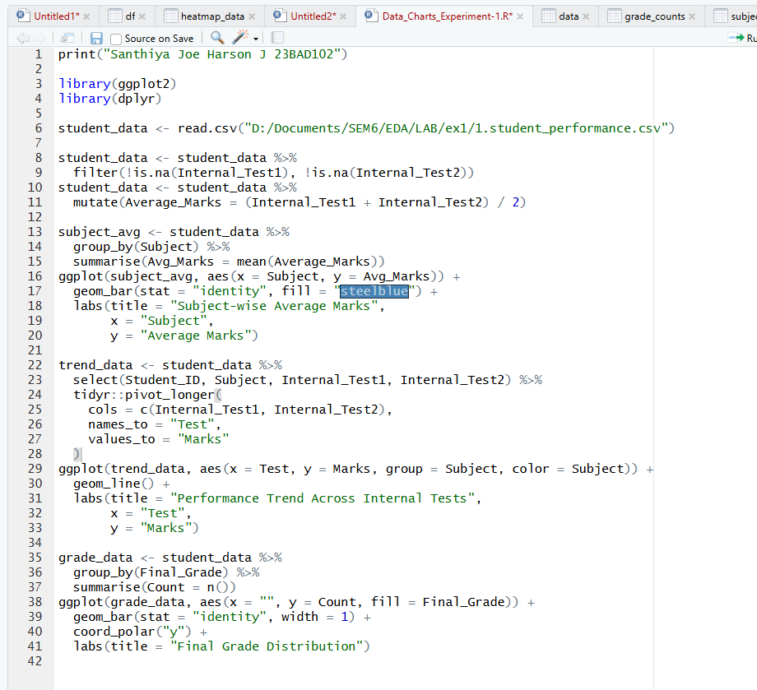

OUTPUT:

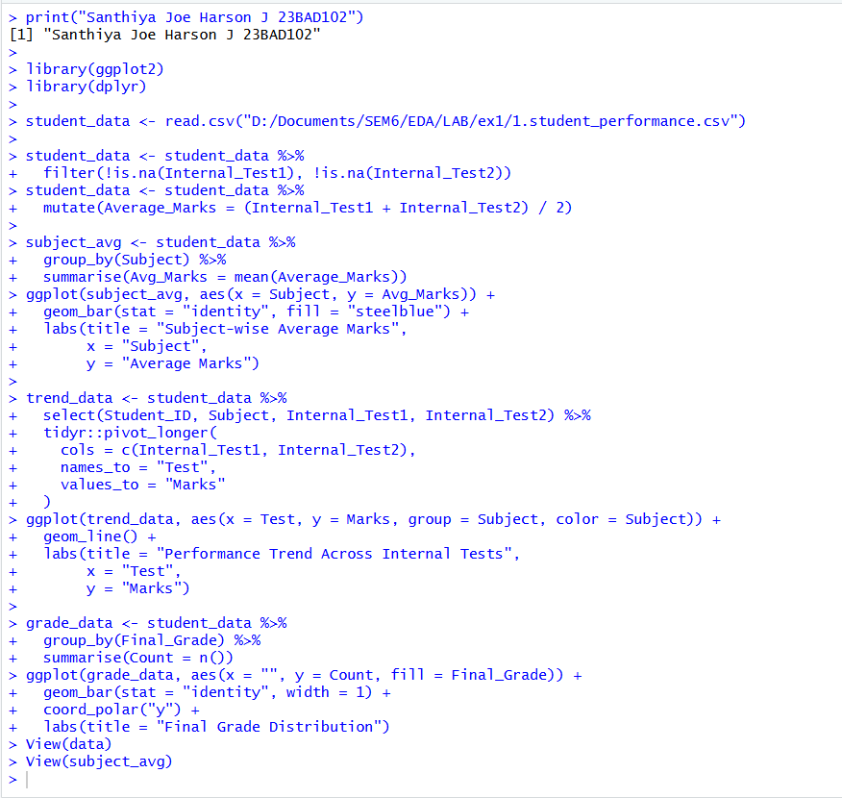

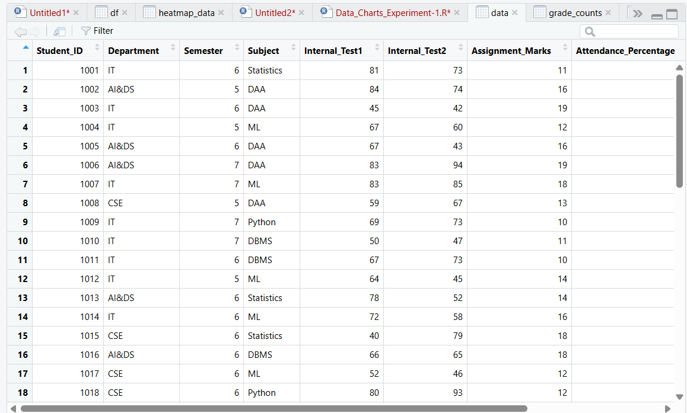

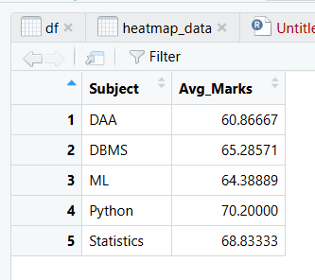

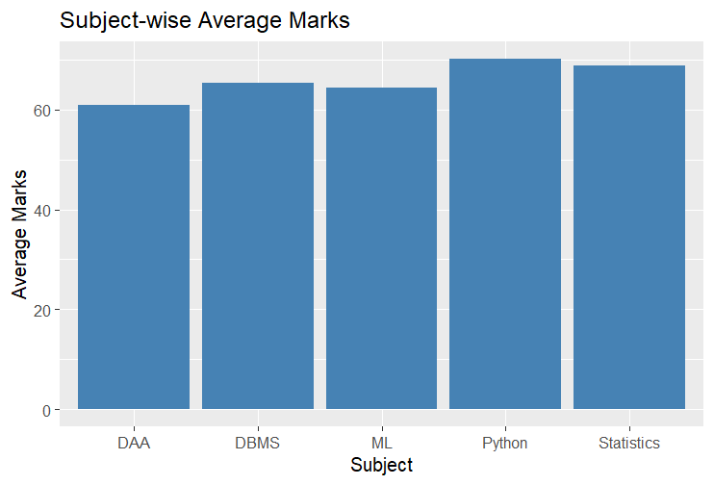
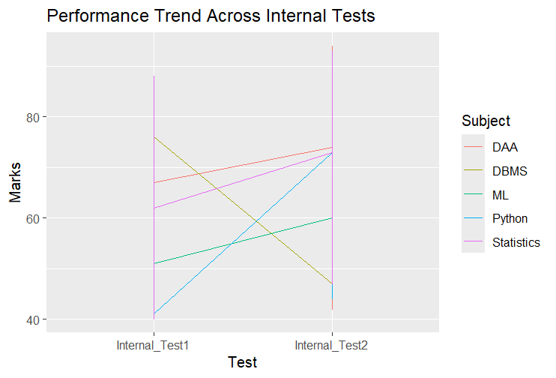

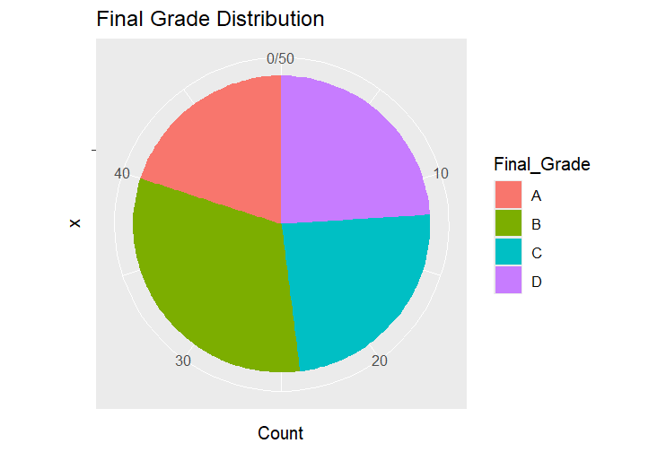

POST-LAB QUESTIONS (PROVIDE BRIEF ANSWERS TO THE FOLLOWING QUESTIONS)
1. Which subject shows consistently low performance and why?
DAA exhibits consistently low performance across assessments. It has the lowest overall average score (60.9) and performs poorly in both Internal Test 1 (62.0) and Internal Test 2 (59.7). This pattern reflects ongoing difficulty with the subject rather than an isolated performance drop.

2. Why is a line chart suitable for trend analysis?
A line chart effectively represents trends by linking data points sequentially. This continuous representation makes it easy to observe performance changes over time, clearly showing increases, decreases, and the rate of variation between tests.

3. What limitations does a pie chart have in analytics?
Pie charts are limited in analytical use because they make precise comparison difficult when values are similar. They cannot show trends over time and become unclear when too many categories are displayed.

4. How can this analysis help curriculum planning?
The analysis helps curriculum planning by highlighting weak subjects and learning gaps. Identifying poor performance in subjects such as DAA and ML enables institutions to revise teaching strategies, add remedial sessions, or restructure course content to improve outcomes.

5. How can such visualizations be integrated into AI-driven academic analytics?
These visualizations can be integrated as monitoring tools in AI-based academic systems. AI models can use performance data to predict at-risk students, while automated dashboards provide faculty with timely insights for early academic intervention.

ASSESSMENT
Description | Max Marks | Marks Awarded
Pre Lab Exercise | 5
In Lab Exercise | 10
Post Lab Exercise | 5
Viva | 10
Total | 30
Faculty Signature

