In the zip folder is our iOS Swift project.

To run it takes many steps. You can look into the direct files instead of trying to open in XCode if you don’t want to go through the trouble. I’ve also made a video demo for quick verification it works.

How to Run Our iOS Swift Program

To run our code, open “Rain.xcodeproj” in Xcode on a Mac. You should see the code opened in Xcode as below:

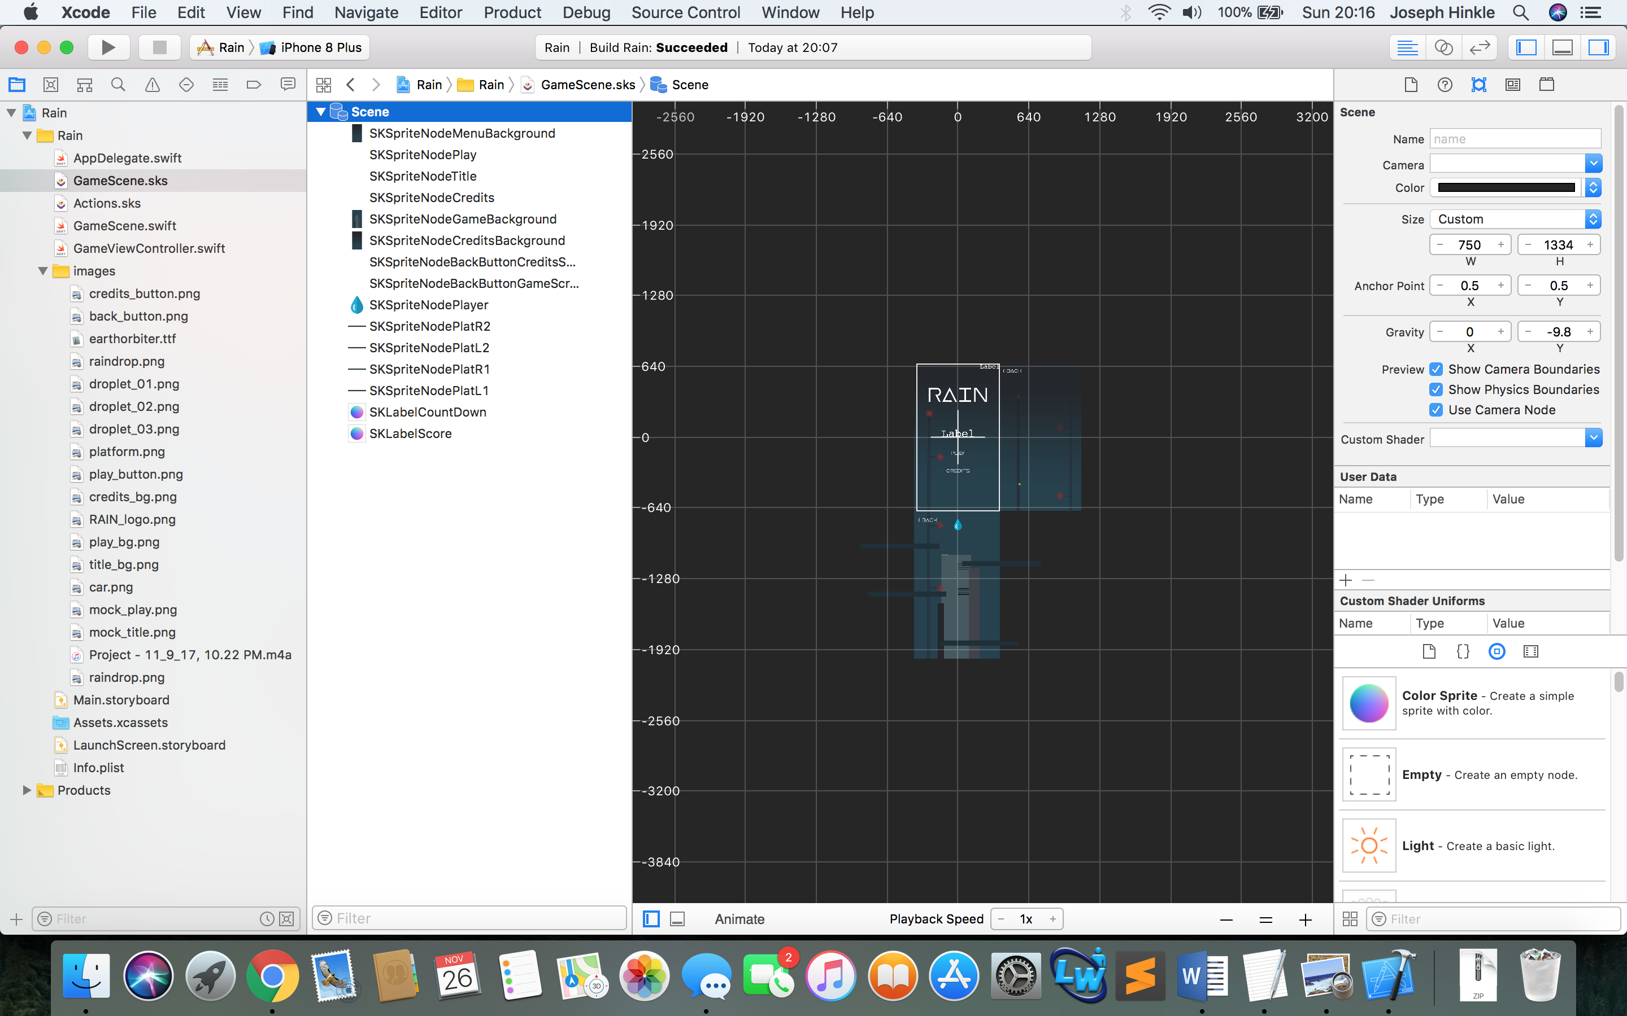

Hit the play button on the top right and it will compile and launch. If you are not on a Mac, you are out of luck. Blame Apple not us.

Here are the main files of concern and their descriptions.

* GameScene.sks – contains layouts
* GameScene.swift – coutains main game logic
* GameViewController.swift – puts game scene into an iOS view controller

All of these files can be found in the root directory of our project:

