Load taking transient of a synchronous generator

For this exercise the VII order model is used. The machine starts from the no-load condition. Since we are in regime conditions with no power delivered, all derivatives and stator currents are null. The only flow inside the system is the direct armature, supported by the excitation current. Furthermore, the load angle δ is zero when empty.
The voltage generated therefore acts only on the quadrature axis. The speed of rotation of the machine is equal to the nominal pulsation of the network with infinite power (ie n = 1).
By modeling the line that connects the stator windings and the infinite power network, its resistance and inductance must be taken into account: there will therefore be a voltage drop on the line.
The following relation can then be written:
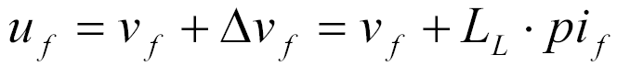

which, transformed first with Park on rotor axes and then separated in its real part and in the imaginary one, must be replaced in the two stator equations of the synchronous machine obtaining:
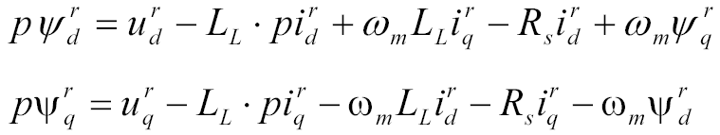

Then, fictitious machine flows are introduced, given by the sum of the stator flows and those associated with the line. What we get are simplified equations in fictitious flows. The new current-flow link will then be:
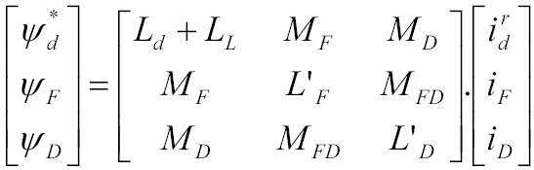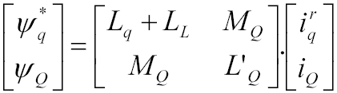

In the transition to fictitious flows, the inductance of the stator windings is thus changed; this leads, consequently, to a variation of the reactive power, while the active one and the electric torque do not change.

For this exercise it is required to vary the mechanical torque, initially zero, with a ramping up to 25% of the nominal drive torque. Furthermore, the voltage must be regulated by means of a regulator. This regulator receives the error given by the difference between a reference voltage signal of the machine and the actual voltage at the terminals; the error is used to correct excitation. Furthermore, the model includes a filter to attenuate high frequency oscillations, the exciter and the parallel of an amplifier and an integrator.

Finally, the exercise requires simulating a contingency in the infinite power network; a statism signal is then introduced into the voltage regulator. Statism consists in reducing the voltage at the machine bars in a proportional way to the Q supplied; thus, two generators in parallel are not at risk of exchanging reactive power. Statism can be natural, but also artificial; the artificial one, used here, is due to the action of the regulator on excitation.

Simulink model
Mainsystem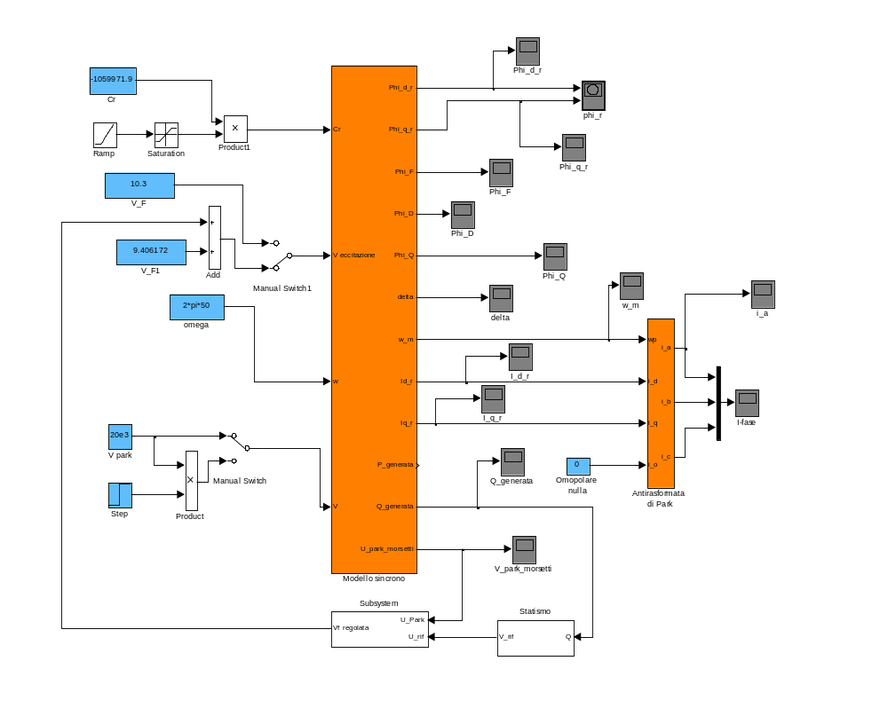

Regulator Block
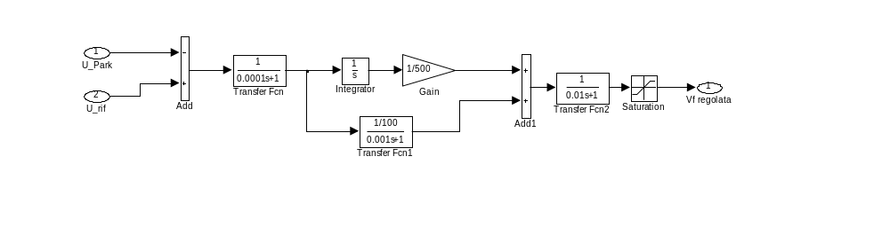
Statism Block
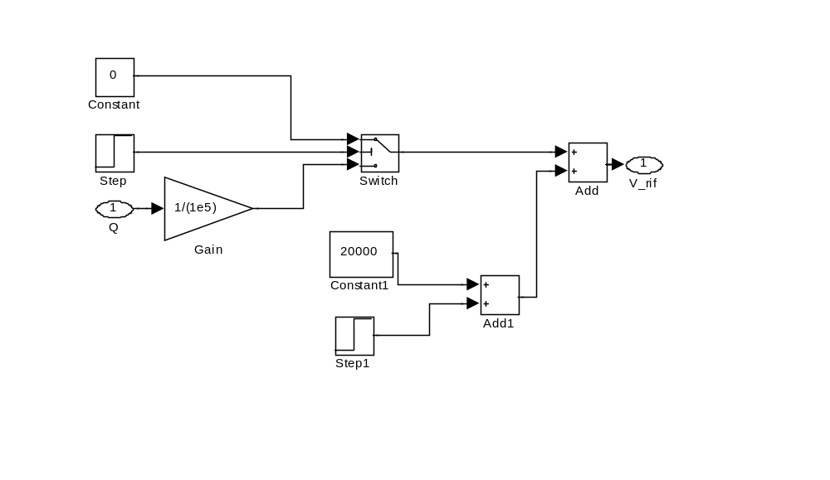

Results analysis

Loading of an unregulated asynchronous generator.

First part

The simulation is so articulated. In the first 15 seconds the machine is not loaded, at 15 seconds it starts to provide drive torque according to a linear law that stops 5 seconds after the trigger. After which the settling of the new regime is observed.

Drive torque
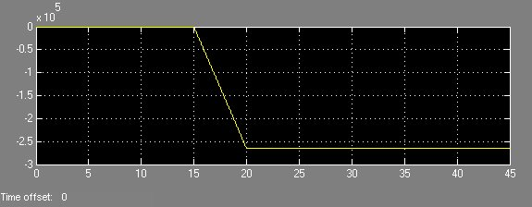

Omega m

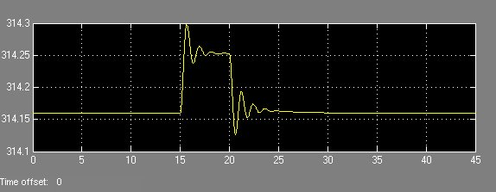

Delta

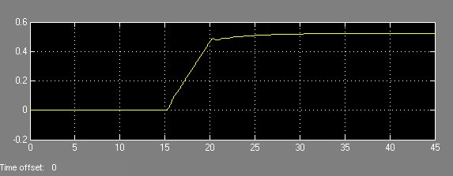

The trend of the mechanical variables shows how the machine actually takes charge after 15 seconds, after the insertion of the driving torque, the delta angle increases and the speed temporarily increases. After 20 seconds, when the power supplied to the machine becomes constant, everything stabilizes at steady state values. From the mechanical point of view it does not seem therefore to see any particularity. Let's move on to electrical quantities.

V Park terminal

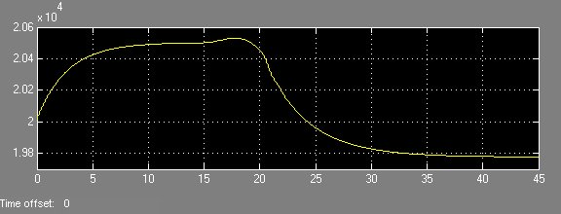

The voltage in the first 15 seconds is brought to the desired speed for which the excitation has been set, or 20500 V. However, at 15 seconds the charging takes the form of a sharp reduction in voltage at the terminals of the machine. To better justify the addict it is good to also observe the graphs that concern the powers involved.

P generation

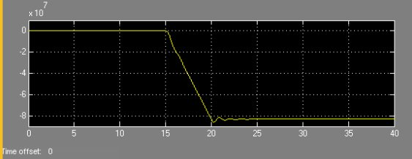

Q generation

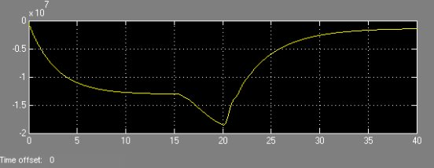

In the first 15 seconds rightly the machine is not delivering active power, however it leads to supply reactive power. This is because it is in the state of overexcitation. The internal electromotive force (from now on E) and the voltage at the terminals (henceforth V) are in phase, in fact it is delta = 0, but they are in modulus of verse, hence the reactive power generated. At the time of taking charge, the powers involved become much higher essentially due to the effect of active power and therefore also the currents on the line become greater. This can be a way of explaining the falls of tensions present which cause the V to shrink considerably. In our case we are considering both the presence of an X and the stator resistance !!! Therefore even if Q decreases, and it is shown that then the V grows (see notes), the presence of a remarkable P and the simultaneous existence of R make that there is indeed a voltage drop. In conclusion we can also observe the current variables and flows.

I d rotor

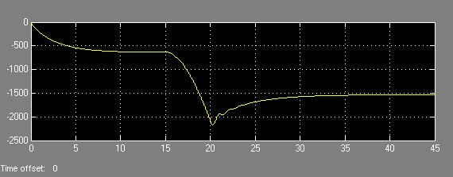

I q rotor

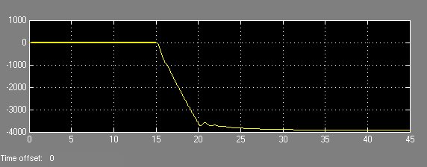

Phi q r  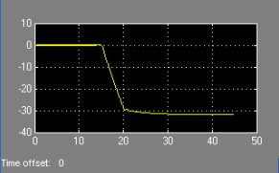 | Phi Q  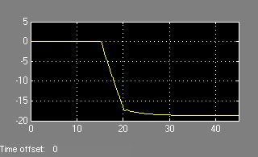
Phi D  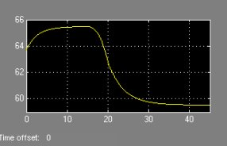 | Phi F  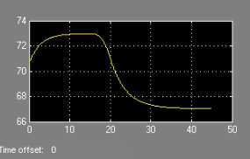

It can be observed that before 15 seconds only quantities are present only on the direct axis. This is because the machine is not generating power, it is not charged and therefore the effect on flows and currents is only due to the excitation located on the axis d. When the machine is loaded it is observed how all the flows decrease. This is because the currents are negative and increase in form. It is therefore observed the defluxing effect of the currents generated by the machine.

Second part

In the following simulation, suppose instead that the machine has a voltage regulator such as to maintain 20500 V at the ends of the machine. This will lead to new situations as far as reactive powers are concerned.

The trend of the mechanical variables is unchanged compared to the previous simulation. This is a first symptom of the fact that from the standpoint of active power, nothing changes. We look at the graphs of power and voltage.

V park terminal

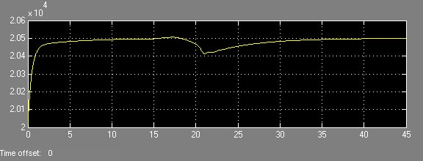

P generation

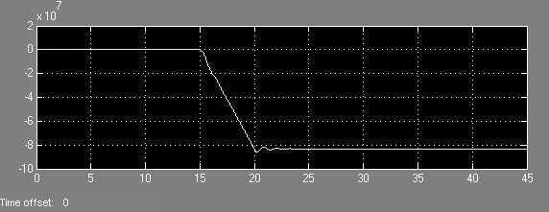

Q generation

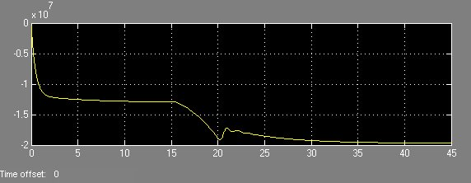

We observe very well how the voltage V is brought back to the constant value thanks to the action of the regulator. However, the adjustment is not painless because it has higher reactive powers. The thing is easily justified with the formula already seen above; 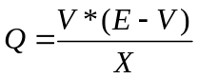; in this case we must supersede V constant while to vary is E. To keep the output voltage at the desired value, the machine is overexcited, the internal voltage drop inevitably increases and with it also the reactive power introduced into the network. The increase of Q, equal to P, also entails greater currents which lead the machine to work in more severe conditions.

I d rotor

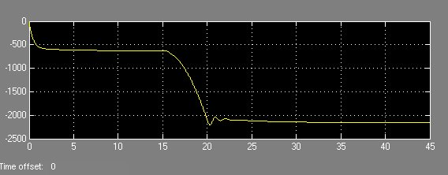

I q rotor

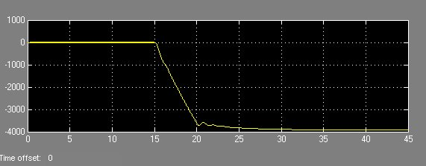

From this simulation it can be observed how voltage regulation is a process that acts exclusively on reactive powers without modifying the active component in any way. Moreover, regulation is not a painless process because greater currents are associated with the increase in Q.
The trend of the flows will be similar to those shown previously, the regime values will change.

Part Three

We now simulate a load taking up to 75% of torque without the presence of a voltage regulator.

Coppia motrice

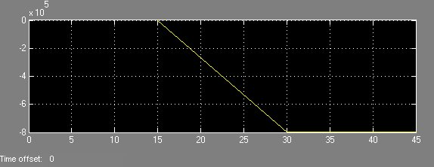

Omega m

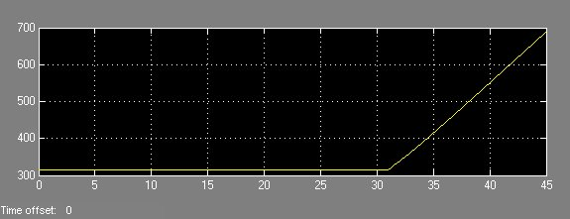

Delta

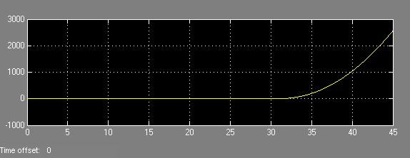

The machine in this case loses pace. The incoming power turns out to be too high, keeping in our case the constant E, being, 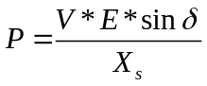, one understands how inevitable the machine is lost. V decreases due to the effect of having it loaded, delta must therefore grow in order to balance the mechanical power supplied but this then leads to instability.
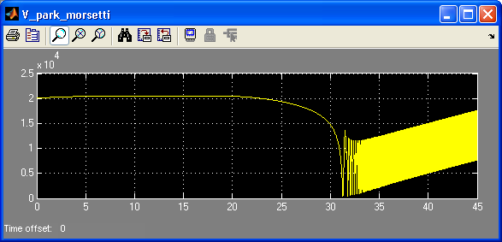
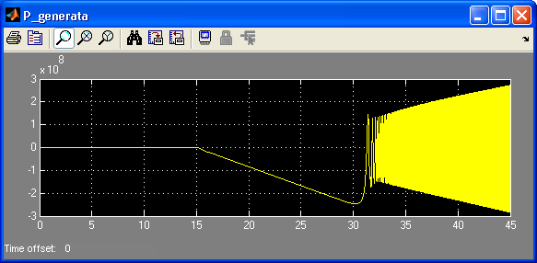

If instead we implement the voltage regulation the machine will probably not lose pace.
The assumptions are confirmed by the graphs.
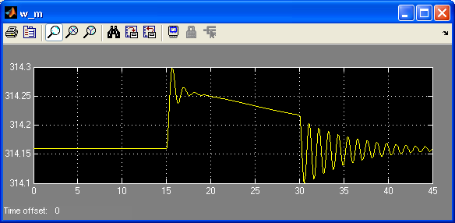
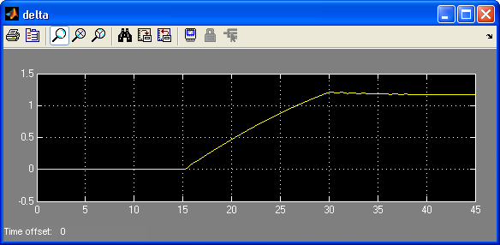
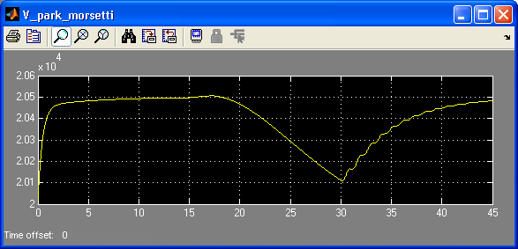

The machine therefore does not lose pace. This is because the voltage regulation allows us to act on the E, thus increasing the maximum power that can be supplied by the machine. However, we also observe how the load angle approaches in an alarming way the pi / 2: the machine manages not to lose the pace, but for a little.
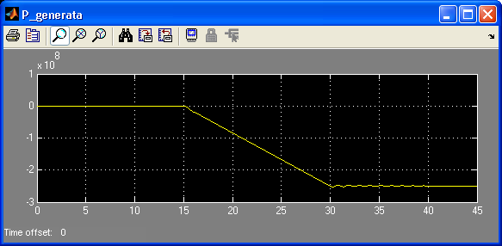
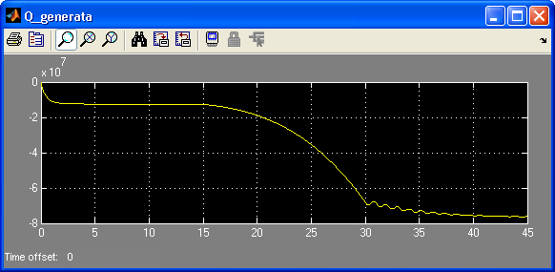

Fourth part

Finally we abandon the first 45 seconds of life to simulate a new event, a contingency in the infinite power network that brings the network voltage to 19 kV. We will observe the behavior of the machine with voltage regulator, when this is controlled with two different logics. In the first few seconds after the contingency, the regulator will ask the machine for another 20,500 V at the terminals, after which the statism control will come into action. The new control logic is to adjust the excitation voltage proportionally to the reactive power in line. In this way, voltage regulation is carried out not on the alternator terminals but on a generic point on the line. Since it is statism, as the reactive power increases, the voltage is reduced, and it is in fact what happens: You will see that the voltage is lowered because we have a high reactive power.
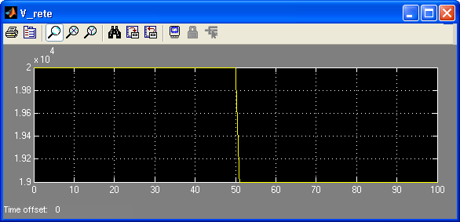

We actually observe the contingency on the grid voltage that occurs 50 seconds from the start of the simulation. The times are as follows: 50 seconds, contingency; 75 seconds, statism activation.
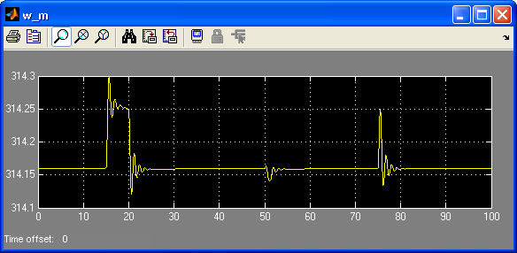
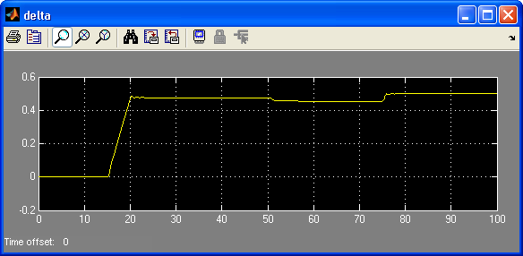
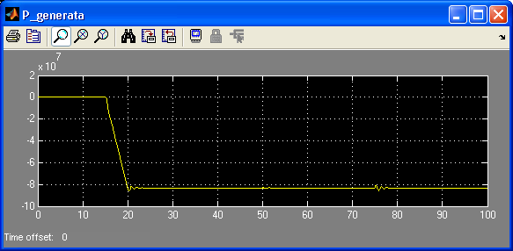

We observe as already done previously that the mechanical variables and the generated power are not particularly affected by the variations due to the contingency. Instead the entry into operation of the statism which involves some fluctuations in the speed and in the angle of load, oscillations that are quickly reabsorbed, is a bit more expensive.
Let's now pass to the significant variables for the simulation.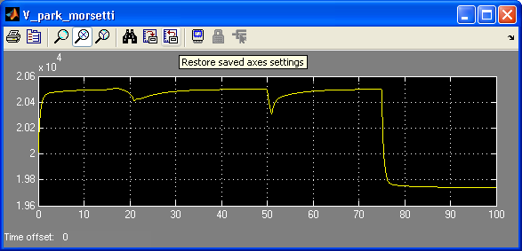

The overall view clearly shows how the system first reacts to the contingency, still returning to the reference voltage, while later on due to statism, the voltage at the terminals is reduced considerably. This will certainly lead to benefits for reactive power and therefore for currents.
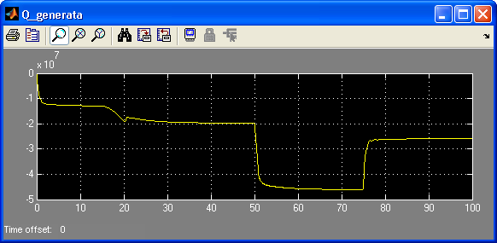

Between 50 and 75 seconds the reactive power is very high, the voltage drop is in fact very large because the machine is still at 20500 V while the mains voltage has dropped considerably.
Thanks to the statismo instead the regulation brings the machine tension to lower values. With her, therefore, the Q is reduced and as can be seen in the next graphs also the currents.
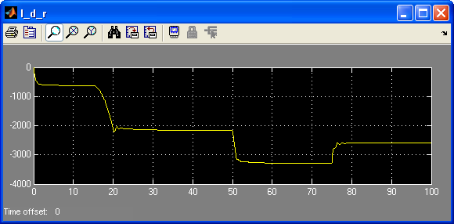
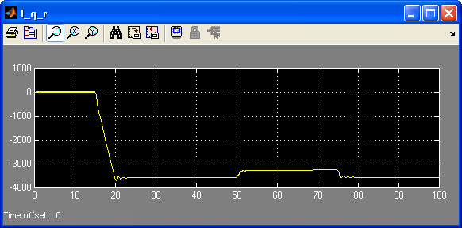

To conclude, let's see how the regulation voltage that comes from the regulator behaves and is then responsible for the value of the excitation voltage.

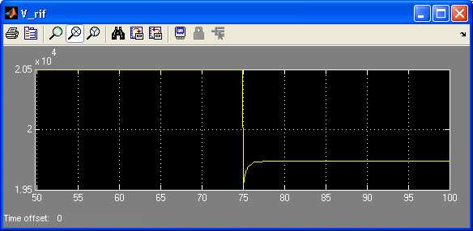

Up to 75 seconds it remains unchanged, the statism signal has not yet activated. Later it is drastically reduced.

