# 开源ceph编码编译及问题总结

## 1.下载

一般是从github下载代码，但是网上看到也有人是通过其他镜像源下载的，像ceph这种大型项目在编译过程中也会下载一些依赖，所以对编译环境的要求比较高。

## **2.编译方式**

编译方式有几种：

1.解压tar包，通过cmake、make方式编译生成对应ceph版本的bin文件

2.通过rpmbuild方式编译整个tar包

我采用的是第一种，其实原来在新华三时，也是通过这种方式进行，然后通过脚本方式把各子模块生成的动态链接库和可执行文件打包，最后生成一个tar包。Tar包的话涉及产品化形态，我觉得还好，主要是把编译打通。

网上可参考的链接：[手动编译ceph | 奋斗的松鼠 - Blog](http://strugglesquirrel.com/2019/01/03/%E6%89%8B%E5%8A%A8%E7%BC%96%E8%AF%91ceph/)

当然他的这篇文章很早了，我估计应该是在自己环境上整的，所以通篇没有什么太大的问题，都是正常的下一步操作，但是我在执行cmake时就遇到了很多问题。

1. 科大讯飞这边申请的编译服务器上比如内核版本是



这边没有专门的内核os部门，所以目前所有的物理服务器上跑的都是centos7的内核版本，这个内核是没有cmake命令的，所以需要自己下载cmake包并执行安装，但是这里要注意cmake的版本，可以查看ceph源码CMakeLists.txt 对cmake版本的要求，省的版本太高或太低

[【Linux】CMake源码编译安装教程 - 知乎](https://zhuanlan.zhihu.com/p/477157242)

[Release v3.10.2 · Kitware/CMake · GitHub](https://github.com/Kitware/CMake/releases/tag/v3.10.2) #tar包

1. gcc编译器版本是gcc4.8.5， 开始ceph15.2.17版本 cmakelists报错，提示CXX至少是17，所以要升级gcc编译器版本，但是这里有个问题，存储集群上的gcc版本是4.8.5，为什么这里提示要升级gcc编译器呢？讲道理，用gcc4.8.5也是可以的， 事实证明，高版本gcc编译器编译的文件可以运行在低版本gcc的环境上，是高向低兼容

对应的版本信息：

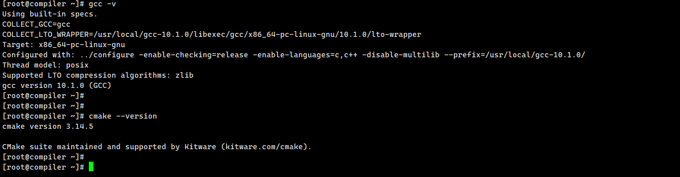

5.继续执行CMakelists.txt，有很多依赖需要安装

有一篇文章里有提到，但是忘记在哪里了，其中包括:

Yum install -y fcgi-devel gperftools-devel jemalloc-devel dpdk-devel python3-devel libnl3 libnl3-devel numactl-devel pkg-config

另外可能还有很多依赖，请见附件

 

6.正常执行cmake .. 预处理以及make 编译，最后在build/bin目录下输出所有ceph的可执行文件

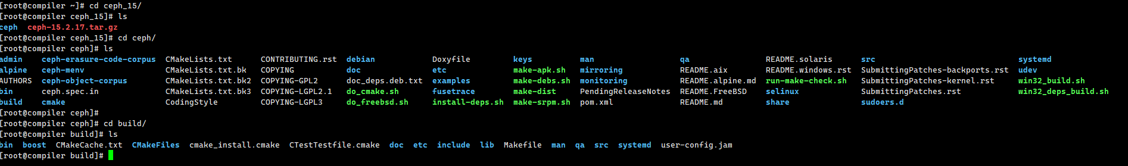



Make install 命令不必在执行了，因为编译机上不需要安装

此时查看ceph-osd 文件依赖如下：

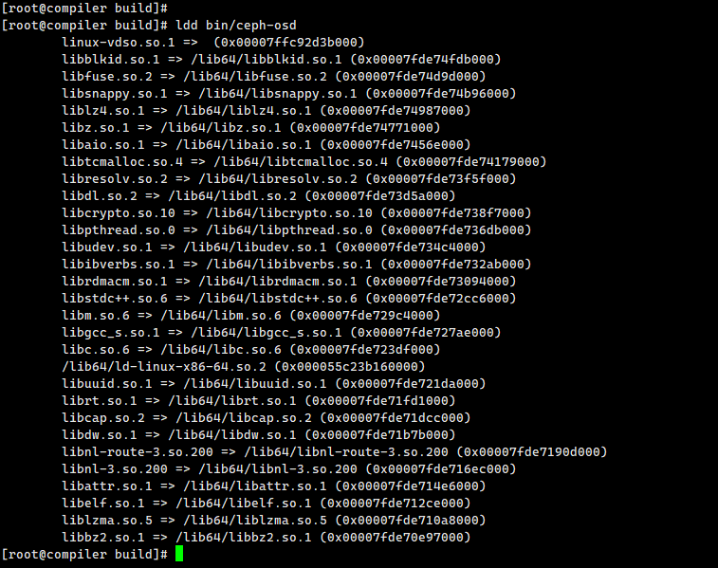

再看存储节点上的ceph-osd文件依赖如下：

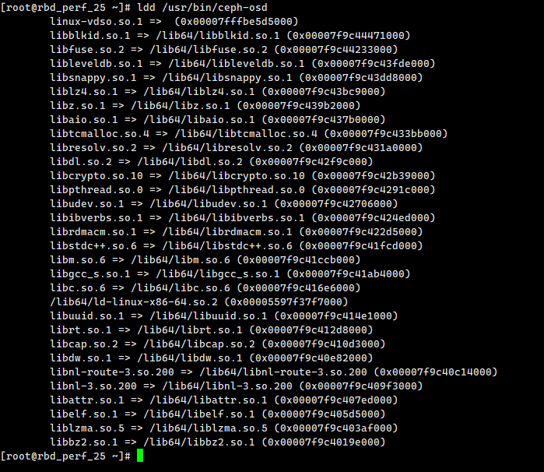

通过yum安装的ceph-osd的依赖只多了一个leveldb的链接库，原因是我的编译服务器上没有安装leveldb，网络是研测的，限制网速，所以就没有再搞，因为15版本已经不再使用levledb了，所以没有也问题不大

7.替换ceph-osd过去，发现ceph osd起不来，通过分析ceph-osd日志发现是缺少依赖的动态链接库

如下有两个：

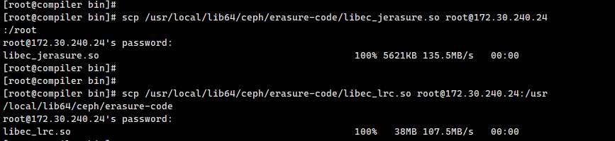

8.执行起来的集群如下，可以看到osd都是正常拉起的

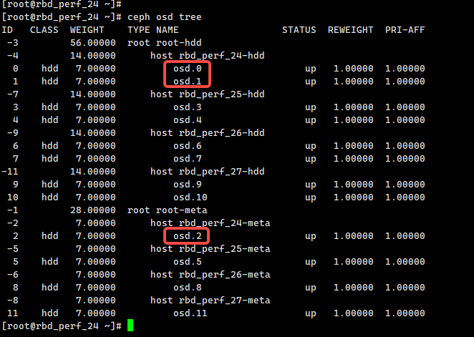

再看对应的文件

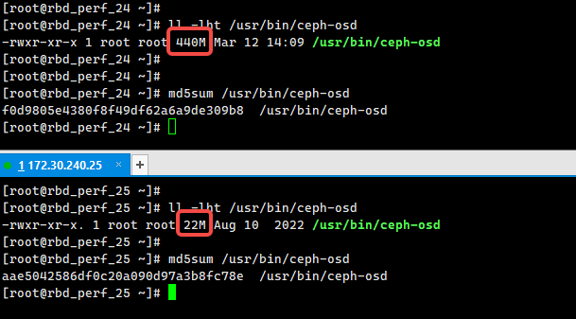

## 3.rpmbuild编译tar包

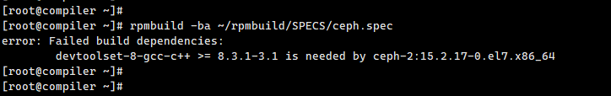

最初的报错信息

刚开始出现如下问题：

//root/rpmbuild/BUILD/ceph-15.2.17/build/lib/libceph-common.so.2: undefined reference to `std::codecvt<wchar_t, char, __mbstate_t> const& std::use_facet<std::codecvt<wchar_t, char, __mbstate_t> >(std::locale const&)@GLIBCXX_3.4'

/root/rpmbuild/BUILD/ceph-15.2.17/build/lib/libcephfs.so: undefined reference to `std::condition_variable::notify_all()@GLIBCXX_3.4.11'

//root/rpmbuild/BUILD/ceph-15.2.17/build/lib/libceph-common.so.2: undefined reference to `std::locale::locale(std::locale const&)@GLIBCXX_3.4'

//root/rpmbuild/BUILD/ceph-15.2.17/build/lib/libceph-common.so.2: undefined reference to `vtable for std::invalid_argument@GLIBCXX_3.4'

/root/rpmbuild/BUILD/ceph-15.2.17/build/lib/libcephfs.so: undefined reference to `std::ostream::operator<<(short)@GLIBCXX_3.4'

/root/rpmbuild/BUILD/ceph-15.2.17/build/lib/libcephfs.so: undefined reference to `std::basic_ostringstream<char, std::char_traits<char>, std::allocator<char> >::~basic_ostringstream()@GLIBCXX_3.4'

//root/rpmbuild/BUILD/ceph-15.2.17/build/lib/libceph-common.so.2: undefined reference to `std::ios_base::failure::what() const@GLIBCXX_3.4'

//root/rpmbuild/BUILD/ceph-15.2.17/build/lib/libceph-common.so.2: undefined reference to `std::runtime_error::runtime_error(std::string const&)@GLIBCXX_3.4'

//root/rpmbuild/BUILD/ceph-15.2.17/build/lib/libceph-common.so.2: undefined reference to `typeinfo for std::bad_exception@GLIBCXX_3.4'

//root/rpmbuild/BUILD/ceph-15.2.17/build/lib/libceph-common.so.2: undefined reference to `std::istream::get()@GLIBCXX_3.4'

//root/rpmbuild/BUILD/ceph-15.2.17/build/lib/libceph-common.so.2: undefined reference to `std::bad_alloc::~bad_alloc()@GLIBCXX_3.4'

/root/rpmbuild/BUILD/ceph-15.2.17/build/lib/libcephfs.so: undefined reference to `std::ios_base::Init::Init()@GLIBCXX_3.4'

//root/rpmbuild/BUILD/ceph-15.2.17/build/lib/libceph-common.so.2: undefined reference to `std::logic_error::what() const@GLIBCXX_3.4'

/root/rpmbuild/BUILD/ceph-15.2.17/build/lib/libcephfs.so: undefined reference to `std::_Hash_bytes(void const*, unsigned long, unsigned long)@CXXABI_1.3.5'

/root/rpmbuild/BUILD/ceph-15.2.17/build/lib/libcephfs.so: undefined reference to `std::__detail::_List_node_base::_M_transfer(std::__detail::_List_node_base*, std::__detail::_List_node_base*)@GLIBCXX_3.4.15'

//root/rpmbuild/BUILD/ceph-15.2.17/build/lib/libceph-common.so.2: undefined reference to `typeinfo for unsigned long long@CXXABI_1.3'

//root/rpmbuild/BUILD/ceph-15.2.17/build/lib/libceph-common.so.2: undefined reference to `typeinfo for std::out_of_range@GLIBCXX_3.4'

//root/rpmbuild/BUILD/ceph-15.2.17/build/lib/libceph-common.so.2: undefined reference to `std::basic_filebuf<char, std::char_traits<char> >::xsgetn(char*, long)@GLIBCXX_3.4'

/root/rpmbuild/BUILD/ceph-15.2.17/build/lib/libcephfs.so: undefined reference to `std::basic_streambuf<char, std::char_traits<char> >::seekpos(std::fpos<__mbstate_t>, std::_Ios_Openmode)@GLIBCXX_3.4'

/root/rpmbuild/BUILD/ceph-15.2.17/build/lib/libcephfs.so: undefined reference to `std::basic_filebuf<char, std::char_traits<char> >::basic_filebuf()@GLIBCXX_3.4'

/root/rpmbuild/BUILD/ceph-15.2.17/build/lib/libcephfs.so: undefined reference to `std::ostream::operator<<(int)@GLIBCXX_3.4'

/root/rpmbuild/BUILD/ceph-15.2.17/build/lib/libcephfs.so: undefined reference to `std::locale::locale()@GLIBCXX_3.4'

//root/rpmbuild/BUILD/ceph-15.2.17/build/lib/libceph-common.so.2: undefined reference to `std::regex_error::~regex_error()@GLIBCXX_3.4.15'

/root/rpmbuild/BUILD/ceph-15.2.17/build/lib/libcephfs.so: undefined reference to `std::ctype<char>::_M_widen_init() const@GLIBCXX_3.4.11'

//root/rpmbuild/BUILD/ceph-15.2.17/build/lib/libceph-common.so.2: undefined reference to `std::ctype<char>::id@GLIBCXX_3.4'

/root/rpmbuild/BUILD/ceph-15.2.17/build/lib/libcephfs.so: undefined reference to `std::basic_ostream<char, std::char_traits<char> >& std::operator<< <std::char_traits<char> >(std::basic_ostream<char, std::char_traits<char> >&, char const*)@GLIBCXX_3.4'

//root/rpmbuild/BUILD/ceph-15.2.17/build/lib/libceph-common.so.2: undefined reference to `std::basic_stringstream<char, std::char_traits<char>, std::allocator<char> >::basic_stringstream(std::string const&, std::_Ios_Openmode)@GLIBCXX_3.4'

/root/rpmbuild/BUILD/ceph-15.2.17/build/lib/libcephfs.so: undefined reference to `std::condition_variable::wait(std::unique_lock<std::mutex>&)@GLIBCXX_3.4.11'

/root/rpmbuild/BUILD/ceph-15.2.17/build/lib/libcephfs.so: undefined reference to `std::__throw_bad_function_call()@GLIBCXX_3.4.14'

/root/rpmbuild/BUILD/ceph-15.2.17/build/lib/libcephfs.so: undefined reference to `vtable for std::runtime_error@GLIBCXX_3.4'

collect2: error: ld returned 1 exit status

Link Error: Ceph FS library not found

make[2]: *** [lib/cython_modules/lib.3/cephfs.cpython-36m-x86_64-linux-gnu.so] Error 1

make[1]: *** [src/pybind/cephfs/CMakeFiles/cython_cephfs.dir/all] Error 2

make[1]: *** Waiting for unfinished jobs....

[ 81%] Building CXX object src/osd/CMakeFiles/osd.dir/scheduler/mClockScheduler.cc.o

[ 81%] Building CXX object src/rgw/CMakeFiles/rgw_a.dir/rgw_realm_reloader.cc.o

[ 81%] Building CXX object src/osd/CMakeFiles/osd.dir/PeeringState.cc.o

[ 81%] Building CXX object src/osd/CMakeFiles/osd.dir/PGStateUtils.cc.o

[ 81%] Building CXX object src/osd/CMakeFiles/osd.dir/MissingLoc.cc.o

[ 81%] Building CXX object src/mgr/CMakeFiles/ceph-mgr.dir/DaemonHealthMetricCollector.cc.o

[ 81%] Building CXX object src/mgr/CMakeFiles/ceph-mgr.dir/DaemonKey.cc.o

[ 81%] Linking CXX executable ../../bin/rados

[ 82%] Building CXX object src/mgr/CMakeFiles/ceph-mgr.dir/DaemonServer.cc.o

[ 82%] Building CXX object src/osd/CMakeFiles/osd.dir/osd_perf_counters.cc.o

[ 82%] Built target rados

[ 82%] Building CXX object src/osd/CMakeFiles/osd.dir/__/common/TrackedOp.cc.o

[ 82%] Building CXX object src/mgr/CMakeFiles/ceph-mgr.dir/DaemonState.cc.o

[ 82%] Linking CXX executable ../../../bin/unittest_rbd_mirror

[ 82%] Building CXX object src/mgr/CMakeFiles/ceph-mgr.dir/Gil.cc.o

[ 82%] Building CXX object src/osd/CMakeFiles/osd.dir/__/mgr/OSDPerfMetricTypes.cc.o

[ 82%] Building CXX object src/osd/CMakeFiles/osd.dir/__/osdc/Objecter.cc.o

[ 82%] Building CXX object src/mgr/CMakeFiles/ceph-mgr.dir/Mgr.cc.o

[ 82%] Building CXX object src/mgr/CMakeFiles/ceph-mgr.dir/MgrStandby.cc.o

[ 83%] Building CXX object src/osd/CMakeFiles/osd.dir/__/osdc/Striper.cc.o

[ 83%] Building CXX object src/mgr/CMakeFiles/ceph-mgr.dir/MetricCollector.cc.o

[ 83%] Building CXX object src/mgr/CMakeFiles/ceph-mgr.dir/OSDPerfMetricTypes.cc.o

[ 83%] Building CXX object src/mgr/CMakeFiles/ceph-mgr.dir/OSDPerfMetricCollector.cc.o

[ 83%] Building CXX object src/mgr/CMakeFiles/ceph-mgr.dir/PyFormatter.cc.o

[ 83%] Building CXX object src/mgr/CMakeFiles/ceph-mgr.dir/PyUtil.cc.o

[ 83%] Building CXX object src/mgr/CMakeFiles/ceph-mgr.dir/PyModule.cc.o

[ 83%] Building CXX object src/rgw/CMakeFiles/rgw_a.dir/rgw_realm_watcher.cc.o

[ 83%] Building CXX object src/mgr/CMakeFiles/ceph-mgr.dir/PyModuleRegistry.cc.o

[ 83%] Building CXX object src/mgr/CMakeFiles/ceph-mgr.dir/PyModuleRunner.cc.o

/root/rpmbuild/BUILD/ceph-15.2.17/src/mgr/DaemonServer.cc: In lambda function:

/root/rpmbuild/BUILD/ceph-15.2.17/src/mgr/DaemonServer.cc:2749:15: warning: comparison of integer expressions of different signedness: 'int' and 'unsigned int' [-Wsign-compare]

if (next != p.get_pgp_num()) {

~~~~~^~~~~~~~~~~~~~~~~~

[ 83%] Linking CXX shared library ../../lib/librbd.so

[ 83%] Building CXX object src/mgr/CMakeFiles/ceph-mgr.dir/PyOSDMap.cc.o

[ 83%] Building CXX object src/mgr/CMakeFiles/ceph-mgr.dir/StandbyPyModules.cc.o

[ 83%] Building CXX object src/mgr/CMakeFiles/ceph-mgr.dir/mgr_commands.cc.o

[ 83%] Built target unittest_rbd_mirror

[ 83%] Building CXX object src/rgw/CMakeFiles/rgw_a.dir/rgw_os_lib.cc.o

[ 83%] Building CXX object src/rgw/CMakeFiles/rgw_a.dir/rgw_process.cc.o

[ 83%] Building CXX object src/rgw/CMakeFiles/rgw_a.dir/rgw_rest_bucket.cc.o

[ 83%] Building CXX object src/rgw/CMakeFiles/rgw_a.dir/rgw_rest_config.cc.o

[ 83%] Building CXX object src/rgw/CMakeFiles/rgw_a.dir/rgw_rest_log.cc.o

[ 83%] Built target librbd

[ 83%] Building CXX object src/rgw/CMakeFiles/rgw_a.dir/rgw_rest_metadata.cc.o

[ 83%] Building CXX object src/rgw/CMakeFiles/rgw_a.dir/rgw_rest_realm.cc.o

[ 83%] Building CXX object src/rgw/CMakeFiles/rgw_a.dir/rgw_rest_swift.cc.o

[ 83%] Building CXX object src/rgw/CMakeFiles/rgw_a.dir/rgw_rest_usage.cc.o

[ 83%] Building CXX object src/rgw/CMakeFiles/rgw_a.dir/rgw_rest_user.cc.o

[ 83%] Building CXX object src/rgw/CMakeFiles/rgw_a.dir/rgw_swift_auth.cc.o

[ 83%] Building CXX object src/rgw/CMakeFiles/rgw_a.dir/rgw_usage.cc.o

[ 83%] Building CXX object src/rgw/CMakeFiles/rgw_a.dir/rgw_opa.cc.o

[ 83%] Building CXX object src/rgw/CMakeFiles/rgw_a.dir/rgw_sts.cc.o

[ 83%] Building CXX object src/rgw/CMakeFiles/rgw_a.dir/rgw_rest_sts.cc.o

[ 83%] Linking CXX static library ../../lib/libosd.a

[ 83%] Built target osd

[ 83%] Linking CXX executable ../../bin/ceph-mgr

[ 83%] Built target ceph-mgr

[ 84%] Linking CXX static library ../../lib/librgw_a.a

[ 84%] Built target rgw_a

make: *** [all] Error 2

error: Bad exit status from /var/tmp/rpm-tmp.QeBAyq (%build)

RPM build errors:

Bad exit status from /var/tmp/rpm-tmp.QeBAyq (%build)

[root@compiler ~]#

[root@compiler ~]#

[root@compiler ~]#

编译过程中出现了很多这种信息，但是可能是不正常的

/usr/bin/cmake3: /usr/local/lib64/libstdc++.so.6: no version information available (required by /usr/bin/cmake3)

/usr/bin/cmake3: /usr/local/lib64/libstdc++.so.6: no version information available (required by /usr/bin/cmake3)

/usr/bin/cmake3: /usr/local/lib64/libstdc++.so.6: no version information available (required by /usr/bin/cmake3)

/usr/bin/cmake3: /usr/local/lib64/libstdc++.so.6: no version information available (required by /usr/bin/cmake3)

/usr/bin/cmake3: /usr/local/lib64/libstdc++.so.6: no version information available (required by /usr/bin/cmake3)

/usr/bin/cmake3: /usr/local/lib64/libstdc++.so.6: no version information available (required by /usr/bin/cmake3)

/usr/bin/cmake3: /usr/local/lib64/libstdc++.so.6: no version information available (required by /usr/bin/cmake3)

/usr/bin/cmake3: /usr/local/lib64/libstdc++.so.6: no version information available (required by /usr/bin/cmake3)

/usr/bin/cmake3: /usr/local/lib64/libstdc++.so.6: no version information available (required by /usr/bin/cmake3)

[ 7%] Building C object src/compressor/zlib/CMakeFiles/ceph_zlib.dir/__/__/isa-l/igzip/igzip_inflate.c.o

/usr/bin/cmake3: /usr/local/lib64/libstdc++.so.6: no version information available (required by /usr/bin/cmake3)

/usr/bin/cmake3: /usr/local/lib64/libstdc++.so.6: no version information available (required by /usr/bin/cmake3)

/usr/bin/cmake3: /usr/local/lib64/libstdc++.so.6: no version information available (required by /usr/bin/cmake3)

/usr/bin/cmake3: /usr/local/lib64/libstdc++.so.6: no version information available (required by /usr/bin/cmake3)

/usr/bin/cmake3: /usr/local/lib64/libstdc++.so.6: no version information available (required by /usr/bin/cmake3)

/usr/bin/cmake3: /usr/local/lib64/libstdc++.so.6: no version information available (required by /usr/bin/cmake3)

/usr/bin/cmake3: /usr/local/lib64/libstdc++.so.6: no version information available (required by /usr/bin/cmake3)

/usr/bin/cmake3: /usr/local/lib64/libstdc++.so.6: no version information available (required by /usr/bin/cmake3)

/usr/bin/cmake3: /usr/local/lib64/libstdc++.so.6: no version information available (required by /usr/bin/cmake3)

[ 7%] Building C object src/erasure-code/jerasure/CMakeFiles/jerasure_objs.dir/jerasure/src/liberation.c.o

/usr/bin/cmake3: /usr/local/lib64/libstdc++.so.6: no version information available (required by /usr/bin/cmake3)

/usr/bin/cmake3: /usr/local/lib64/libstdc++.so.6: no version information available (required by /usr/bin/cmake3)

/usr/bin/cmake3: /usr/local/lib64/libstdc++.so.6: no version information available (required by /usr/bin/cmake3)

/usr/bin/cmake3: /usr/local/lib64/libstdc++.so.6: no version information available (required by /usr/bin/cmake3)

/usr/bin/cmake3: /usr/local/lib64/libstdc++.so.6: no version information available (required by /usr/bin/cmake3)

/usr/bin/cmake3: /usr/local/lib64/libstdc++.so.6: no version information available (required by /usr/bin/cmake3)

/usr/bin/cmake3: /usr/local/lib64/libstdc++.so.6: no version information available (required by /usr/bin/cmake3)

/usr/bin/cmake3: /usr/local/lib64/libstdc++.so.6: no version information available (required by /usr/bin/cmake3)

/usr/bin/cmake3: /usr/local/lib64/libstdc++.so.6: no version information available (required by /usr/bin/cmake3)

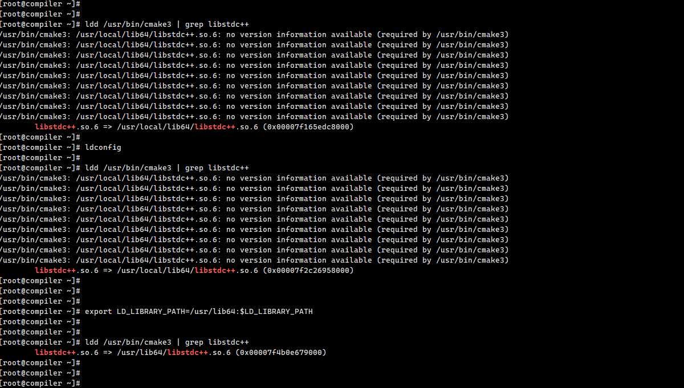

还出了一个问题，是安装gcc10编译器版本，结果执行gcc -v发现还是gcc8.3.0的版本，问题解决如下：

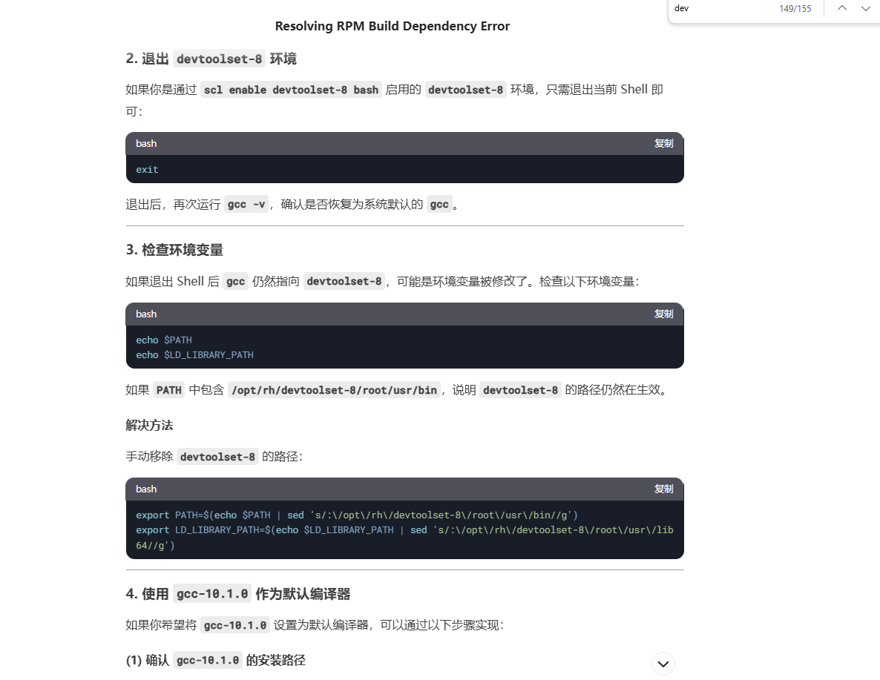

最终编译完成后的输入如下：

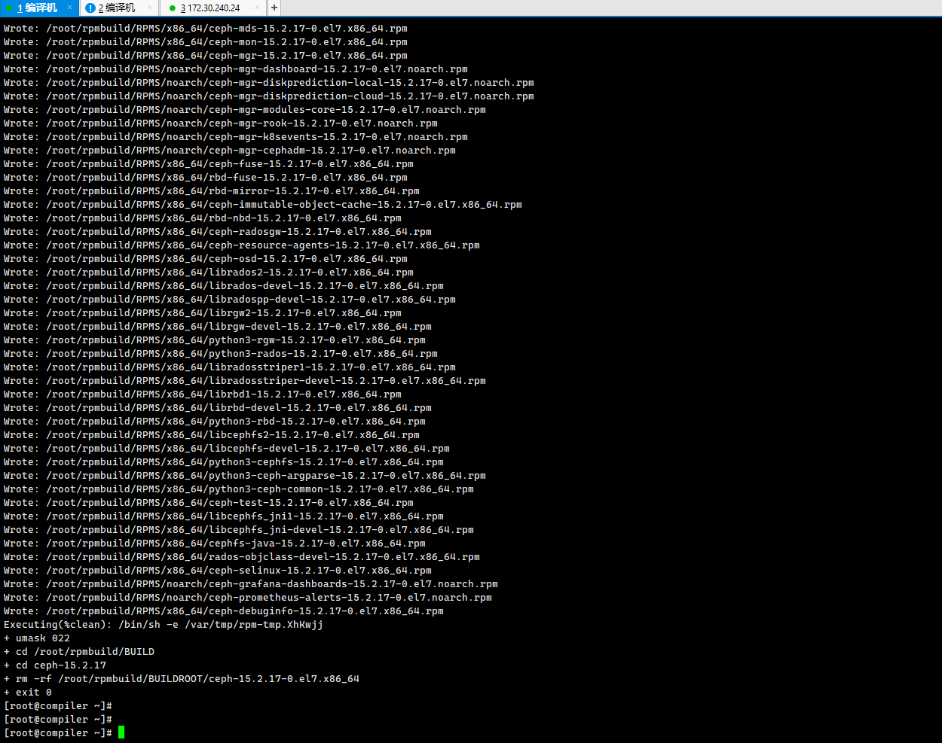

## **4.参考链接**

[ceph 16.2.15(Pacific)编译 - 佟晖 - 博客园](https://www.cnblogs.com/tongh/p/18706383)

[Build Ceph — Ceph Documentation](https://docs.ceph.com/en/nautilus/install/build-ceph/)