<https://review.udacity.com/#!/rubrics/3078/view>

The joined data on the ‘Product Inventory’ table of the Customer List is split into 6 columns, each labeled with correct formatting and no resulting Power Query errors.

The ‘Purchase List’ table is un-pivoted, organized, and has a date column that is correctly formatted as a date. There should be no resulting Power Query errors for any of the columns or rows.

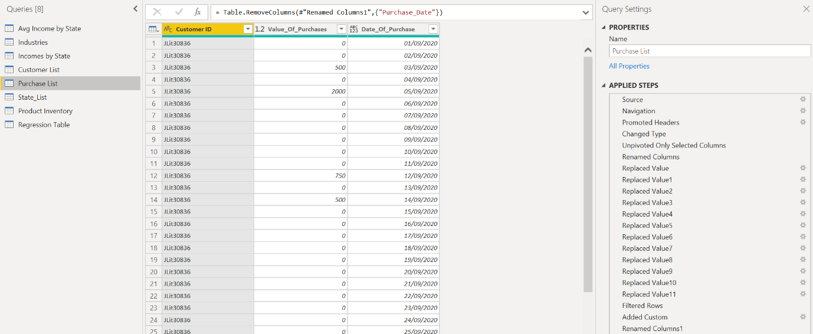

The income categories should be defined using a DAX formula. The DAX formula should aggregate the different predicted customer incomes into buckets which can be used to create a histogram. The appropriate bin size for the histogram can be determined by the student but should still be a good reflection of the range, distribution, and shape of the data. It is recommended that the histogram contain at least 4 columns. Refer to the histogram example in the instructions section.

The product recommendations should be defined using a DAX formula. The DAX formula should use logic to determine which products are recommended to different income categories. The recommended product for each income category can be determined by the student.

