## **Market Analysis Report for National Clothing Chain**

Joe Hunter/2022-01-02

**Introduction**

Sales present a story of two halves with 6 months of the year showing strong sales and weaker returns for the remaining 6 months. The main recommendation from this report is to consider how to boost sales during these weaker months.

**Analysis Questions**

1. **What is the correlation (R2 value) between sales and income?**

**With an R-squared value of 0.78**, sales and income are strongly correlated. This should be factored into consideration for any targeted advertising and customers with the highest predicted income should be considered first.

1. **What is the correlation (R2 value) between customer ratings and product return rate?**

At 0.69, there is a strong correlation between customer ratings and product return rate.

1. **What are the linear regression formulas to predict customer sales and customer incomes?**

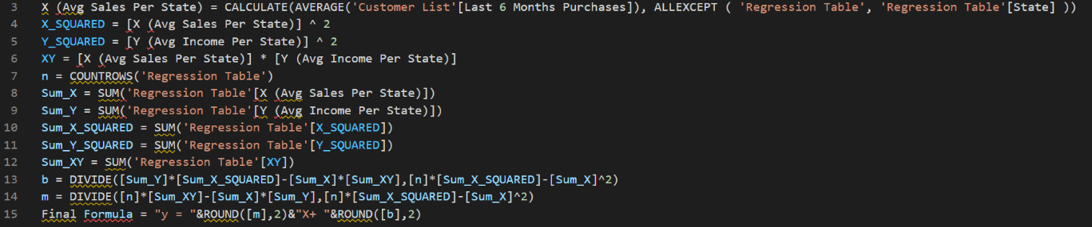Each of the formulae are presented below

1. **Which customer do you predict has the highest income?**

Sorting the “Customer List” table by predicted income in descending order, we have predicted that Jon Little with Customer ID JLit30836 has the highest income.

1. **Which product will be advertised the most?**

The Chronograph Watch with Product ID CWa1982, it has the highest Customer Rating.

**Additional Analysis**

As mentioned in the introduction, we decided to perform additional temporal analysis to look at the aggregate value of purchases per calendar month. The most striking visual is the “Frequency of Purchases Per Month” we have presented in the “Additional Analysis” page and reproduced below:

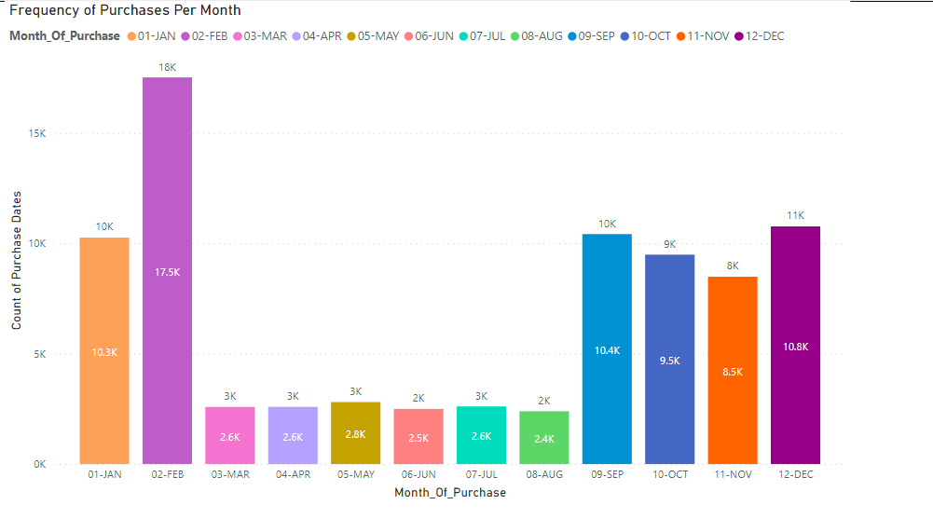

There are 6 months of the year, from March to August inclusive, where sales have effectively flatlined not exceeded $3,000. **Our recommendation therefore is targeted advertising during these months to encourage sales and attempt to reach parity with the other 6 months.** Christmas purchases during December should far out stretch the remaining 11 months however we are not seeing that being borne out in the data. To boost Christmas sales, we suggest a brief but targeted advertising campaign in November.