Digital Image Processing Quiz2 Student ID: 04050432 Name: 戴寧

- What is “Inverse Filtering”(反轉濾波)? What is the main problem of it?
給一陣列b,影像乘1/b
反轉濾波對噪聲非常敏感，除非我們知道噪聲的分佈情況（事實上，這也很難知道），幾乎不可用，恢復圖像效果極差。但若知道噪聲分佈，也是可以完全復原信息的。
如果b的某些元素的幅值低於閾值，丟失了兩個元素，圖像會出現扭曲。
會有較多雜質，利用wiener濾波可以減少這個問題
2. What are the three main criteria of the “Canny edge detector”(Canny邊緣偵測)?
(1) 低錯偵率
(2) 邊的定位須精準
(3) 單一結果(無多重邊)

3. Which of the following edge detection filters (邊緣偵測濾波器) are first derivative filter (一階導函數濾波器)? bcd
( a)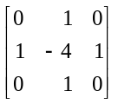 (b) 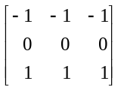 (c) 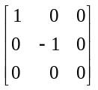 (d) 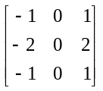

4. Why Hough transform uses xcosθ+ysinθ=r instead of y=mx+b to represent a line(直線)? Explain it.
垂直線無法以y ＝ mx + c 表示，因為m 代表斜率，而垂直線的斜率是無限大。所以利用xcosθ+ysinθ=r來表示
可以由兩個參數r 與θ 來描述：
r 是直線到原點的垂直距離
θ 是此直線的垂直線與x 軸的相交角度

5. For the following image and structuring element(結構元素), calculate (a) the erosion(侵蝕), and (b) the dilation (膨脹).
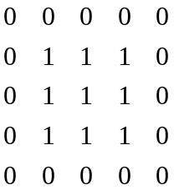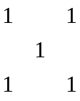
(a) 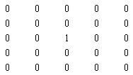
(b) 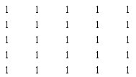
6. Execute the following instructions to produce a motion-blurring image.
>>b=imread(‘ic.tif’);
>>m=fspecial(‘motion’, 9, 0);
>>bm=imfilter(b,m);
>>imshow(bm);
Deblur this image by using the motion deblurring technique with (a) straight division, and (b) Constrained division. Display the final results.
clear all;close all;
b=imread('ic.tif');
m=fspecial('motion', 9, 0);
bm=imfilter(b,m);
figure,imshow(bm);
m2=zeros(256,256);
m2(1,1:9)=m;
mf=fft2(m2)
bmi=ifft2(fft2(bm)./mf);
figure,fftshow(bmi,'abs')
d=0.02;
mf=fft2(m2);
mf(find(abs(mf)<d))=1;
bmi=ifft2(fft2(bm)./mf);
figure,imshow(mat2gray(abs(bmi))*2)
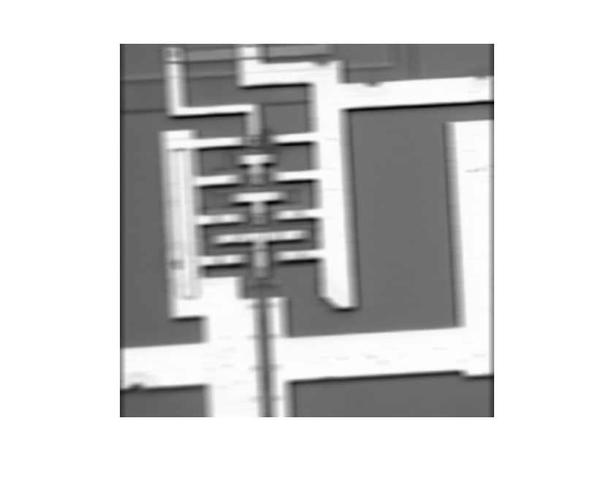
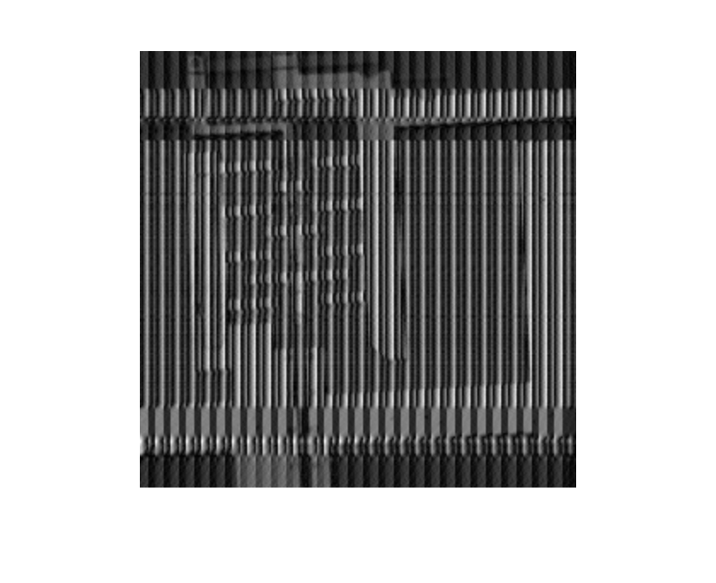
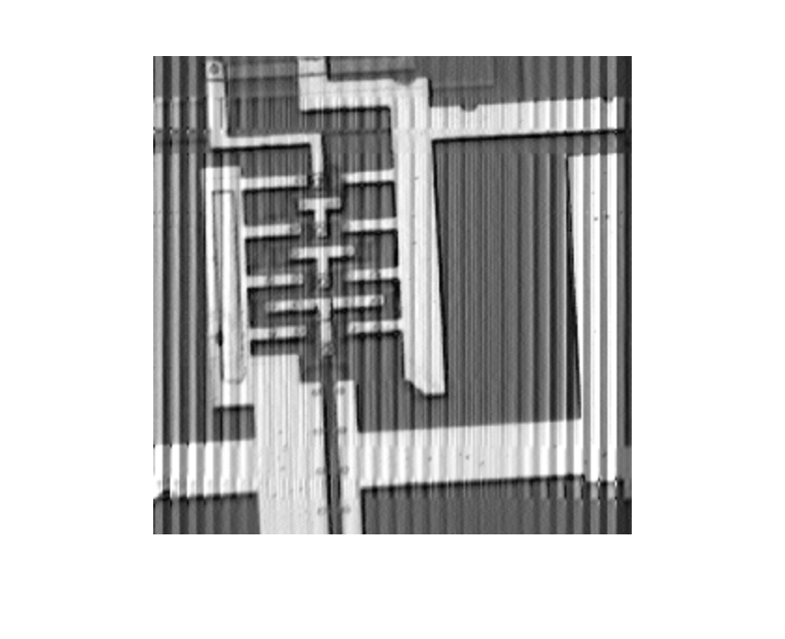

7. (a) Get the image “circle_vary.bmp” and display it.
(b)Apply adaptive thresholding to this image to isolate the circles from the background (use the function blkproc()). Display the final result.

clear all;close all;
t=imread('circle_vary.bmp');
[x,y]=meshgrid(1:256,1:256);
t2=double(t).*((x+y)/2+64)+x+y;
t3=uint8(255*mat2gray(t2));
fun=inline('im2bw(x,graythresh(x))');
t4=blkproc(t3,[30,30],fun);
imshow(t);
%figure,imshow(t3);
figure,imshow(t4);
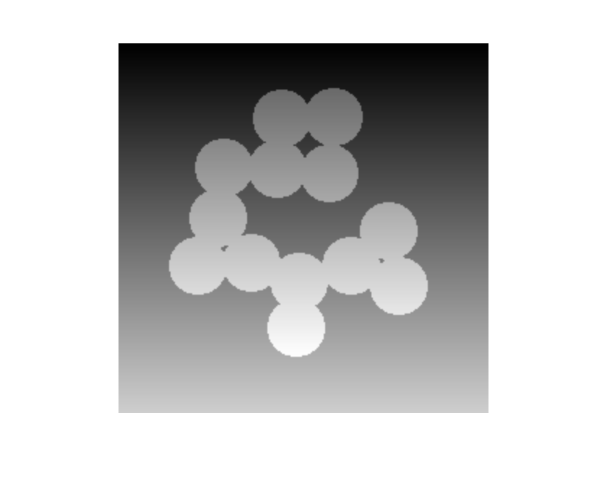
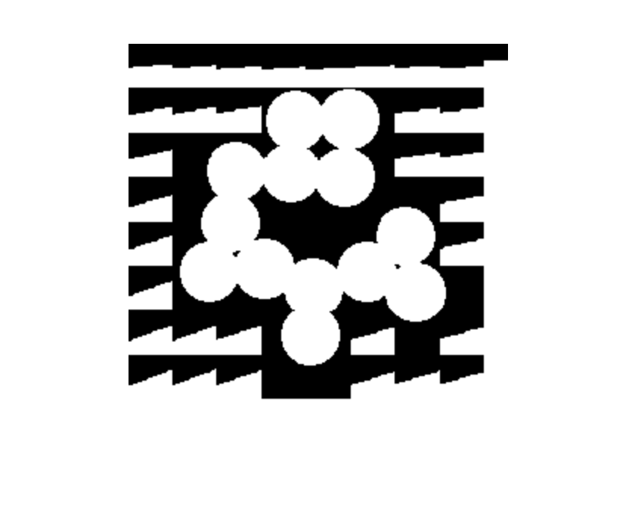

8. Get the image ‘SIGN1.bmp’.
(a) Use the function hough( ) to obtain the Hough transform of this image. Display the accumulator array as an image.
(b) Show [r, theta] values of the top 5 points from the transform.
(c) Display the image ‘SIGN1.bmp’. Then use the function houghline( ) to plot the five possible lines on this image.
clear all;close all;
c=imread('SIGN1.bmp');
hc=hough(c);
imshow(mat2gray(hc)*1.5);
max(hc(:))
[r,theta]=find(hc>173)
c1=imadd( imdivide(c, 4), 192);
figure,imshow (c1);
houghline( c1, r(1), theta(1));
houghline( c1, r(2), theta(2));
houghline( c1, r(3), theta(3));
houghline( c1, r(4), theta(4));
houghline( c1, r(5), theta(5));
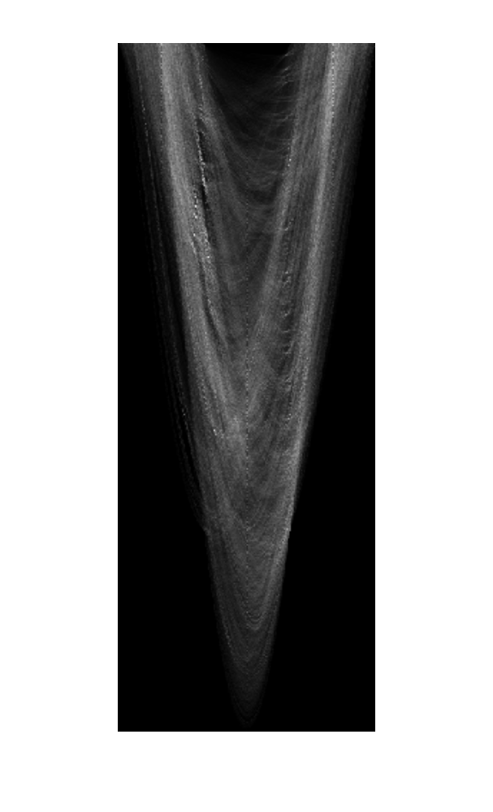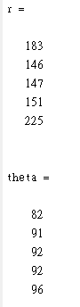
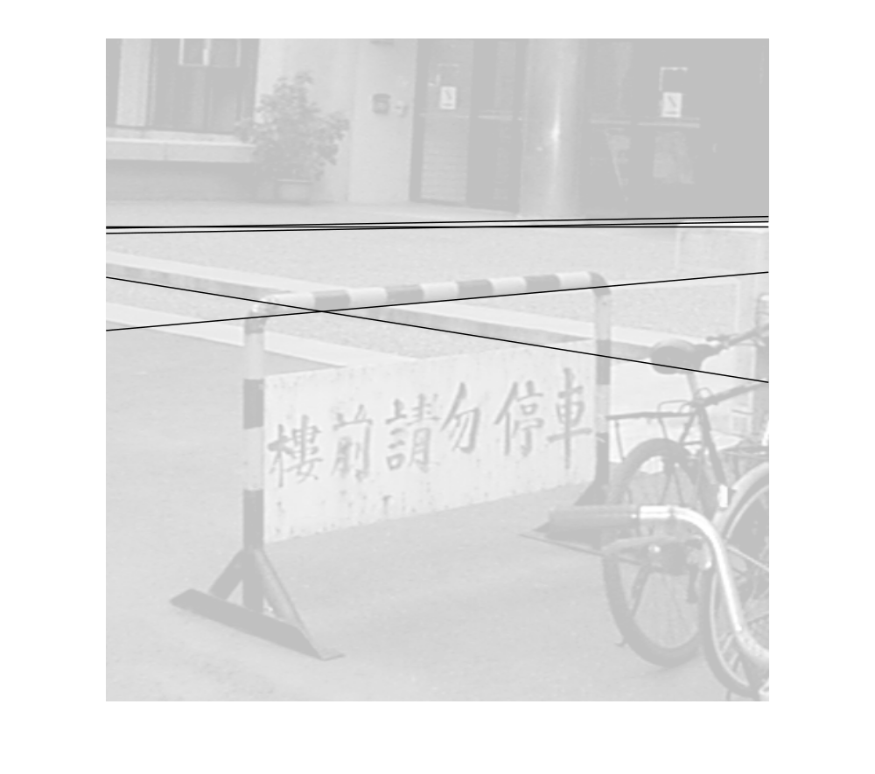

9. Get the image ‘rice.tif’ and apply 20% shot noise to it:
>>c = imread(‘rice.tif’);
>>x = rand (size(c));
>>d1 = find(x<=0.1);
>>d2 = find(x>=0.9);
>>c(d1)=0;
>>c(d2)=1;
>>c=c>110
>>imshow(c)
Let the structuring element be a 3×3 square kernel
- Perform Dilation on the image c. Show the result.
- Perform Erosion on the image c. Show the result.
- Perform morphological filtering (that is, an Opening followed by a Closing) on the image c. Show the result.

clear all;
close all;
c = imread('rice.tif');
x = rand (size(c));
d1 = find(x<=0.1);
d2 = find(x>=0.9);
c(d1)=0;
c(d2)=1;
c=c>110;
imshow(c);
sq=ones(3,3);
cd1=imdilate(c,sq);
figure,imshow(cd1);
ce1=imerode(c,sq);
figure,imshow(ce1);
cm1=imopen(c,sq);
cm2=imclose(cm1,sq);
figure,imshow(cm2);
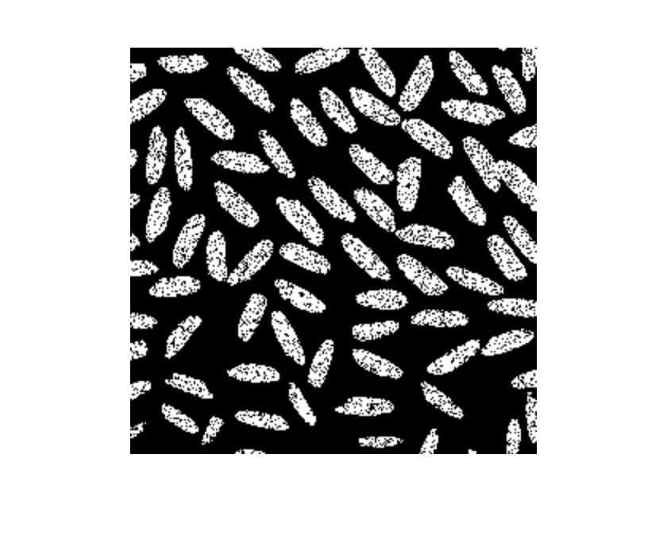
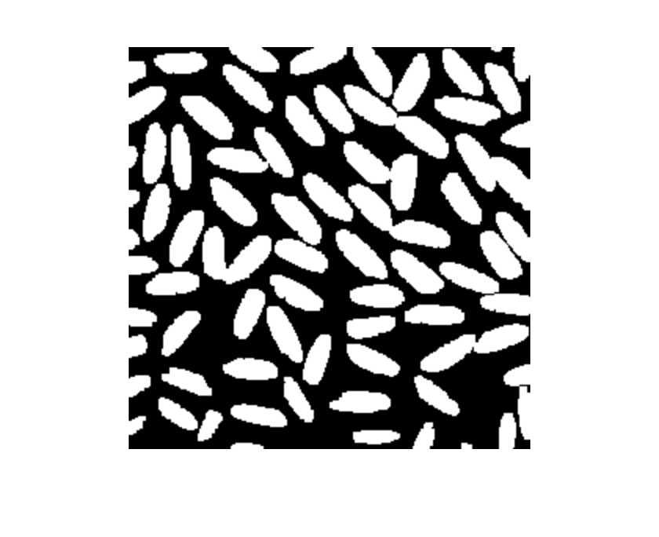
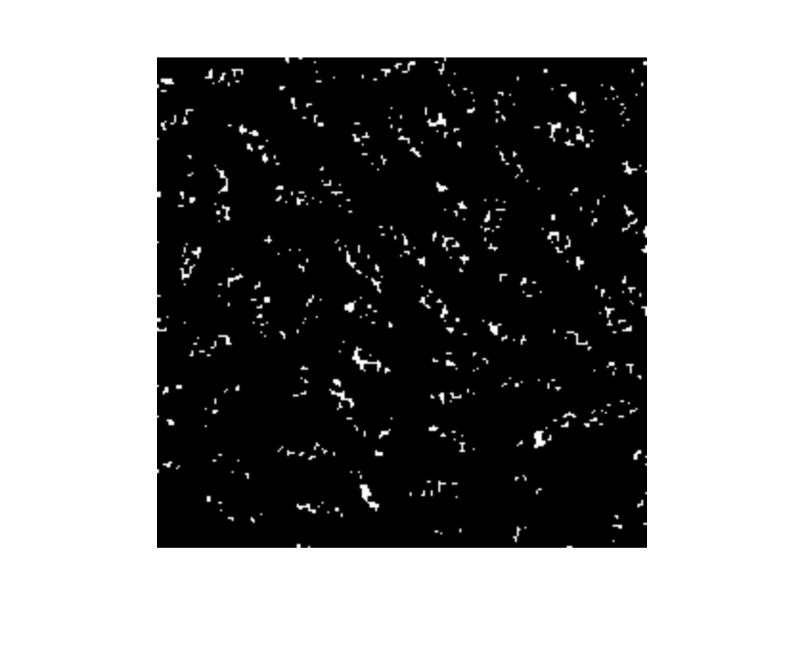


10. Read in the image circlesm.tif.
(a) Erode with square of size 5x5 and display the resulting image.
- Compute the internal boundary of the image obtained in (a).

clear all; close all;
a=imread('circlesm.tif');
b=ones(5,5);
a1=im2bw(a)
ae=imerode(a1,b);
imshow(ae);
c=a1&~ae;
figure,imshow(c);

