Digital Image Processing Quiz2 Student ID: 04050484 Name: 蔡照森

1. What is “Inverse Filtering”(反轉濾波)? What is the main problem of it?
如果我們知道或者可以創建模糊功能的良好模型來破壞圖像，則恢復的最快和最簡單的方法是通過反轉濾波。不幸的是，由於反轉濾波器是高通濾波器的一種形式，反轉濾波對圖像中存在的任何噪聲響應非常差，因為噪聲往往是高頻的。

2. What are the three main criteria of the “Canny edge detector”(Canny邊緣偵測)?
低錯偵率
邊之定位須精準
單一結果(無多重邊)

3. Which of the following edge detection filters (邊緣偵測濾波器) are first derivative filter (一階導函數濾波器)?
( a)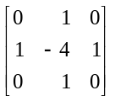 (b) 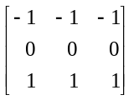 (c) 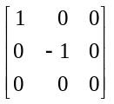 (d) 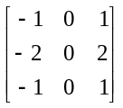

b c d

4. Why Hough transform uses xcosθ+ysinθ=r instead of y=mx+b to represent a line(直線)? Explain it.
因為直線方程式y=mx+b 無法表示垂直的斜率所以用 r跟 θ來描述
r是直線在原點的距離，θ為直線垂直線與平面的夾角
因此就不會有無法表示的斜率了

5. For the following image and structuring element(結構元素), calculate (a) the erosion(侵蝕), and (b) the dilation (膨脹).
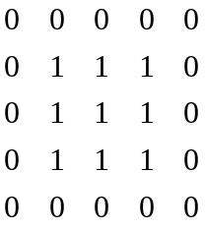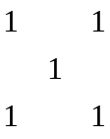

侵蝕
0 0 0 0 0
0 0 0 0 0
0 0 1 0 0
0 0 0 0 0
0 0 0 0 0

膨脹
1 1 1 1 1
1 1 1 1 1
1 1 1 1 1
1 1 1 1 1
1 1 1 1 1

6. Execute the following instructions to produce a motion-blurring image.
>>b=imread(‘ic.tif’);
>>m=fspecial(‘motion’, 9, 0);
>>bm=imfilter(b,m);
>>imshow(bm);
Deblur this image by using the motion deblurring technique with (a) straight division, and (b) Constrained division. Display the final results.

close all;
clear all;
bc=imread('ic.tif');
figure,imshow(bc);
m=fspecial('motion',9,0);
bm=imfilter(bc,m);
figure,imshow(bm);
m2=zeros(256,256);
m2(1,1:9)=m;
mf=fft2(m2);
bmi=ifft2(fft2(bm)./mf);
figure,fftshow(bmi,'abs');
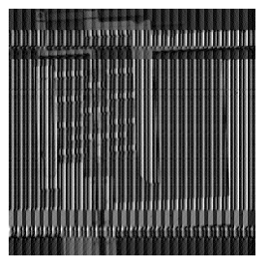
close all;
clear all;
bc=imread('ic.tif');
figure,imshow(bc); bm=imfilter(bc,m);
figure,imshow(bm);
m2=zeros(256,256);
m2(1,1:9)=m;
d=0.02;
mf=fft2(m2);mf(find(abs(mf)<d))=1;
bmi=ifft2(fft2(bm)./mf);
figure,imshow(mat2gray(abs(bmi))*2);

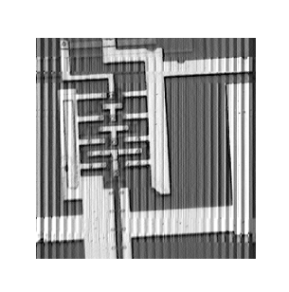

7. (a) Get the image “circle_vary.bmp” and display it.
(b)Apply adaptive thresholding to this image to isolate the circles from the background (use the function blkproc()). Display the final result.
clear all;close all;
c=imread('circle_vary.bmp');
x=ones(256,1)*[1:256];
c2=double(c).*(x/2+50)+(1-double(c)).*x/2;
c3=uint8(255*mat2gray(c2));
figure,imshow(c3);
fun = inline('im2bw(x,graythresh(x))');
t4=blkproc(c3,[50,50],fun);
figure,imshow(t4);
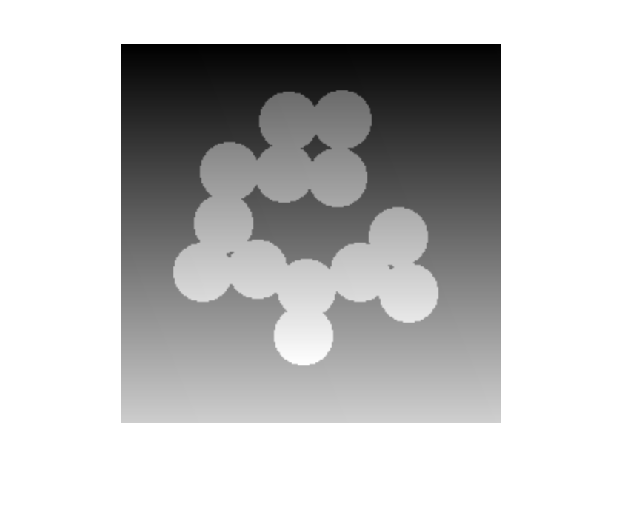


8. Get the image ‘SIGN1.bmp’.
(a) Use the function hough( ) to obtain the Hough transform of this image. Display the accumulator array as an image.

(b) Show [r, theta] values of the top 5 points from the transform.

(c) Display the image ‘SIGN1.bmp’. Then use the function houghline( ) to plot the five possible lines on this image.
clear all;
close all;

c=imread('SIGN1.bmp');
hc=hough(c);
imshow(mat2gray(hc)*1.5);
max(hc(:))
[r,theta]=find(hc>173)
c1=imadd( imdivide(c, 4), 192);
figure,imshow (c1);
houghline( c1, r(1), theta(1));
houghline( c1, r(2), theta(2));
houghline( c1, r(3), theta(3));
houghline( c1, r(4), theta(4));
houghline( c1, r(5), theta(5));

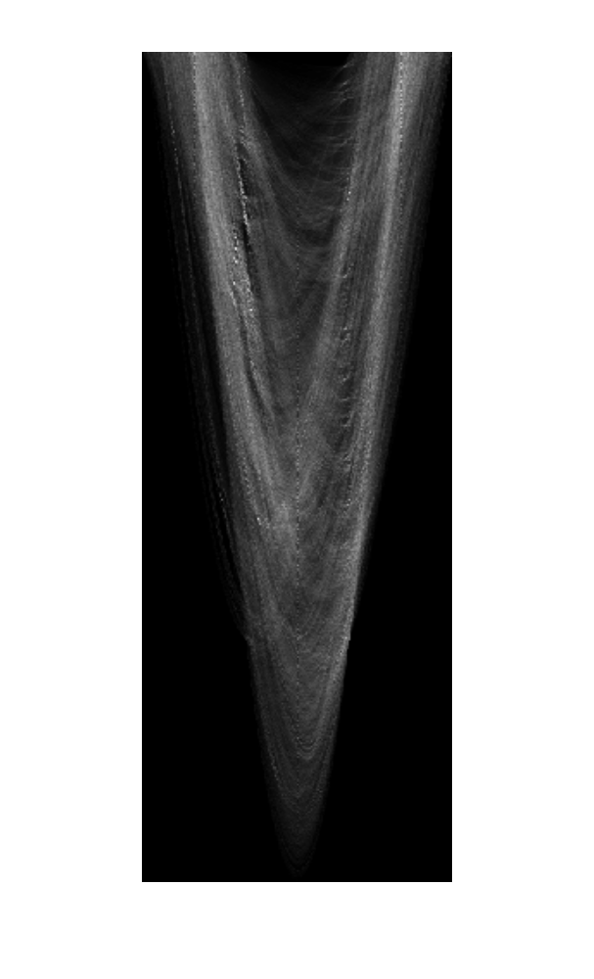

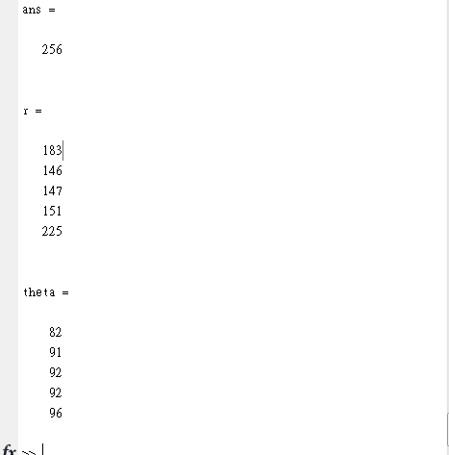

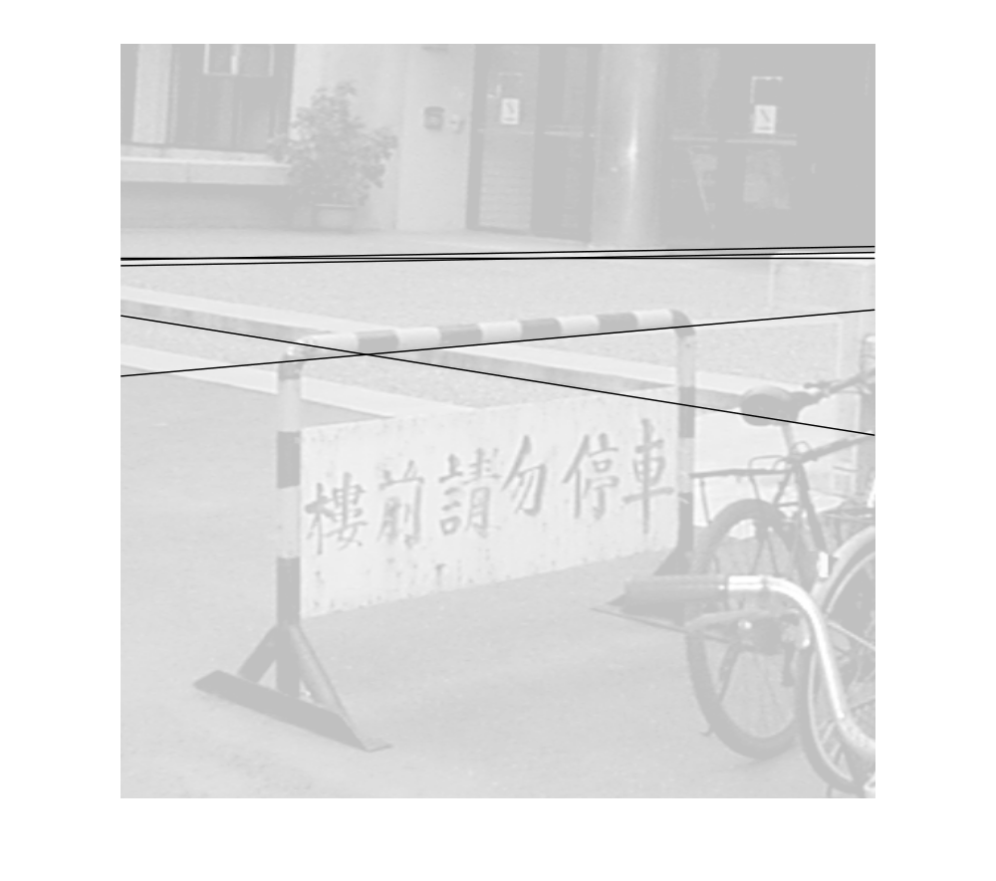
9. Get the image ‘rice.tif’ and apply 20% shot noise to it:
>>c = imread(‘rice.tif’);
>>x = rand (size(c));
>>d1 = find(x<=0.1);
>>d2 = find(x>=0.9);
>>c(d1)=0;
>>c(d2)=1;
>>c=c>110
>>imshow(c)
Let the structuring element be a 3×3 square kernel
- Perform Dilation on the image c. Show the result.
- Perform Erosion on the image c. Show the result.
- Perform morphological filtering (that is, an Opening followed by a Closing) on the image c. Show the result.

clear all;
close all;
c = imread('rice.tif');
x = rand (size(c));
d1 = find(x<=0.1);
d2 = find(x>=0.9);
c(d1)=0;
c(d2)=1;
c=c>110;
imshow(c);
sq=ones(3,3);
%Dilation
cd1=imdilate(c,sq);
figure,imshow(cd1);
% Erosion
ce1=imerode(c,sq);
figure,imshow(ce1);
%Opening followed by a Closing
cm1=imopen(c,sq);
cm2=imclose(cm1,sq);
figure,imshow(cm2);
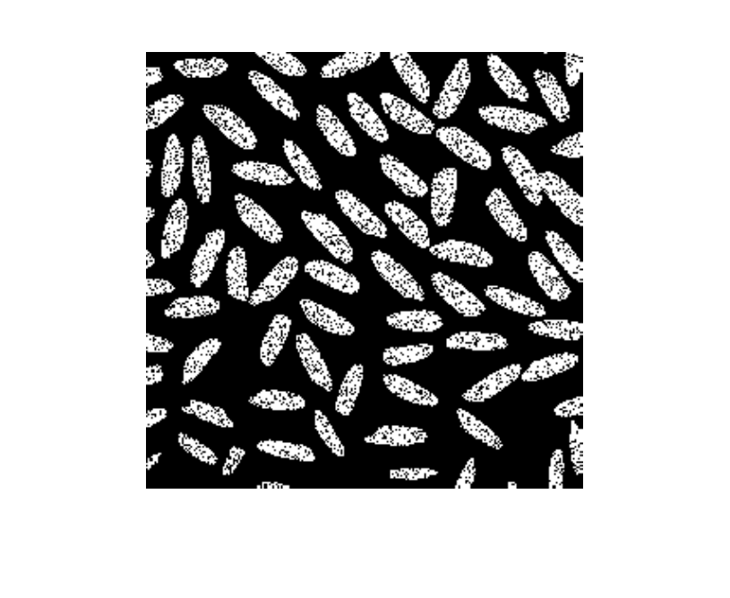
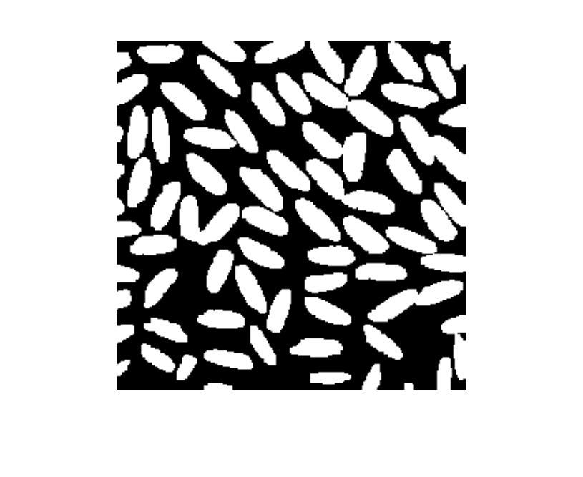
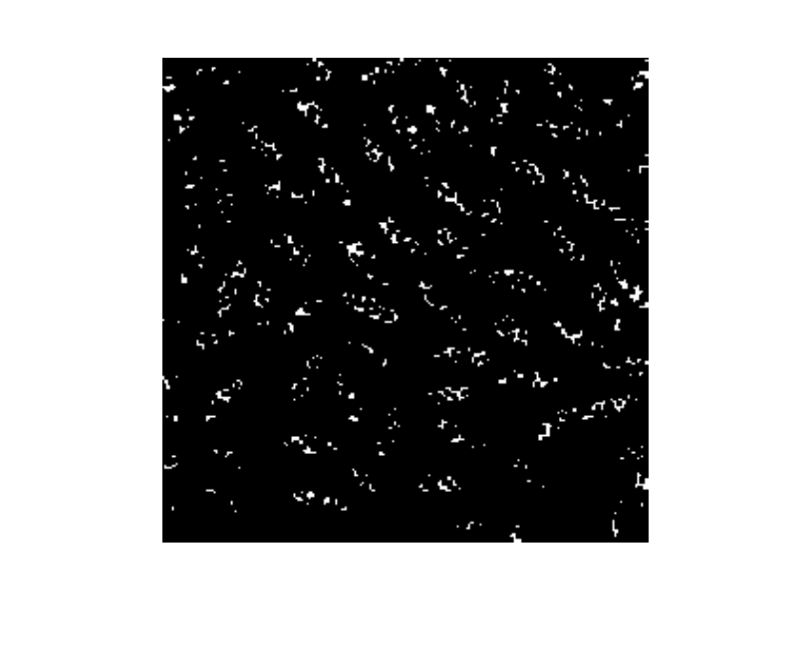
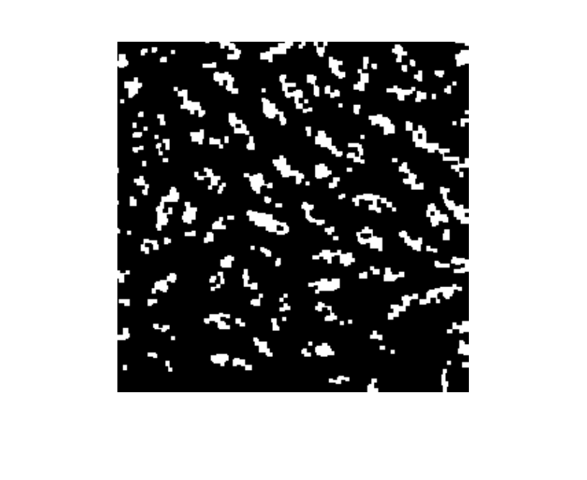
10. Read in the image circlesm.tif.
(a) Erode with square of size 5x5 and display the resulting image.
- Compute the internal boundary of the image obtained in (a).
clear all;
close all;
n=imread('circlesm.tif');
imshow(n);
sq=ones(5,5);
ne=imerode(n,sq);
figure,imshow(n-ne);


