電通二乙微處理器實驗 實驗結報

實驗名稱 | Lab11
組別 | 18 | 組員 | 05050422/王新喬

- 實驗目的
將7697利用wifi連到
- 實驗步驟
- 辦Mediatek cloud sadbox 帳號
- 新增測試裝置
- 更改程式碼
- 燒錄程式
- 成功!!!!!!!!
- 程式碼
#include <LWiFi.h>
#include "MCS.h"

char _lwifi_ssid[] = "05050422";
char _lwifi_pass[] = "87878787";
MCSDevice mcs("DNYQwPbS", "vulc0Cewc4H00h5A");

MCSControllerOnOff led("12540911");
MCSDisplayOnOff remote ("05050422");

void setup()
{
Serial.begin(9600);

Serial.println("Connect to Wifi");
while (WiFi.begin(_lwifi_ssid, _lwifi_pass) != WL_CONNECTED) {
Serial.println("Wifi Reconnecting..");
delay(1000);
}

Serial.println("Connect to MCS...");
while (!mcs.connected()) {
Serial.println("MCS Reconnecting..");
mcs.connect();
}
Serial.println("MCS Connected!");
mcs.addChannel(led);
mcs.addChannel(remote);

pinMode(7, OUTPUT);

}

void loop()
{
while (!mcs.connected()) {
Serial.println("MCS.connect()...");
mcs.connect();
if (mcs.connected()) {
Serial.println("MCS Reconnect");
}
}
mcs.process(1000);
while(!led.valid())
{
Serial.println("read LED value from MCS...");
led.value(); //取得MCS數值
}
Serial.print("done, LED value = ");
Serial.println(led.value()); //顯示出來

if (led.value() == 1) {
digitalWrite(7, HIGH);

} else {
digitalWrite(7, LOW);

}

delay(200);
if(!remote.set(led.value()))
{
Serial.print("Failed to update remote");
Serial.println(remote.value());
}

}

#include <LWiFi.h>
#include "MCS.h"

char _lwifi_ssid[] = "05050422";
char _lwifi_pass[] = "87878787";
MCSDevice mcs("Dd1EPvKG", "nO2fBhPa7bq0GFpj");

MCSDisplayInteger Temp("Temp");

void setup()
{
Serial.begin(9600);

Serial.println("Connect to Wifi");
while (WiFi.begin(_lwifi_ssid, _lwifi_pass) != WL_CONNECTED) {
Serial.println("Wifi Reconnecting..");
delay(1000);
}

Serial.println("Connect to MCS...");
while (!mcs.connected()) {
Serial.println("MCS Reconnecting..");
mcs.connect();
}
Serial.println("MCS Connected!");

mcs.addChannel(Temp);

}

void loop()
{
while (!mcs.connected()) {
mcs.connect();
if (mcs.connected()) {
Serial.println("MCS Reconnect");
}
}
mcs.process(1000);

int sensor = analogRead(A0);

Temp.set(sensor);
Serial.println("Add sensor value.");
delay(200);
}
- 實驗結果及分析
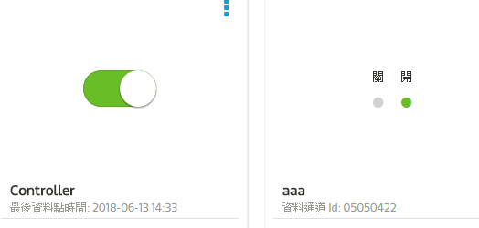
2.
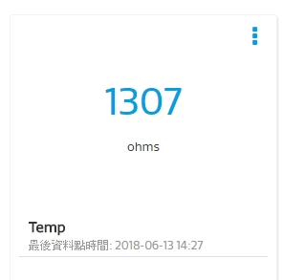

- 心得討論
第一次使用wi-fi剛凱始還沒有開數據 還以為是程式打錯 覺得這次還滿容易的

- 修正電路圖
- 修正程式碼

