Digital Image Processing, Midterm Exam. Student ID:05050422 Name:王新喬

- Explain what is the“Neighborhood processing”(鄰域處理) of an image. List three types of the neighborhood processing.
主要的概念便是將遮罩（邊長通常為奇數的方形或其他形狀）覆蓋到指定影像的每個像素上面。
忽略邊緣
補零
鏡射
- Which of the following filters are high-pass filters ? b d
- Average (均值) filter
- Laplacian (拉普拉斯) filter
- Unsharp Masking (去銳利化遮罩)
- Laplacian of Gaussian (Log高斯的拉普拉斯) filter
- Gaussian(高斯) filter
- The following figure shows an FFT spectrum (頻譜) and its shift version (偏移版本).
- Where are the high-frequency components (高頻分量) before shifting (偏移前)? (a)A區 (b) B區(c) C區 (d) D區 b
- Where are the high-frequency components after shifting (偏移後)? (a)外圍 (b)左上方 (c)內部中間部分 (d) 右下方 c
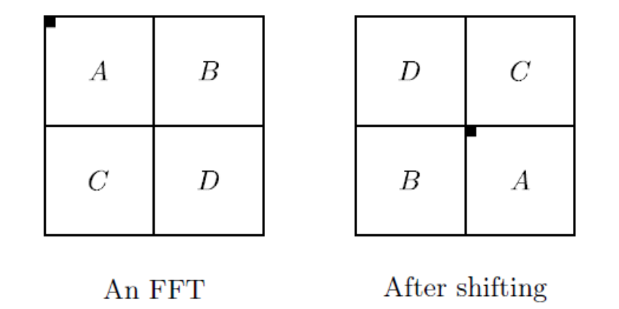
- What is the outlier method(歧異點法)? Please explain it.
1. 選擇閥值D。
2. 比較指定像素值p 與周圍8 個像素的平均數值m。
3. 若 | p – m |> D，則認定該像素為雜訊；反之則否。
4. 若像素為雜訊，則用m 取代；反之，則保留原數值。

- Which of the following methods are appropriate (合適) for cleaning Salt and Pepper noise(清除胡椒鹽雜訊)?
- Median filtering (中位數濾波)
- Adaptive filtering (可適性濾波)
- Outlier method(歧異點法)
- Laplacian (拉普拉斯) filter
- Rank-Order (排序) filter
?
b
- (a) Read the image “blocks.tif”, and display it.
clear all;
close all;
a=imread('blocks.tif');
imshow(a);
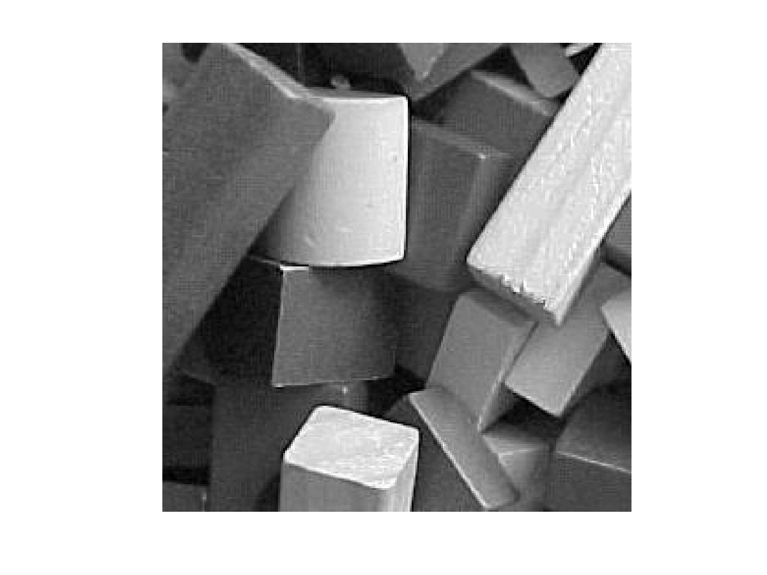

(b) Use the function imadjust() to perform histogram stretching on this image (let a= 100/255, b= 150/255, c= 50/255, d= 200/255, gumma= 0.2), display the resulting image.
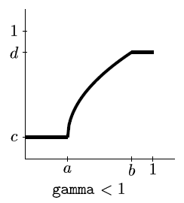
clear all;
close all;
a=imread('blocks.tif');
c=imadjust(a,[100/255,150/255],[50/255,200/255],0.2);
imshow(c);

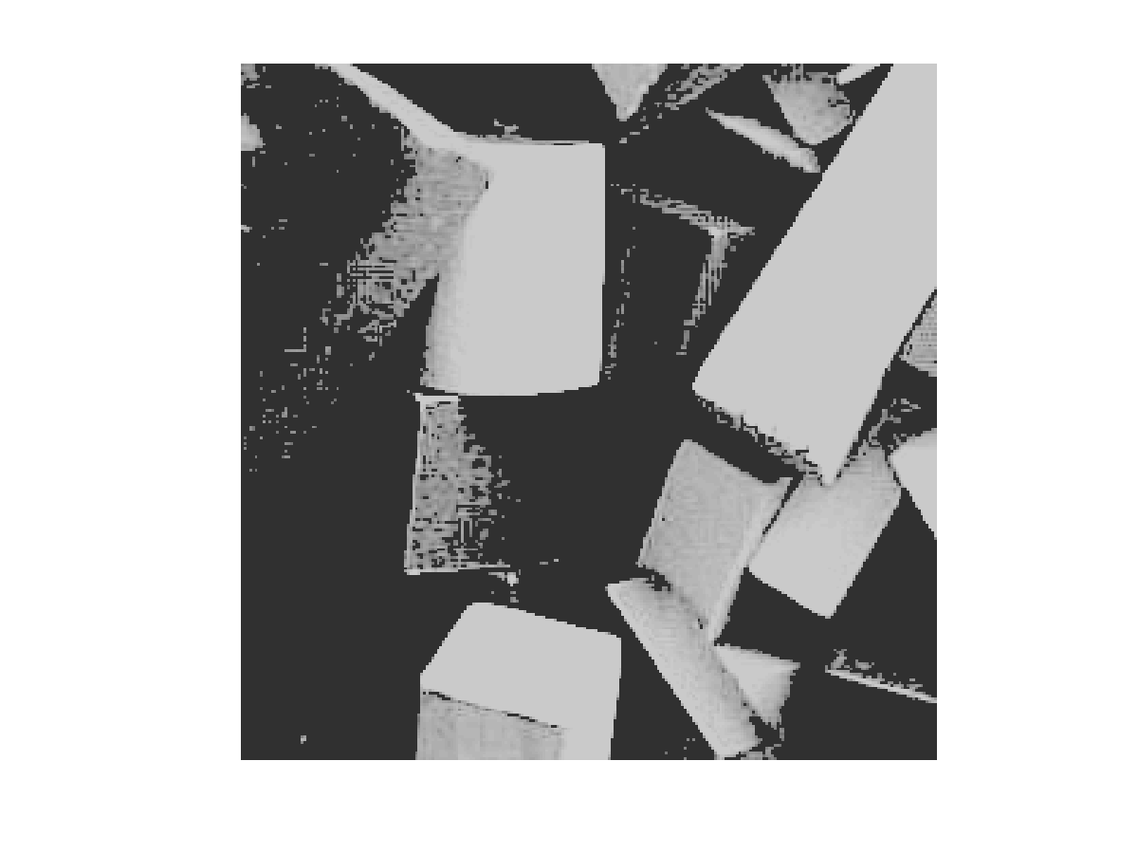
(c) Display the stretching function with the “plot” function.
clear all;
close all;
a=imread('blocks.tif');
c=imadjust(a,[100/255,150/255],[50/255,200/255],0.2);
figure,plot(a,c,'.'),axis tight
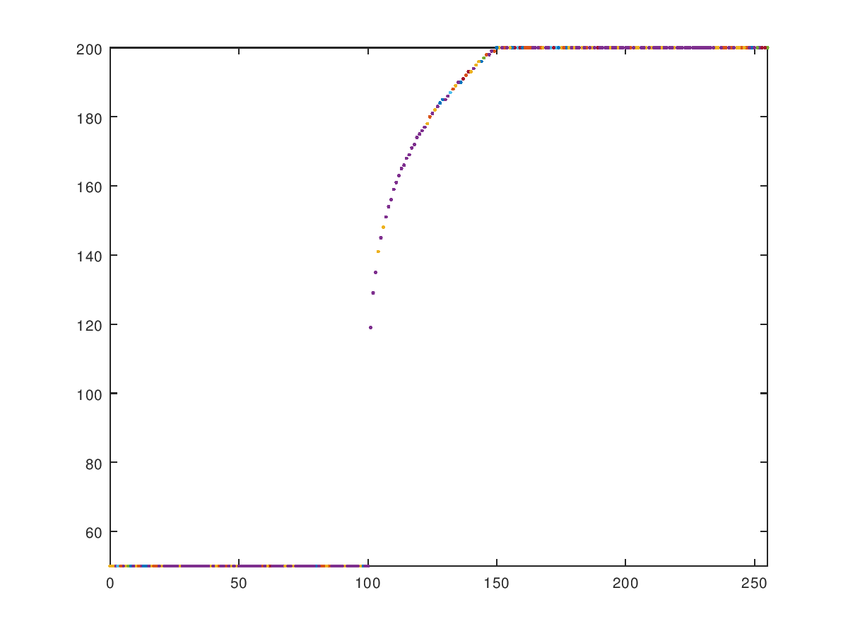

- (a) Read the image “wombats.tif”, then display it.
clear all;
close all;
c=imread('wombats.tif');
figure,imshow(c);
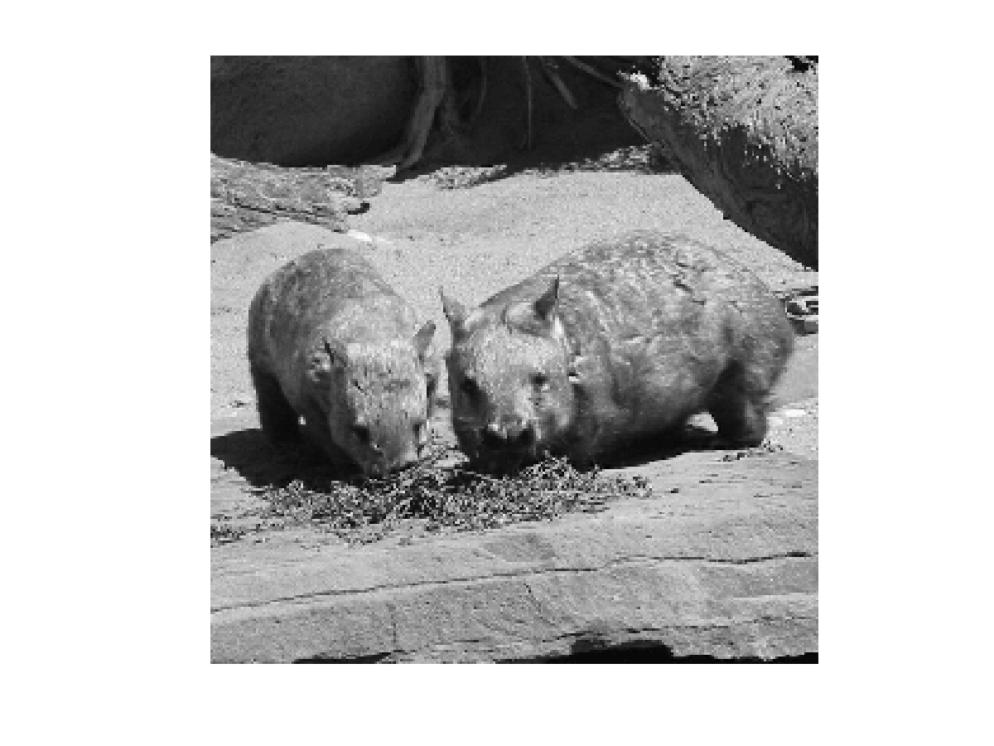
(b) Use the function fspecial to produce a Gaussian filter of size 7×7, then apply this filter to the image in (a). Display the resulting image.
clear all;
close all;
c=imread('wombats.tif');
f1=fspecial('gaussian',[7 7]);
cf1=filter2(f1,c);
figure,imshow(cf1/255);
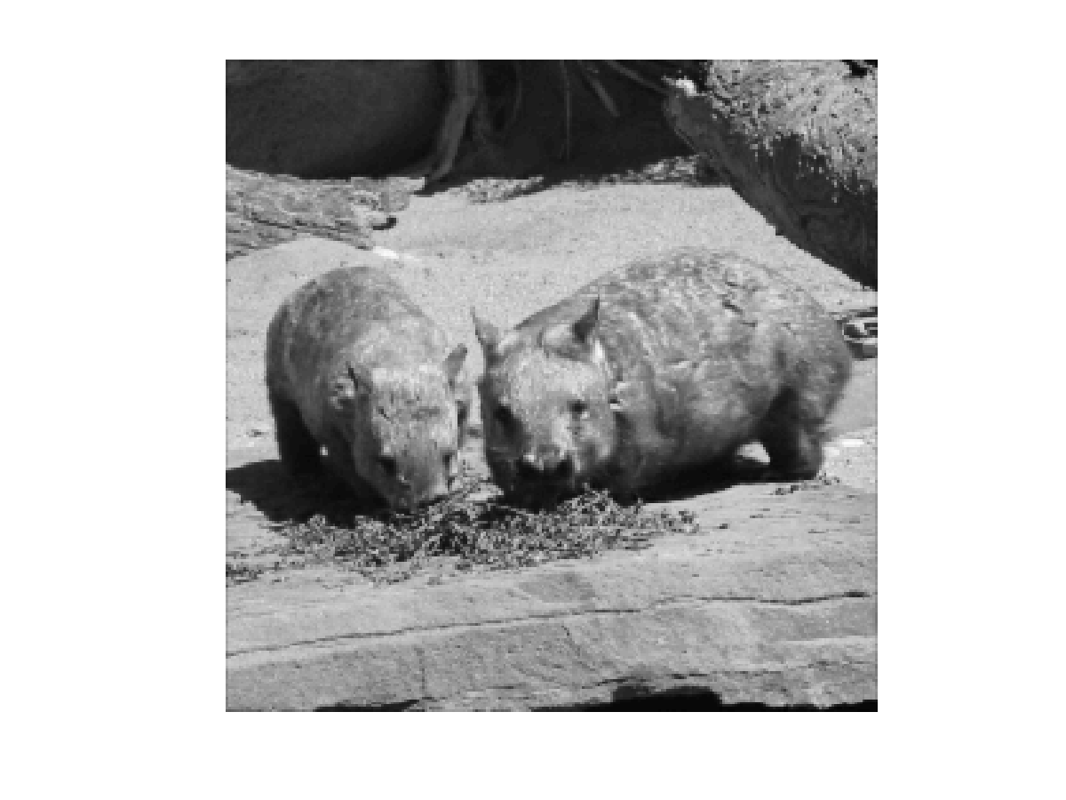
(c) Use the function fspecial to produce a Laplacian of a Gaussian filter (log) of size 5×5, then apply this filter to the image in (a). Display the resulting image.
clear all;
close all;
c=imread('wombats.tif');
f2 = fspecial('log',[5 5]);
cf2=filter2(f2,c);
figure,imshow(cf2/255);

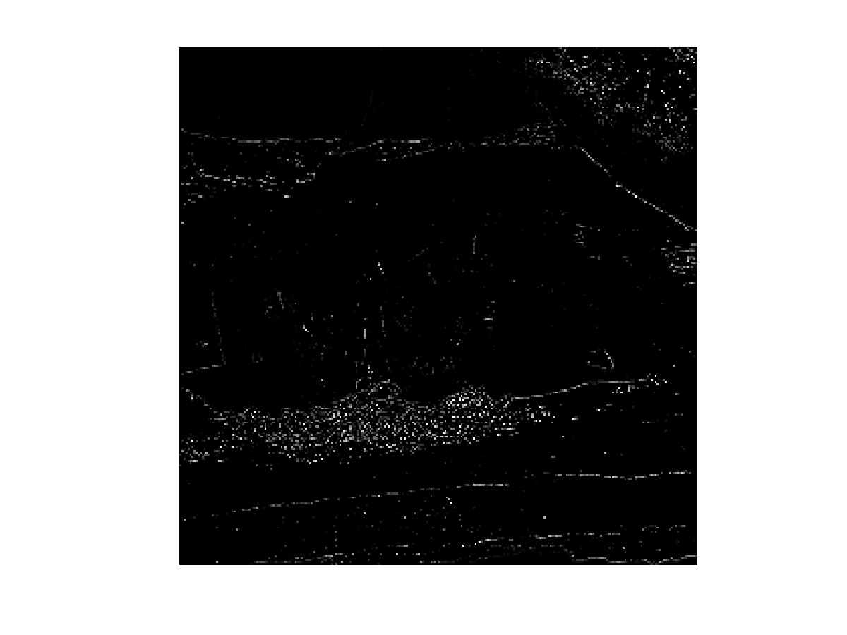
8. (a) Read the image ‘LENNA.bmp’. Apply 2-D DFT on this image by using the function ‘fft2’, then use the function ‘fftshift’ to shift the result such that the DC component are located on the center of the matrix. Display the final result by using the function ‘fftshow’.
clear all;
close all;
cm=imread('LENNA.bmp');
dcm=fftshift(fft2(cm));
figure,fftshow(dcm,'log');
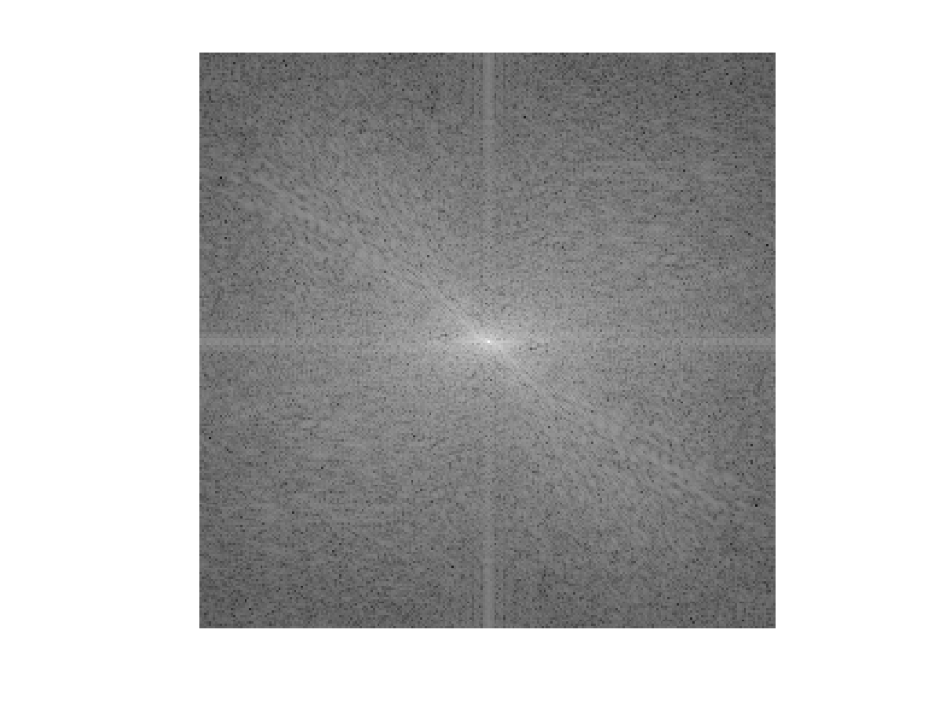
(b) Apply the second order Butterworth low-pass filtering (D=20) to the image ‘LENNA.bmp’. Use the function ‘fftshow’ to display the spectrum after Butterworth low-pass filtering.
clear all;
close all;
cm=imread('LENNA.bmp');
dcm=fftshift(fft2(cm));
bl=lbutter(cm,20,1);
cfbl = cm.*bl;
figure,fftshow(cfbl,'log');
cfbli = ifft2 (cfbl);
figure,fftshow(cfbli,'abs');
(c) Apply the second order Butterworth high-pass filtering (D=20) to the image ‘LENNA.bmp’. Use the function ‘fftshow’ to display the spectrum after Butterworth high-pass filtering.
clear all;
close all;
cm=imread('LENNA.bmp');
dcm=fftshift(fft2(cm));
bl=hbutter(cm,20,1);
cfbl = cm.*bl;
figure,fftshow(cfbl,'log');
cfbli = ifft2 (cfbl);
figure,fftshow(cfbli,'abs');
(d) Use the function ‘ifft2’ to take the inverse DFT of the result obtained in (b) and (c), then use the function ‘fftshow’ to display the resulting images.

9.(a) Add 5% salt & pepper noise to the image “LENNA.bmp”. Display the resulting image.
clear all;
close all;
a=imread('LENNA.bmp');
s=imnoise(a,'salt & pepper',0.05);
imshow(a);
figure,imshow(s);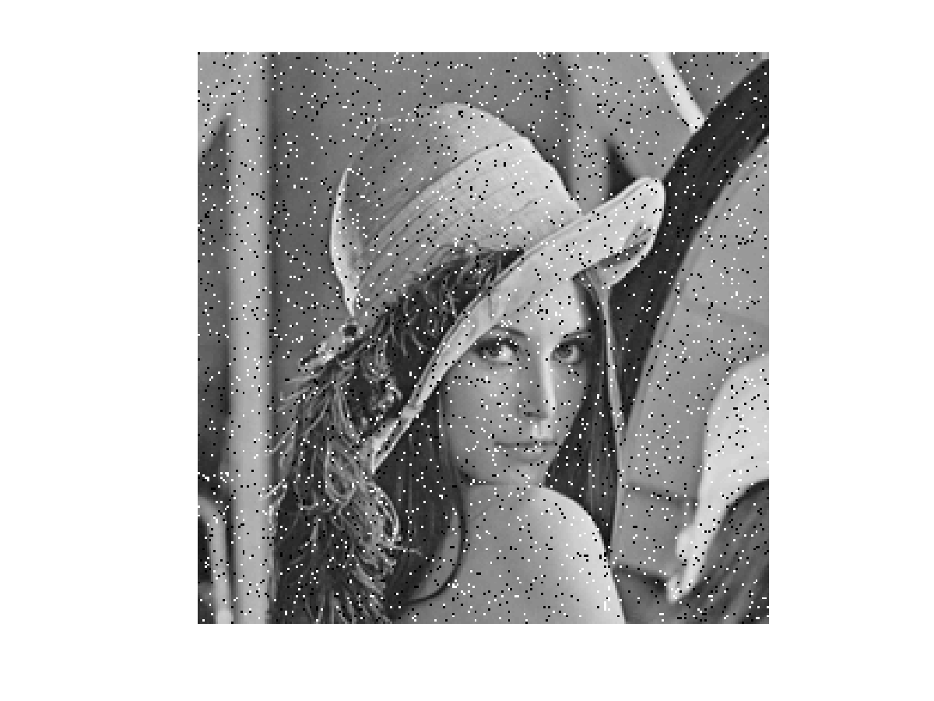

(b) Use rank-order filtering (5 x 5 cross-shape mask) to remove the noise image generated in (a). Display the resulting image.
clear all;
close all;
a=imread('LENNA.bmp');
s=imnoise(a,'salt & pepper',0.05);
imshow(a);
figure,imshow(s);

s2=ordfilt2(s,5,[0 0 1 0 0;0 0 1 0 0;1 1 1 1 1;0 0 1 0 0;0 0 1 0 0]);
figure,imshow(s2);
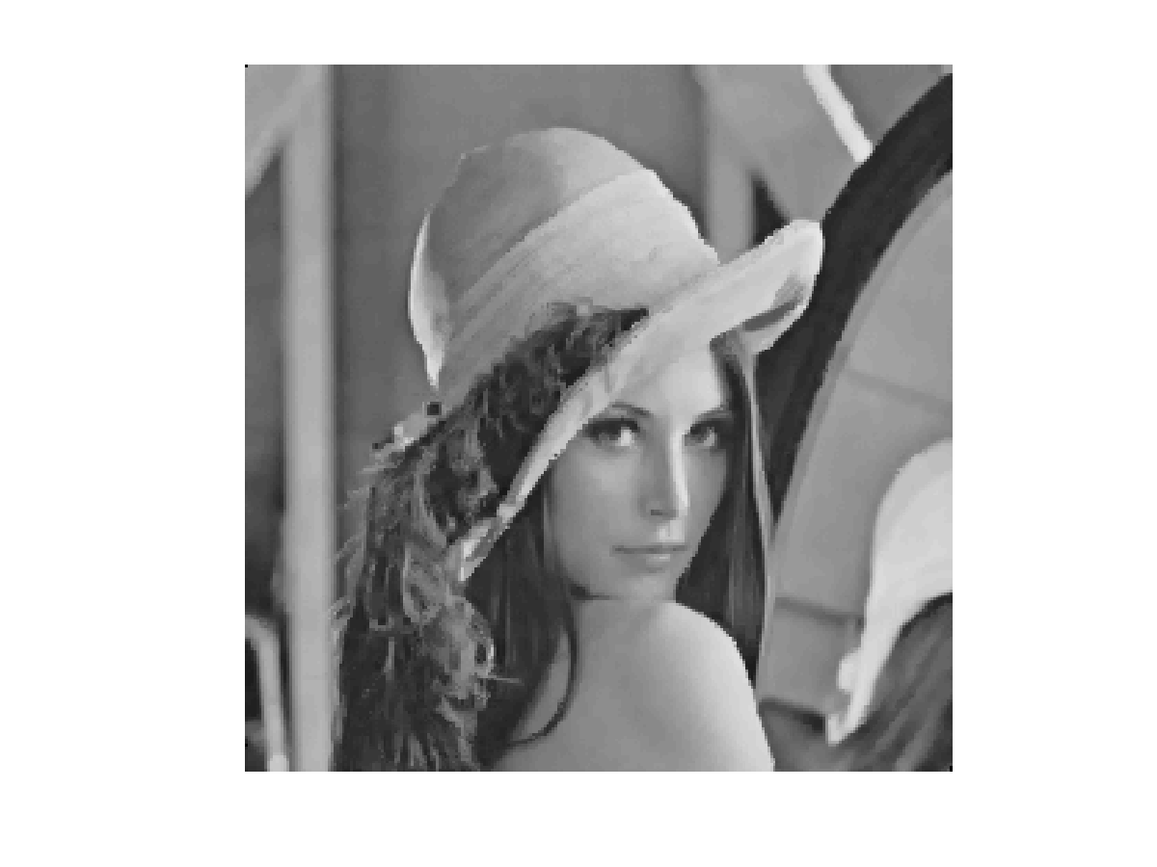

(c) Use the outlier method (D=0.4) to remove the noise image generated in (a). Display the resulting image.
clear all;
close all;
a=imread('LENNA.bmp');
s=imnoise(a,'salt & pepper',0.05);
ss=outlier(s,0.4);
figure,imshow(ss);
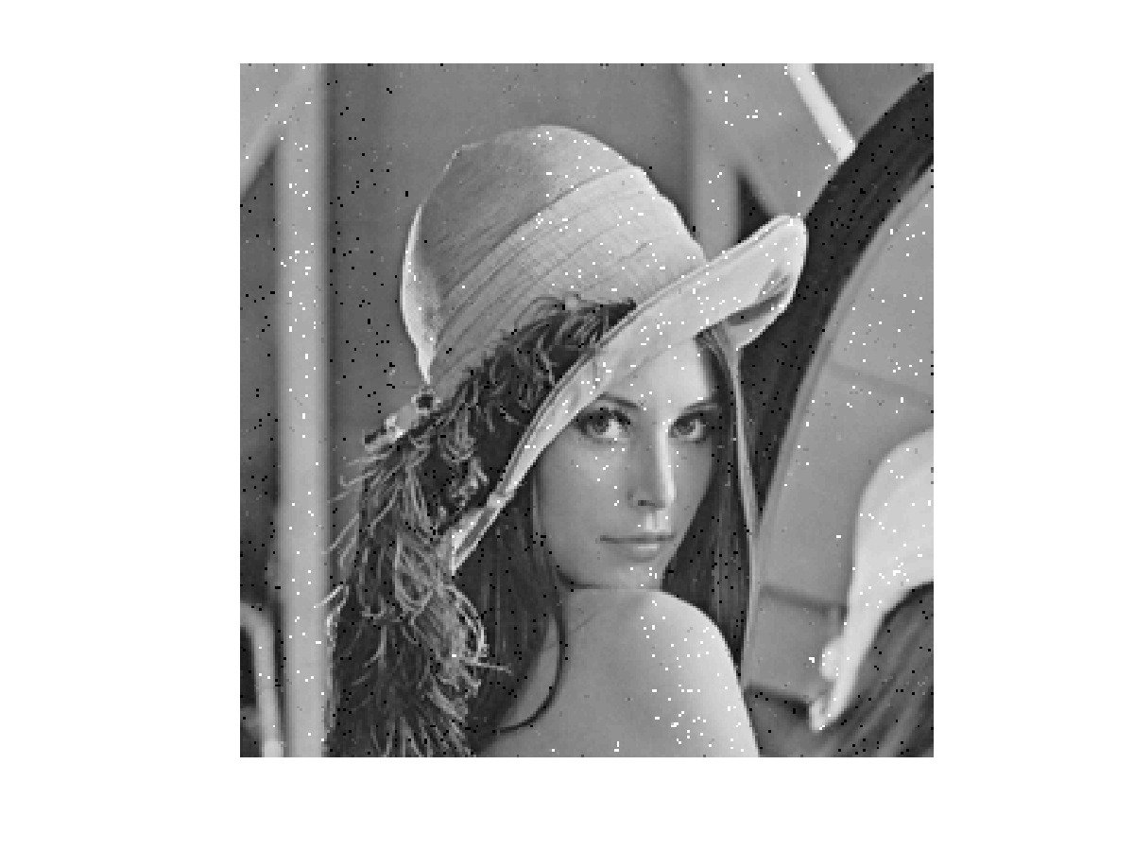

10. Add the sine waves to the image “cameraman.tif”
>> en=imread(‘cameraman.tif’);
>>[x,y]=meshgrid(1:256,1:256);
>> s=1+sin(x/3+y/5);
>> ep=(double(en)/128+s)/4;
- Show the noise image and its spectrum.

en=imread('cameraman.tif');
[x,y]=meshgrid(1:256,1:256);
s=1+sin(x/3+y/5);
ep=(double(en)/128+s)/4;

imshow(ep)
cf=fftshift(fft2(ep));
figure,fftshow(cf,'log'),pixval on;
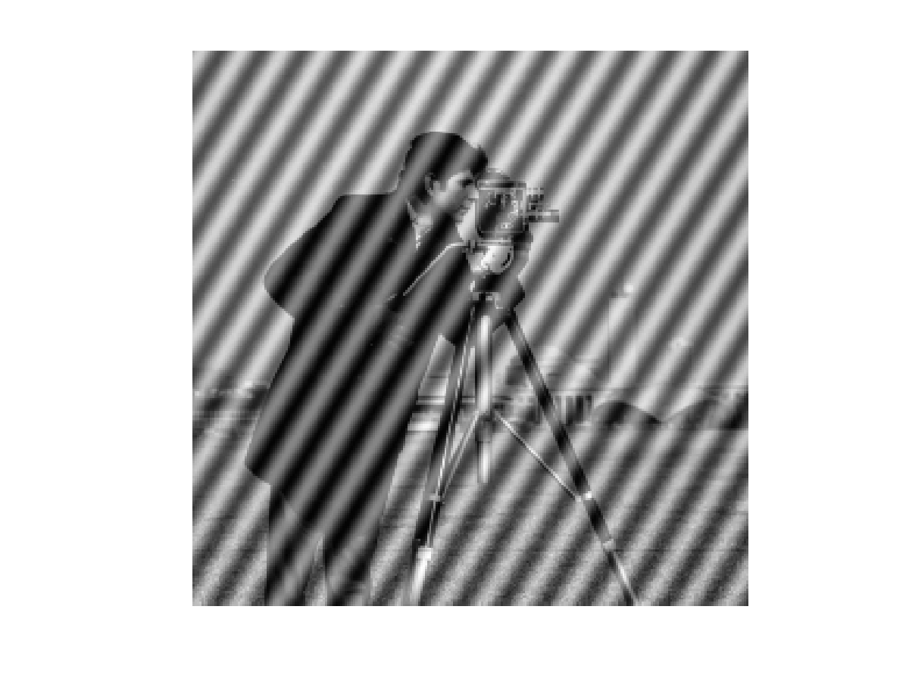
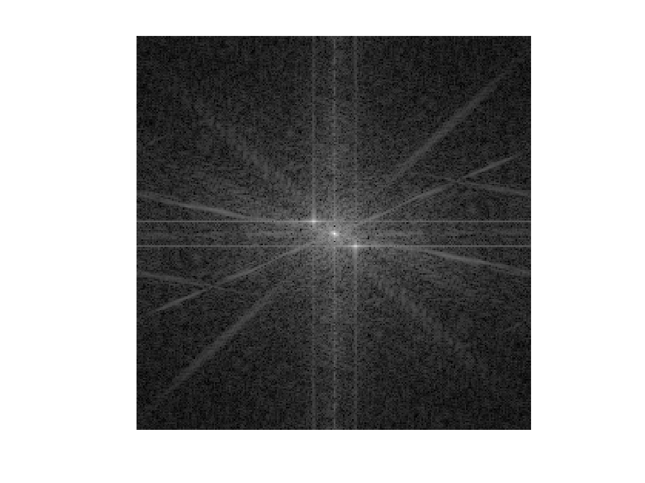
- Remove the noise using band-reject filtering(帶拒濾波). Show the resulting spectrum and the resulting image
en=imread('cameraman.tif');
[x,y]=meshgrid(1:256,1:256);
s=1+sin(x/3+y/5);
ep=(double(en)/128+s)/4;

cf=fftshift(fft2(ep));
z=sqrt((x-129).^2+(y-129).^2);
br=(z<26|z>30);
tbr=cf.*br;
fftshow(tbr,'log')
tbri=ifft2(tbr);
figure,fftshow(tbri,'abs')
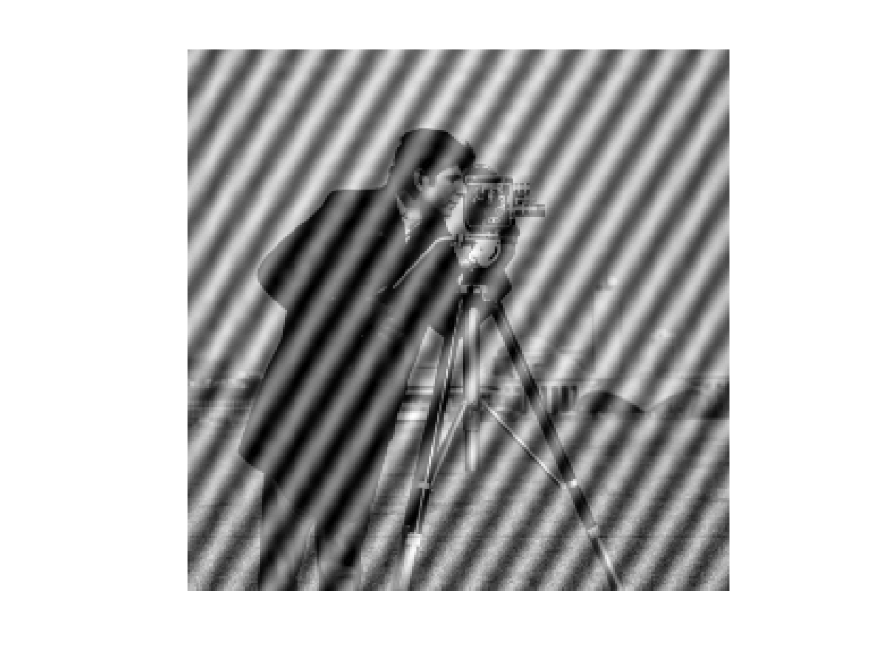
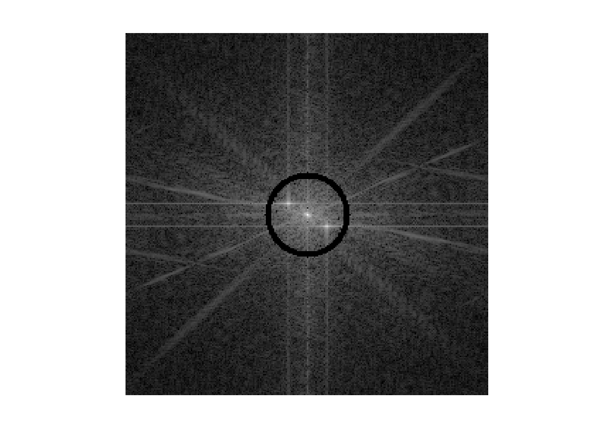
- Remove the noise using notch filtering(陷波濾波). Show the resulting spectrum and the resulting image
clear,close all;
en=imread('cameraman.tif');
[x,y]=meshgrid(1:256,1:256);
s=1+sin(x/3+y/5);
ep=(double(en)/128+s)/4;

cf=fftshift(fft2(ep));
cf(156,:)=0;
cf(102,:)=0;
cf(:,121)=0;
cf(:,137)=0;
cfi=ifft2(cf);
figure,fftshow(cfi,'abs');
figure,fftshow(cf,'log');

