Company Data Department Report

Excusive Summary

We exported the sales data from our data base and we conducted some analysis on it to gain insights into some of our sales operations and study ways of enhancing our services based on a certain scope.

Scope
- Customer Loyalty
- Strengths And Weaknesses
- Performance
- Customer Experience

Data specs:
Here are the tables we used to conduct our analysis.
- Orders Table
- Return Table
- Shipping Cost Table
- People Table

The analysis

Customer Loyalty
- What is the most used shipping method by our customers?
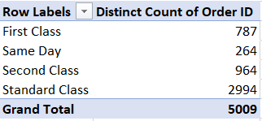
Based on the table above we counted the number of times each shipping mode occurred in the orders table.
And found that the Standard Class shipping mode was the most one by our customers.

Recommendations:
- we should focus more promotion on the standard shipping mode as it the most used.
- We should find ways to reduce the cost of the standard shipping mode and make sure it's profitable as it is the most used shipping mode.
- Same day Shipping mode was the least used shipping mode, which might be better to revise the cost and the possible scenarios where it might be removed.

- Who are our top 10 customers in terms of sales and order frequency?
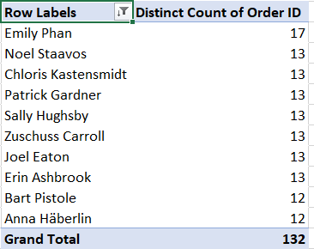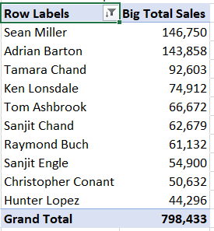
Based on the tables above we counted the Sum of Sales for our customers and Order Frequency occurred in the orders table, and found that Sean Miller, Adrian Barton, Tamara Chand and the other in sales, another side Emily Phan, Noel Staavos, Chloris Kasten Smidt and other, we found that the common aspect among most of them is the Consumer customer segment.

Recommendations:
- we should focus more promotion on this segment in market plan or even focus on which product this segment most buy.
- We can make Some competitions and linking them to the number of times an order or purchase is made, and the top 3 customers in terms of order rate get a good discount.

Strengths And Weaknesses
- Which segment of clients generates the most sales?
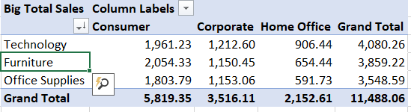
Based on the tables above we counted all of segments by sales and found that consumer segment is the most, especially in Furniture category products, Home Office in Office Supplies is the least sales.

Recommendations:
- We need to focus on consumer segment exactly when add new Furniture product to our products list.
- Home Office segment in Office Supplies category is the least sales, which might be better to revise the possible scenarios where customers tend to leave her.

- Which city has the highest sales value?
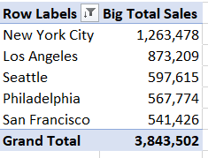
From table result we found that New York city have the highest sales value.

Recommendations:
- Intensifying the state's upcoming marketing plan.
- Add more of our branches or sales services in that city.

- Which state generates the highest sales value percentage by region?
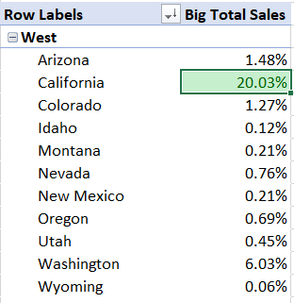
Here we see that California have the highest sales value percentage in west region.
after it there is New York and taxes.

Recommendations:
- Reducing shipping costs specifically for that state, which increases the customer's desire to leave the competitor and resort to us due to a noticeable difference in shipping costs.
- If we take central Branche in west region be better to choose the California state to be the place.

Performance
- What are the top performing product categories in terms of sales and profit?
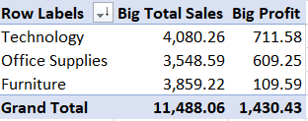
As we show here, the answer is the technology category in both terms of sales and profit.
And we found that the furniture category has high sales; however, its profit is very low (it's present at 33% of sales, whereas in profit it's only 7%).
In general, the level of profit is low in relation to sales. Comparing profit and sales, we find that we only profit 12% of what we sell.

Recommendations:
- Check COGS of Furniture and discount value or percent and change or edit the price.
- We need to reduce discounts and link them to the quantity and number of products in one order.

- What is the most profitable product that we sell?
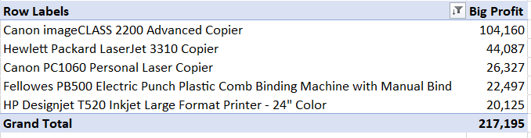
The Canon image CLASS 2200 Advanced Copier is the most profitable product that we sell and it occupies the largest percentage of profit by 48%, in all of these products there one only in office
suppliers Fellowes PB500 Electric Punch Plastic Comb Binding Machine with Manual Bind.
The vast majority of the most profitable products are printing machines.

Recommendations:
- We should focus on how market for printers in total and how can solve its disadvantage.
- We should promotion or get newest version of "Canon image CLASS 2200" To become the interface for our printers.

Customer Experience
- On average, how long does it take for orders to reach our clients?
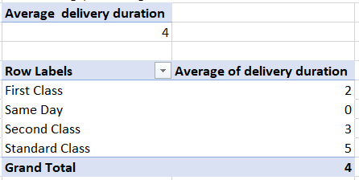
On average, when the number of days is four days, this is a good rate. I found that both the first class and the second class are one day late for the minimum arrival time in the magazine, which is very good.

Recommendations:
- We should focus on promoting the First-Class shipping mode to do the best performance.
- We can focus promotion on Second-Class to be the same in time only as First-Class at the same price.

- What is the return rate for our orders?
We found that 6% of our orders were returned, which makes 8% of our sales and profit percentage 7%.
Know that the highest state California, Washington, Texas, and New York have the highest percentage of returned orders; office suppliers have the highest orders returned, in ship mode. The percentages are close to what is normal, yet there are 19 customers who have returned their orders.

Recommendations:
- Communicate to these customers and know why they returned their orders.
- In highest state the top 3 city in only California state we need to study customer behavior.

