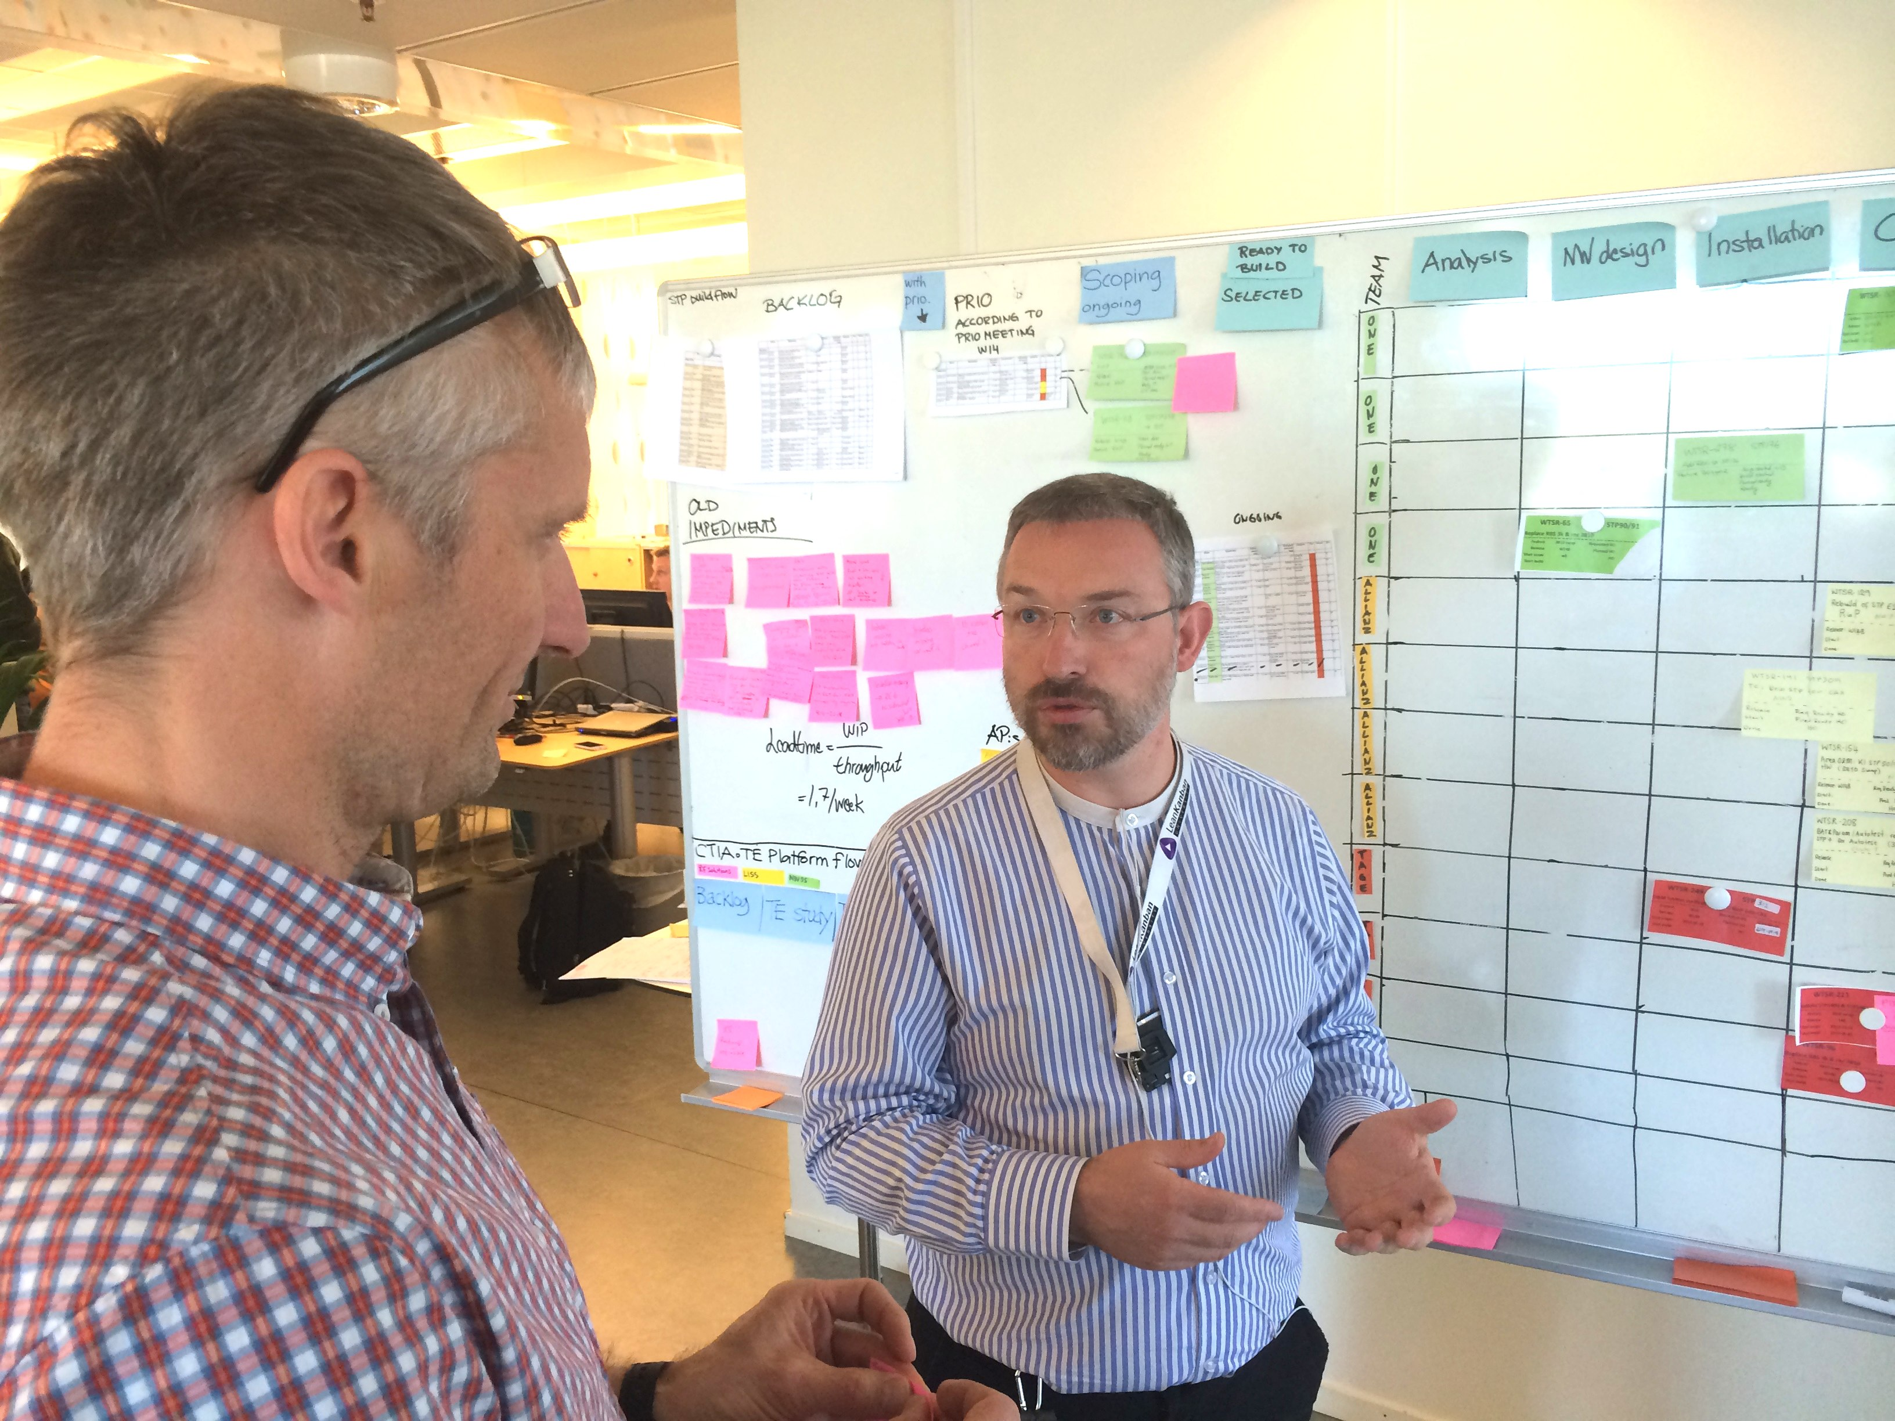

This is our current evolution of standard work for managers, and we find that it is an effective framework in our environments.

Please use it for your own context, but we strongly encourage you to continually evolve it to meet your own needs.

By When

Found Where

Known Effects

Boardwalk

**Standard Work For Managers**

Using Visual Management and Coaching Dialogues to build a learning culture.

**Impediment Record**

By Whom

When

£ Impact

By Whom

Boardwalk by Martin Burns and Håkan Forss is licensed under a Creative Commons Attribution-NonCommercial-ShareAlike 4.0 International License.

You can download copies and an editable version from   
http://www.everydaylean.info/downloads

Want this where you work? Contact: martin.burns@avegagroup.se

Version 3.4.4 Last updated: 23 Sept 2014

Definition of Done

Known Effects



Reflect

* What did you observe?
* What did you learn?
* What actions, if any, do you bring from the meeting?

Prepare

* What system context is this team working in?
* What dependencies do they have with other teams?
* What team needs have you taken on?
  + What progress have you made?
* What do you expect?
  + What status do you expect?
  + How do you expect that to be demonstrated visually?
* Enter the team area
* Make observations in silence  
  (Visual Management, Team mood & behaviour)

Interact

* ”Is this still a good time? If not: when?”
* ”What are you trying to achieve?”
* ”When we were here last week, you expressed this need…”
  + ”What we did was…”
  + ”Will this fulfil your needs?”
  + ”What’s your view of the situation now?”
* ”How are things working right now?”
  + ”Can you show me the data?”
* ”What is preventing us achieving our purpose?”   
  (repeat for each impediment)
  + ”Why is **this** a problem?”
  + ”How do we best protect in the short term?”
  + ”Have you seen this before? How often?”
  + ”Do we need to change how we work?”  
    (input to Improvement Experiments)
  + ”How can management help?”
* ”Is there something that we forgot to ask? Do you have anything else that you would like to tell us?”
* ”Thank you for your time. We are planning to come back ….”
* Leave the team area

Notes: Expectation

Notes: Observations

Learning

Actions