LFG model
- Uses a local Fermi gas when generating a target nucleon in the nucleus (Fermi momentum depends on position in the nucleus).
- Uses LFG when the Pauli Blocker to determines if the final nucleon escapes the nucleus
- Uses LFG when calculating the nuclear suppression factor
- When generating splines, the model averages over many nucleons when calculating the cross section for a given neutrino energy. In each iteration, a radius is generated first, then a nucleon is generated.

Plots:

Initial Nucleon distributions for a local Fermi gas vs a relativistic Fermi gas
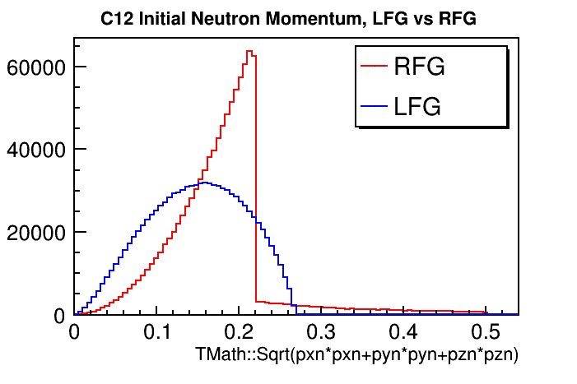
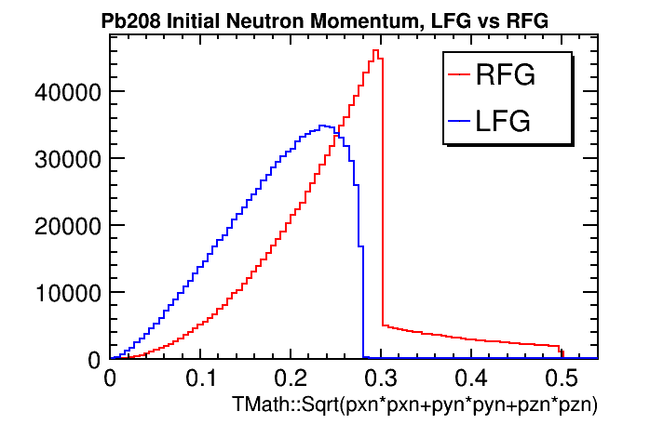
Splines:
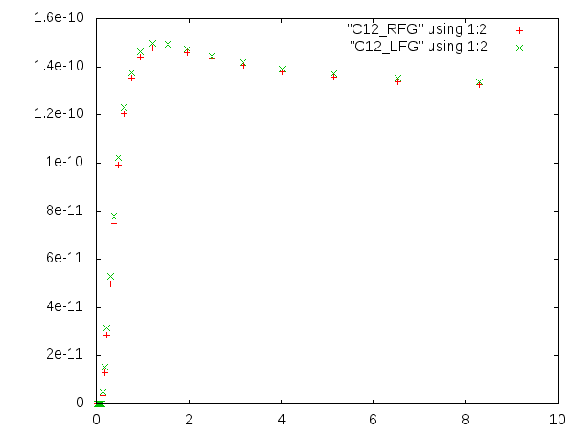
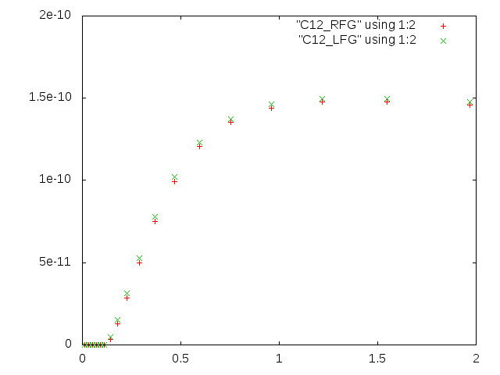
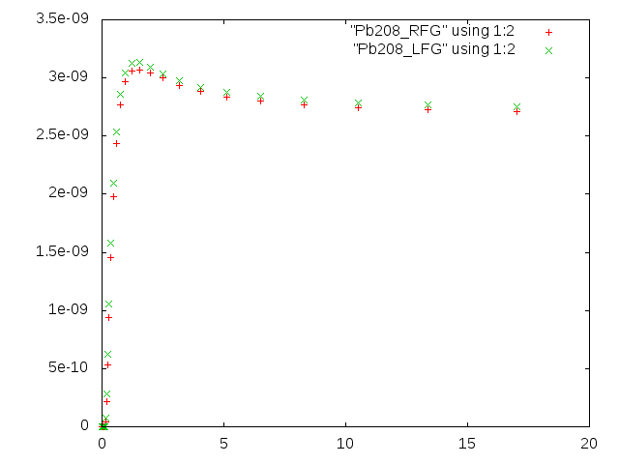

Nieves RPA:

QELKinematicsGenerator and QELPrimaryLeptonGenerator have been updated to work with the LFG model. A lepton is generated by the Kinematics Generator before calculating the cross section, then the lepton is stored if the cross section is accepted. The following plot shows lepton distributions for the LwlynSmith model (which does not depend on the outgoing lepton kinematics) before and after the QEL Generators were updated, to demonstrate that leptons are still generated correctly:

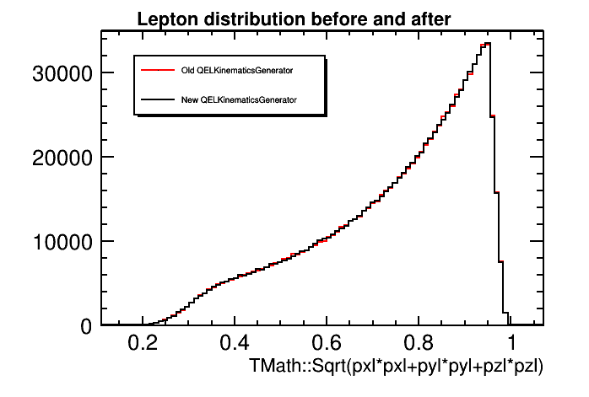
Thus, between the QEL Generators and the LFG model, we have nuclear suppression, pauli blocking, and lepton generated handled as they should be for Nieves' RPA model to work correctly in GENIE.

I noticed that the PrimaryLeptonGenerator class already had code that said it accounts for Coulomb Suppression. I will look into that more, and see how it differs from Nieves' method of handling Coulomb suppression.

