**INDUSTRIAL TRAINING REPORT**

AT



Helicopter Complex

Hindustan Aeronautics Limited

Bangalore – 560 017

***In partial fulfilment of the requirements for the award of the degree of***

**Bachelor of Technology**

in

**MECHANICAL ENGINEERING**

At



**DELHI TECHNOLOGICAL UNIVERSITY**

(formerly Delhi College of Engineering)

Shahbad Daulatpur, Main Bawana Road, Delhi - 42

Submitted by

**Joe Joseph**

**2K14/ME/072**

**CERTIFICATE OF TRAINING**

This is to certify that **Mr. Joe Joseph,** Roll No. **2K14/ME/072** a **III-year** **Mechanical Engineering,** is student of Delhi Technological University, underwent Practical Training in our Organization from **5th December** to **24th December 2016** during this period he acquired Practical Training for working **18** days excluding Sundays and other Holidays. Confidential Report on his performance and conduct is not being sent separately

.

Full name of the Organisation: **HAL Helicopter Division**

Full Postal Address: **Helicopter Complex**

**Hindustan Aeronautics Limited**

**Bangalore – 560 017**

Authorized Signatory: ___________________________

Name: ___________________________

Official Seal: ___________________________

**DELHI TECHNOLOGICAL UNIVERSITY**

**DEPARTMENT OF TRAINING AND PLACEMENT**

**Shahbad Daulatpur, Bawana Road Delhi-110 042**

**TRAINING REPORT (For T & P Department)**

(To be completed by the Training / Personnel / Officer and Counter signed by Training/ Personnel Officer / General Manager. Please send letter direct to the professor and Head, Deptt. of Trg. & Placement)

NAME OF THE TRAINER ORGANISATION: **HAL Helicopter Division**

NAME OF STUDENT: **Joe Joseph** ROLL NO. **2K14/ME/072**

BRANCH OF ENGINEERING OF THE STUDENT: **Mechanical Engineering,**

DATE OF COMPLETION OF THE TRAINING: **24th December 2016**

Actual number of days training taken: **18 Days**

(Please exclude level taken, Sundays & Holidays, unless he had taken training on a Sunday / Holiday.)

**Deptt. / Sections where the students took training with approximate time spent in each place.**

(Refer to Training Schedule)

(Any useful / important suggestions made by the trainees for improvement in technical, managerial of procedural aspects which the Organizations appreciates / accepted.)

Comments on student's conduct and behaviour and /or any other aspect.

Date: __________________ Signature: __________________

Countersigned: __________________ Name: __________________

Name: __________________ Designation:__________________ Designation: __________________ Ph. (Off.): __________________ Email: __________________ Official Seal: _________________ Phone (Off.): __________________ Email: __________________

**ACKNOWLEDGMENT**

I would like to take this opportunity to convey my sincerest gratitude to all the intellectuals concerned for their magnanimous vision by virtue of which I have been guided through to complete my Industrial Training.

The completion of any work is the endeavour of all the individuals that supports, inculcate and foster the much-needed enthusiasm and confidence to the doer of the work without which the whole task proves to be an impossible mission.

At the very outset, I wish my sincere gratitude to all the Managers, Senior Managers, Chief Managers, Additional General Managers, Director General Managers of the Various departments I have undergone Training in HAL Helicopter Division for their co-operation during my industrial training tenure.

Towards the successful completion of the training, I would like to acknowledge my debt to my advisors. The training work would have not been possible without their support, encouragement and constructive comments I received from them.

**And last but not the least, I am indebted to all the HAL employees for their endless support!**

**Joe Joseph**

**TABLE OF CONTENTS**

|  |  |
| --- | --- |
|  |  |
| Introduction | 6-7 |
| Brief History | 7-8 |
| HAL Today | 9 |
| About the Helicopter Division | 10-11 |
| Introduction to Helicopters | 12-20 |
| Machine Shop | 21-22 |
| Methods & Tooling | 23 |
| Heat Treatment | 24 |
| Process Shop (Protective treatments) | 25-26 |
| Maintenance Department | 27 |
| Welding & Sheet Metal Shop | 28 |
| Blade Shop | 29-30 |
| Transmission Assembly | 31-33 |
| Structural Assembly | 34-37 |
| Final Assembly | 38-39 |
| Benefit of the training | 40 |

**INTRODUCTION**

**HAL or Hindustan Aeronautics Limited** is an Indian state owned **Aerospace and Defence company** based in Bangalore, Karnataka. It is governed under the management of Indian Ministry of Defence.

The government based organization is primarily involved in the operations of aerospace industry. These include manufacturing and assembly of aircraft, including navigation and related communication equipment and airports operation.

HAL built its first aircraft in South Asia. It is currently involved in design, fabrication and assembly of Aircrafts (Aircraft Div.), Jet Engines (Engine Div.), Helicopters (Helicopter Div.) and their spare parts.

[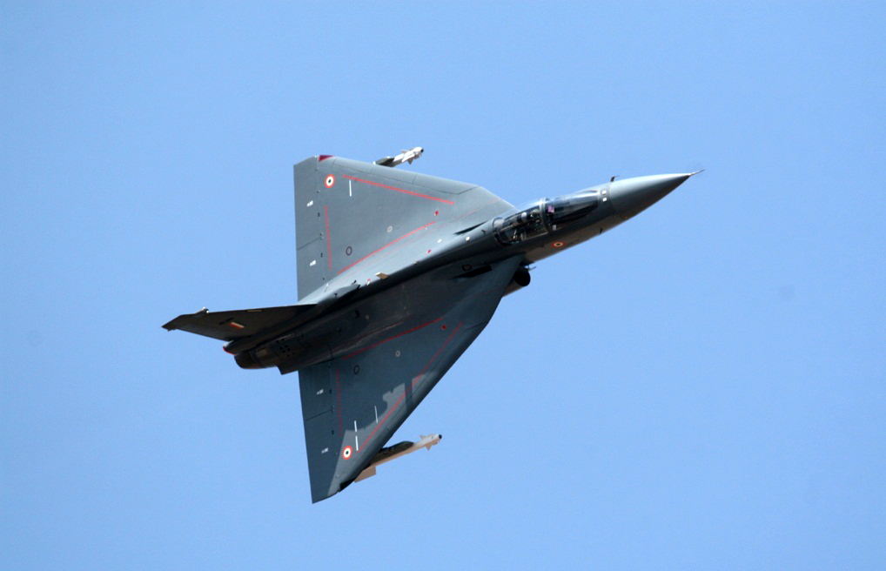](https://www.google.co.in/url?sa=i&rct=j&q=&esrc=s&source=images&cd=&cad=rja&uact=8&ved=0ahUKEwjj35WGh4jRAhVEuY8KHYa8Bm8QjRwIBw&url=http://www.thebetterindia.com/60284/indian-air-force-light-combat-aircraft-tejas/&bvm=bv.142059868,d.c2I&psig=AFQjCNHtKNwB1_qdmJiseE_gZfyspoMXuA&ust=1482504837811101)

**Figure 1: Tejas**-The Light Combat Aircraft (LCA) is the smallest and lightest multi-role supersonic fighter aircraft designed and developed by the Aeronautical Development Agency (ADA) and Hindustan Aeronautics Limited (HAL) for the Indian Air Force and the Indian Navy. (Image courtesy www.thebetterindia.com)

**HAL** has several facilities spread across the country. The locations where the manufacturing plants are operated by HAL include **Nasik, Korwa, Kanpur, Lucknow, Bangalore and Hyderabad**. The German engineer Kurt Tank designed the **HF-24 MARUT** fighter-bomber, the first fighter aircraft made in the country.

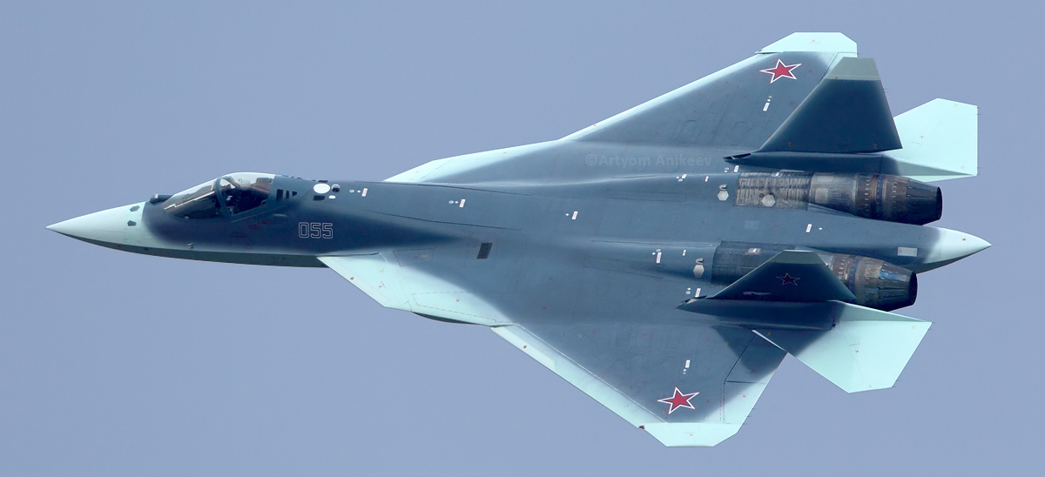

**Figure 2:** The **Sukhoi/HAL** Fifth Generation Fighter Aircraft (**FGFA**) is a Fifth-Generation fighter being developed by Russia and India. It is a derivative project from the **PAK FA** (T-50 is the prototype) being developed for the Indian Air Force (FGFA is the official designation for the Indian version).

**HAL** has a long history of collaboration with several other international and domestic aerospace agencies such as Airbus, Boeing, Lockheed Martin, Suk hoi Aviation Corporation, Elbit Systems, Israel Aircraft Industries, RSK MiG, BAE Systems, Rolls-Royce plc, Dassault Aviation, MBDA,EADS, Tuple, Ilyushin Design Bureau, Dornier Flugzeugwerke, the Indian Aeronautical Development Agency (IADA) and the Indian Space Research Organization (ISRO).

**BRIEF HISTORY**

**HAL** was established as **Hindustan Aircraft** in Bangalore in 1940. On 23 Dec 1940. Hindustan Aircraft Company was duly incorporated under the Mysore Companies Act as a private Ltd Company. Walchand–Tulsidas-Khatau Ltd was the Managing agency.

In Dec 1945, the company was placed under the administrative control of Ministry of Industry & Supply. In January 1951, Hindustan Aircraft Private Limited was placed under the Administrative control of Ministry of Defence

The Company had built aircraft and engines of foreign design under licence, such as Prentice, Vampire and Gnat aircraft. It also undertook the design and development of aircraft indigenously. In August 1951, the HT-2 Trainer aircraft, designed and produced by the company under the able leadership of Dr. V.M.Ghatge flew for the first time.

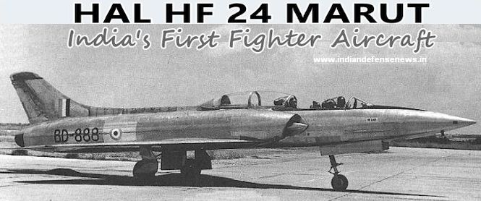

**Figure 3: India’s 1st Indigenous fighter** (Image courtesy www.indiandefensenews.in)

Nearly 200 Trainers were manufactured and supplied to the Indian Air Force and other customers. With gradual building-up of its design capability, the company successfully designed and developed four other aircraft i.e. two seater “Pushpak” suitable for flying clubs, “Krishak” for Air Observatory Post (AOP) role, **HF-24 Jet Fighter “Marut”** and the **HJT-16 Basic Jet Trainer “Kiran”.**

Amalgamation of the two companies i.e. Hindustan Aircraft Limited and Aeronautics India Limited was brought about on **1st Oct 1964** by an Amalgamation order issued by the Government of India and the Company was named as **"Hindustan Aeronautics Limited (HAL)"** with its principal business being design, development, manufacture, repair and overhaul of Aircraft, Helicopter, Engines and related systems like Avionics, Instruments and Accessories.

**HAL TODAY**

The current programs under progress at HAL are production of:

* SU-30 MKI,
* Hawk-AJT,
* Light Combat Aircraft (LCA),
* DO-228 Aircraft,
* Dhruv-ALH and
* Cheetal/ Cheetah / Chetak Helicopters,
* Repair Overhaul of Jaguar,
* Kiran MkI/IA/II,
* Mirage 2000,
* HS-748,
* AN-32,
* MiG 21

HAL is currently meeting the requirements of structures for aerospace launch vehicles and satellites of **ISRO** through its dedicated Aerospace Division. Infrastructure has also been set up to undertake completed assembly of the strap-on L-40 stage booster. Structures for **GSLV Mk.III** have been productionised. HAL has also contributed to Mars mission by supplying riveted structural assemblies and welded propellant tankages for the **PSLV-C25**.

Industrial and Marine Gas Turbine:  The LM-2500 marine gas turbine engine, a 20 MW aero derivative, is being produced and overhauled from the production line in the Industrial and Marine Gas Turbine Division, Bangalore.

**DEVELOPMENT PROJECT**

The major on-going indigenous development programs are the Light Combat Aircraft **(LCA)**, Intermediate Jet Trainer **(IJT),** Light Combat Helicopter **(LCH),** Light Utility Helicopter **(LUH),** Weapon System integration on ALH, Multi-role Transport Aircraft **(MTA),** Fifth Generation Fighter Aircraft **(FGFA),** Basic Turboprop Trainer. Design and Development of medium thrust engine has also been taken up.

**ABOUT THE HELICOPTER DIVISION**

Helicopter Division was established in **July 1970**. The division manufactures single engine as well as twin engine helicopters to cater the growing needs of the market.

Helicopter Division manufactures:

* ALH - Rudra, Dhruv (MK I to IV)
* Cheetah, Chetak, Cheetal &
* Lancer helicopters.

The division is supported by the co-located R&D centre – Rotary Wing Research & Design Centre (**RWR&DC**).

The **MRO** division caters to the Maintenance, Repair & Overhaul activities of helicopters.  The Rotary Wing Academy focuses on training of pilots.

HAL started manufacturing of helicopters in 1962, by entering an agreement with M/s SUD-AVIATION (Presently M/s EUROCOPTER, France) for production of Alouette III helicopters. (Chetak). The first Chetak (Alouette III) in ‘Fly Away’ condition delivered in 1965.

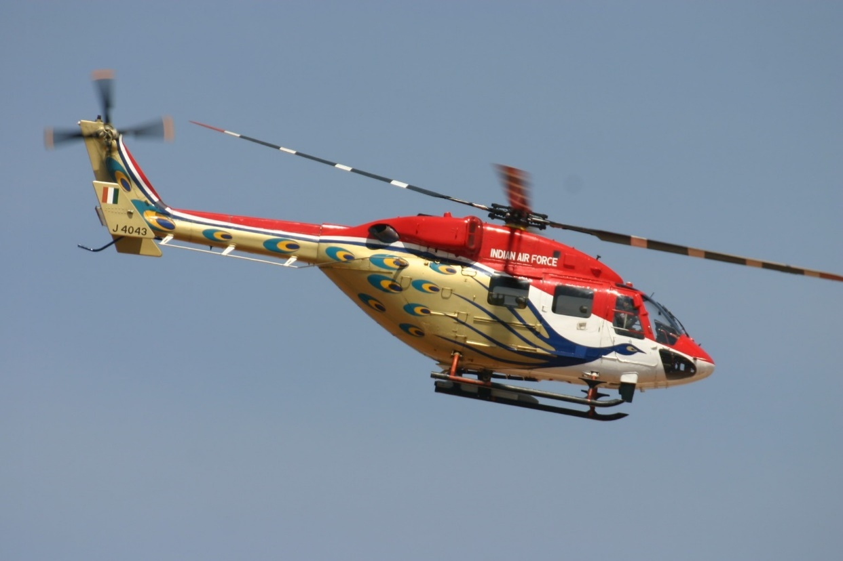

**Figure 4: Sarang** is the helicopter display team of the Indian Air Force. The team flies four modified **HAL Dhruv** helicopters.

In 1990s, HAL has developed a light attack helicopter “Lancer”. The basic structure of the lancer is derived from reliable and proven Cheetah helicopter. The helicopter has bullet proof front panels. Gun cum Rocket pod one each. An optical sight has been fitted for accurate firing.

The Cheetal helicopter is an engine upgraded variant of Cheetah helicopter. The Cheetal helicopter set the world record of world’s highest landing at “Saser Kangri” of Himalayas in 2006.

HAL Helicopter division has successfully manufactured 600 Single Engine helicopters. HAL achieved self-reliance in design, developing & manufacturing of twin engine Advanced Light Helicopter “Dhruv”.  Dhruv is a multi-role, multi mission all weather helicopter in the 5.5-ton category. The indigenously designed twin engine helicopter started series production during 2001-2002.

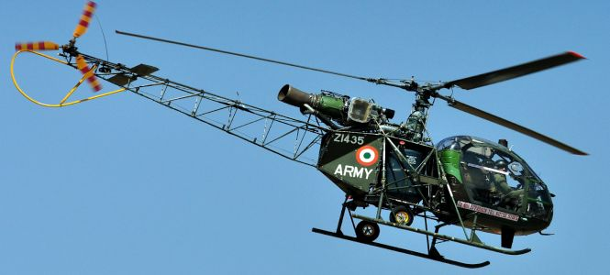

**Figure 5: Cheetah / Cheetal** light helicopters are widely used in the Military Aviation.

HAL with the proven track record of manufacturing more than 700 helicopters, The helicopter division has expand its design, developing & production range by manufacturing new helicopters like Weapon System Integrated (WSI) version of Dhruv (Christened as “Rudra”), Light Combat Helicopter (LCH) and Light Utility Helicopter (LUH).Helicopter Division was established in July 1970. The division manufactures single engine as well as twin engine helicopters to cater the growing needs of the market.   
  
Helicopter Division manufactures Rudra, Dhruv, Cheetah, Chetak, Cheetal & Lancer helicopters.   
  
The division is supported by the co-located R&D centre – Rotary Wing Research & Design Centre (RWR&DC).  
The MRO division caters to the Maintenance, Repair & Overhaul activities of helicopters.  The Rotory Wing Academy focuses on training of pilots.  
  
HAL started manufacturing of helicopters in 1962, by entering an agreement with M/s SUD-AVIATION (Presently M/s EUROCOPTER, France) for production of Aloutte III helicopters. (Chetak). The first Chetak (Aloutte III) in ‘Fly Away’ condition delivered in 1965.   
  
License agreement for production of Cheetah (LAMA SA 315-B) signed with M/s SNIAS (presently M/s, Eurocopter) in 1970. First Cheetah manufactured from raw materials was delivered in 1976-77.  
  
In 1990s, HAL has developed a light attack helicopter “Lancer”. The basic structure of the lancer is derived from reliable and proven Cheetah helicopter. The helicopter has bullet proof front panels. Gun cum Rocket pod one each (70 mm Rocket+12.5 mm Gun) fitted on either side. An optical sight has been fitted for accurate firing.  
  
The Cheetal helicopter is a re-engined variant of Cheetah helicopter. The Cheetal helicopter set the world record of world’s highest landing at ‘Saser Kangri’ of Himalayas in 2006.  
  
HAL Helicopter division has successfully manufactured 600 Single Engine helicopters. HAL achieved self-reliance in design, developing & manufacturing of twin engine Advanced Light Helicopter “Dhruv”.  Dhruv is a multi role, multi mission all weather helicopter in the 5.5 ton category. The indigenously designed twin engine helicopter started series production during 2001-2002.  
  
The division is accredited with AS 9100 C & ISO 14001:2004 certifications. The division is also approved by Directorate General of Civil Aviation (DGCA) for CAR 21, CAR 145 & CAR M certifications.   
  
HAL with the proven track record of manufacturing more than 700 helicopters, the helicopter division has expand its design, developing & production range by manufacturing new helicopters like Weapon System Integrated (WSI) version of Dhruv (Christened as “Rudra”), Light Combat Helicopter (LCH) and Light Utility Helicopter (LUH).Helicopter Division was established in July 1970. The division manufactures single engine as well as twin engine helicopters to cater the growing needs of the market.   
  
Helicopter Division manufactures Rudra, Dhruv, Cheetah, Chetak, Cheetal & Lancer helicopters.   
  
The division is supported by the co-located R&D centre – Rotary Wing Research & Design Centre (RWR&DC).  
The MRO division caters to the Maintenance, Repair & Overhaul activities of helicopters.  The Rotory Wing Academy focuses on training of pilots.  
  
HAL started manufacturing of helicopters in 1962, by entering an agreement with M/s SUD-AVIATION (Presently M/s EUROCOPTER, France) for production of Aloutte III helicopters. (Chetak). The first Chetak (Aloutte III) in ‘Fly Away’ condition delivered in 1965.   
  
License agreement for production of Cheetah (LAMA SA 315-B) signed with M/s SNIAS (presently M/s, Eurocopter) in 1970. First Cheetah manufactured from raw materials was delivered in 1976-77.  
  
In 1990s, HAL has developed a light attack helicopter “Lancer”. The basic structure of the lancer is derived from reliable and proven Cheetah helicopter. The helicopter has bullet proof front panels. Gun cum Rocket pod one each (70 mm Rocket+12.5 mm Gun) fitted on either side. An optical sight has been fitted for accurate firing.  
  
The Cheetal helicopter is a re-engined variant of Cheetah helicopter. The Cheetal helicopter set the world record of world’s highest landing at ‘Saser Kangri’ of Himalayas in 2006.  
  
HAL Helicopter division has successfully manufactured 600 Single Engine helicopters. HAL achieved self-reliance in design, developing & manufacturing of twin engine Advanced Light Helicopter “Dhruv”.  Dhruv is a multi role, multi mission all weather helicopter in the 5.5 ton category. The indigenously designed twin engine helicopter started series production during 2001-2002.  
  
The division is accredited with AS 9100 C & ISO 14001:2004 certifications. The division is also approved by Directorate General of Civil Aviation (DGCA) for CAR 21, CAR 145 & CAR M certifications.   
  
HAL with the proven track record of manufacturing more than 700 helicopters, the helicopter division has expand its design, developing & production range by manufacturing new helicopters like Weapon System Integrated (WSI) version of Dhruv (Christened as “Rudra”), Light Combat Helicopter (LCH) and Light Utility Helicopter (LUH).

**INTRODUCTION TO HELICOPTERS**

Helicopters come in many sizes and shapes, but most share the same major components.

COMPONENTS OF HELICOPTER

* Cabin where the payload and crew are carried.
* Airframe, which houses the various components, or where components are attached.
* Power Plant or engine.
* Transmission, which, among other things, takes the power from the engine and transmits it to the Main Rotor, which provides the aerodynamic forces that make the helicopter fly.
* Anti-torque System to keep the helicopter from turning due to torque.
* Landing Gear, which could be skids, wheels, skis, or floats.

[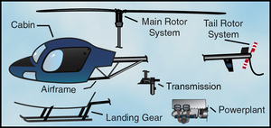](https://www.google.co.in/url?sa=i&rct=j&q=&esrc=s&source=images&cd=&cad=rja&uact=8&ved=0ahUKEwjcz4DuuIjRAhXDLo8KHQ7AAN8QjRwIBw&url=https://en.wikibooks.org/wiki/Rotorcraft_Fundamentals/Introduction_to_the_Helicopter&psig=AFQjCNG_iw59C0pFT_-V_GhwC-auhPmhoA&ust=1482518178104781)

**Figure 6:** Basic Components of a Helicopter

THE MAIN ROTOR SYSTEM

The rotor system found on helicopters can consist of a single main rotor or dual rotors. With most dual rotors, the rotors turn in opposite directions so the torque from one rotor is opposed by the torque of the other. This cancels the turning tendencies.

In general, a rotor system can be classified:

* Fully articulated rotor system
* Semi-rigid rotor system.
* Rigid system.

SWASH PLATE ASSEMBLY

The purpose of the swash plate is to transmit control inputs from the collective and cyclic controls to the main rotor blades.

[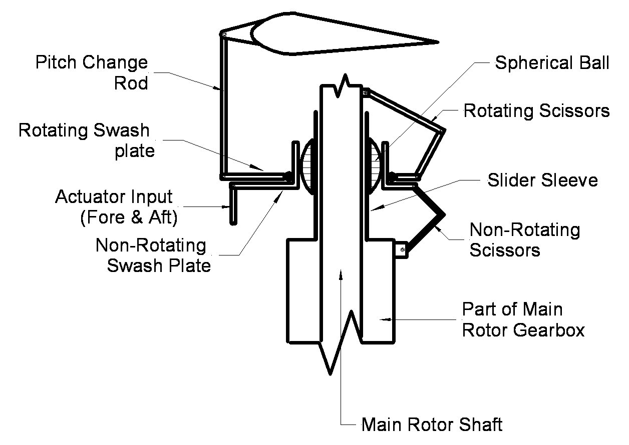](https://www.google.co.in/url?sa=i&rct=j&q=&esrc=s&source=images&cd=&cad=rja&uact=8&ved=0ahUKEwibxe-CuojRAhWCrI8KHXQFCVoQjRwIBw&url=http://aviamech.blogspot.com/2011/09/swash-plate-assembly.html&psig=AFQjCNHOkPNv8MNfPCnf3chbxXLYE6qjog&ust=1482518521403388)

**Figure 7: Simple Swash Plate,** Assembly and mechanism

It consists of two main parts:

* The stationary swash plate: The purpose of the swash plate is to transmit control inputs from the **collective and cyclic controls** to the main rotor blades. It is restrained from rotating but is able to tilt in all directions and move vertically.
* The rotating swash plate: The rotating swash plate is mounted to the stationary swash plate by means of a bearing and is allowed to rotate with the main rotor mast. Both swash plates tilt and slide up and down as one unit. The rotating swash plate is connected to the pitch horns by the pitch links.

**Collective and cyclic** control inputs are transmitted to the stationary swash plate by control rods causing it to tilt or to slide vertically. The pitch links attached from the rotating swash plate to the pitch horns on the rotor hub transmit these movements to the blades.

[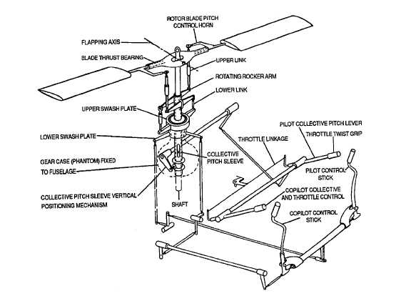](https://www.google.co.in/url?sa=i&rct=j&q=&esrc=s&source=images&cd=&cad=rja&uact=8&ved=0ahUKEwi2-Lu8u4jRAhVGsY8KHeCmAM4QjRwIBw&url=http://aviationmaintenance.tpub.com/TM-1-1500-204-23-5/css/TM-1-1500-204-23-5_38.htm&bvm=bv.142059868,d.c2I&psig=AFQjCNEIxwfQ3gxvJkrF1HDNF_YtddoRSw&ust=1482518889312217)

**Figure 8: Control Mechanisms,** Collective, Cyclic. (radar not shown but similar to collective but as foot pedals

TAIL ROTOR

Most helicopters with a single, main rotor system require a separate rotor to overcome torque. This is accomplished through a variable pitch. **anti-torque rotor or tail rotor**. You will need to vary the thrust of the anti-torque system to maintain directional control whenever the main rotor torque changes, or to make heading changes while hovering, also known as Yaw control.

[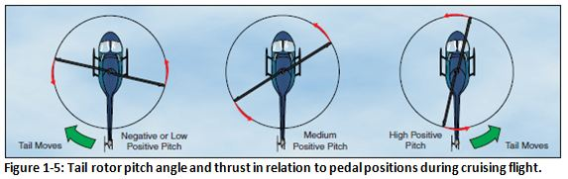](https://www.google.co.in/url?sa=i&rct=j&q=&esrc=s&source=images&cd=&cad=rja&uact=8&ved=0ahUKEwjEldv19orRAhUHuI8KHRrkC5QQjRwIBw&url=https://www.faasafety.gov/gslac/ALC/course_content.aspx?cID%3D105%26sID%3D456%26preview%3Dtrue&psig=AFQjCNFNFfsAXS_-HonmIHcMdGpd2B1big&ust=1482603576606155)

NOTAR

The NOTAR system is an alternative to the anti- torque rotor. The system uses low-pressure air that is forced into the tail boom by a fan mounted within the helicopter.

The air is then fed through horizontal slots, located on the right side of the tail boom. and to a controllable rotating nozzle to provide anti torque and directional control.

The low-pressure air coming from the horizontal slots, in conjunction with the downwash from the main rotor, creates a phenomenon called "Coanda Effect," which produces a lifting force on the right side of the tail boom.

[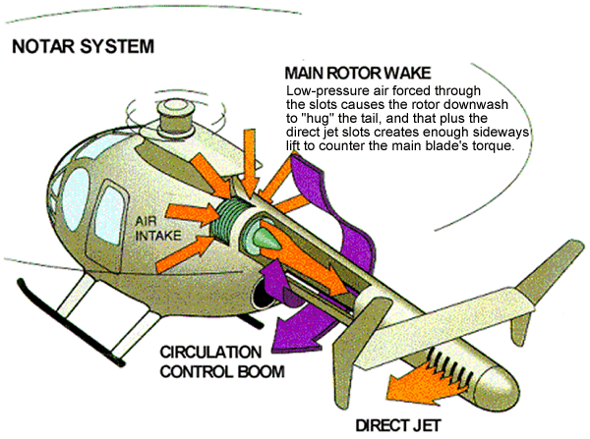](https://www.google.co.in/url?sa=i&rct=j&q=&esrc=s&source=images&cd=&cad=rja&uact=8&ved=0ahUKEwjxu6W194rRAhUHuY8KHUwaCWAQjRwIBw&url=http://www.pprune.org/archive/index.php/t-444591.html&bvm=bv.142059868,d.c2I&psig=AFQjCNHUSEju-x-QdoCNbBTgz2UCWPMevg&ust=1482603669034224)

TRANSMISSION SYSTEM

The transmission system transfers power from the engine to the main rotor, tail rotor, and other accessories.

The main components:

* The main rotor transmission.
* Tail rotors drive system.
* Clutch.
* Freewheeling unit.
* Chip detectors.

Helicopter transmissions are normally lubricated and cooled with their own oil supply. A sight gauge is provided to check the oil level. Some transmissions have chip detectors located in the sump. These detectors are wired to warning lights located on the pilot's instrument panel that illuminate in the event of an internal problem.

[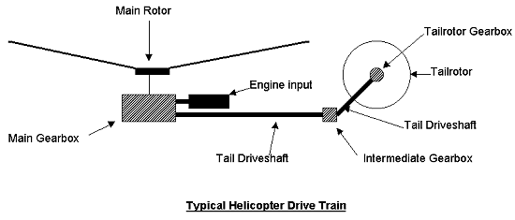](https://www.google.co.in/url?sa=i&rct=j&q=&esrc=s&source=images&cd=&cad=rja&uact=8&ved=0ahUKEwiE55Td94rRAhXKKo8KHb5HCxcQjRwIBw&url=http://www.pilotfriend.com/training/flight_training/rotary/helis.htm&bvm=bv.142059868,d.c2I&psig=AFQjCNGR-nOqFWjw_hFFm_EuiBZTcjdcWg&ust=1482603786721872)

MAIN ROTOR SYSTEM

The primary purpose of the main rotor transmission is to reduce engine output rpm to optimum rotor rpm. This reduction is different for the various helicopters. Most helicopters use a dual-needle tachometer to show both engine and rotor rpm or a percentage of engine and rotor rpm.

The rotor rpm needle normally is used only during clutch engagement to monitor rotor acceleration, and in autorotation to maintain rpm within prescribed limits.

In helicopters with horizontally mounted engines, another purpose of the main rotor transmission is to change the axis of rotation from the horizontal axis of the engine to the vertical axis of the rotor shaft.

TAIL ROTOR DRIVE SYSTEM

The tail rotor drive system consists of a tail rotor drive shaft powered from the main transmission and a tail rotor transmission mounted at the end of the tail boom.

The drive shaft may consist of one long shaft or a series of shorter shafts connected at both ends with flexible couplings. This allows the drive shaft to flex with the tail boom. The tail rotor transmission provides a right-angle drive for the tail rotor and may also include gearing to adjust the output to optimum tail rotor rpm.

CLUTCH

In a conventional airplane, the engine and propeller are permanently connected. However, in a helicopter there is a different relationship between the engine and the rotor. Because of the greater weight of a rotor in relation to the power of the engine, as compared to the weight of a propeller and the power in an airplane, the rotor must be disconnected from the engine when you engage the starter.

A clutch allows the engine to be started and then gradually pick up the load of the rotor. On free turbine engines, no clutch is required, as the gas producer turbine is essentially disconnected from the power turbine.

On reciprocating helicopters, there are two main types of clutches: The centrifugal clutch and the belt drive clutch.

FREEWHEELING UNIT

Since lift in a helicopter is provided by rotating air foils, these air foils must be free to rotate if the engine fails. The freewheeling unit automatically disengages the engine from the main rotor when engine rpm is less than main rotor rpm. This allows the main rotor to continue turning at normal in-flight speeds.

The transmission can then exceed the speed of the engine. In this condition, engine speed is less than that of the drive system, and the helicopter is in an auto-rotation state.

LANDING GEAR

The landing gear forms the principal support of the airplane on the surface.

Types of landing gear:

* Skid type gear, which is suitable for landing on various types of surfaces.
* Floats for water operations.
* Skis for landing on snow or soft terrain.
* Wheels are another type of landing gear. They may be in a tricycle or four-point configuration.
* The nose or tail gear is free to swivel as the helicopter is taxied on the ground.

FLIGHT CONTROL SYSTEM

When you begin flying a helicopter, you will use four basic flight controls during flight.

* Cyclic pitch control.
* Collective pitch control.
* The Throttle.
* Anti-torque pedals.

**The Cyclic Pitch Control**

The cyclic pitch control tilts the main rotor disc by changing the pitch angle of the rotor blades in their cycle of rotation. When the main rotor disc is tilted, the horizontal component of lift moves the helicopter in the direction of tilt. The rotor disc tilts in the direction that pressure is applied to the cyclic pitch control.

If the cyclic is moved forward, the rotor disc tilts forward; if the cyclic is moved aft, the disc tilts aft, and so on. Because the rotor disc acts like a gyro, the mechanical linkages for the cyclic control rods are rigged in such a way that they decrease the pitch angle of the rotor blade approximately 90° before it reaches the direction of cyclic displacement, and increase the pitch angle of the rotor blade approximately 90° after it passes the direction of displacement.

An increase in pitch angle increases angle of attack; a decrease in pitch angle decreases angle of attack. For example, if the cyclic is moved forward, the angle of attack decreases as the rotor blade passes the right side of the helicopter and increases on the left side. This results in maximum downward deflection of the rotor blade in front of the helicopter and maximum upward deflection behind it, causing the rotor disc to tilt forward.

**The Collective Pitch Control**

The Collective pitch control, located on the left side of the pilot’s seat, changes the pitch angle of all main rotor blades simultaneously, or collectively, as the name implies.

As the collective pitch control is raised, there is a simultaneous and equal increase in pitch angle of all the main rotor blades; as it is lowered, there is a simultaneous and equal decrease in pitch angle. This is done through a series of mechanical linkages and the amount of movement in the collective level determines the amount of blade pitch change. An adjustable friction control helps prevent inadvertent collective pitch movement.

Changing the pitch angle on the blade changes the angle of attack on each blade. With a change in angle of attack comes a change in drag, which affects the speed or rpm of the main rotor. As the pitch angle increases. angle of attack increases, drag increases and rotor rpm decreases. Decreasing pitch angle decreases both angle of attack and drag, while rotor rpm increases in order to maintain a constant rotor rpm, which is essential in helicopter operations, a proportionate change in power is required to compensate for the change in drag. This is accomplished with the throttle control or a correlator and/or governor, which automatically adjusts engine power.

**The Throttle**

The function of the throttle is to regulate engine rpm If the correlator or governor system does not maintain the desired rpm when the collective is raised or lowered, or if those systems are not installed, the throttle has to be moved manually with the twist grip in order to maintain rpm. Twisting the throttle outboard increases rpm; twisting it inboard decreases rpm. Which is usually a twist grip control located on the end of the collective lever. A twist grip throttle is usually mounted on the end of the collective lever. Some turbine helicopters have the throttles mounted on the overhead panel or on the floor in the cockpit.

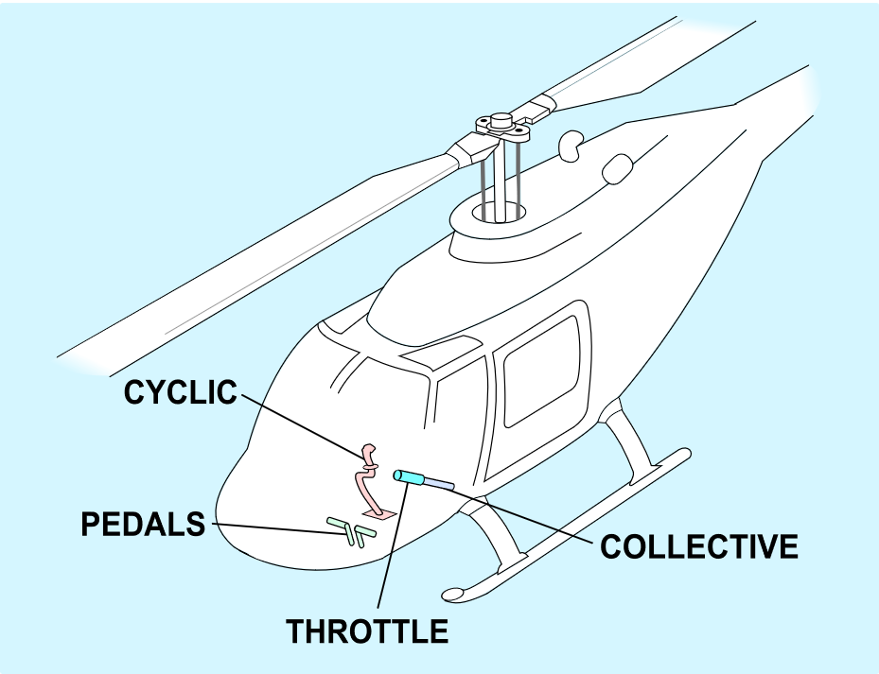

**Figure 9: Flight Control Mechanisms in a Helicopter,** Collective, Cyclic, pedals and throttle.

**MACHINE SHOP**

The machine shop division is the responsible for the manufacturing all the basic parts that go into the Helicopter Assembly, be it the transmission elements such as Gears and Shafts or the jigs and fixtures elements such as rivets or spars of the helicopter blades. Machine shop is a room, building, or department where all machining is done. In a machine shop, machinists use machine tool sand cutting tools to make parts, usually of metal or plastic.

The production can consist various operations such as centering, Turing, cutting, facing, shaping, drilling, hobbing, thread cutting, spline cutting, knurling chamfering, filleting, grinding, tooth cutting, reaming, finishing, and other special processes. The machine that are typically used are either manually of automatic, which include lathes, milling machines, jig boring, machining centers, multitasking machines, drill presses, or grinding machines. Many of these are controlled using CNC (Computer Numerical Control), these machines guide a cutting tool to the work piece using a computer programme. This has lot of advantages compared to manual operations.

Other processes, such as heat treating, electroplating, de-plating, anodizing, painting etc. of parts during their particular manufacturing route, i.e. either before or after machining, are often done in separate allied facilities which are discussed later.

The Machine shop floor is a process layout production floor. This means that due to the machines being relatively larger, they are kept static in the assembly line (or manufacturing plant) and the parts, which are primarily transmission parts, like gears, shafts, housings, mounts, brackets, sleeves, spacers, bushings etc.

To ensure the smooth operation of the product (the various components) and to keep up to the schedules, the Machine Shop has been divided into various Cells. These include:

* Bevel Gear Cell
* Shaft Cell
* Spline Cell
* Oil jet Cell
* Structure Support Cell

These cells receive various components to manufacture in batches. These Batches are then sequentially operated on buy the various specialised machines available in the cells.

Some of them include:

* CNC Milling Machines
* DMG 5 Axis CNC Machining Center
* 4 Axis CNC Machining Center
* Gear Machining Centres
* Cooper CNC Gear shaper
* Gleason Conventional Gear Generator

To ensure Highest standards in manufacturing quality, various checks are given to the components, these checks are mostly non-destructive and are primarily done to satisfy the very stringent certifications required by the components to be allowed for assembly in the final helicopter.

These tests or measuring or validating is done by coordinate measuring machine (CMM). These machines use a computer program to move a pointer (ruby tip), which maps out the component that is fixed, in 3D space. These machines have a very high tolerance, up to 0.1 µm, whereas most CNC machines only have up to 1 to 0.5 µm tolerance. Non-destructive testing occurs in Process Shop.

The Table indicating the various standards and their respective certifying agencies are as follows:

|  |  |
| --- | --- |
| **CERTIFICATION** | **ACCREDITED BY** |
| AS 9100 ‘C’  (Aerospace Standard) | ANAB  DEKRA CERT INC |
| Production Organization Exposition (POE) Under  Civil Aviation Requirements – 21 (CAR-21) | DGCA |
| Maintenance Organization Exposition (MOE) Under  Civil Aviation Requirements – 145 (CAR-145) | DGCA |
| Continuing Airworthiness Management Organization (CAMO) Under  Civil Aviation Requirements – M (CAR-M) | DGCA |
| DGAQA Certification Under  AFQMS -2011(Approval of Firm and Its Quality Management System) | DGAQA |
| ISO 14001:2004 (Environment Management System Standard) | NVT-QC |

DGAQA- The Directorate General Aeronautical Quality Assurance.

DGCA- Directorate General of Civil Aviation

**METHODS & TOOLING**

The methods department is basically a support department that is concerned with providing the most feasible and best applicable methods for manufacturing a component.

The method department looks into the need that arise regarding the number and the type of the components to be manufactured.

Alternatively, it can be described as the design of the productive process in which a person is involved. The task of the Methods engineer is to decide where humans will be utilized in the process of converting raw materials to finished products and how workers can most effectively perform their assigned tasks.

Lowering costs and increasing reliability and productivity are the objectives of methods engineering. These objectives are met in a five-step sequence as follows: Project selection, data acquisition and presentation, data analysis, development of an ideal method based on the data analysis and, finally, presentation and implementation of the method.

Tools department is also a support department that manufactures the special tools that are designed to meet specific arrangements. General tools such as the single point cutting tools etc. are brought from the market however specific applications tools are manufactured in house.

A tool is a device that is used to perform a certain operation on a work piece and yield a particular geometry out of the raw material that is available by performing various operations on the work piece.

Tools are manufactured or brought and are sent to the tools shop where they are stored and are used by several other parameters such as machine shops, assembly unit, sheet metal shop etc. Machine tools and the tooling, such as cutting tools, fixtures, and accessories, that is used on them Cutting tool (machining), any of hundreds of kinds of cutters, Fixture (tool), a fixed work holding or support device, Jig (tool), a movable work holding or support device. Tool management, keeping track of, and maximizing efficient use of, all the tooling.

Agile tooling, term used to describe the process of using modular means to design tooling that is produced by additive manufacturing or 3D printing methods to enable quick prototyping and responses to tooling and fixture needs

**HEAT TREATMENT SHOP**

Heat treating is a group of industrial and metal working processes used to alter the physical, and sometimes chemical, properties of a material. The most common application is metallurgical.

Heat treatments are also used in the manufacture of many other materials, such as glass. Heat treatment involves the use of heating or chilling, normally to extreme temperatures, to achieve a desired result such as hardening or softening of a material.

Heat treatment techniques include annealing, case hardening, precipitation strengthening, tempering, normalizing and quenching. It is noteworthy that while the term heat treatment applies only to processes where the heating and cooling are done for the specific purpose of altering properties intentionally.

The various heat treating methods include:

* Carburizing
* Nitriding (ion/plasma)
* Muffle Hardening
* Air circulating Furnace
* Salt Bath Hardening
* Vacuum Hardening
* Solutionizing

These various processes carter for the different design requirements for different materials like, Aluminum, Steel, Titanium and Magnesium Alloys.

[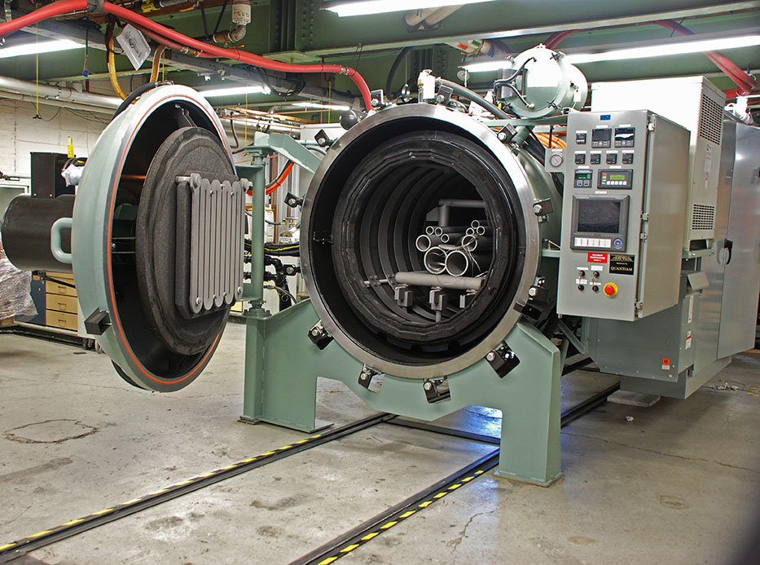](https://www.google.co.in/url?sa=i&rct=j&q=&esrc=s&source=images&cd=&ved=0ahUKEwiIid7a7YvRAhUGMY8KHZZTDJAQjRwIBw&url=http://thefurnacesource.com/&psig=AFQjCNHjGrvaDN_Vr1AE1xusHNg7F3F-HQ&ust=1482635466628096)

**PROCESS SHOP**

Process Shop is an allied Manufacturing department the caters to the needs of Machine Shop and the various processes in the manufacturing of a component.

The various processes of the shop are divided into two stations, Ferrous metals and Non-Ferrous metals, the processes that take place are primarily Electroplating, these include:

* Copper Plating
* Cadmium Plating
* Nickel Plating
* Hard Chrome Plating

The Various other processes include:

* Alkaline Degreasing
* Sulpho-chromic Pickling
* Alodine
* Chromic and sulphuric Acid Anodizing
* Hard Anodizing
* Chemical Milling (etching)

This Department requires various processing essentials like steam, cold water, Chemical baths, electricity etc. Those are managed by the maintenance department (discussed later).

The other Process that takes place here is, NDT or Non-Destructive Testing. NDT methods include, Dye penetrant, Magnetic Particle inspection (MPI), Fluorescent Particle Inspection. (FPI) etc.

[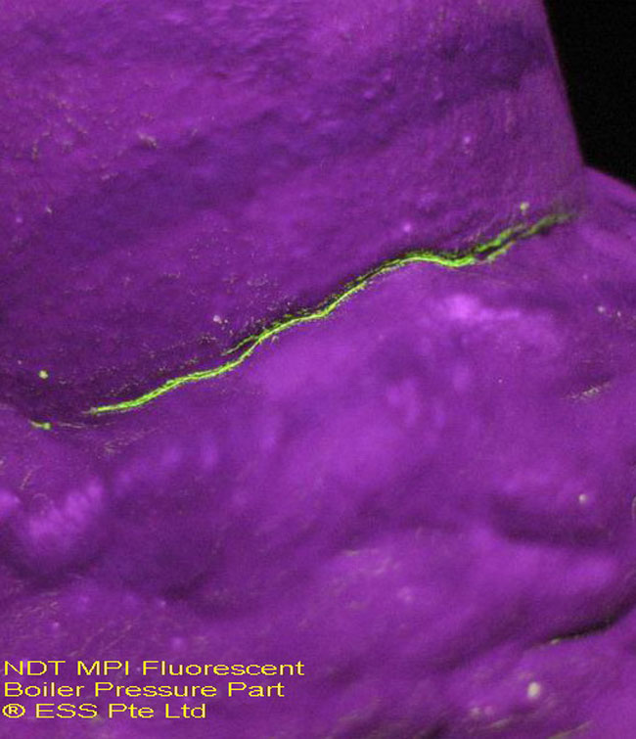](https://www.google.co.in/url?sa=i&rct=j&q=&esrc=s&source=images&cd=&cad=rja&uact=8&ved=0ahUKEwjBjpa67ovRAhWEso8KHeowD0cQjRwIBw&url=http://www.keu-indonesia.com/ndt-welding&bvm=bv.142059868,d.c2I&psig=AFQjCNG7QTVHUZl6D-JUkLsGMzYY-Lz6wA&ust=1482635656707362)

(NDT) is a wide group of analysis techniques used in science and technology industry to evaluate the properties of a material, component or system without causing damage. Because NDT does not permanently alter the article being inspected, it is a highly valuable technique that can save both money and time in product evaluation, troubleshooting, and research.

[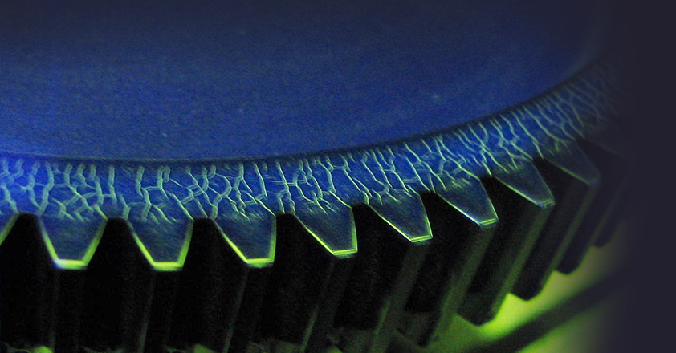](https://www.google.co.in/url?sa=i&rct=j&q=&esrc=s&source=images&cd=&cad=rja&uact=8&ved=0ahUKEwiiosOz8ovRAhUHO48KHR_PBhYQjRwIBw&url=http://americantestingservices.com/services/non-destructive-testing/magnetic-particle/&bvm=bv.142059868,d.c2I&psig=AFQjCNG7QTVHUZl6D-JUkLsGMzYY-Lz6wA&ust=1482635656707362)

**Figure 10:** Showing of micro cracks of component under UV (Ultraviolet Light), These are visible due to the fluorescent particles are dissolved in liquid which helps it penetrate the cracks and remain there even after washing off all the excess. This reveals the cracks in the component.

The Other common NDT methods include ultrasonic, radiographic, remote visual inspection (RVI), eddy-current testing, and low coherence interferometry. Innovations in the field of nondestructive testing have had a profound impact on medical imaging, including echocardiography, medical ultrasonography.

**[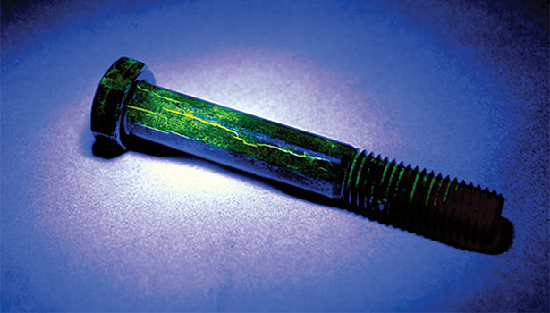](https://www.google.co.in/url?sa=i&rct=j&q=&esrc=s&source=images&cd=&cad=rja&uact=8&ved=0ahUKEwiO2LGp84vRAhUYTY8KHddzBUwQjRwIBw&url=http://www.qualitymag.com/articles/90976-magnetic-particle-powder-performance&bvm=bv.142059868,d.c2I&psig=AFQjCNG7QTVHUZl6D-JUkLsGMzYY-Lz6wA&ust=1482635656707362)**

**MAINTENANCE DEPARTMENT**

Maintenance department is an allied department of the Helicopter Division. This allied division has the following responsibilities.

* Process Planning
* Shop Floor Planning
* Vetting of Processes made by the Sub-Contractor
* Validation of Special Processes
* CNC programming
* Resource and Utility Planning
* Capital and Revenue procurement
* New Projects

The Maintenance Department performs cyclical preventative maintenance on various campus systems. It also provides services required for life safety and other regulatory compliance issues.

The department repairs campus equipment and facilities. Using the department’s trade experience, they also assist in the repair of department-specific equipment.

The alliance of various departments that are taken by the Maintenance Department and its associated jobs pertaining to the department

* **Civil:** Construction and repair of buildings for the factory requirement
* **Mechanical:** Operation and repair of various machines (boilers and compressors included for processing)
* **Electrical:** Ensuring constant supply and power back up for machines
* **Safety and Maintenance:** treatment of effluents based on local health code laws, safety equipment, and worker ergonomics.
* **Planning Cell:** Ensures coordination between departments during the conception of new projects
* **Contract:** Dealing with the outsourcing and logistics of certain components.

**WELDING & SHEET METAL SHOP**

Welding is a fabrication or sculptural process that joins materials, usually metals thermoplastics, by causing fusion, which is distinct from lower temperature metal-joining techniques such as brazing and soldering, which do not melt the base metal.

In addition to melting the base metal, a filler material is typically added to the joint to form a pool of molten material (the weld pool) that cools to form a joint that is usually stronger than the base material. Pressure may also be used in conjunction with heat, or by itself, to produce a weld.

Although less common, there are also solid state welding processes such as friction welding or shielded active gas welding in which metal does not melt.

Sheet metal is metal formed by an industrial process into thin, flat pieces. It is one of the fundamental forms used in metalworking and it can be cut and bent into a variety of shapes. Countless everyday objects are fabricated from sheet metal. Thicknesses can vary significantly; extremely thin thicknesses are considered foil or leaf, and pieces thicker than 6 mm (0.25 in) are considered plate.

Sheet metal is available in flat pieces or coiled strips. The coils are formed by running a continuous sheet of metal through a roll slitter.

The thickness of sheet metal is in the USA commonly specified by a traditional, non-linear measure known as its gauge. The larger the gauge number, the thinner the metal. Commonly used steel sheet metal ranges from 30 gauge to about 7 gauge. Gauge differs between ferrous (iron based) metals and nonferrous metals such as aluminum or copper; copper thickness, for example is measured in ounces, which represents the thickness of one ounce of copper rolled out to an area of one square foot. In the rest of the world, the sheet metal thickness is given in millimeters.

**BLADE SHOP**

The helicopter rotor is powered by the engine, through the transmission, to the rotating mast. The mast is a cylindrical metal shaft that extends upward from and is driven by the transmission. At the top of the mast is the attachment point for the rotor blades called the hub. The rotor blades are then attached to the hub.

The following are driven by the link rods from the rotating part of the swashplate. Pitch hinges, allowing the blades to twist about the axis extending from blade root to blade tip. Teeter hinge, allowing one blade to rise vertically while the other falls vertically. This motion occurs whenever translational relative wind is present, or in response to a cyclic control input. Scissor link and counterweight, carries the main shaft rotation down to the upper swash plate. Rubber covers protect moving and stationary shafts Swashplates, transmitting cyclic and collective pitch to the blades (the top one rotates) Three non-rotating control rods transmit pitch information to the lower swashplate Main mast leading down to main gearbox.

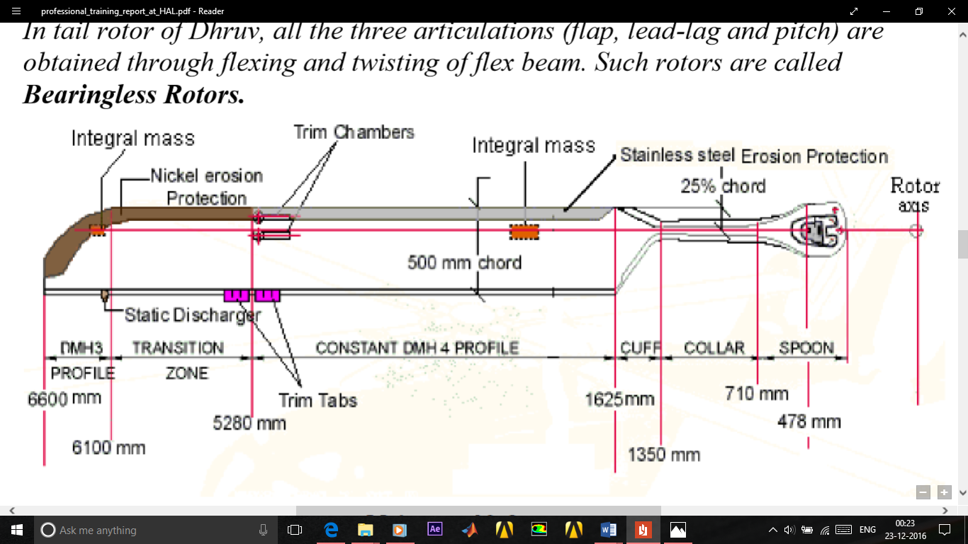

Specifications of main rotor:

* Rotor type: Hinge less, Fiber-elastomeric
* Number of blades: 4 (composite material)
* Rotor speed: 314 rpm.
* Direction of rotation: Clockwise (as seen from top)
* Rotor diameter: 13.2 m (43.3 feet)
* Blade plan form: Rectangular with Parabolic tip.
* Blade chord: 0.5 m up to 0.9242R, 0.167 m at the tip
* Airfoil: DMH 4 up to 0.8R (STA 5280) DMH3 from 0.9242R (STA 6100) to 1R (STA 6600

Blade Shop at Helicopter Division only manufactures blades for the Cheetah, Chetak helicopters, which are Aluminium and foam bonded material. ALH has composite blades manufactured in HAL composite division.

Manufacturing stages (Main Rotor Blade):

* De-greasing of metallic sheet
* Soaking
* Folding (by skin folding machine)
* Stretching (manually and by skin stretch press machine)
* 1st stage Pickling (in sulpho-chromic solution & then in cold water)
* Bonding
* 1st stage Heat treatment
* Trimming stage
* Tip & Ribs attaching
* 2nd stage burning
* Filling of home material (i.e. composite material)
* 2nd stage bonding
* Trimming of Trim Tabs
* Twist check
* Static Balancing
* Weighing
* Dynamic Balancing
* Deliver for assembly section of helicopter
* Structural analysis of Tail Rotor Blade
* Manufacturing process of Tail Rotor Blade

[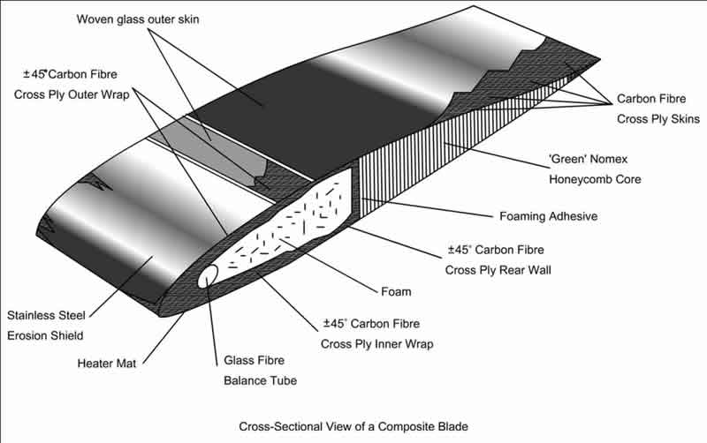](https://www.google.co.in/url?sa=i&rct=j&q=&esrc=s&source=images&cd=&cad=rja&uact=8&ved=0ahUKEwiQn93c9IvRAhVBQY8KHZjuAM0QjRwIBw&url=http://classroom.materials.ac.uk/caseRoto.php&bvm=bv.142059868,d.c2I&psig=AFQjCNGr_rbbJb7XQPT__C1FQJqDv6U8fg&ust=1482637355149399)

**TRANSMISSION ASSEMBLY**

To get engine power to your wheels, your vehicle relies on an assembly of gears called the Transmission Assembly. This system, also known as a gearbox, allows you to "shift" gears as you drive. It lets your vehicle move backward and forward in varying speeds using different amounts of power. That way, you can adjust to various road and driving conditions.

Often, a transmission has multiple gear ratios (or simply "gears") with the ability to switch between them as speed varies. This switching may be done manually (by the operator) or automatically. Directional (forward and reverse) control may also be provided. Single-Ratio transmissions also exist, which simply change the speed and torque (and sometimes direction) of motor output.

In helicopters, the Transmission system acts as a power delivery and torque reduction system. It consists of the following basic parts:

[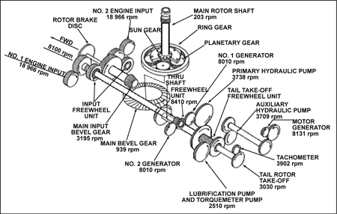](https://www.google.co.in/url?sa=i&rct=j&q=&esrc=s&source=images&cd=&cad=rja&uact=8&ved=0ahUKEwjTu4mN-ovRAhUHQo8KHfMbAV8QjRwIBw&url=https://www.quora.com/How-does-the-transmission-in-a-helicopter-work&bvm=bv.142059868,d.c2I&psig=AFQjCNHQG8DKGBE6qwuPAyH_hEVFWNsLeg&ust=1482638805676192)

**Figure 11: Sample Transmission System of a Helicopter,** Showing various gears, pinions with their respective teeth and shaft RPM. Various components are driven by the power transmitted through this system.

In Helicopters, the power from the engine has to be delivered to the systems that require this rotational power, they include:

* Main Rotor Blades
* Tail Rotor Blades
* Hydraulic Pumps
* Pneumatic Pumps
* Lubrication Pumps
* Fuel Pumps
* Compressors
* Alternators
* Various other Auxiliaries

In the Cheetah/Chetak and ALH, the Various parts of the Transmission system are:

* Main Gear Box
* Actuated Free Wheel Assembly
* Non-Actuated Free Wheel Assembly
* Main Rotor hub & UCS Assembly
* Tail Gear Box
* Auxiliary Gear Box
* Intermediate Gear Box
* Tail Drive shaft
* ARIS (Anti Resonance Isolation System)

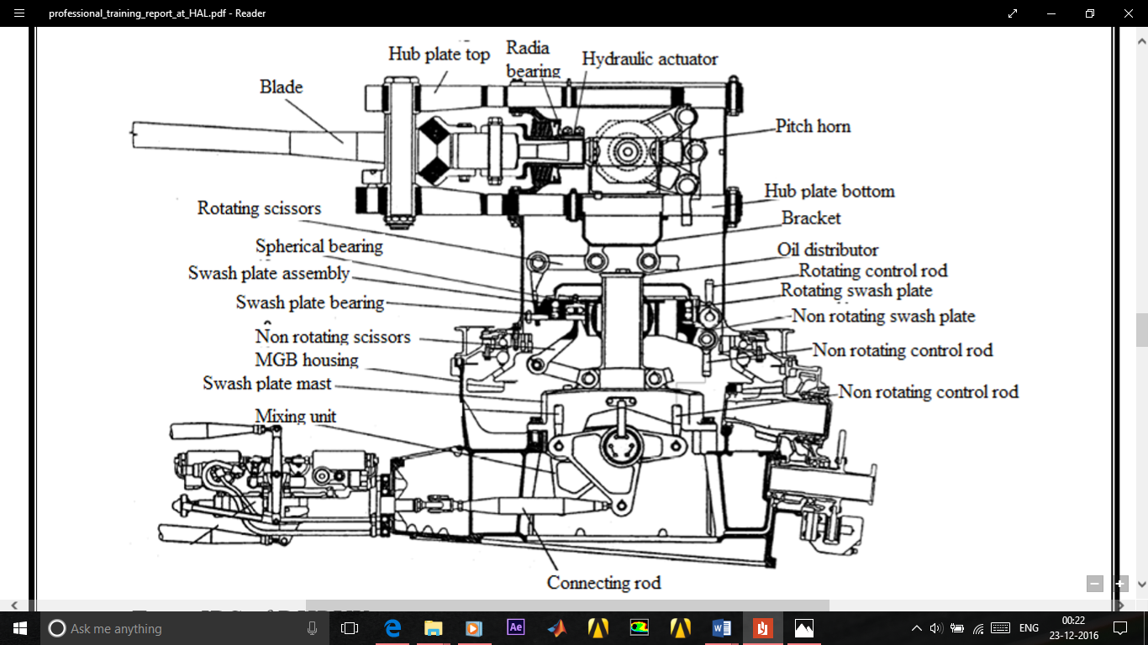**Figure 12: Main Gear Box (MGB), ALH.** Diagram showing various components of the MGB of HAL- ALH.

The Transmission System of the ALH has a schematic as follows, this shows the different gears and pinions along with the shaft speed and teeth.

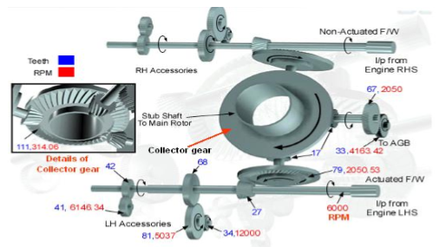

**Figure 13: Schematic of Transmission System in ALH.** Diagram showing various Gears, Pinions and shafts.

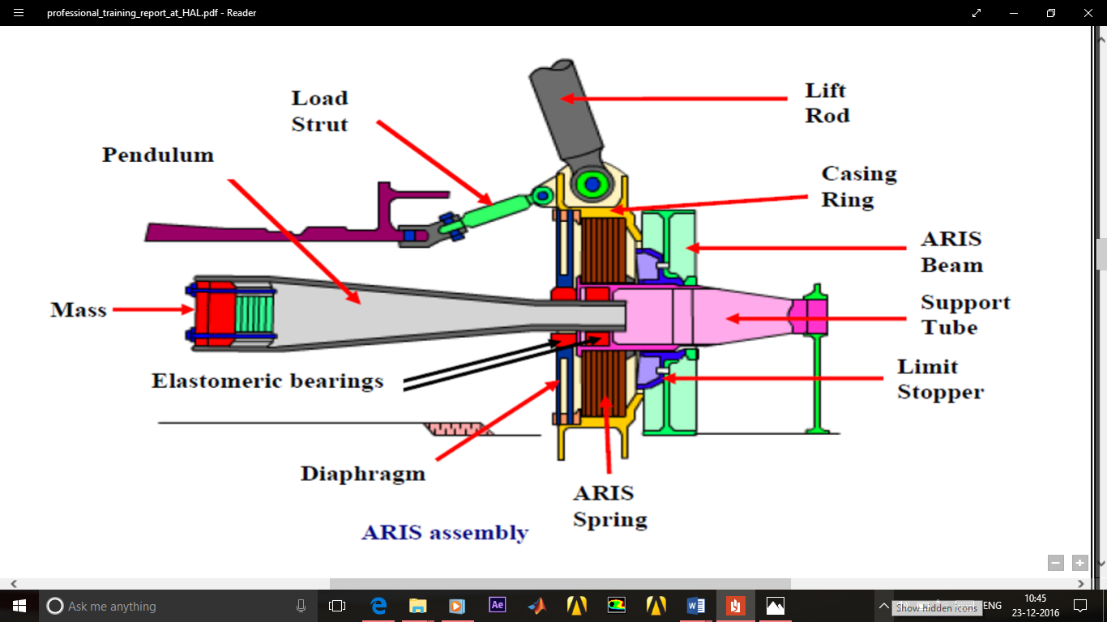

**Figure 14: ARIS (Anti Resonance Isolation System).** This component helps in absorbing all the vibrations that are dynamically being transmitted by the MGB and even the Transmission system. This system uses composite springs and pendulum masses to counter any undue vibrations. This component is tuned to each specific Helicopter.

**STRUCTURAL ASSEMBLY**

Airframe:

Preparing the tubing. Each individual tubular part is cut by a tube cutting machine that can be quickly set to produce different, precise lengths and specified batch quantities. Tubing requiring angular bends is shaped to the proper angle in a bending machine that utilizes interchangeable tools for different diameters and sizes.

For other than minor bends, tubes are filled with molten sodium silicate that hardens and eliminates kinking by causing the tube to bend as a solid bar. The so-called water glass is then removed by placing the bent tube in boiling water, which melts the inner material. Tubing that must be curved to match fuselage contours is fitted over a stretch forming machine, which stretches the metal to a precisely contoured shape.

Next, the tubular details are delivered to the machine shop where they are held in clamps so that their ends can be machined to the required angle and shape. The tubes are then deburred (a process in which any ridges or fins that remain after preliminary machining are ground off) and inspected for cracks.

Gussets (reinforcing plates or brackets) and other reinforcing details of metal are machined from plate, angle, or extruded profile stock by routing, shearing, blanking, or sawing.

Some critical or complex details may be forged or investment cast. The latter process entails injecting wax or an alloy with a low melting point into a mould or die. When the template has been formed, it is dipped in molten metal as many times as necessary to achieve the thickness desired.

When the part has dried, it is heated so that the wax or alloy will melt and can be poured out. Heated to a higher temperature to purify it and placed in a mould box where it is supported by sand, the mould is then ready to shape molten metal into reinforcement parts.

After removal and cooling, these parts are then finish-machined by standard methods before being deburred once again. The tubes are chemically cleaned, fitted into a subassembly fixture, and MIG (metal-arc inert gas) welded.

In this process, a small electrode wire is fed through a welding torch, and an inert, shielding gas (usually argon or helium) is passed through a nozzle around it; the tubes are joined by the melting of the wire.

[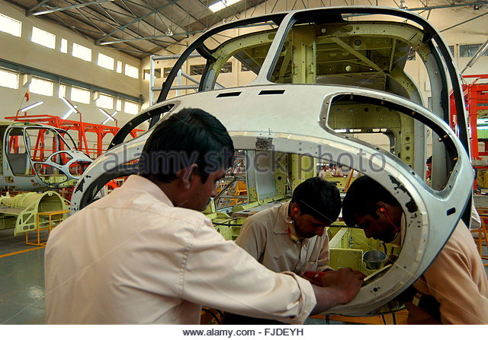](https://www.google.co.in/url?sa=i&rct=j&q=&esrc=s&source=images&cd=&cad=rja&uact=8&ved=0ahUKEwiFj9-X-4vRAhVBso8KHRNkBGoQjRwIBw&url=http://www.alamy.com/stock-photo/advanced-light-helicopter-alh-assembly.html&bvm=bv.142059868,d.c2I&psig=AFQjCNGY2R51Vi7RCKoExufUPG1-VXpAeA&ust=1482639089202871)

After welding, the subassembly is stress relieved—heated to a low temperature so that the metal can recover any elasticity it has lost during the shaping process. Finally, the welds are inspected for flaws. Forming sheet metal details4 Sheet metal, which makes up other parts of the airframe, is first cut into blanks (pieces cut to predetermine size in preparation for subsequent work) by abrasive water-jet, blanking dies, or routing.

Aluminium blanks are heat-treated to anneal them (give them a uniform, strain-free structure that will increase their malleability). The blanks are then refrigerated until they are placed in dies where they will be pressed into the proper shape. After forming, the sheet metal details are aged to full strength and trimmed by routing to final shape and size.5 Sheet metal parts are cleaned before being assembled by riveting or adhesive bonding.

Aluminium parts and welded subassemblies may be anodized (treated to thicken the protective oxide film on the surface of the aluminium), which increases corrosion resistance.

All metal parts are chemically cleaned and primer-painted, and most receive finish paint by spraying with epoxy or other durable coating. Making the cores of composite components6 Cores, the central parts of the composite components, are made of Nomex (a brand of aramid produced by Du Pont) or Aluminium "honeycomb," which is cut to size by bandsaw or reciprocating knife.

If necessary, the cores then have their edges trimmed and bevelled by a machine tool similar to a pizza cutter or meat slicing blade. The material with which each component is built up from its cores (each component may use multiple cores) is called pre-preg ply.

The plies are layers of oriented fibres, usually epoxy or polyimide, that have been impregnated with resin. Following written instructions from the designers, workers create highly contoured skin panels by setting individual plies on bond mould tools and sandwiching cores between additional plies as directed.

Installing the engine, transmission, and rotors10 Modern helicopter engines are turbine rather than piston type and are purchased from an engine supplier. The helicopter manufacturer may purchase or produce the transmission assembly, which transfers power to the rotor assembly. Transmission cases are made of Aluminium or magnesium alloy.

As with the above, the main and tail rotor assemblies are machined from specially selected high-strength metals but are produced by typical machine shop methods. The rotor blades themselves are machined from composite layup shapes.

Main rotor blades may have a sheet metal layer adhesively bonded to protect the leading edges.

Systems and controls12 Wiring harnesses are produced by laying out the required wires on special boards that serve as templates to define the length and path to connectors.

Looms, or knitted protective covers, are placed on the wire bundles, and the purchased connectors are soldered in place by hand. Hydraulic tubing is either hand-cut to length or hand-formed by craftsmen, or measured, formed, and cut by tube-bending machines. Ends are flared, and tubes are inspected for dimensional accuracy and to ensure that no cracks are present.

Hydraulic pumps and actuators, instrumentation, and electrical devices are typically purchased to specification rather than produced by the helicopter manufacturer. Final assembly finished and inspected detail airframe parts, including sheet metal, tubular, and machined and welded items, are delivered to subassembly jigs (fixtures that clamp parts being assembled).

Central parts are located in each jig, and associated details are either bolted in place or, where rivets are to be used, match-drilled using pneumatically powered drills to drill and ream each rivet hole. For aerodynamic smoothness on sheet metal or composite skin panels, holes are countersunk so that the heads of flat-headed screws won't protrude.

All holes are deburred and rivets applied. A sealant is often applied in each rivet hole as the rivet is inserted. For some situations, semi-automated machines may be used for moving from one hole location to the next, drilling, reaming, sealing, and installing the rivets under operator control.

After each subassembly is accepted by an inspector, it typically moves to another jig to be further combined with other small subassemblies and details such as brackets. Inspected "top level" subassemblies are then delivered to final assembly jigs, where the overall helicopter structure is integrated.

Upon completion of the structure, the propulsion components are added, and wiring and hydraulics are installed and tested. Canopy, windows, doors, instruments, and interior elements are then added to complete the vehicle. Finish-painting and trimming are completed at appropriate points during this process.

Once tubular components have been formed, they are inspected for cracks. To find defects, workers treat the tubes with a fluorescent liquid penetrant that seeps into cracks and other surface flaws. After wiping off the excess fluid, they dust the coated tube with a fine powder that interacts with the penetrant to render defects visible.

After the tubular components, have been welded, they are inspected using X-ray and/or fluorescent penetrant methods to discover flaws. Upon completion, the contours of sheet metal details are checked against form templates and hand-worked as required to fit. After they have been autoclaved and trimmed, composite panels are ultrasonically inspected to identify any possible breaks in laminations or gas-filled voids that could lead to structural failure.

Prior to installation, both the engine and the transmission subassemblies are carefully inspected, and special test equipment, custom-designed for each application, is used to examine the wiring systems. All of the other components are also tested before assembly, and the completed aircraft is flight-tested in addition to receiving an overall inspection.

**FINAL ASSEMBLY**

Assembling & Equipping of ALH

ALH final assembly assembles the DHRUV helicopter in four specific stages carried out at 4 different work stations under the same hanger consisting of 37 equipping stages. After the helicopter is assembled, the various functional tests are carried out for each system under differing atmospheric conditions, it includes:

* Functional testing of Hydraulic system
* Functional testing of PP & FUEL system
* Functional testing of electrical AFCS & Avionic system
* Rain water testing
* Break out force Measurement testing

Then in next stage “Optional equipment” is installed to the helicopter.

Once helicopter is ready with all the required equipment as per customer demand, it is taken for final inspection followed by FOD check & CRI. After these all, the helicopter is ready for ground run.

ALH Final Assembly looks after the assembling & equipping of ALH (Advanced Light Helicopter). In particular, I was trained to the ALH hanger which is engaged in development & manufacture of ALH named 'DHRUV' DHRUV is a light 5.5 tonne class, multi-role, multi-mission helicopter, fitted with two Turbomeca TM333 2B2 engines.

The advanced technologies incorporated in the ALH design includes:

* Automatic Flight Control System (AFCS)
* Anti-Resonance Vibration Isolation System (ARIS)
* Active Vibration Control System (AVCS)
* Full Authority Digital Engine Control (FADEC)
* Hinge Less Main Rotor & Bearing Less Tail Rotor
* Integrated Dynamic System (IDS)

LIST OF FINAL ASSEMBLY EQUIPMENT ACTIVITY:

1. Internal painting of helicopter structure
2. Fuel tank installation & finalization of floor board
3. MGB deck clearance
4. ARIS & torque plate installation
5. Engine deck preparation from STAR & EQUIPMENT
6. Preparation for LOOM installation
7. LOOM installation
8. Preparation for NLG & MLG installation
9. Finalization of LG
10. Tail Boom installation
11. Wind shield glass finalization
12. Continuity & MEGGAR checks of LOOM
13. DOOR Finalization
14. FCS BELL CRANK & Control rod installation
15. IDS installation
16. AGB, IGB, TGB installation
17. Gear box alignment
18. TDS bracket riveting
19. Engine Installation & Alignment
20. Cowling Finalization
21. Hydraulic system finalization
22. MRB installation
23. MIP & Center console finalization
24. Electrical OH & CB panel installation
25. Electrical / AFCS /Avionics LRU installation
26. Power ON
27. Rigging
28. AIR condition installation
29. Functional testing of Hydraulic system
30. Functional testing of PP & FUEL system
31. Functional testing of electrical AFCS & Avionic system
32. Optional equipment
33. Rain water testing
34. Finalization of AC & oxygen system
35. Break out force Measurement
36. Final inspection, FOD check & CRI
37. GROUND RUN

**BENEFIT OF THE TRAINING**

As the training was fully concentrated towards our approach in any industry, it was time to face our future in the present scenario as a student. This training will contribute to boost me in future, when I step in the shoes of an engineer

In the coming years. This training will also help me in my future project work along with the theoretical knowledge I have gained in my college, as of today, I am more confident with my approach towards the machining, stressing, stretching and other processes on any of the materials I have worked on in my short stay with the industry.

This short stay at HAL HELICOPTER DIVISION will be essentially fruitful and to the uttermost utility, at the time when I am required to apply my knowledge and creativity through the wisdom and experience I have gained here, as it is said:

“Invention is the place where poetry and engineering come together”.

Helicopter Division was established in July 1970. The division manufactures single engine as well as twin engine helicopters to cater the growing needs of the market.   
  
Helicopter Division manufactures Rudra, Dhruv, Cheetah, Chetak, Cheetal & Lancer helicopters.   
  
The division is supported by the co-located R&D centre – Rotary Wing Research & Design Centre (RWR&DC).  
The MRO division caters to the Maintenance, Repair & Overhaul activities of helicopters.  The Rotory Wing Academy focuses on training of pilots.  
  
HAL started manufacturing of helicopters in 1962, by entering an agreement with M/s SUD-AVIATION (Presently M/s EUROCOPTER, France) for production of Aloutte III helicopters. (Chetak). The first Chetak (Aloutte III) in ‘Fly Away’ condition delivered in 1965.   
  
License agreement for production of Cheetah (LAMA SA 315-B) signed with M/s SNIAS (presently M/s, Eurocopter) in 1970. First Cheetah manufactured from raw materials was delivered in 1976-77.  
  
In 1990s, HAL has developed a light attack helicopter “Lancer”. The basic structure of the lancer is derived from reliable and proven Cheetah helicopter. The helicopter has bullet proof front panels. Gun cum Rocket pod one each (70 mm Rocket+12.5 mm Gun) fitted on either side. An optical sight has been fitted for accurate firing.  
  
The Cheetal helicopter is a re-engined variant of Cheetah helicopter. The Cheetal helicopter set the world record of world’s highest landing at ‘Saser Kangri’ of Himalayas in 2006.  
  
HAL Helicopter division has successfully manufactured 600 Single Engine helicopters. HAL achieved self-reliance in design, developing & manufacturing of twin engine Advanced Light Helicopter “Dhruv”.  Dhruv is a multi role, multi mission all weather helicopter in the 5.5 ton category. The indigenously designed twin engine helicopter started series production during 2001-2002.  
  
The division is accredited with AS 9100 C & ISO 14001:2004 certifications. The division is also approved by Directorate General of Civil Aviation (DGCA) for CAR 21, CAR 145 & CAR M certifications.   
  
HAL with the proven track record of manufacturing more than 700 helicopters, the helicopter division has expand its design, developing & production range by manufacturing new helicopters like Weapon System Integrated (WSI) version of Dhruv (Christened as “Rudra”), Light Combat Helicopter (LCH) and Light Utility Helicopter (LUH).