## Csc 227 documentation

## DECLARATION

I hereby declare that this project is my own work, and as to the best of my knowledge, has not been submitted to any other institution of higher learning.

Student: KABUCHO JOSEPH Reg. No: P15/42519/2017

Signature: ………………………………………………… Date: ………………………………………………………

Supervisor: DR.AGNES WAUSI

Signature: ………………………………………………… Date: ………………………………………………………

This project has met the requirements for Bachelor of Science in Computer Science at the University of Nairobi and the university supervisor.

**Table of Contents**

[**Table of Figures**](https://mail.google.com/mail/u/0/#m_-3518859819678019442_m_-4236391625674868925__Toc485940485)

# Technical Terms

* **Gravida**- Gravida or gravidity describes the total number of confirmed pregnancies that a woman has had, regardless of the outcome.
* **Parity (PARA)** - Para or parity is **defined** as the number of births that a woman has had after 20 weeks gestation.
* **Reactive**- Stands for HIV positive tested person
* **Non- Reactive**- Stands for HIV Negative tested person
* **Prophylaxi**s- treatment given or action taken to prevent disease.
* **Serology**- the scientific study or diagnostic examination of blood serum, especially with regard to the response of the immune system to pathogens or introduced substances
* **Antibody**-a blood protein produced in response to and counteracting a specific antigen. Antibodies combine chemically with substances which the body recognizes as alien, such as bacteria, viruses, and foreign substances in the blood

# ABBREVIATIONS

* **EHR**- Electronic Health Record
* **CDC**- Centre of Disease Control
* **MOH**- Ministry of Health
* **ICT**- Information Communication Authority
* **PMTCT**- Prevention of Mother and child Transmission
* **MCH**- Mother and child health
* **HIV**-Human Immunodeficiency Virus
* **LMP**- Last Menstrual Period
* **EDD**- Expected Delivery Date
* **BMI**- Body Mass Index
* **HB**- Haemoglobin concentration
* **AEFI**- Adverse event following immunization
* **BCG**- Bacille Calmette Guerin. It’s a weakened (attenuated) version of a bacteria called Mycobacterium bovis which is closely related to Mycobacterium tuberculosis, the agent responsible for tuberculosis
* **OPV**- Oral Polio vaccines are vaccines used to prevent poliomyelitis.
* **PCV**- Pneumococcal conjugate vaccine (PCV) is a pneumococcal vaccine and a conjugate vaccineused to protect infants, young children, and adults against disease caused by the bacterium Streptococcus pneumoniae (the pneumococcus).
* **PCR**- (polymerase chain reaction) is a technique in molecular genetics that permits the analysis of any short sequence of DNA (or RNA) even in samples containing only minute quantities of DNA or RNA.PCR is used to reproduce (amplify) selected sections of DNA or RNA for analysis.
* **CD4**- (cluster of differentiation 4) is a glycoprotein found on the surface of immune cells such as T helper cells, monocytes, macrophages, and dendritic cells.

# Vision

A connected maternal and child healthcare system in Kenya.

# Mission

To improve the safety, cost effectiveness, and quality of healthcare in Kenya through widespread secure, confidential electronic clinical mother and child care information systems including promotion of electronic health records and facilitation of health information exchange.

[**1.** **INTRODUCTION**](https://mail.google.com/mail/u/0/#m_-3518859819678019442_m_-4236391625674868925__Toc485940486)

[**1.1** **Background**](https://mail.google.com/mail/u/0/#m_-3518859819678019442_m_-4236391625674868925__Toc485940487)

Global neonatal mortality declined by about 40 percent from 1990 to 2013, however it still accounted for about 2.6 million deaths globally and constituted 42 percent of global under-five deaths. Most of these deaths occur in developing countries. Antenatal care (ANC) is a globally recommended strategy used to prevent neonatal deaths. In Kenya, over 90 percent of pregnant women attend at least one ANC visit during pregnancy. However, Kenya is currently among the 10 countries that contribute the most neonatal deaths globally. (Malachi et al, 2017)

The highest odds of neonatal mortality were among neonates whose mothers did not attend any ANC visit (adjusted odds ratio [aOR] 4.0, 95% confidence interval [CI] 1.7–9.1) and whose mothers lacked skilled ANC attendance during pregnancy (aOR 3.0, 95% CI 1.4–6.1). Lack of tetanus injection relative to one tetanus injection was significantly associated with neonatal mortality (aOR 2.5, 95% CI 1.0–6.0). About 38 percent of all neonatal deaths in Kenya were attributable to lack of check-ups for pregnancy complications. (Malachi, 2017)

Lack of check-ups for pregnancy complications, unskilled ANC provision and lack of tetanus injection were associated with neonatal mortality in Kenya. Integrating community ANC outreach programmes in the national policy strategy and training geared towards early detection of complications can have positive implications for neonatal survival. (Malachi, 2017)

[**1.2** **Problem Definition**](https://mail.google.com/mail/u/0/#m_-3518859819678019442_m_-4236391625674868925__Toc485940488)

Typically, a different level of information is present in each type of record. The paper-based record consists chiefly of unstructured or less-structured free text. The highly standardized “data abstract” component of the EPR provides structured elements and a controlled vocabulary. Furthermore, it consists of standard codes for classifications in main parts. To study both records' contents comparatively, researchers must transform the records into a common representation. One way to accomplish this is through retrospective coding of information from the paper-based record, as shown in, and as used in our study. The focus of the authors' own investigation was to determine the validity of EPR-based ICD-10-/OPS-301 codes as an equivalent to paper-based patient records. How to accomplish this is a crucial issue for the generalizability and applicability of the results for all studies, not just the one reported. (Jürgen, 2013)

Inconsistencies between a patient's electronic and paper-based medical record can lead to significant problems for the health care staff in daily practice. Comparative studies are therefore necessary. Personnel cannot base their decisions on one record type alone if the two differ. For example, a physician working the night shift may deal with an established patient who is unknown to the physician. The physician must check the EPR in addition to the paper-based record to review all past complications and comorbidities. (Jürgen, 2013)

[**1.3 Project Goal**](https://mail.google.com/mail/u/0/#m_-3518859819678019442_m_-4236391625674868925__Toc485940489)**s**

The primary goals for the health information exchange service are accuracy, openness and transparency, accessibility, accountability and oversight, and privacy and security.

[**1.4 Objective**](https://mail.google.com/mail/u/0/#m_-3518859819678019442_m_-4236391625674868925__Toc485940490)

**Broad Objective**

Digitalization of maternal and post-natal care system, immunization and early childhood health in a system consist of electronic health records for mother and child health MCH.

[**1.5 Project Justification**](https://mail.google.com/mail/u/0/#m_-3518859819678019442_m_-4236391625674868925__Toc485940491)

Research shows that structured electronic medical records can result in quicker data entry, improved quality and records that are useful in daily clinical work. Doctors and nurses prefer structured data entry; electronic nursing records are better and databases with structured electronic patient records can be used on a large scale to develop treatment regimens and quality assurance. Clinical decision support systems integrated into electronic medical records can provide positive cost-effectiveness. Most doctors and nurses understand the importance of such systems. (Krüger, 2018)

Structured data entry seems to be an important element in successful electronic medical record systems.(Krüger, 2018)

[**1.6 Project Scope**](https://mail.google.com/mail/u/0/#m_-3518859819678019442_m_-4236391625674868925__Toc485940492)

[**2.** **LITERATURE REVIEW**](https://mail.google.com/mail/u/0/#m_-3518859819678019442_m_-4236391625674868925__Toc485940493)

A study done by (Meghea CI, 2018)To evaluate effects of EHR adoption and use during pregnancy on maternal and child health care utilization and health among pregnant mothers and their infant with a study population was comprised of all Medicaid-insured pregnant women who delivered a singleton birth in Michigan between 1/1/2009 and 12/31/2012 and their infants (N = 226,558). Linked data included birth records, maternal and infant medical claims, and EHR adoption, implementation, upgrading and meaningful use data. Pre-post comparisons with a control group (difference-in-difference) took advantage of a natural experiment of EHR adoption and use among providers in Michigan. Women and infants who received care from providers who adopted and used EHR were compared with those who received care from other providers, in a quasi-experimental framework.

It revealed that over 34 % of all women in the analytic sample received perinatal care from providers who adopted and used EHR. Multivariate regressions indicate that women who received prenatal care mainly from a provider who adopted and used EHR were more likely to have any well-child visits (0.05, p = 0.04), and the appropriate number of well-child visits during the first year of life (0.03, p < 0.01). Form this study the findings were consistent with EHR adoption and use supporting improved child health care utilization. The findings have the potential to provide Medicaid and other healthcare program officials with evidence of the potential gains to be derived from EHRs for vulnerable low-income women and infants. (Meghea CI, 2018)

A study done by (Frøen and L. Myhre, 2016) revealed that, the computerization of hospital clinical records of birth is innovative subject to the obstetrics and is promising at the same time due to the relevance of its potential in causing positive impact on the healthcare assistance challenges in that area. However, to make this kind of approach viable it is necessary to bring together the clinic obstetrical experience in following the deliveries on one hand, especially high-risk where the complications are more frequent, and on the other hand, an experienced service that stands out in the scientific and technological production of health information services. The reports generated by the prototype to the maternity proved it useful far beyond describing automatically and for the first time the indicators of results in this healthcare service, it allowed the positioning of the institution in face of the goals preset by the hospital and by the government. Another relevant gain was the questioning of the goals themselves. By not considering the characteristics of a university reference service, whose profile of admission of maternal and neonatal high-risk pregnancies is beyond 50%, were proposed some unreachable goals. (Frøen and L. Myhre, 2016)

The care challenges are not the same faced by general maternity hospitals that aid women with low gestational risk and therefore are not comparable to each other, under the same goals to be reached. The preview of the indicators in a graphic format, throughout the five months, allowed specialists and connoisseurs of the maternity hospital’s reality important perceptions, just by analyzing visually the evolution of the rate of cesarean sections. Among those, the verification that cesarean sections were frequent between pregnant women associated with some risk factor. Important discussions followed the release of the first reports and motivated the search for a new procedure standard by the health professionals. The real-time preview of the administrative indicators by the managers of this healthcare service, as much as the admission lengths, creates formerly non existing opportunities of adopting measures more quickly and with better potential of resoluteness to challenges such as: the occupation of high-risk beds by public care reference services. The proposition of an adjusted rate to the frequency of the Apgar scores in the 5th minute under 7, between neonates compatible with survival by the birth was one of the most important products of the discussion on the performance indicators automatically generated by the SisMater panels. This was possible thanks to the setting of a clearer clinical-epidemiological profile of the pregnancies attended in this health facility, bringing to light the frequency and severity of the illnesses that complicate pregnancies in the admitted cases, in the studied period. (Frøen and L. Myhre, 2016)

The percentile of severe malformed fetuses was estimated, easing the understanding of the specific needs of this healthcare facility and its indicators particularly distinct from those of other public maternity hospitals, out of the universities. It is important to comment that in Brazil the anticipated interruption of pregnancies due to malformed fetuses is not legally possible, except for the recently established case of anencephalic fetuses. Similarly, the rate of breastfeeding in the 1st hour of life, adjusted for the cases in which it is really recommended, brought up the discussion on the expressive number of pregnancies complicated by AIDS/HIV positive, as much as for the quality of the clinical records and the procedures on birth existing on paper forms. The estimated values, even if adjusted, of this humanizing practice, are much below the projected by the government (goal 100%). (Frøen and L. Myhre, 2016)

They don’t reflect the reality of this practice routinely applied by this maternity’s health professionals. Such finding raised attention upon the responsibility of the professionals responsible for the annotations in the paper forms used in this health facility today. Due to referring to an experience of computerization of health clinical records in a tertiary public maternity inside a school hospital, the study intends to contribute to the establishment of new patterns of reference to the indicators of performance, which may come to benchmark more reliably the quality of the care provided in health services of this nature. In that order, it will also involve a study on the proposition of new adjusted rates, when made necessary, intended to be more adequate to the specific particularities of fetal medicine and the care of high-risk pregnancies. (Frøen and L. Myhre, 2016)

The conclusion of the study was that the presentation of results in the graphic form allowed a simple and more direct reading of the most relevant values, being, doubtlessly an added value in the assistance to the management of the control of efficiency of the health facilities. SisMater has shown, already in the presentation of the first results, efficient in the proposition of indicator panels of maternal-infantile and neonatal quality of the maternity hospital. Despite that the service doesn’t feature an Electronic Health Record System (HER-S) it was possible to obtain knowledge of the reality of the maternal and neonatal care. From this comprehension was possible to identify some deficiencies of the service and set new action priorities, in order to reach, in the future, better results in the quality of the care offered to the parturients and neonates. Last but not least, stands out that knowing in detail the reality of the studied population allowed to establish new adjusted indicators and, therefore, contest/debate, either in the scope of the hospital or in the governmental sphere determined goals impossible to attend in facilities of high-risk pregnancy attendance. (Frøen and L. Myhre, 2016)

[**RESEARCH AND METHODOLOGY**](https://mail.google.com/mail/u/0/#m_-6186555639887004368__Toc485940504)

[**SYSTEM ANALYSIS**](https://mail.google.com/mail/u/0/#m_-6186555639887004368__Toc485940505)

[**Introduction**](https://mail.google.com/mail/u/0/#m_-6186555639887004368__Toc485940506)

It is a process of collecting and interpreting facts, identifying the problems, and decomposition of a system into its components.

The act, process, or profession of studying an activity (such as a procedure, a business, or a physiological function) typically by mathematical means in order to define its goals or purposes and to discover operations and procedures for accomplishing them most efficiently.

In this section we aim to break down the system into bits to describe each step sequentially and how user will interact with it.

System analysis was conducted for the purpose of studying a system or its parts in order to identify its objectives. It is a problem-solving technique that improves the system and ensures that all the components of the system work efficiently to accomplish its purpose.

[**Feasibility Study**](https://mail.google.com/mail/u/0/#m_-6186555639887004368__Toc485940507)

**Technical feasibility.**

The developers meet minimum requirements to make the system .Also the users have technical expertise to enter data accurately into thesystem for proper analysis of data.

**Legal feasibility**

The system meets the minimum requirements asspecified by Ministry of Health in MOH HL7 according to the booklet.

**Also it complies with the following policies from this bodies.**

**ISO 22220**

Identification ofsubjects of health care

**TR 20514**

**-Electronic health record**

**—** Definition, scope and context ISO 13606 Health informatics Health **i**nformatics — Electronic health record communication Parts 1,2,3 and 4

**-** Part I of ISO 13606 specifies the information architecture required for interoperable communications between systems and services that need or provide EHR data

**-**Part II of ISO 13606 specifies the communication of part or all of the electronic health record (EHR) of a single identified subject of care between EHR systems, or between EHR systems and a centralized EHR data repository

**ISO/TR 18307:2001**

**-**Interoperability andcompatibility in messaging and communication standards — Key characteristics

**ISO/TS 18308:2004**

Health informatics Requirementsfor an electronic health record architecture

**ISO 27799**

**—** Information security management in health using ISO/IEC 27002

This International Standard specifies a set of detailed controls for managing health information security and provides health information security best practice guidelines**.** By implementing this International Standard, health care organizations and other custodians of health information will be able to ensure a minimum requisite level of security that is appropriate to their organization’s circumstances and that will maintain the confidentiality, integrity and availability of personal health information

**ISO 17090:2008**

Public keyinfrastructure Parts 1, 2 and 3

**Operational feasibility**

It eases the work of health workers and has increased data collection andavailability to the ministry by 56% and both the system users including mothers and health practitioners have found it easier to use it compared to physical records.

**Schedule feasibility**

It used up the required amountof time adequately with no activity overlapping over the other.

**Resource feasibility**

It took up more resources to develop than required but of which was manageable**.**

**Financial feasibility**

The price set was both comfortablefor the institutions and the system owners reaching financial feasibility. Also, the amount of money allocated for development was enough to cater for all needs of the development team.

# METHODOLOGY

## Data collection

**Primary data collection**

1. Interviews with hospital staff and personnel

2. Hiring a health specialist to explain workflow

**3.** Obtaining various forms from the hospital to feed them into the system

**4.** observing a hospital setting workflow

**5.**questionearres

**E.g:**

# Example – user questionnaire issued

1. Are you:

1. Male
2. Female

2. What is your age?

1. 18-24
2. 35-44
3. 55-64
4. 25-34
5. 45-54
6. 65 or over

3. What is the highest level of formal education you have completed? (Please check only one.)

1. Attended High School
2. Attended College
3. Post-Graduate Study Without Degree
4. Graduated High School
5. Graduated College
6. Post-Graduate Degree

4. What is your marital status?

1. Married
2. Separated or Divorced
3. Single, Never Married
4. Widowed

5. How many children under the age of 18 live in your household? __________

6. What is your take on health data being stored online?

1. Don’t like it
2. comfortable
3. not sure

7. If you don’t like it what’s your reason

1. Security reasons
2. Don’t understand technology
3. Unable to retrieve the data
4. Systems are unreliable
5. Data is a problem
6. Data is not accurate

8a. would you recommend to digitalize Mother and Child health data?

1. Yes
2. No

8b. If “Yes,” what is the reason?

1. Better analytics
2. Data accuracy
3. Efficient storage
4. Easily retrievable
5. Allow for future studies
6. Good data delivery

Other reason: _______________________________ (please specify)

9. What is the probability of you recommending this system to someone else

* Highly Likely
* Likely
* Unlikely
* N/A

**Secondary data collection**

Reviewing of previous systems to pick up useful data.

## development

**Rapid application development**

**Reasons**

* Short time frame
* Few users to interact with the system
* Crucial user interface
* Limited documentation time
* Vital integrity and security
* Vital reusability
* Better quality
* Risk control
* More projects completed on time and within budge

**The disadvantages include**:

* The risk of a new approach. For most IT shops RAD was a new approach that required experienced professionals to rethink the way they worked. Humans are virtually always averse to change and any project undertaken with new tools or methods will be more likely to fail the first time simply due to the requirement for the team to learn.
* Requires time of scarce resources. One thing virtually all approaches to RAD have in common is that there is much more interaction throughout the entire life-cycle between users and developers. In the waterfall model, users would define requirements and then mostly go away as developers created the system. In RAD users are involved from the beginning and through virtually the entire project. This requires that the business is willing to invest the time of application domain experts. The paradox is that the better the expert, the more they are familiar with their domain, the more they are required to actually run the business and it may be difficult to convince their supervisors to invest their time. Without such commitments RAD projects will not succeed.
* Less control. One of the advantages of RAD is that it provides a flexible adaptable process. The ideal is to be able to adapt quickly to both problems and opportunities. There is an inevitable trade-off between flexibility and control, more of one means less of the other. If a project (e.g. [life-critical software](https://en.wikipedia.org/wiki/Life-critical_system)) values control more than agility RAD is not appropriate.
* Poor design. The focus on prototypes can be taken too far in some cases resulting in a "hack and test" methodology where developers are constantly making minor changes to individual components and ignoring system architecture issues that could result in a better overall design. This can especially be an issue for methodologies such as Martin's that focus so heavily on the user interface of the system.
* Lack of scalability. RAD typically focuses on small to medium-sized project teams. The other issues cited above (less design and control) present special challenges when using a RAD approach for very large scale systems

**It will be divided into 4 phases**

**Requirements planning phase**– combines elements of the system planning and systems analysis phases of the [Systems Development Life Cycle](https://en.wikipedia.org/wiki/Systems_Development_Life_Cycle) (SDLC).

**User design phase**-during this phase, users interact with systems analysts and develop models and prototypes that represent all system processes, inputs, and outputs.

**Construction phase** – focuses on program and application development task similar to the SDLC.

**Cutover phase**– resembles the final tasks in the SDLC implementation phase, including data conversion, testing, changeover to the new system, and user training

# Timeline.

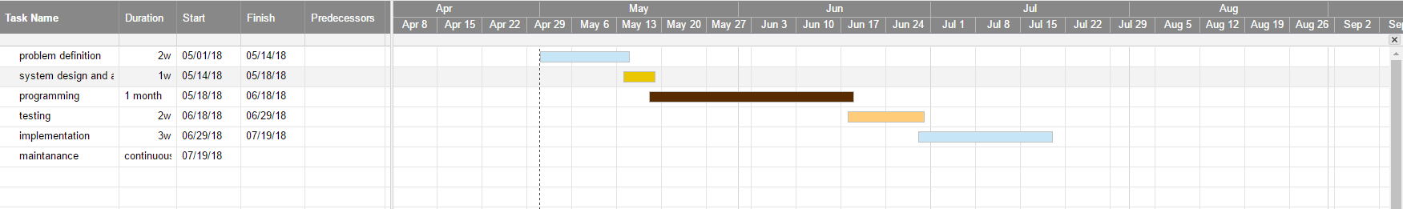

[**3.1.6 Requirement Analysis**](https://mail.google.com/mail/u/0/#m_-6186555639887004368__Toc485940511)

Requirements analysis is critical to the success or failure of a systems or software project.[[3]](https://en.wikipedia.org/wiki/Requirements_analysis#cite_note-3) The requirements should be documented, actionable, measurable, testable, traceable, related to identified business needs or opportunities, and defined to a level of detail sufficient for system design.Standards Referenced This section references the following standards:

**1. ISO /TR 20514: Health Informatics –** Electronic Health Record – Definition, scope and context

**2. ISO/TS 22220:** Health Informatics Identification of Subjects of health care

**3. HL7 Electronic Health Record –** System Functional Model, Release 1 February 2007

**4. ISO/TS 18303: Health informatics —** Requirements for an electronic health record architecture

**5. CCHIT Certified** 2009 EMR Certification Criteria

**Basic Demographic and Clinical Health Information**

**This refers to patient-related information and includes patient identification information and clinic attendance or encounter information.**

**Hospitali EHR systems are required to:**

* Collect and display essential demographic patient information such as: name, birth date, gender, etc.
* Manage patients problem / diagnosis list: coded diagnosis, onset date, history, chronicity, date resolved
* Collect anddisplay patient medication iv. Collect and display patient **a**llergies
* Collect and display test results
* Accept encounterclinical data: vital signs, weight, height, calculate BMI

**Clinical Decision Support**

This refers to functions and processes that assist health workers in making clinical decisions to enhance patient care.

Hospitali EHR is required to**:**

* High**l**ight abnormal test results
* Alert provider of abnormal (outside the normal range) vital signs
* Alert provider if a known allergic drug is prescribed or if a known drug interaction is likely to occur
* Provide reminders of recommended care due such as tests due and medication due

**Order Entry and Prescribing**

Order entry is the process by which a health care worker electronically enters instructions for the care and treatment of patients under his or her care.

**Health Information and Reporting**

One advantage of EMR systems is to improve the reporting and use of health information. To support this function,

Hospitali EHR is required to:

* Gene**r**ate reports from clinical data to support quality improvement
* Generate aggregate reports for submission to health ministries and other consumers.

**Supporting Security and Confidentiality**

Health data security and confidentiality is fundamental to any EMR system to ensure that the privacy of patient data is maintained.

Hospitali EHR is required to:

* Haveaccess control functions that limit access to health data to selected individuals, based on defined and document roles
* Maintain detailedaudit trails of all events within the EMR system
* Follow definedstandard practices on logins and passwords
* Ensuredata protection by meeting requirements regarding data backup, recovery and documentation of systems
* **v**.Incorporate technical security functions in line with requirements regarding encryption and data transmission.

**Exchange of Electronic Information**

EMR systems co-exist with other systems in the health care setting. These include other EMR systems, laboratory systems and pharmacy systems. In order to promote inter-operability between systems,

Hospitali EHR is required to:

1. Receivepatient information as a clinical document using a recognized standard
2. Generatepatient summary information as a clinical document using a recognizedstandard

**iii.** Generateaggregate clinical care information using a recognized standard Implementation Guidance The following table outlines the functional requirements for the EMR systems in greater

**Results**

* System has the capability to manage, and present current and historical test results to appropriate clinical personnel for review, with the ability to filter and compare results with previous tests.
* System is capable of receiving test results from laboratory and radiology (imaging results).
* Laboratory and radiology results are received via a standard MOH HL7 interface.
* When displaying results, the system, at a minimum, displays the patient name, date and time of order, and date and time results were last updated.
* System uses visual cues to highlight abnormal results.
* System allows the provider to comment on received lab results, or allows data entry personnel to capture comments on results.

**Medication and Immunization Management**

* System creates prescriptions or other medication orders with detail adequate for correct filling and administration, and captures the identity of the prescriber. At minimum, system should capture: the name of the drug, the dose and frequency of administration.
* Standards and Guidelines for Electronic Medical Records Systems in Kenya 25
* System has the capability of creating and maintaining a current medication list for each patient.
* System presents clinicians/users with list of medications that are to be administered to a patient and captures administration details including dose of medications and route of administration. The clinician is able to select prescribed drugs from pull down menus.
* System identifies drug interaction warnings at the point of medication ordering.
* System provides the capability to select the drug to be prescribed from pull down menus.
* System maintains patient-specific adverse reaction lists and allows on reporting from such lists.
* System provides the capability for electronic transfer of prescription information to a selected pharmacy for dispensing.
* System provides the ability to recommend required immunizations and when they are due based on the Kenya Extended Programme for Immunization (KEPI) immunization schedule.
* System is capable of preparing a report on a patient’s immunization history.

**Children’s Health**

System displays the age of a child.

System displays growth charts showing plotted values of height, weight, head circumference, and BMI against age and sex data. L

System allows for capture, storage and management of pediatric specific laboratory tests such as HIV-DNA PCR tests, CD4%. H

System verifies appropriate drug dose for children when given the child’s weight in kgs or BSA in cubic meters. H

**Pregnancy Care**

System accepts coded input for historical items that are asked at each pregnancy visit such as loss of fluid, fetal movement, etc.

Where collected, the system makes obstetric past history available to the provider for future pregnancies.

System provides for capturing dates to be used for notifications and alerts such as date to start ART prophylaxis, date to schedule for caesarean section, date to perform a check ultrasound, etc.

System displays the estimated date of delivery (EDD) given the patient’s last menstrual period (LMP).

System creates a printable view of all visits, labs, due date, ultrasound, problem list and plans which can be given to a patient for purposes of communicating with providers on a Labor and Delivery floor.

**Requirements analysis issues**

**Stakeholder issues**

* Users do not understand what they want or users don't have a clear idea of their requirements
* Users will not commit to a set of written requirements
* Users insist on new requirements after the cost and schedule have been fixed
* Communication with users is slow
* Users often do not participate in reviews or are incapable of doing so
* Users are technically unsophisticated
* Users do not understand the development process
* Users do not know about present technology

Possible problems caused by engineers and developers during requirements analysis are:

* Technical personnel and end users may have different vocabularies. Consequently, they may wrongly believe they are in perfect agreement until the finished product is supplied.
* Engineers and developers may try to make the requirements fit an existing system or model, rather than develop a system specific to the needs of the client.
* Analysis may often be carried out by engineers or programmers, rather than personnel with the people skills and the domain knowledge to understand a client's needs properly.

**Attempted solutions**

The best of these tools offer:

* electronic whiteboards to sketch application flows and test alternatives
* ability to capture business logic and data needs
* ability to generate high fidelity prototypes that closely imitate the final application

Software Development Process – activities and steps

* interactivity
* capability to add contextual requirements and other comments
* ability for remote and distributed users to run and interact with the simulation

[**Data Analysis**](https://mail.google.com/mail/u/0/#m_-6186555639887004368__Toc485940510)

Data Validation and Quality

To improve on data quality, the EMR systems are required to adhere to the set validation guidelines. The following overview provides general guidance to how data validation should be incorporated.

First order validation

First order validation verifies that data elements are entered in a valid format and value and are within an acceptable range.

o the system should generate an alert when an incorrect regimen combination has been prescribed.

o The system should alert the provider or data entry personnel of a change of treatment regimen that occurs without an indicated reason.

• EMR systems should validate all date formats.

• Dates should be checked for range and limits. For example: o Date started on ART should not be before date found eligible for ART

o Date enrolled in care cannot be before date of birth

• Dates should be displayed in the format dd/mm/yyyy as per Kenyan date formats.

• All laboratory results data should be validated against set ranges. For example: o Hemoglobin levels should be validated against the normal ranges for both male and female patients,

o CD4 counts and CD% should be validated against the normal range.

• Vital signs shall be validated against normal human ranges, including: o Weight

Standards and Guidelines for Electronic Medical Records Systems in Kenya 37

o Height

o Blood pressure

o BMI Where applicable, EMR systems should have listed data in lookups to reduce data entry time and limit errors. Lists should be defined and changed by the authorized users. Intra-field validation should be implemented where there is a logical or causal relationship. For example:

1. The system should not allow for selection of pregnancy tests when the client is male.

2. The system should allow for collection of PMTCT data for a pregnant woman and keep these elements invisible for a non-pregnant woman. Second order validation Second order validation is the historical comparison for the same data element so that an alert is prompted if an indicator increases or decreases abruptly.

• All data should be validated for trends and change, for example: o Weight shall be validated for sudden increases and decreases. o Laboratory tests such as CD4 counts and CD% shall be validated for sudden change in trends. Third order validation Third order validation assesses data elements for consistency within a specific form or set of indicators. For example:

• Number of women receiving PMTCT services checked against the number of pregnant women treated for a given time period

• Number of clients receiving cotrimoxazole therapy checked against the number of clients enrolled for care.

[**3.1.8 Use Case Model**](https://mail.google.com/mail/u/0/#m_-6186555639887004368__Toc485940513)



test cases

[**3.1.9 System Context Diagram**](https://mail.google.com/mail/u/0/#m_-6186555639887004368__Toc485940514)



[**3.1.10 Data flow diagram**](https://mail.google.com/mail/u/0/#m_-6186555639887004368__Toc485940515)







[**3.2 SYSTEM DESIGN**](https://mail.google.com/mail/u/0/#m_-6186555639887004368__Toc485940516)

[**3.2.1 Conceptual Model**](https://mail.google.com/mail/u/0/#m_-6186555639887004368__Toc485940517)

[**3.2.2 System Flowchart**](https://mail.google.com/mail/u/0/#m_-6186555639887004368__Toc485940518)









[**3.2.3 User Interface Design**](https://mail.google.com/mail/u/0/#m_-6186555639887004368__Toc485940519)

**landing**

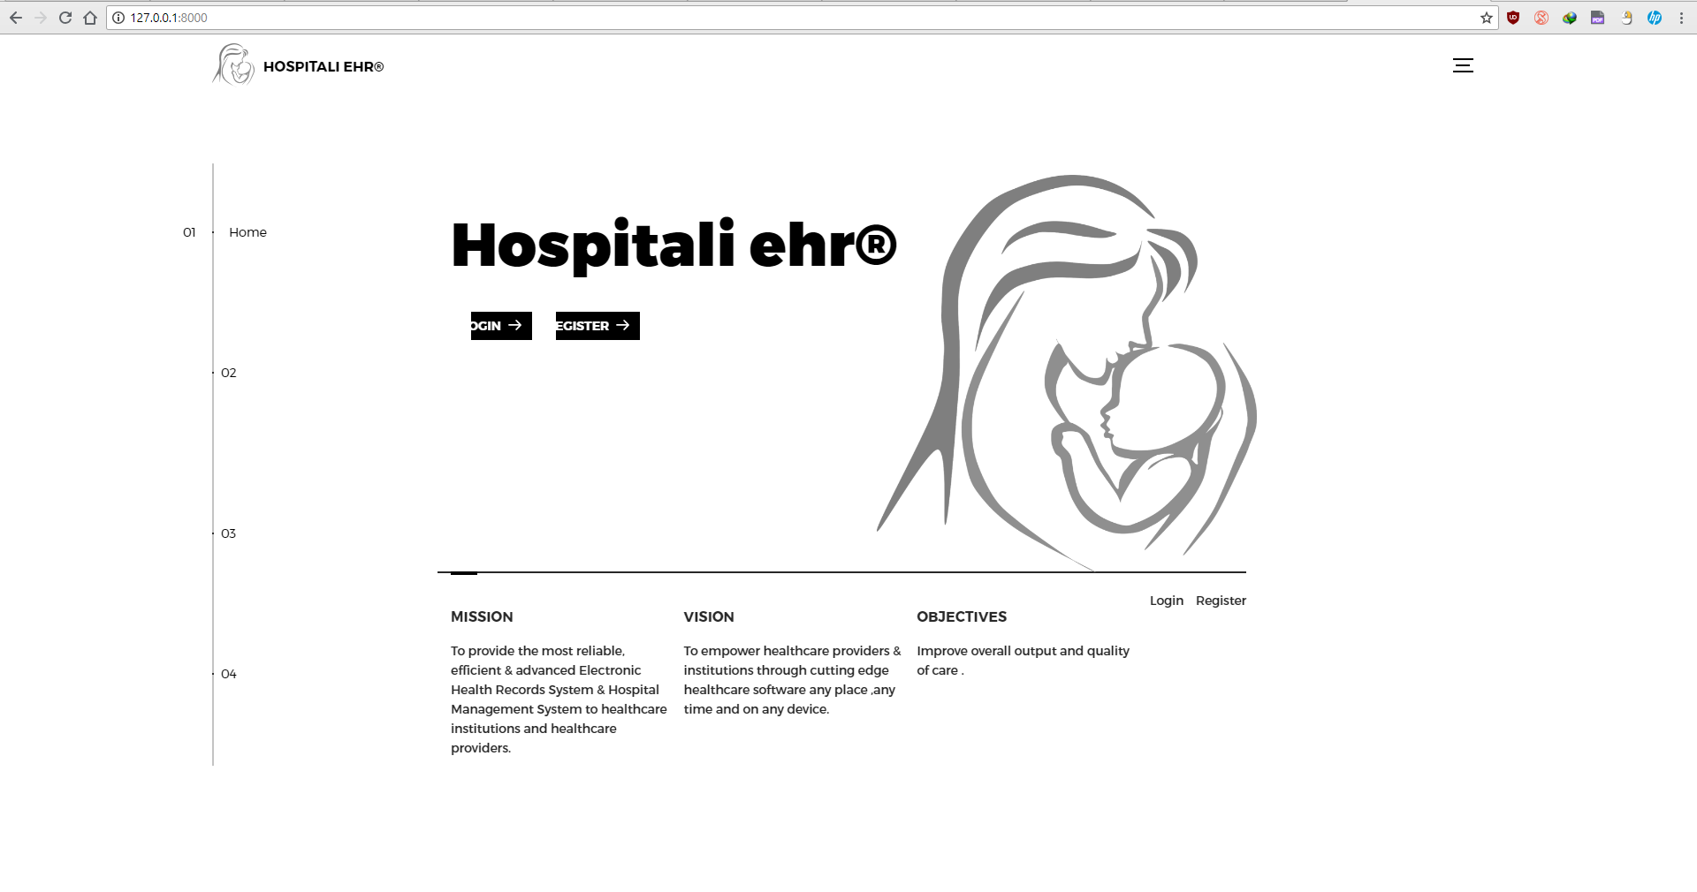

**System definition**

**8**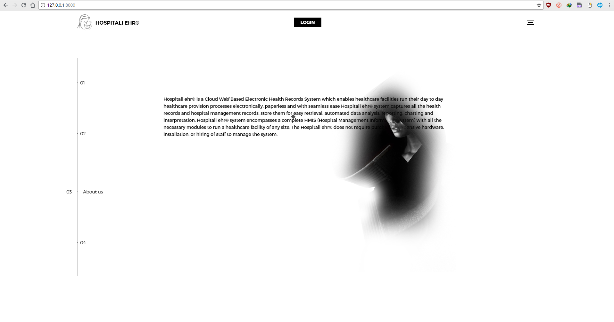

**System vision and mission**

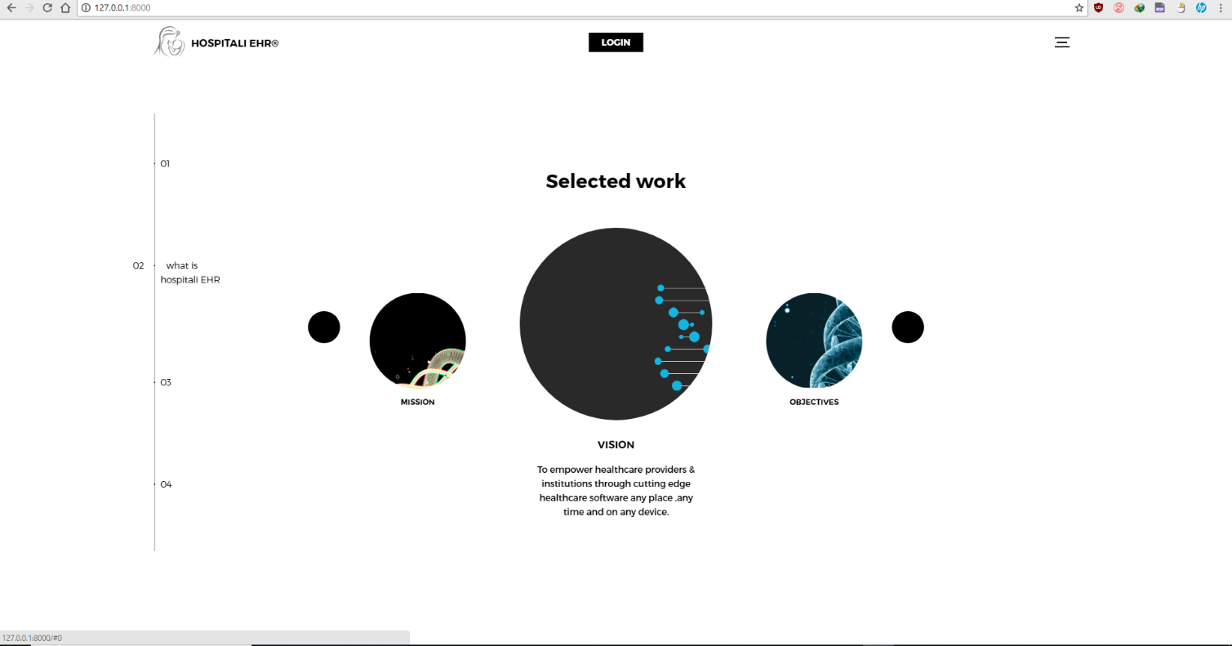

**Navigation**

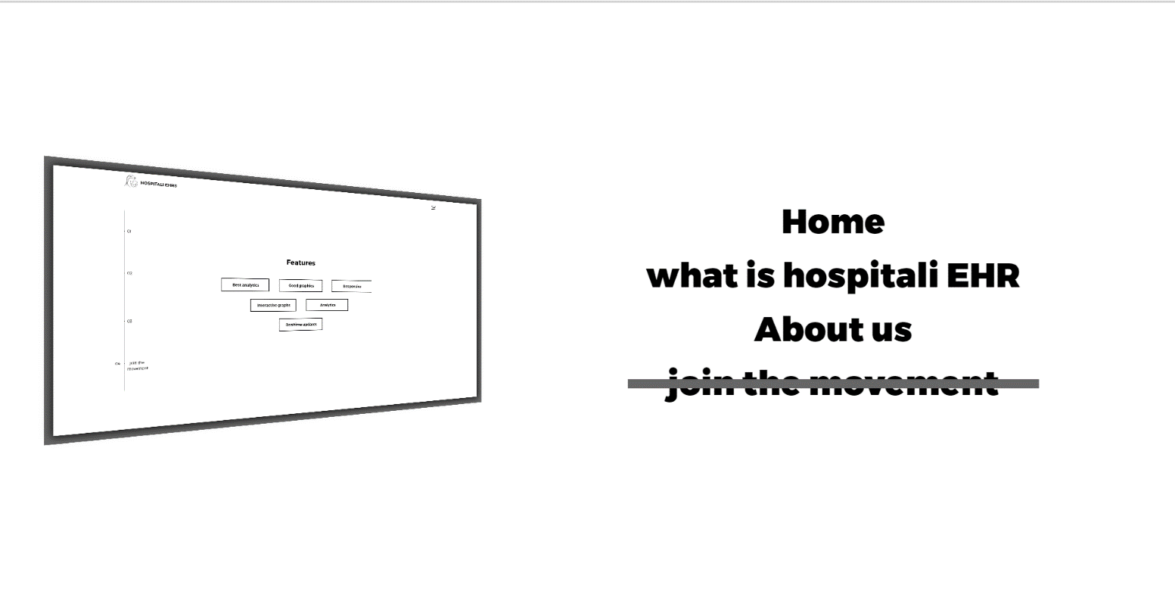

**Login form**

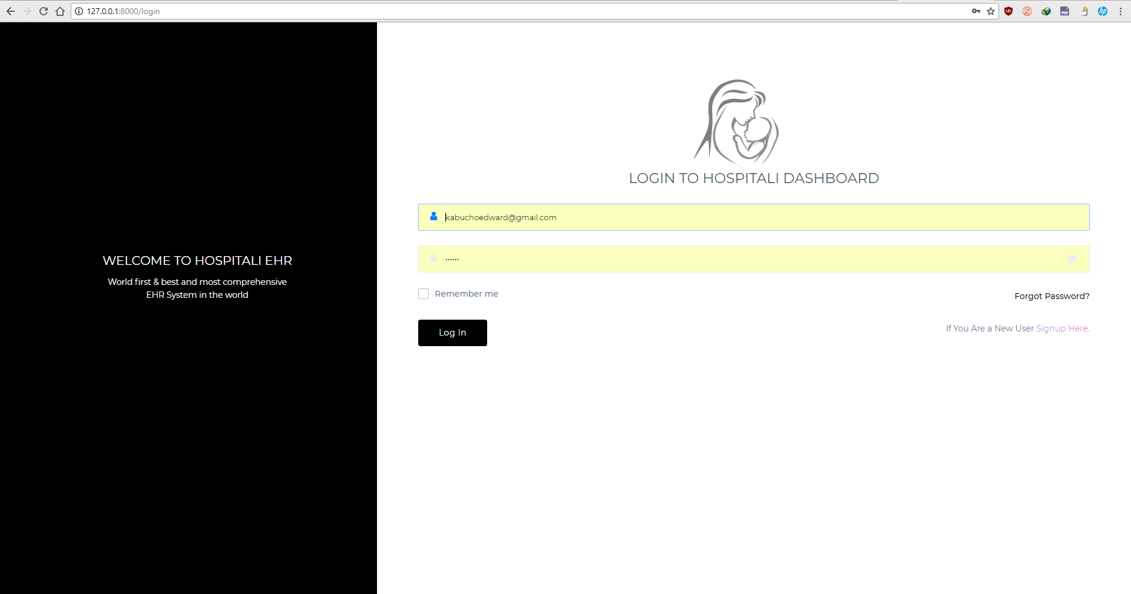

**Register form**

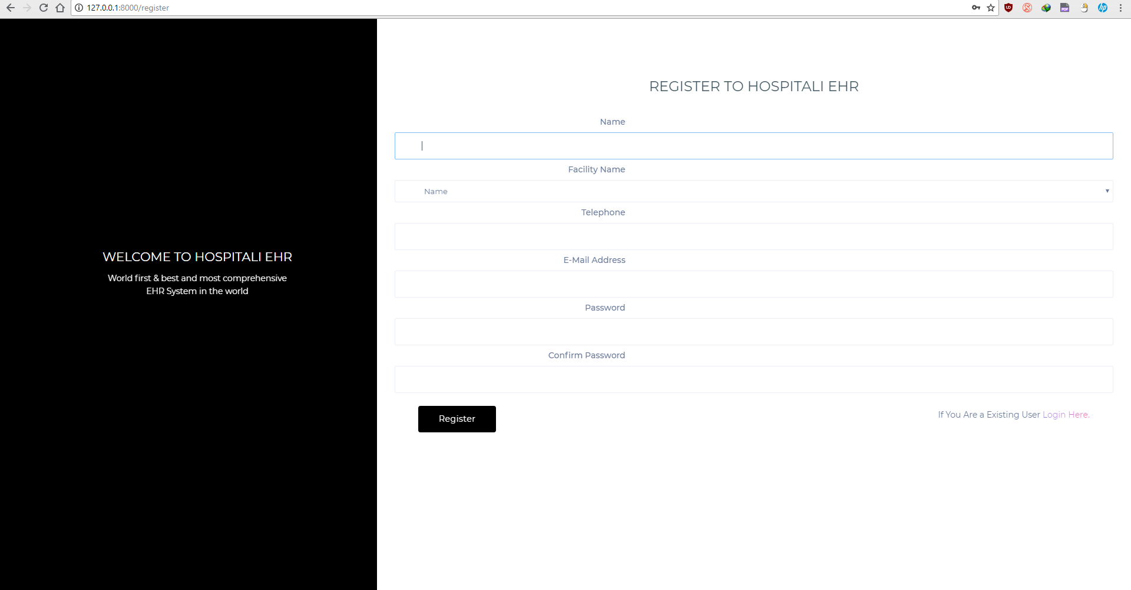

**Homepage**

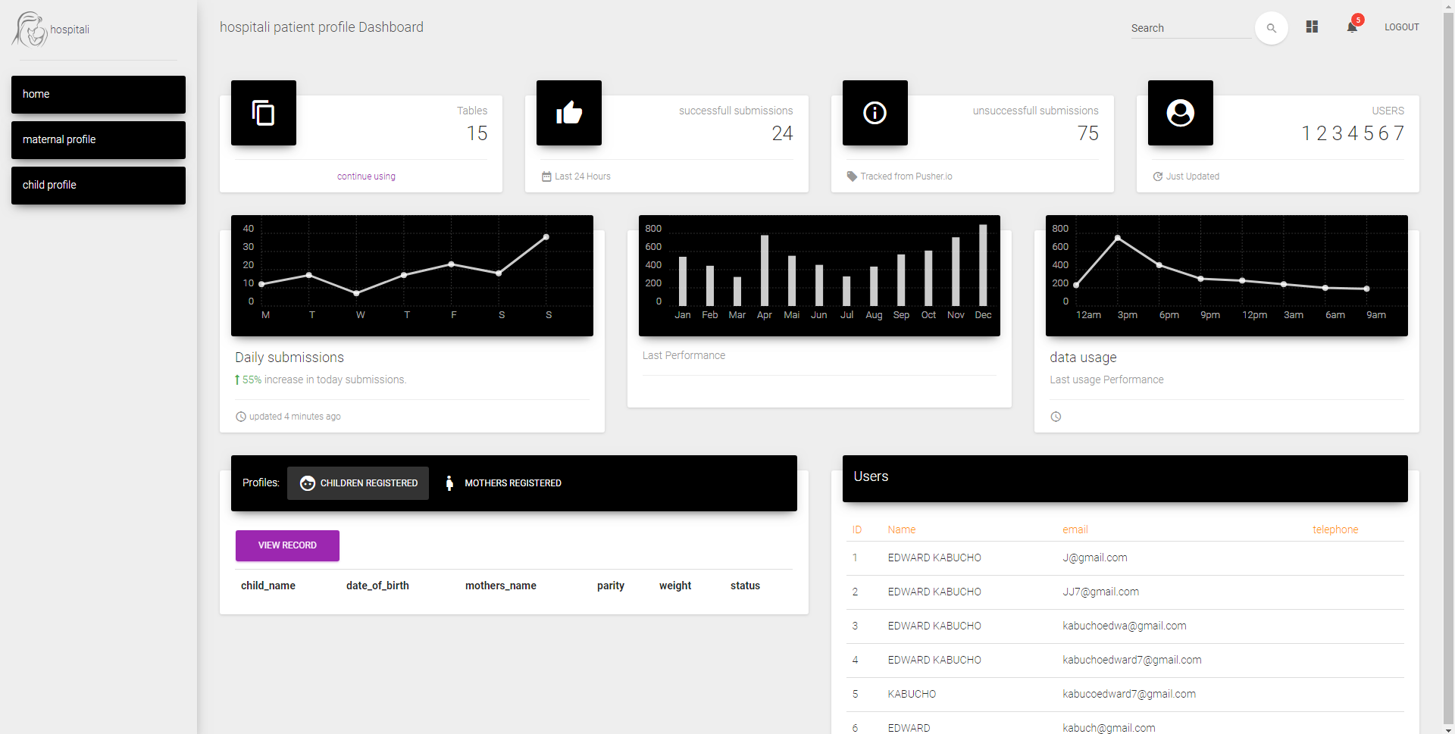

**Report form**

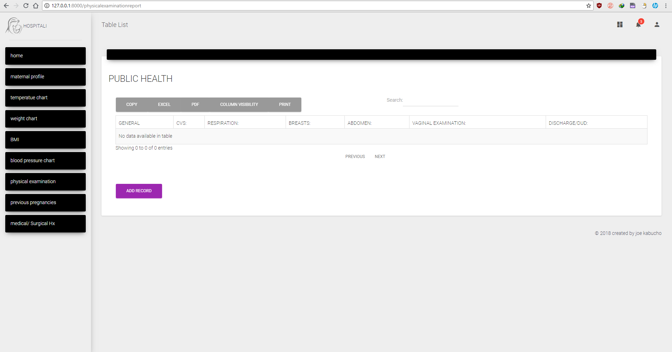

**Data entry form**

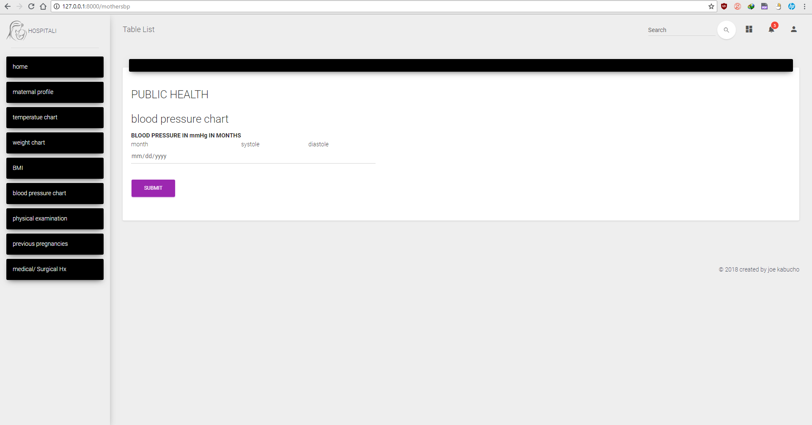

[**Database Design**](https://mail.google.com/mail/u/0/#m_-6186555639887004368__Toc485940520)

Sample database migration code

**<?php  
  
use** Illuminate\Support\Facades\Schema;  
**use** Illuminate\Database\Schema\Blueprint;  
**use** Illuminate\Database\Migrations\Migration;  
  
**class** CreateUsersTable **extends** Migration  
{  
 */**  
 * Run the migrations.  
 *  
 \** ***@return*** *void  
 */* **public function** up()  
 {  
 Schema::*create*(**'users'**, **function** (Blueprint $table) {  
 $table->increments(**'id'**);  
 $table->integer(**'user_type'**)->default(1);  
 $table->string(**'name'**)->nullable();  
 $table->string(**'email'**)->unique();  
 $table->string(**'password'**);  
 $table->string(**'avatar'**)->default(**'default-user.png'**);  
 $table->string(**'cover'**)->default(**'default-cover.png'**);  
 $table->boolean(**'account_active'**)->default(**false**);  
 $table->boolean(**'is_admin'**)->default(**false**);  
 $table->string(**'telephone'**)->nullable();  
 $table->string(**'type'**)->nullable();  
 $table->string(**'keph_level'**)->nullable();  
 $table->string(**'facility_type'**)->nullable();  
 $table->string(**'owner'**)->nullable();  
 $table->string(**'regulatory_body'**)->nullable();  
 $table->string(**'bed_capacity'**)->nullable();  
 $table->string(**'branches'**)->nullable();  
 $table->string(**'working_days'**)->nullable();  
 $table->string(**'brief_description_of_services'**)->nullable();  
 $table->string(**'insurance'**)->nullable();  
 $table->string(**'company_name'**)->nullable();  
 $table->string(**'legal_name'**)->nullable();  
 $table->string(**'tax_id'**)->nullable();  
 $table->string(**'street_address'**)->nullable();  
 $table->string(**'city'**)->nullable();  
 $table->string(**'county'**)->nullable();  
 $table->string(**'address'**)->nullable();  
 $table->string(**'sub_county'**)->nullable();  
 $table->string(**'ward'**)->nullable();  
 $table->rememberToken();  
 $table->timestamps();  
 });  
 }  
  
 */**  
 * Reverse the migrations.  
 *  
 \** ***@return*** *void  
 */* **public function** down()  
 {  
 Schema::*dropIfExists*(**'users'**);  
 }  
}

**ERD**





[**4. SYSTEM IMPLEMENTATION**](https://mail.google.com/mail/u/0/#m_-6186555639887004368__Toc485940521)

# Software and hardware resources

**Operating System:**

Windows 10

**Memory**

16 GB recommended, (8 GB minimum)

**Monitor:**

Screen Display - 2160 by 1920 (XGA)

**Processor**

Intel core i7 7500 HQ

A Dual-Core processor is recommended; it is likely that the program will not function at an acceptable performance level without it.

**Development software**

JetBrains php storm

Laravel libraries

Git bash, Git kraken, Git hub private account, Bit bucket

Composer

Gitbash

[**4.1.3 Programming Languages and Tools**](https://mail.google.com/mail/u/0/#m_-6186555639887004368__Toc485940523)

Html

Css

Vue js

D3.js

Bootstrap

Laravel-PHP

Sql

Scss

Sass

Jquery

Ajax

Chartist.js

[**4.2 TESTING**](https://mail.google.com/mail/u/0/#m_-6186555639887004368__Toc485940524)

[**4.2.1 Approaches Used in Testing**](https://mail.google.com/mail/u/0/#m_-6186555639887004368__Toc485940525)

[**4.2.2 Test Cases**](https://mail.google.com/mail/u/0/#m_-6186555639887004368__Toc485940526)

[**4.2.3 Sample Outputs**](https://mail.google.com/mail/u/0/#m_-6186555639887004368__Toc485940527)

[**5. CONCLUSION**](https://mail.google.com/mail/u/0/#m_-6186555639887004368__Toc485940528)

[**5.1 Achievements**](https://mail.google.com/mail/u/0/#m_-6186555639887004368__Toc485940529)

[**5.2 Constraints**](https://mail.google.com/mail/u/0/#m_-6186555639887004368__Toc485940530)

[**APPENDIX A: USER MANUAL**](https://mail.google.com/mail/u/0/#m_-6186555639887004368__Toc485940531)

[**APPENDIX B: SAMPLE CODE**](https://mail.google.com/mail/u/0/#m_-6186555639887004368__Toc485940532)

**sample ui code**

**@extends('MCH.mchmaster')  
@section('footer')** <**script src="https://cdnjs.cloudflare.com/ajax/libs/Chart.js/2.5.0/Chart.min.js"**></**script**>  
 <**script**>  
 **new** *Chart*(**document**.getElementById(**"bar-chart-horizontal"**), {  
 **type**: **'horizontalBar'**,  
 **data**: {  
 **labels**: [ **@if(isset**($motherweight_results)**)  
 @foreach(**$motherweight_results **as** $motherweight_result**)** {{$motherweight_result->**month**}},  
 **@endforeach  
 @endif**],  
 **datasets**: [  
 {  
 **label**: **"weight"**,  
 **backgroundColor**: [**"#fffffb"**,**"#fffffb"**,**"#fffffb"**,**"#fffffb"**,**"#fffffb"**,**"#fffffb"**,**"#fffffb"**,**"#fffffb"**,**"#fffffb"**,**"#fffffb"**,**"#fffffb"**,**"#fffffb"**,**"#fffffb"**,**"#fffffb"**,**"#fffffb"**,**"#fffffb"**,**"#fffffb"**,**"#fffffb"**,**"#fffffb"**,**"#fffffb"**,**"#fffffb"**],  
 **data**: [ **@if(isset**($motherweight_results)**)  
 @foreach(**$motherweight_results **as** $motherweight_resultss**)** {{$motherweight_resultss->**weight**}},  
 **@endforeach  
 @endif**]  
 }  
 ]  
 },  
 **options**: {  
 **legend**: { **display**: **false** },  
 **title**: {  
 **display**: **true**,  
 **text**: **'weight'** }  
 }  
 });  
 </**script**>  
 <**script**>  
 **new** *Chart*(**document**.getElementById(**"line-chart"**), {  
 **type**: **'line'**,  
 **data**: {  
 **labels**: [**@if(isset**($motherstemperature_results)**)  
 @foreach(**$motherstemperature_results **as** $motherstemperature_result**)** {{$motherstemperature_result->**month**}},  
 **@endforeach  
 @endif**],  
 **datasets**: [{  
 **data**: [**@if(isset**($motherstemperature_results)**)  
 @foreach(**$motherstemperature_results **as** $motherstemperature_resultss**)** {{$motherstemperature_resultss->**temp**}},  
 **@endforeach  
 @endif**],  
 **label**: **"temp"**,  
 **borderColor**: **"#fffffb"**,  
 **fill**: **false** }  
 ]  
 },  
 **options**: {  
 **title**: {  
 **display**: **true**,  
 **text**: **'temperature'** }  
 }  
 });  
  
 </**script**>  
<**script**>  
 *// Bar chart* **new** *Chart*(**document**.getElementById(**"line-charts"**), {  
 **type**: **'line'**,  
 **data**: {  
 **labels**: [**@if(isset**($mothersbloodpressure_results)**)  
 @foreach(**$mothersbloodpressure_results **as** $mothersbloodpressure_result**)** {{$mothersbloodpressure_result->**month**}},  
 **@endforeach  
 @endif**],  
 **datasets**: [{  
 **data**: [**@if(isset**($mothersbloodpressure_results)**)  
 @foreach(**$mothersbloodpressure_results **as** $mothersbloodpressure_resultsss**)** {{$mothersbloodpressure_resultsss->**systole**}},  
 **@endforeach  
 @endif**],  
 **label**: **"systole"**,  
 **borderColor**: **"#fffffb "**,  
 **fill**: **false** }, {  
 **data**: [**@if(isset**($mothersbloodpressure_results)**)  
 @foreach(**$mothersbloodpressure_results **as** $mothersbloodpressure_resultss**)** {{$mothersbloodpressure_resultss->**diastole**}},  
 **@endforeach  
 @endif**],  
 **label**: **"diastole"**,  
 **borderColor**: **"#8e5ea2"**,  
 **fill**: **false** }  
 ]  
 },  
 **options**: {  
 **title**: {  
 **display**: **true**,  
 **text**: **'blood pressure'** }  
 }  
 });  
</**script**>  
  
**@endsection  
@section('content')** <**div class="wrapper"**>  
 <**div class="sidebar" data-color="black" data-image="../assets/img/sidebar-1.jpg"**>  
 *<!--  
 Tip 1: You can change the color of the sidebar using: data-color="purple | blue | green | orange | red"  
  
 Tip 2: you can also add an image using data-image tag  
 -->* <**div class="logo"**>  
 <**img style="height**: 50**px " src="assets/landing/assets/img/Mother-PNG-Image.png" alt="Welcome"**>  
 hospitali  
  
 </**div**>  
 <**div class="sidebar-wrapper"**>  
 <**ul class="nav"**>  
 <**li class="active"**>  
 <**a href="**{{ url(**'home'**) }}**"**>  
 <**i class="material-icons"**></**i**>  
 <**p**>home</**p**>  
 </**a**>  
 </**li**>  
  
 <**li class="active"**>  
 <**a href="**{{ url(**'maternalreport'**) }}**"**>  
 <**i class="material-icons"**></**i**>  
 <**p**>maternal profile</**p**>  
 </**a**>  
 </**li**>  
 <**li class="active"**>  
 <**a href="**{{ url(**'motherstemp'**) }}**"**>  
 <**i class="material-icons"**></**i**>  
 <**p**>temperatue chart</**p**>  
 </**a**>  
 </**li**>  
 <**li class="active"**>  
 <**a href="**{{ url(**'mothersweight'**) }}**"**>  
 <**i class="material-icons"**></**i**>  
 <**p**>weight chart</**p**>  
 </**a**>  
 </**li**>  
 <**li class="active"**>  
 <**a href="**{{ url(**'bmi'**) }}**"**>  
 <**i class="material-icons"**></**i**>  
 <**p**>BMI</**p**>  
 </**a**>  
 </**li**>  
 <**li class="active"**>  
 <**a href="**{{ url(**'mothersbp'**) }}**"**>  
 <**i class="material-icons"**></**i**>  
 <**p**> blood pressure chart</**p**>  
 </**a**>  
 </**li**>  
  
 <**li class="active"**>  
 <**a href="**{{ url(**'physicalexaminationreport'**) }}**"**>  
 <**i class="material-icons"**></**i**>  
 <**p**>physical examination</**p**>  
 </**a**>  
 </**li**>  
  
  
  
 <**li class="active"**>  
 <**a href="**{{ url(**'previousreport'**) }}**"**>  
 <**i class="material-icons"**></**i**>  
 <**p**>previous pregnancies</**p**>  
 </**a**>  
 </**li**>  
 <**li class="active"**>  
 <**a href="**{{ url(**'surgicalreport'**) }}**"**>  
 <**i class="material-icons"**></**i**>  
 <**p**>medical/ Surgical Hx</**p**>  
 </**a**>  
 </**li**>  
  
  
  
  
  
 </**ul**>  
 </**div**>  
 </**div**>  
 <**div class="main-panel"**>  
 <**nav class="navbar navbar-transparent navbar-absolute"**>  
 <**div class="container-fluid"**>  
 <**div class="navbar-header"**>  
 <**button type="button" class="navbar-toggle" data-toggle="collapse"**>  
 <**span class="sr-only"**>Toggle navigation</**span**>  
 <**span class="icon-bar"**></**span**>  
 <**span class="icon-bar"**></**span**>  
 <**span class="icon-bar"**></**span**>  
 </**button**>  
 <**a class="navbar-brand" href="#"**> MATERNAL PROFILE </**a**>  
 </**div**>  
 <**div class="collapse navbar-collapse"**>  
 <**ul class="nav navbar-nav navbar-right"**>  
 <**li**>  
 <**a href="#pablo" class="dropdown-toggle" data-toggle="dropdown"**>  
 <**i class="material-icons"**>dashboard</**i**>  
 <**p class="hidden-lg hidden-md"**>Dashboard</**p**>  
 </**a**>  
 </**li**>  
 <**li class="dropdown"**>  
 <**a href="#" class="dropdown-toggle" data-toggle="dropdown"**>  
 <**i class="material-icons"**>notifications</**i**>  
 <**span class="notification"**>5</**span**>  
 <**p class="hidden-lg hidden-md"**>Notifications</**p**>  
 </**a**>  
 <**ul class="dropdown-menu"**>  
 <**li**>  
 <**a href="#"**>Mike John responded to your email</**a**>  
 </**li**>  
 <**li**>  
 <**a href="#"**>You have 5 new tasks</**a**>  
 </**li**>  
 <**li**>  
 <**a href="#"**>new doctors appointment</**a**>  
 </**li**>  
 <**li**>  
 <**a href="#"**>Another Notification</**a**>  
 </**li**>  
 <**li**>  
 <**a href="#"**>Another One</**a**>  
 </**li**>  
 </**ul**>  
 </**li**>  
 <**li**>  
 <**a class="dropdown-item" href="**{{ route(**'logout'**) }}**"  
 onclick="**event.preventDefault();  
 **document**.getElementById(**'logout-form'**).submit();**"**>  
 {{ __(**'Logout'**) }}  
 </**a**>  
  
 <**form id="logout-form" action="**{{ route(**'logout'**) }}**" method="POST" style="display**: **none**;**"**>  
 **@csrf** </**form**>  
 </**li**>  
 </**ul**>  
 <**form class="navbar-form navbar-right" role="search"**>  
 <**div class="form-group is-empty"**>  
 <**input type="text" class="form-control" placeholder="Search"**>  
 <**span class="material-input"**></**span**>  
 </**div**>  
 <**button type="submit" class="btn btn-white btn-round btn-just-icon"**>  
 <**i class="material-icons"**>search</**i**>  
 <**div class="ripple-container"**></**div**>  
 </**button**>  
 </**form**>  
 </**div**>  
 </**div**>  
 </**nav**>  
 <**div class="content"**>  
 <**div class="container-fluid"**>  
 <**div class="row"**>  
 <**div class="col-lg-3 col-md-6 col-sm-6"**>  
 <**div class="card card-stats"**>  
 <**div class="card-header" data-background-color="black"**>  
 <**i class="material-icons"**>content_copy</**i**>  
 </**div**>  
 <**div class="card-content"**>  
 <**p class="category"**>Tables</**p**>  
 <**h3 class="title"**>15  
  
 </**h3**>  
 </**div**>  
 <**div class="card-footer"**>  
 <**div class="stats"**>  
 <**i class="material-icons text-danger"**>thank you</**i**>  
 <**a href="#pablo"**>continue using</**a**>  
 </**div**>  
 </**div**>  
 </**div**>  
 </**div**>  
 <**div class="col-lg-3 col-md-6 col-sm-6"**>  
 <**div class="card card-stats"**>  
 <**div class="card-header" data-background-color="black"**>  
 <**i class="material-icons attach-money"**>thumb_up</**i**>  
 </**div**>  
 <**div class="card-content"**>  
 <**p class="category"**>successfull submissions</**p**>  
 <**h3 class="title"**>24</**h3**>  
 </**div**>  
 <**div class="card-footer"**>  
 <**div class="stats"**>  
 <**i class="material-icons"**>date_range</**i**> Last 24 Hours  
 </**div**>  
 </**div**>  
 </**div**>  
 </**div**>  
 <**div class="col-lg-3 col-md-6 col-sm-6"**>  
 <**div class="card card-stats"**>  
 <**div class="card-header" data-background-color="black"**>  
 <**i class="material-icons"**>info_outline</**i**>  
 </**div**>  
 <**div class="card-content"**>  
 <**p class="category"**>unsuccessfull submissions</**p**>  
 <**h3 class="title"**>75</**h3**>  
 </**div**>  
 <**div class="card-footer"**>  
 <**div class="stats"**>  
 <**i class="material-icons"**>local_offer</**i**> Tracked from Pusher.io  
 </**div**>  
 </**div**>  
 </**div**>  
 </**div**>  
 <**div class="col-lg-3 col-md-6 col-sm-6"**>  
 <**div class="card card-stats"**>  
 <**div class="card-header" data-background-color="black"**>  
 <**i class="fa fa-user-circle"**></**i**>  
 </**div**>  
 <**div class="card-content"**>  
 <**p class="category"**>USERS</**p**>  
 <**h3 class="title"**>1</**h3**>  
 </**div**>  
 <**div class="card-footer"**>  
 <**div class="stats"**>  
 <**i class="material-icons"**>update</**i**> Just Updated  
 </**div**>  
 </**div**>  
 </**div**>  
 </**div**>  
 </**div**>  
 <**div class="row"**>  
 <**div class="col-md-4"**>  
 <**div class="card"**>  
 <**div class="card-header card-chart" data-background-color="black"**>  
 <**canvas id="line-chart" width="800" height="450"**></**canvas**>  
 </**div**>  
 <**div class="card-content"**>  
 <**h4 class="title"**>temperature chart</**h4**>  
 <**p class="category"**>  
 <**span class="text-success"**><**i class="fa fa-long-arrow-up"**></**i**> 15% </**span**> increase in temperature submissions.</**p**>  
 </**div**>  
  
 </**div**>  
 </**div**>  
 <**div class="col-md-4"**>  
 <**div class="card"**>  
 <**div class="card-header card-chart" data-background-color="black"**>  
 <**canvas id="line-charts" width="800" height="450"**></**canvas**>  
 </**div**>  
 <**div class="card-content"**>  
 <**p class="category"**>blood pressure chart</**p**>  
 </**div**>  
 <**div class="card-footer"**>  
 <**div class="stats"**>  
 <**i class="material-icons"**></**i**>  
 </**div**>  
 </**div**>  
 </**div**>  
 </**div**>  
 <**div class="col-md-4"**>  
 <**div class="card"**>  
 <**div class="card-header card-chart" data-background-color="black"**>  
 <**canvas id="bar-chart-horizontal" width="800" height="450"**></**canvas**>  
 </**div**>  
 <**div class="card-content"**>  
 <**h4 class="title"**>weight chart</**h4**>  
  
 </**div**>  
 <**div class="card-footer"**>  
 <**div class="stats"**>  
 <**i class="material-icons"**>access_time</**i**>  
 </**div**>  
 </**div**>  
 </**div**>  
 </**div**>  
 </**div**>  
 <**div class="row"**>  
 <**div class="col-lg-6 col-md-12"**>  
 <**div class="card card-nav-tabs"**>  
 <**div class="card-header" data-background-color="black"**>  
 <**div class="nav-tabs-navigation"**>  
 <**div class="nav-tabs-wrapper"**>  
 <**span class="nav-tabs-title"**>Profiles:</**span**>  
 <**ul class="nav nav-tabs" data-tabs="tabs"**>  
 <**li class="active"**>  
 <**a href="#profile" data-toggle="tab"**>  
 <**i class="material-icons"**>face</**i**>children registered  
 <**div class="ripple-container"**></**div**>  
 </**a**>  
 </**li**>  
 <**li class=""**>  
 <**a href="#messages" data-toggle="tab"**>  
 <**i class="material-icons"**>pregnant_woman</**i**> mothers registered  
 <**div class="ripple-container"**></**div**>  
 </**a**>  
 </**li**>  
  
 </**ul**>  
 </**div**>  
 </**div**>  
 </**div**>  
 <**div class="card-content"**>  
 <**div class="tab-content"**>  
 <**div class="tab-pane active" id="profile"**>  
 <**table class="table"**>  
 <**tbody**>  
 *<!-- Button trigger modal -->* <**button type="button" class="btn btn-primary" data-toggle="modal" data-target="#exampleModal"**>  
 view record  
 </**button**>  
  
 *<!-- Modal -->* <**div class="modal fade" id="exampleModal" tabindex="-1" role="dialog" aria-labelledby="exampleModalLabel" aria-hidden="true"**>  
 <**div class="modal-dialog" role="document"**>  
 <**div class="modal-content"**>  
 <**div class="modal-header"**>  
 <**h5 class="modal-title" id="exampleModalLabel"**></**h5**>  
 <**button type="button" class="close" data-dismiss="modal" aria-label="Close"**>  
 <**span aria-hidden="true"**>**&times;**</**span**>  
 </**button**>  
 </**div**>  
  
 <**div class="modal-body"**>  
 <**div class="col-m-3 offset-md-2"**>  
 <**H3 class="mt-20 "**>  
 CHILD PROFILE  
 </**H3**>  
 </**div**>  
  
 <**div class="row"**>  
 **@foreach(** $create_child_results **as** $create_child_resultss**)** <**div class="col-sm-6"**>  
 <**div class="row"**>  
 <**label for="staticEmail" class="col-sm-3 col-form-label"**>CHILDS NAME</**label**>  
 <**div class="col-sm-6"**>  
 {{ $create_child_resultss->**child_name** }}  
 </**div**>  
 </**div**>  
  
 <**div class="row"**>  
 <**label for="staticEmail" class="col-sm-3 col-form-label"**>DATE OF BIRTH:</**label**>  
 <**div class="col-sm-6"**>  
 {{ $create_child_resultss->**date_of_birth** }}  
 </**div**>  
 </**div**>  
 <**div class="row"**>  
 <**label for="staticEmail" class="col-sm-3 col-form-label"**>MOTHERS NAME</**label**>  
 <**div class="col-sm-6"**>  
 {{ $create_child_resultss->**mothers_name** }}  
 </**div**>  
 </**div**>  
 <**div class="row"**>  
 <**label for="staticEmail" class="col-sm-3 col-form-label"**>PARITY:</**label**>  
 <**div class="col-sm-6"**>  
 {{ $create_child_resultss->**parity** }}  
 </**div**>  
 </**div**>  
 <**div class="row"**>  
 <**label for="staticEmail" class="col-sm-3 col-form-label"**>WEIGHT:</**label**>  
 <**div class="col-sm-6"**>  
 {{ $create_child_resultss->**weight** }}  
 </**div**>  
 </**div**>  
  
  
  
  
 <**div class="row"**>  
 <**label for="staticEmail" class="col-sm-3 col-form-label"**> STATUS:</**label**>  
 <**div class="col-sm-6"**>  
 {{ $create_child_resultss->**status** }}  
 </**div**>  
 </**div**>  
  
 </**div**>  
 **@endforeach** </**div**>  
 </**div**>  
 </**div**>  
 <**tr**>  
 <**th**>child_name</**th**>  
 <**th**>date_of_birth</**th**>  
 <**th**>mothers_name</**th**>  
 <**th**>parity</**th**>  
 <**th**>weight</**th**>  
 <**th**>status</**th**>  
 </**tr**>  
 </**thead**>  
 <**tbody**>  
  
 **@foreach(** $create_child_results **as** $create_child_result**)** <**tr**>  
 <**td**>{{ $create_child_result->**child_name** }}</**td**>  
 <**td**>{{ $create_child_result->**date_of_birth** }}</**td**>  
 <**td**>{{ $create_child_result->**mothers_name**}}</**td**>  
 <**td**>{{ $create_child_result->**parity** }}</**td**>  
 <**td**>{{ $create_child_result->**weight**}}</**td**>  
 <**td**>{{ $create_child_result->**status**}}</**td**>  
  
  
  
 </**tr**>  
  
 **@endforeach** </**tbody**>  
 </**table**>  
 </**div**>  
 <**div class="tab-pane" id="messages"**>  
 <**table class="table"**>  
  
 <**button type="button" class="btn btn-primary" data-toggle="modal" data-target=".bd-example-modal-lg"**>view record</**button**>  
  
 <**div class="modal fade bd-example-modal-lg" tabindex="-1" role="dialog" aria-labelledby="myLargeModalLabel" aria-hidden="true"**>  
 <**div class="modal-dialog modal-lg"**>  
 <**div class="modal-content"**>  
 <**div class="modal-header"**>  
 <**h5 class="modal-title" id="exampleModalLabel"**></**h5**>  
 <**button type="button" class="close" data-dismiss="modal" aria-label="Close"**>  
 <**span aria-hidden="true"**>**&times;**</**span**>  
 </**button**>  
 </**div**>  
 <**div class="modal-body"**>  
 <**div class="col-m-3 offset-md-2"**>  
 <**H3 class="mt-20 "**>  
 MATERNAL PROFILE  
 </**H3**>  
 </**div**>  
 **@foreach(** $maternalreport_results **as** $maternalreport_resultss**)** <**div class="row"**>  
 <**div class="col-sm-6"**>  
 <**div class="row"**>  
 <**label for="staticEmail" class="col-sm-3 col-form-label"**>NAME OF INSTITUTION:</**label**>  
 <**div class="col-sm-6"**>  
 {{ $maternalreport_resultss->**name_of_institution**}}  
 </**div**>  
 </**div**>  
 <**div class="row"**>  
 <**label for="staticEmail" class="col-sm-3 col-form-label"**>NAME OF CLIENT:</**label**>  
 <**div class="col-sm-6"**>  
 {{ $maternalreport_resultss->**name_of_client**}}  
 </**div**>  
 </**div**>  
 <**div class="row"**>  
 <**label for="staticEmail" class="col-sm-3 col-form-label"**>DATE OF BIRTH:</**label**>  
 <**div class="col-sm-6"**>  
 {{ $maternalreport_resultss->**date_of_birth**}}  
 </**div**>  
 </**div**>  
 <**div class="row"**>  
 <**label for="staticEmail" class="col-sm-3 col-form-label"**>GRAVIDA:</**label**>  
 <**div class="col-sm-6"**>  
 {{ $maternalreport_resultss->**gravida**}}  
 </**div**>  
 </**div**>  
 <**div class="row"**>  
 <**label for="staticEmail" class="col-sm-3 col-form-label"**>PARITY:</**label**>  
 <**div class="col-sm-6"**>  
 {{ $maternalreport_resultss->**parity**}}  
 </**div**>  
 </**div**>  
 <**div class="row"**>  
 <**label for="staticEmail" class="col-sm-3 col-form-label"**>HEIGHT:</**label**>  
 <**div class="col-sm-6"**>  
 {{ $maternalreport_resultss->**height**}}  
 </**div**>  
 </**div**>  
 <**div class="row"**>  
 <**label for="staticEmail" class="col-sm-3 col-form-label"**>L.M.P:</**label**>  
 <**div class="col-sm-6"**>  
 {{ $maternalreport_resultss->**lmp**}}  
 </**div**>  
 </**div**>  
 <**div class="row"**>  
 <**label for="staticEmail" class="col-sm-3 col-form-label"**>EDD:</**label**>  
 <**div class="col-sm-6"**>  
 {{ $maternalreport_resultss->**edd**}}  
 </**div**>  
 </**div**>  
  
  
  
 <**div class="row"**>  
 <**label for="staticEmail" class="col-sm-3 col-form-label"**>MARITAL STATUS:</**label**>  
 <**div class="col-sm-6"**>  
 {{ $maternalreport_resultss->**marital_status**}}  
 </**div**>  
 </**div**>  
 </**div**>  
 <**div class="col-sm-6"**>  
 <**br**><**br**>  
 <**div class="row"**>  
 <**label for="staticEmail" class="col-sm-3 col-form-label"**>EDUCATION:</**label**>  
 <**div class="col-sm-6"**>  
 {{ $maternalreport_resultss->**education**}}  
 </**div**>  
 </**div**>  
 <**div class="row"**>  
 <**label for="staticEmail" class="col-sm-3 col-form-label"**>ADDRESS:</**label**>  
 <**div class="col-sm-6"**>  
 {{ $maternalreport_resultss->**address**}}  
 </**div**>  
 </**div**>  
 <**div class="row"**>  
 <**label for="staticEmail" class="col-sm-3 col-form-label"**>TELEPHONE:</**label**>  
 <**div class="col-sm-6"**>  
 {{ $maternalreport_resultss->**telephone**}}  
 </**div**>  
 </**div**>  
 <**div class="row"**>  
 <**label for="staticEmail" class="col-sm-3 col-form-label"**>OCCUPATION:</**label**>  
 <**div class="col-sm-6"**>  
 {{ $maternalreport_resultss->**occupation**}}  
 </**div**>  
 </**div**>  
 <**div class="row"**>  
 <**label for="staticEmail" class="col-sm-3 col-form-label"**>NEXT OF KIN:</**label**>  
 <**div class="col-sm-6"**>  
 {{ $maternalreport_resultss->**next_of_kin**}}  
 </**div**>  
 </**div**>  
 <**div class="row"**>  
 <**label for="staticEmail" class="col-sm-3 col-form-label"**>NEXT OF KIN ADDRESS:</**label**>  
 <**div class="col-sm-6"**>  
 {{ $maternalreport_resultss->**next_of_kin_address**}}  
 </**div**>  
 </**div**>  
 **@endforeach** </**div**>  
 </**div**>  
 </**div**>  
 </**div**>  
 </**div**>  
  
  
  
 </**div**>  
 </**div**>  
 </**div**>  
 </**tr**>  
 <**thead**>  
 <**tr**>  
 <**th**>NAME OF INSTITUTION</**th**>  
 <**th**>NAME OF CLIENT</**th**>  
 <**th**>DATE OF BIRTH</**th**>  
 <**th**>HEIGHT</**th**>  
 <**th**>MARITAL STATUS</**th**>  
 <**th**>TELEPHONE</**th**>  
 <**th**>NEXT OF KIN</**th**>  
  
 </**tr**>  
 </**thead**>  
 <**tbody**>  
  
 **@foreach(** $maternalreport_results **as** $maternalreport_result**)** <**tr**>  
 <**td**>{{ $maternalreport_result->**name_of_institution**}}</**td**>  
 <**td**>{{ $maternalreport_result->**name_of_client**}}</**td**>  
 <**td**>{{ $maternalreport_result->**date_of_birth**}}</**td**>  
 <**td**>{{ $maternalreport_result->**height**}}</**td**>  
 <**td**>{{ $maternalreport_result->**marital_status**}}</**td**>  
 <**td**>{{ $maternalreport_result->**telephone**}}</**td**>  
 <**td**>{{ $maternalreport_result->**next_of_kin**}}</**td**>  
  
 </**tr**>  
 **@endforeach** </**tbody**>  
 </**table**>  
 </**div**>  
 <**div class="tab-pane" id="messages"**>  
 <**table class="table"**>  
 <**tbody**>  
 <**tr**>  
 <**td**>  
 <**div class="checkbox"**>  
 <**label**>  
 <**input type="checkbox" name="optionsCheckboxes" checked**>  
 </**label**>  
 </**div**>  
 </**td**>  
 <**td**>pending issues to be resolved  
 </**td**>  
 <**td class="td-actions text-right"**>  
 <**button type="button" rel="tooltip" title="Edit Task" class="btn btn-primary btn-simple btn-xs"**>  
 <**i class="material-icons"**>edit</**i**>  
 </**button**>  
 <**button type="button" rel="tooltip" title="Remove" class="btn btn-danger btn-simple btn-xs"**>  
 <**i class="material-icons"**>close</**i**>  
 </**button**>  
 </**td**>  
 </**tr**>  
 <**tr**>  
 <**td**>  
 <**div class="checkbox"**>  
 <**label**>  
 <**input type="checkbox" name="optionsCheckboxes"**>  
 </**label**>  
 </**div**>  
 </**td**>  
 <**td**>upcoming features to be added"</**td**>  
 <**td class="td-actions text-right"**>  
 <**button type="button" rel="tooltip" title="Edit Task" class="btn btn-primary btn-simple btn-xs"**>  
 <**i class="material-icons"**>edit</**i**>  
 </**button**>  
 <**button type="button" rel="tooltip" title="Remove" class="btn btn-danger btn-simple btn-xs"**>  
 <**i class="material-icons"**>close</**i**>  
 </**button**>  
 </**td**>  
 </**tr**>  
 </**tbody**>  
 </**table**>  
 </**div**>  
 <**div class="tab-pane" id="settings"**>  
 <**table class="table"**>  
 <**tbody**>  
 <**tr**>  
 <**td**>  
 <**div class="checkbox"**>  
 <**label**>  
 <**input type="checkbox" name="optionsCheckboxes"**>  
 </**label**>  
 </**div**>  
 </**td**>  
 <**td**>Pending process</**td**>  
 <**td class="td-actions text-right"**>  
 <**button type="button" rel="tooltip" title="Edit Task" class="btn btn-primary btn-simple btn-xs"**>  
 <**i class="material-icons"**>edit</**i**>  
 </**button**>  
 <**button type="button" rel="tooltip" title="Remove" class="btn btn-danger btn-simple btn-xs"**>  
 <**i class="material-icons"**>close</**i**>  
 </**button**>  
 </**td**>  
 </**tr**>  
 <**tr**>  
 <**td**>  
 <**div class="checkbox"**>  
 <**label**>  
 <**input type="checkbox" name="optionsCheckboxes" checked**>  
 </**label**>  
 </**div**>  
 </**td**>  
 <**td**>Successful submission  
 </**td**>  
 <**td class="td-actions text-right"**>  
 <**button type="button" rel="tooltip" title="Edit Task" class="btn btn-primary btn-simple btn-xs"**>  
 <**i class="material-icons"**>edit</**i**>  
 </**button**>  
 <**button type="button" rel="tooltip" title="Remove" class="btn btn-danger btn-simple btn-xs"**>  
 <**i class="material-icons"**>close</**i**>  
 </**button**>  
 </**td**>  
 </**tr**>  
 <**tr**>  
 <**td**>  
 <**div class="checkbox"**>  
 <**label**>  
 <**input type="checkbox" name="optionsCheckboxes"**>  
 </**label**>  
 </**div**>  
 </**td**>  
 <**td**>Server error?"</**td**>  
 <**td class="td-actions text-right"**>  
 <**button type="button" rel="tooltip" title="Edit Task" class="btn btn-primary btn-simple btn-xs"**>  
 <**i class="material-icons"**>edit</**i**>  
 </**button**>  
 <**button type="button" rel="tooltip" title="Remove" class="btn btn-danger btn-simple btn-xs"**>  
 <**i class="material-icons"**>close</**i**>  
 </**button**>  
 </**td**>  
 </**tr**>  
 </**tbody**>  
 </**table**>  
 </**div**>  
 </**div**>  
 </**div**>  
 </**div**>  
 </**div**>  
 <**div class="col-lg-6 col-md-12"**>  
 <**div class="card"**>  
 <**div class="card-header" data-background-color="black"**>  
 <**h4 class="title"**>Users</**h4**>  
 </**div**>  
 <**div class="card-content table-responsive"**>  
 <**table class="table table-hover"**>  
 <**thead class="text-warning"**>  
 <**th**>ID</**th**>  
 <**th**>Name</**th**>  
 <**th**>email</**th**>  
 <**th**>telephone</**th**>  
 </**thead**>  
 <**tbody**>  
 **@foreach(** $create_user_results **as** $create_user_results**)** <**tr**>  
 <**td**>{{ $create_user_results->**id** }}</**td**>  
 <**td**>{{ $create_user_results->**name** }}</**td**>  
 <**td**>{{ $create_user_results->**email** }}</**td**>  
 <**td**>{{ $create_user_results->**telephone** }}</**td**>  
  
  
  
  
 </**tr**>  
  
 **@endforeach** </**tr**>  
 </**tbody**>  
 </**table**>  
 </**div**>  
 </**div**>  
 </**div**>  
 </**div**>  
 </**div**>  
 </**div**>  
 <**footer class="footer"**>  
 <**div class="container-fluid"**>  
  
 <**p class="copyright pull-right"**>  
 **&copy;** <**script**>  
 **document**.write(**new** Date().getFullYear())  
 </**script**>  
 created by joe kabucho  
 </**p**>  
 </**div**>  
 </**footer**>  
 </**div**>  
 </**div**>  
**@endsection**

**sample database code**

**<?php  
  
use** Illuminate\Support\Facades\Schema;  
**use** Illuminate\Database\Schema\Blueprint;  
**use** Illuminate\Database\Migrations\Migration;  
  
**class** CreateChildhealthcardsTable **extends** Migration  
{  
 */**  
 * Run the migrations.  
 *  
 \** ***@return*** *void  
 */* **public function** up()  
 {  
 Schema::*create*(**'childhealthcards'**, **function** (Blueprint $table) {  
 $table->increments(**'id'**);  
 $table->text(**'health_facility_name'**)->nullable();  
 $table->text(**'service_delivery_point_no'**)->nullable();  
 $table->text(**'childs_name'**)->nullable();  
 $table->date(**'date_of_birth'**)->nullable();  
 $table->integer(**'gestation_age'**)->nullable();  
 $table->text(**'place_of_birth'**)->nullable();  
 $table->text(**'home'**)->nullable();  
 $table->text(**'health_facility'**)->nullable();  
 $table->text(**'fathers_name'**)->nullable();  
 $table->text(**'mothers_name'**)->nullable();  
 $table->text(**'province'**)->nullable();  
 $table->text(**'district'**)->nullable();  
 $table->text(**'division'**)->nullable();  
 $table->text(**'location'**)->nullable();  
 $table->text(**'estate'**)->nullable();  
 $table->text(**'po_box'**)->nullable();  
 $table->text(**'town'**)->nullable();  
 $table->integer(**'telephone'**)->nullable();  
 $table->date(**'date'**)->nullable();  
 $table->text(**'description'**)->nullable();  
 $table->text(**'antigen'**)->nullable();  
 $table->text(**'batch_no'**)->nullable();  
 $table->date(**'manufacture_date'**)->nullable();  
 $table->text(**'expiry_date'**)->nullable();  
 $table->text(**'manufacturer_name'**)->nullable();  
 $table->timestamps();  
 });  
 }  
  
 */**  
 * Reverse the migrations.  
 *  
 \** ***@return*** *void  
 */* **public function** down()  
 {  
 Schema::**dropIfExists**(**'childhealthcards'**);  
 }  
}

**sample css styling code**

*/*//////////////////////////////////////////////////////////////////  
[ FONT ]*/***@font-face** {  
 **font-family**: **Poppins-Regular**;  
 **src**: **url**(**'../fonts/poppins/Poppins-Regular.ttf'**);   
}  
  
**@font-face** {  
 **font-family**: **Poppins-Medium**;  
 **src**: **url**(**'../fonts/poppins/Poppins-Medium.ttf'**);   
}  
  
**@font-face** {  
 **font-family**: **Poppins-Bold**;  
 **src**: **url**(**'../fonts/poppins/Poppins-Bold.ttf'**);   
}  
  
**@font-face** {  
 **font-family**: **Poppins-SemiBold**;  
 **src**: **url**(**'../fonts/poppins/Poppins-SemiBold.ttf'**);   
}  
  
  
  
  
*/*//////////////////////////////////////////////////////////////////  
[ RESTYLE TAG ]*/***\*** {  
 **margin**: 0**px**;   
 **padding**: 0**px**;   
 **box-sizing**: **border-box**;  
}  
  
**body**, **html** {  
 **height**: 100%;  
 **font-family**: **Poppins-Regular**, **sans-serif**;  
}  
  
*/*---------------------------------------------*/***a** {  
 **font-family**: **Poppins-Regular**;  
 **font-size**: 14**px**;  
 **line-height**: 1.7;  
 **color**: **#666666**;  
 **margin**: 0**px**;  
 **transition**: **all** 0.4**s**;  
 **-webkit-transition**: **all** 0.4**s**;  
 **-o-transition**: **all** 0.4**s**;  
 **-moz-transition**: **all** 0.4**s**;  
}  
  
**a**:**focus** {  
 **outline**: **none !important**;  
}  
  
**a**:**hover** {  
 **text-decoration**: **none**;  
 **color**: **#6a7dfe**;  
 **color**: **-webkit-linear-gradient**(**left**, **#21d4fd**, **#b721ff**);  
 **color**: **-o-linear-gradient**(**left**, **#21d4fd**, **#b721ff**);  
 **color**: **-moz-linear-gradient**(**left**, **#21d4fd**, **#b721ff**);  
 **color**: **linear-gradient**(**left**, **#21d4fd**, **#b721ff**);  
}  
  
*/*---------------------------------------------*/***h1**,**h2**,**h3**,**h4**,**h5**,**h6** {  
 **margin**: 0**px**;  
}  
  
**p** {  
 **font-family**: **Poppins-Regular**;  
 **font-size**: 14**px**;  
 **line-height**: 1.7;  
 **color**: **#666666**;  
 **margin**: 0**px**;  
}  
  
**ul**, **li** {  
 **margin**: 0**px**;  
 **list-style-type**: **none**;  
}  
  
  
*/*---------------------------------------------*/***input** {  
 **outline**: **none**;  
 **border**: **none**;  
}  
  
**textarea** {  
 **outline**: **none**;  
 **border**: **none**;  
}  
  
**textarea**:**focus**, **input**:**focus** {  
 **border-color**: **transparent !important**;  
}  
  
**input**:**focus**::**-webkit-input-placeholder** { **color**:**transparent**; }  
**input**:**focus**:**-moz-placeholder** { **color**:**transparent**; }  
**input**:**focus**::**-moz-placeholder** { **color**:**transparent**; }  
**input**:**focus**:**-ms-input-placeholder** { **color**:**transparent**; }  
  
**textarea**:**focus**::**-webkit-input-placeholder** { **color**:**transparent**; }  
**textarea**:**focus**:**-moz-placeholder** { **color**:**transparent**; }  
**textarea**:**focus**::**-moz-placeholder** { **color**:**transparent**; }  
**textarea**:**focus**:**-ms-input-placeholder** { **color**:**transparent**; }  
  
**input**::**-webkit-input-placeholder** { **color**: **#adadad**;}  
**input**:**-moz-placeholder** { **color**: **#adadad**;}  
**input**::**-moz-placeholder** { **color**: **#adadad**;}  
**input**:**-ms-input-placeholder** { **color**: **#adadad**;}  
  
**textarea**::**-webkit-input-placeholder** { **color**: **#adadad**;}  
**textarea**:**-moz-placeholder** { **color**: **#adadad**;}  
**textarea**::**-moz-placeholder** { **color**: **#adadad**;}  
**textarea**:**-ms-input-placeholder** { **color**: **#adadad**;}  
  
*/*---------------------------------------------*/***button** {  
 **outline**: **none !important**;  
 **border**: **none**;  
 **background**: **transparent**;  
}  
  
**button**:**hover** {  
 **cursor**: **pointer**;  
}  
  
**iframe** {  
 **border**: **none !important**;  
}  
  
  
*/*//////////////////////////////////////////////////////////////////  
[ Utility ]*/*.**txt1** {  
 **font-family**: **Poppins-Regular**;  
 **font-size**: 13**px**;  
 **color**: **#666666**;  
 **line-height**: 1.5;  
}  
  
.**txt2** {  
 **font-family**: **Poppins-Regular**;  
 **font-size**: 13**px**;  
 **color**: **#333333**;  
 **line-height**: 1.5;  
}  
  
*/*//////////////////////////////////////////////////////////////////  
[ login ]*/*.**limiter** {  
 **width**: 100%;  
 **margin**: 0 **auto**;  
}  
  
.**container-login100** {  
 **width**: 100%;   
 **min-height**: 100**vh**;  
 **display**: **-webkit-box**;  
 **display**: **-webkit-flex**;  
 **display**: **-moz-box**;  
 **display**: **-ms-flexbox**;  
 **display**: **flex**;  
 **flex-wrap**: **wrap**;  
 **justify-content**: **center**;  
 **align-items**: **center**;  
 **padding**: 15**px**;  
 **background**: **#f2f2f2**;   
}  
  
.**wrap-login100** {  
 **width**: 390**px**;  
 **background**: **#fff**;  
 **border-radius**: 10**px**;  
 **overflow**: **hidden**;  
 **padding**: 77**px** 55**px** 33**px** 55**px**;  
  
 **box-shadow**: 0 5**px** 10**px** 0**px rgba**(0, 0, 0, 0.1);  
 **-moz-box-shadow**: 0 5**px** 10**px** 0**px rgba**(0, 0, 0, 0.1);  
 **-webkit-box-shadow**: 0 5**px** 10**px** 0**px rgba**(0, 0, 0, 0.1);  
 **-o-box-shadow**: 0 5**px** 10**px** 0**px rgba**(0, 0, 0, 0.1);  
 **-ms-box-shadow**: 0 5**px** 10**px** 0**px rgba**(0, 0, 0, 0.1);  
}  
  
  
*/*------------------------------------------------------------------  
[ Form ]*/*.**login100-form** {  
 **width**: 100%;  
}  
  
.**login100-form-title** {  
 **display**: **block**;  
 **font-family**: **Poppins-Bold**;  
 **font-size**: 30**px**;  
 **color**: **#333333**;  
 **line-height**: 1.2;  
 **text-align**: **center**;  
}  
.**login100-form-title i** {  
 **font-size**: 60**px**;  
}  
  
*/*------------------------------------------------------------------  
[ Input ]*/*.**wrap-input100** {  
 **width**: 100%;  
 **position**: **relative**;  
 **border-bottom**: 2**px solid #adadad**;  
 **margin-bottom**: 37**px**;  
}  
  
.**input100** {  
 **font-family**: **Poppins-Regular**;  
 **font-size**: 15**px**;  
 **color**: **#555555**;  
 **line-height**: 1.2;  
  
 **display**: **block**;  
 **width**: 100%;  
 **height**: 45**px**;  
 **background**: **transparent**;  
 **padding**: 0 5**px**;  
}  
  
*/*---------------------------------------------*/*.**focus-input100** {  
 **position**: **absolute**;  
 **display**: **block**;  
 **width**: 100%;  
 **height**: 100%;  
 **top**: 0;  
 **left**: 0;  
 **pointer-events**: **none**;  
}  
  
.**focus-input100**::**before** {  
 **content**: **""**;  
 **display**: **block**;  
 **position**: **absolute**;  
 **bottom**: -2**px**;  
 **left**: 0;  
 **width**: 0;  
 **height**: 2**px**;  
  
 **-webkit-transition**: **all** 0.4**s**;  
 **-o-transition**: **all** 0.4**s**;  
 **-moz-transition**: **all** 0.4**s**;  
 **transition**: **all** 0.4**s**;  
  
 **background**: **#6a7dfe**;  
 **background**: **-webkit-linear-gradient**(**left**, **#21d4fd**, **#b721ff**);  
 **background**: **-o-linear-gradient**(**left**, **#21d4fd**, **#b721ff**);  
 **background**: **-moz-linear-gradient**(**left**, **#21d4fd**, **#b721ff**);  
 **background**: **linear-gradient**(**left**, **#21d4fd**, **#b721ff**);  
}  
  
.**focus-input100**::**after** {  
 **font-family**: **Poppins-Regular**;  
 **font-size**: 15**px**;  
 **color**: **#999999**;  
 **line-height**: 1.2;  
  
 **content**: **attr**(**data-placeholder**);  
 **display**: **block**;  
 **width**: 100%;  
 **position**: **absolute**;  
 **top**: 16**px**;  
 **left**: 0**px**;  
 **padding-left**: 5**px**;  
  
 **-webkit-transition**: **all** 0.4**s**;  
 **-o-transition**: **all** 0.4**s**;  
 **-moz-transition**: **all** 0.4**s**;  
 **transition**: **all** 0.4**s**;  
}  
  
.**input100**:**focus** + .**focus-input100**::**after** {  
 **top**: -15**px**;  
}  
  
.**input100**:**focus** + .**focus-input100**::**before** {  
 **width**: 100%;  
}  
  
.**has-val**.**input100** + .**focus-input100**::**after** {  
 **top**: -15**px**;  
}  
  
.**has-val**.**input100** + .**focus-input100**::**before** {  
 **width**: 100%;  
}  
  
*/*---------------------------------------------*/*.**btn-show-pass** {  
 **font-size**: 15**px**;  
 **color**: **#999999**;  
  
 **display**: **-webkit-box**;  
 **display**: **-webkit-flex**;  
 **display**: **-moz-box**;  
 **display**: **-ms-flexbox**;  
 **display**: **flex**;  
 **align-items**: **center**;  
 **position**: **absolute**;  
 **height**: 100%;  
 **top**: 0;  
 **right**: 0;  
 **padding-right**: 5**px**;  
 **cursor**: **pointer**;  
 **-webkit-transition**: **all** 0.4**s**;  
 **-o-transition**: **all** 0.4**s**;  
 **-moz-transition**: **all** 0.4**s**;  
 **transition**: **all** 0.4**s**;  
}  
  
.**btn-show-pass**:**hover** {  
 **color**: **#6a7dfe**;  
 **color**: **-webkit-linear-gradient**(**left**, **#21d4fd**, **#b721ff**);  
 **color**: **-o-linear-gradient**(**left**, **#21d4fd**, **#b721ff**);  
 **color**: **-moz-linear-gradient**(**left**, **#21d4fd**, **#b721ff**);  
 **color**: **linear-gradient**(**left**, **#21d4fd**, **#b721ff**);  
}  
  
.**btn-show-pass**.**active** {  
 **color**: **#6a7dfe**;  
 **color**: **-webkit-linear-gradient**(**left**, **#21d4fd**, **#b721ff**);  
 **color**: **-o-linear-gradient**(**left**, **#21d4fd**, **#b721ff**);  
 **color**: **-moz-linear-gradient**(**left**, **#21d4fd**, **#b721ff**);  
 **color**: **linear-gradient**(**left**, **#21d4fd**, **#b721ff**);  
}  
  
  
  
*/*------------------------------------------------------------------  
[ Button ]*/*.**container-login100-form-btn** {  
 **display**: **-webkit-box**;  
 **display**: **-webkit-flex**;  
 **display**: **-moz-box**;  
 **display**: **-ms-flexbox**;  
 **display**: **flex**;  
 **flex-wrap**: **wrap**;  
 **justify-content**: **center**;  
 **padding-top**: 13**px**;  
}  
  
.**wrap-login100-form-btn** {  
 **width**: 100%;  
 **display**: **block**;  
 **position**: **relative**;  
 **z-index**: 1;  
 **border-radius**: 25**px**;  
 **overflow**: **hidden**;  
 **margin**: 0 **auto**;  
}  
  
.**login100-form-bgbtn** {  
 **position**: **absolute**;  
 **z-index**: -1;  
 **width**: 300%;  
 **height**: 100%;  
 **background**: **#a64bf4**;  
 **background**: **-webkit-linear-gradient**(**right**, **#21d4fd**, **#b721ff**, **#21d4fd**, **#b721ff**);  
 **background**: **-o-linear-gradient**(**right**, **#21d4fd**, **#b721ff**, **#21d4fd**, **#b721ff**);  
 **background**: **-moz-linear-gradient**(**right**, **#21d4fd**, **#b721ff**, **#21d4fd**, **#b721ff**);  
 **background**: **linear-gradient**(**right**, **#21d4fd**, **#b721ff**, **#21d4fd**, **#b721ff**);  
 **top**: 0;  
 **left**: -100%;  
  
 **-webkit-transition**: **all** 0.4**s**;  
 **-o-transition**: **all** 0.4**s**;  
 **-moz-transition**: **all** 0.4**s**;  
 **transition**: **all** 0.4**s**;  
}  
  
.**login100-form-btn** {  
 **font-family**: **Poppins-Medium**;  
 **font-size**: 15**px**;  
 **color**: **#fff**;  
 **line-height**: 1.2;  
 **text-transform**: **uppercase**;  
  
 **display**: **-webkit-box**;  
 **display**: **-webkit-flex**;  
 **display**: **-moz-box**;  
 **display**: **-ms-flexbox**;  
 **display**: **flex**;  
 **justify-content**: **center**;  
 **align-items**: **center**;  
 **padding**: 0 20**px**;  
 **width**: 100%;  
 **height**: 50**px**;  
}  
  
.**wrap-login100-form-btn**:**hover** .**login100-form-bgbtn** {  
 **left**: 0;  
}  
  
  
*/*------------------------------------------------------------------  
[ Responsive ]*/***@media** (**max-width**: 576**px**) {  
 .**wrap-login100** {  
 **padding**: 77**px** 15**px** 33**px** 15**px**;  
 }  
}  
  
  
  
*/*------------------------------------------------------------------  
[ Alert validate ]*/*.**validate-input** {  
 **position**: **relative**;  
}  
  
.**alert-validate**::**before** {  
 **content**: **attr**(**data-validate**);  
 **position**: **absolute**;  
 **max-width**: 70%;  
 **background-color**: **#fff**;  
 **border**: 1**px solid #c80000**;  
 **border-radius**: 2**px**;  
 **padding**: 4**px** 25**px** 4**px** 10**px**;  
 **top**: 50%;  
 **-webkit-transform**: **translateY**(-50%);  
 **-moz-transform**: **translateY**(-50%);  
 **-ms-transform**: **translateY**(-50%);  
 **-o-transform**: **translateY**(-50%);  
 **transform**: **translateY**(-50%);  
 **right**: 0**px**;  
 **pointer-events**: **none**;  
  
 **font-family**: **Poppins-Regular**;  
 **color**: **#c80000**;  
 **font-size**: 13**px**;  
 **line-height**: 1.4;  
 **text-align**: **left**;  
  
 **visibility**: **hidden**;  
 **opacity**: 0;  
  
 **-webkit-transition**: **opacity** 0.4**s**;  
 **-o-transition**: **opacity** 0.4**s**;  
 **-moz-transition**: **opacity** 0.4**s**;  
 **transition**: **opacity** 0.4**s**;  
}  
  
.**alert-validate**::**after** {  
 **content**: **"\f06a"**;  
 **font-family**: **FontAwesome**;  
 **font-size**: 16**px**;  
 **color**: **#c80000**;  
  
 **display**: **block**;  
 **position**: **absolute**;  
 **background-color**: **#fff**;  
 **top**: 50%;  
 **-webkit-transform**: **translateY**(-50%);  
 **-moz-transform**: **translateY**(-50%);  
 **-ms-transform**: **translateY**(-50%);  
 **-o-transform**: **translateY**(-50%);  
 **transform**: **translateY**(-50%);  
 **right**: 5**px**;  
}  
  
.**alert-validate**:**hover**:**before** {  
 **visibility**: **visible**;  
 **opacity**: 1;  
}  
  
**@media** (**max-width**: 992**px**) {  
 .**alert-validate**::**before** {  
 **visibility**: **visible**;  
 **opacity**: 1;  
 }  
}

**sample chart codes**

<**script src="https://cdnjs.cloudflare.com/ajax/libs/Chart.js/2.5.0/Chart.min.js"**></**script**>  
 <**script**>  
 **new** *Chart*(**document**.getElementById(**"bar-chart-horizontal"**), {  
 **type**: **'horizontalBar'**,  
 **data**: {  
 **labels**: [ **@if(isset**($motherweight_results)**)  
 @foreach(**$motherweight_results **as** $motherweight_result**)** {{$motherweight_result->**month**}},  
 **@endforeach  
 @endif**],  
 **datasets**: [  
 {  
 **label**: **"weight"**,  
 **backgroundColor**: [**"#fffffb"**,**"#fffffb"**,**"#fffffb"**,**"#fffffb"**,**"#fffffb"**,**"#fffffb"**,**"#fffffb"**,**"#fffffb"**,**"#fffffb"**,**"#fffffb"**,**"#fffffb"**,**"#fffffb"**,**"#fffffb"**,**"#fffffb"**,**"#fffffb"**,**"#fffffb"**,**"#fffffb"**,**"#fffffb"**,**"#fffffb"**,**"#fffffb"**,**"#fffffb"**],  
 **data**: [ **@if(isset**($motherweight_results)**)  
 @foreach(**$motherweight_results **as** $motherweight_resultss**)** {{$motherweight_resultss->**weight**}},  
 **@endforeach  
 @endif**]  
 }  
 ]  
 },  
 **options**: {  
 **legend**: { **display**: **false** },  
 **title**: {  
 **display**: **true**,  
 **text**: **'weight'** }  
 }  
 });  
 </**script**>  
 <**script**>  
 **new** *Chart*(**document**.getElementById(**"line-chart"**), {  
 **type**: **'line'**,  
 **data**: {  
 **labels**: [**@if(isset**($motherstemperature_results)**)  
 @foreach(**$motherstemperature_results **as** $motherstemperature_result**)** {{$motherstemperature_result->**month**}},  
 **@endforeach  
 @endif**],  
 **datasets**: [{  
 **data**: [**@if(isset**($motherstemperature_results)**)  
 @foreach(**$motherstemperature_results **as** $motherstemperature_resultss**)** {{$motherstemperature_resultss->**temp**}},  
 **@endforeach  
 @endif**],  
 **label**: **"temp"**,  
 **borderColor**: **"#fffffb"**,  
 **fill**: **false** }  
 ]  
 },  
 **options**: {  
 **title**: {  
 **display**: **true**,  
 **text**: **'temperature'** }  
 }  
 });  
  
 </**script**>  
<**script**>  
 *// Bar chart* **new** *Chart*(**document**.getElementById(**"line-charts"**), {  
 **type**: **'line'**,  
 **data**: {  
 **labels**: [**@if(isset**($mothersbloodpressure_results)**)  
 @foreach(**$mothersbloodpressure_results **as** $mothersbloodpressure_result**)** {{$mothersbloodpressure_result->**month**}},  
 **@endforeach  
 @endif**],  
 **datasets**: [{  
 **data**: [**@if(isset**($mothersbloodpressure_results)**)  
 @foreach(**$mothersbloodpressure_results **as** $mothersbloodpressure_resultsss**)** {{$mothersbloodpressure_resultsss->**systole**}},  
 **@endforeach  
 @endif**],  
 **label**: **"systole"**,  
 **borderColor**: **"#fffffb "**,  
 **fill**: **false** }, {  
 **data**: [**@if(isset**($mothersbloodpressure_results)**)  
 @foreach(**$mothersbloodpressure_results **as** $mothersbloodpressure_resultss**)** {{$mothersbloodpressure_resultss->**diastole**}},  
 **@endforeach  
 @endif**],  
 **label**: **"diastole"**,  
 **borderColor**: **"#8e5ea2"**,  
 **fill**: **false** }  
 ]  
 },  
 **options**: {  
 **title**: {  
 **display**: **true**,  
 **text**: **'blood pressure'** }  
 }  
 });  
</**script**>

**sample sass codes**

*// This is the single file output by sass. It is intended to ONLY @import other files.  
  
  
// BASE***@import 'base/fonts'  
@import 'base/normalize'  
@import 'base/vars'  
@import 'base/selection-colors'  
@import 'base/body-element'***// LAYOUTS***@import 'layouts/grid'***// MODULES***@import 'modules/device-notification'  
@import 'modules/section'  
@import 'modules/header'  
@import 'modules/side-nav'  
@import 'modules/intro'  
@import 'modules/work'  
@import 'modules/about'  
@import 'modules/contact'  
@import 'modules/hire'  
@import 'modules/outer-nav'**

**sample scss codes**

*/*! normalize.css v3.0.2 | MIT License | git.io/normalize */***html** {  
 **font-family**: **sans-serif**;  
 **-ms-text-size-adjust**: 100%;  
 **-webkit-text-size-adjust**: 100%;  
}  
  
**body** {  
 **margin**: 0;  
}  
  
**article**,  
**aside**,  
**details**,  
**figcaption**,  
**figure**,  
**footer**,  
**header**,  
**hgroup**,  
**main**,  
**menu**,  
**nav**,  
**section**,  
**summary** {  
 **display**: **block**;  
}  
  
**audio**,  
**canvas**,  
**progress**,  
**video** {  
 **display**: **inline-block**;  
 **vertical-align**: **baseline**;  
}  
  
**audio**:**not**([**controls**]) {  
 **display**: **none**;  
 **height**: 0;  
}  
  
[**hidden**],  
**template** {  
 **display**: **none**;  
}  
  
**a** {  
 **background-color**: **transparent**;  
}  
  
**a**:**active**,  
**a**:**hover** {  
 **outline**: 0;  
}  
  
**abbr**[**title**] {  
 **border-bottom**: 1**px dotted**;  
}  
  
**b**,  
**strong** {  
 **font-weight**: **bold**;  
}  
  
**dfn** {  
 **font-style**: **italic**;  
}  
  
**h1** {  
 **font-size**: 2**em**;  
 **margin**: 0.67**em** 0;  
}  
  
**mark** {  
 **background**: **#ff0**;  
 **color**: **#000**;  
}  
  
**small** {  
 **font-size**: 80%;  
}  
  
**sub**,  
**sup** {  
 **font-size**: 75%;  
 **line-height**: 0;  
 **position**: **relative**;  
 **vertical-align**: **baseline**;  
}  
  
**sup** {  
 **top**: -0.5**em**;  
}  
  
**sub** {  
 **bottom**: -0.25**em**;  
}  
  
**img** {  
 **border**: 0;  
}  
  
**svg**:**not**(:**root**) {  
 **overflow**: **hidden**;  
}  
  
**figure** {  
 **margin**: 1**em** 40**px**;  
}  
  
**hr** {  
 **-moz-box-sizing**: **content-box**;  
 **box-sizing**: **content-box**;  
 **height**: 0;  
}  
  
**pre** {  
 **overflow**: **auto**;  
}  
  
**code**,  
**kbd**,  
**pre**,  
**samp** {  
 **font-family**: **monospace**, **monospace**;  
 **font-size**: 1**em**;  
}  
  
**button**,  
**input**,  
**optgroup**,  
**select**,  
**textarea** {  
 **color**: **inherit**;  
 **font**: **inherit**;  
 **margin**: 0;  
}  
  
**button** {  
 **overflow**: **visible**;  
}  
  
**button**,  
**select** {  
 **text-transform**: **none**;  
}  
  
**button**,  
**html input**[**type**=**"button"**],  
**input**[**type**=**"reset"**],  
**input**[**type**=**"submit"**] {  
 **-webkit-appearance**: **button**;  
 **cursor**: **pointer**;  
}  
  
**button**[**disabled**],  
**html input**[**disabled**] {  
 **cursor**: **default**;  
}  
  
**button**::**-moz-focus-inner**,  
**input**::**-moz-focus-inner** {  
 **border**: 0;  
 **padding**: 0;  
}  
  
**input** {  
 **line-height**: **normal**;  
}  
  
**input**[**type**=**"checkbox"**],  
**input**[**type**=**"radio"**] {  
 **box-sizing**: **border-box**;  
 **padding**: 0;  
}  
  
**input**[**type**=**"number"**]::**-webkit-inner-spin-button**,  
**input**[**type**=**"number"**]::**-webkit-outer-spin-button** {  
 **height**: **auto**;  
}  
  
**input**[**type**=**"search"**] {  
 **-webkit-appearance**: **textfield**;  
 **-moz-box-sizing**: **content-box**;  
 **-webkit-box-sizing**: **content-box**;  
 **box-sizing**: **content-box**;  
}  
  
**input**[**type**=**"search"**]::**-webkit-search-cancel-button**,  
**input**[**type**=**"search"**]::**-webkit-search-decoration** {  
 **-webkit-appearance**: **none**;  
}  
  
**fieldset** {  
 **border**: 1**px solid #c0c0c0**;  
 **margin**: 0 2**px**;  
 **padding**: 0.35**em** 0.625**em** 0.75**em**;  
}  
  
**legend** {  
 **border**: 0;  
 **padding**: 0;  
}  
  
**textarea** {  
 **overflow**: **auto**;  
}  
  
**optgroup** {  
 **font-weight**: **bold**;  
}  
  
**table** {  
 **border-collapse**: **collapse**;  
 **border-spacing**: 0;  
}  
  
**td**,  
**th** {  
 **padding**: 0;  
}

**sample chart codes**

**sample chart codes**

**sample js code-calculating BMI**

<**script type="text/javascript"**>  
  
 **function** *computeBMI*()  
  
 {  
  
 *//Obtain user inputs* **var** height=Number(**document**.getElementById(**"height"**).value);  
  
 **var** heightunits=**document**.getElementById(**"heightunits"**).value;  
  
 **var** weight=Number(**document**.getElementById(**"weight"**).value);  
  
 **var** weightunits=**document**.getElementById(**"weightunits"**).value;  
  
  
  
  
  
  
  
  
  
 *//Convert all units to metric* **if** (heightunits==**"inches"**) height/=39.3700787;  
  
 **if** (weightunits==**"lb"**) weight/=2.20462;  
  
 **if** (heightunits==**"cm"**) height/=100;  
  
  
  
  
  
 *//Perform calculation* **var** BMI=weight/***Math***.pow(height,2);  
  
  
  
  
  
 *//Display result of calculation* **document**.getElementById(**"output"**).**innerText**=***Math***.round(BMI*100)/100;  
  
  
  
  
  
 **var** output = ***Math***.round(BMI*100)/100  
  
 **if** (output<18.5)  
  
 **document**.getElementById(**"comment"**).**innerText** = **"Underweight"**;  
  
 **else if** (output>=18.5 && output<=25)  
  
 **document**.getElementById(**"comment"**).**innerText** = **"Normal"**;  
  
 **else if** (output>=25 && output<=30)  
  
 **document**.getElementById(**"comment"**).**innerText** = **"Obese"**;  
  
 **else if** (output>30)  
  
 **document**.getElementById(**"comment"**).**innerText** = **"Overweight"**;  
  
 *// document.getElementById("answer").value = output;* }  
  
</**script**>

**Since Laravel is a model view controller framework**

**Model**

**<?php  
  
namespace** App;  
  
**use** Illuminate\Database\Eloquent\Model;  
  
**class** maternal **extends** Model  
{  
 **protected $fillable**= [**'name_of_institution'**,  
**'name_of_client'**,  
**'date_of_birth'**,  
**'gravida'**,  
**'parity'**,  
**'height'**,  
**'lmp'**,  
**'edd'**,  
**'marital_status'**,  
**'education'**,  
**'address'**,  
**'telephone'**,  
**'occupation'**,  
**'next_of_kin'**,  
**'next_of_kin_address'**];  
  
 **public function** mother()  
 {  
 **return** $this->hasMany(**'App\createchild'**);  
 }  
}

**View**

**@extends('MCH.mchmaster')  
  
@section('content')** <**div class="sidebar" data-color="black" data-image="../assets/img/sidebar-1.jpg"**>  
 *<!--  
 Tip 1: You can change the color of the sidebar using: data-color="purple | blue | green | orange | red"  
  
 Tip 2: you can also add an image using data-image tag  
-->* <**div class="logo"**>  
 <**img style="height**: 50**px " src="assets/landing/assets/img/Mother-PNG-Image.png" alt="Welcome"**>  
 HOSPITALI  
  
 </**div**>  
 <**div class="sidebar-wrapper"**>  
 <**ul class="nav"**>  
 <**li class="active"**>  
 <**a href="**{{ url(**'child_home'**) }}**"**>  
 <**i class="material-icons"**></**i**>  
 <**p**>home</**p**>  
 </**a**>  
 </**li**>  
 <**li class="active"**>  
 <**a href="**{{ url(**'create_child_report'**) }}**"**>  
 <**i class="material-icons"**></**i**>  
 <**p**>register child</**p**>  
 </**a**>  
 </**li**>  
 <**li class="active"**>  
 <**a href="**{{ url(**'weight'**) }}**"**>  
 <**i class="material-icons"**></**i**>  
 <**p**>weight chart</**p**>  
 </**a**>  
 </**li**>  
 <**li class="active"**>  
 <**a href="**{{ url(**'childmonitoring'**) }}**"**>  
 <**i class="material-icons"**></**i**>  
 <**p**>child monitoring chart</**p**>  
 </**a**>  
 <**li class="active"**>  
 <**a href="**{{ url(**'childhealthcardreport'**) }}**"**>  
 <**i class="material-icons"**></**i**>  
 <**p**>child health card</**p**>  
 </**a**>  
 </**li**>  
 <**li class="active"**>  
 <**a href="**{{ url(**'childhealthcard1report'**) }}**"**>  
 <**i class="material-icons"**></**i**>  
 <**p**>child immunization card </**p**>  
 </**a**>  
 </**li**>  
 <**li class="active"**>  
 <**a href="**{{ url(**'childhealthcard2report'**) }}**"**>  
 <**i class="material-icons"**></**i**>  
 <**p**>vitamin A</**p**>  
 </**a**>  
 </**li**>  
 <**li class="active"**>  
 <**a href="**{{ url(**'childhealthcard3report'**) }}**"**>  
 <**i class="material-icons"**></**i**>  
 <**p**>developmental milestones</**p**>  
 </**a**>  
 </**li**>  
 <**li class="active"**>  
 <**a href="**{{ url(**'childhealthcard4report'**) }}**"**>  
 <**i class="material-icons"**></**i**>  
 <**p**>identification of exposed children</**p**>  
 </**a**>  
 </**li**>  
 <**li class="active"**>  
 <**a href="**{{ url(**'childhealthcard5report'**) }}**"**>  
 <**i class="material-icons"**></**i**>  
 <**p**>Health worker consultants</**p**>  
 </**a**>  
 </**li**>  
 <**li class="active"**>  
 <**a href="**{{ url(**'childhealthcard6report'**) }}**"**>  
 <**i class="material-icons"**></**i**>  
 <**p**>PMTCT</**p**>  
 </**a**>  
 </**li**>  
  
  
  
 </**ul**>  
 </**div**>  
 </**div**>  
 <**div class="main-panel"**>  
 <**nav class="navbar navbar-transparent navbar-absolute"**>  
 <**div class="container-fluid"**>  
 <**div class="navbar-header"**>  
 <**button type="button" class="navbar-toggle" data-toggle="collapse"**>  
 <**span class="sr-only"**>Toggle navigation</**span**>  
 <**span class="icon-bar"**></**span**>  
 <**span class="icon-bar"**></**span**>  
 <**span class="icon-bar"**></**span**>  
 </**button**>  
 <**a class="navbar-brand" href="#"**> Table List </**a**>  
 </**div**>  
 <**div class="collapse navbar-collapse"**>  
 <**ul class="nav navbar-nav navbar-right"**>  
 <**li**>  
 <**a href="#pablo" class="dropdown-toggle" data-toggle="dropdown"**>  
 <**i class="material-icons"**>dashboard</**i**>  
 <**p class="hidden-lg hidden-md"**>Dashboard</**p**>  
 </**a**>  
 </**li**>  
 <**li class="dropdown"**>  
 <**a href="#" class="dropdown-toggle" data-toggle="dropdown"**>  
 <**i class="material-icons"**>notifications</**i**>  
 <**span class="notification"**>5</**span**>  
 <**p class="hidden-lg hidden-md"**>Notifications</**p**>  
 </**a**>  
 <**ul class="dropdown-menu"**>  
 <**li**>  
 <**a href="#"**>Mike John responded to your email</**a**>  
 </**li**>  
 <**li**>  
 <**a href="#"**>You have 5 new tasks</**a**>  
 </**li**>  
 <**li**>  
 <**a href="#"**>You're now friend with Andrew</**a**>  
 </**li**>  
 <**li**>  
 <**a href="#"**>Another Notification</**a**>  
 </**li**>  
 <**li**>  
 <**a href="#"**>Another One</**a**>  
 </**li**>  
 </**ul**>  
 </**li**>  
 <**li**>  
 <**a href="#pablo" class="dropdown-toggle" data-toggle="dropdown"**>  
 <**i class="material-icons"**>person</**i**>  
 <**p class="hidden-lg hidden-md"**>Profile</**p**>  
 </**a**>  
 </**li**>  
 </**ul**>  
 <**form class="navbar-form navbar-right" role="search"**>  
 <**div class="form-group is-empty"**>  
 <**input type="text" class="form-control" placeholder="Search"**>  
 <**span class="material-input"**></**span**>  
 </**div**>  
 <**button type="submit" class="btn btn-white btn-round btn-just-icon"**>  
 <**i class="material-icons"**>search</**i**>  
 <**div class="ripple-container"**></**div**>  
 </**button**>  
 </**form**>  
 </**div**>  
 </**div**>  
 </**nav**>  
 <**div class="content"**>  
 <**div class="container-fluid"**>  
 <**div class="row"**>  
 <**div class="col-md-12"**>  
 <**div class="card"**>  
 <**div class="card-header" data-background-color="black"**>  
  
 </**div**>  
 <**div class="card-content table-responsive"**>  
  
 <**div class="col-m-3 offset-md-2"**>  
 <**H3 class="mt-20 "**>  
 PUBLIC HEALTH  
 </**H3**>  
 </**div**>  
 <**div class="col-m-3 offset-md-2"**>  
 <**H3 class="mt-20 "**>  
 temperature chart  
 </**H3**>  
 </**div**>  
 <**form action="**{{route(**'childmonitemp_post'**)}}**" method="post" enctype="multipart/form-data"**>{!! csrf_field() !!}  
 <**table class="table table-bordered"**>  
  
 <**table class="table-responsive"**>  
 <**thead**>  
 <**tr**>  
 <**th**>TEMPERATURE IN 'C IN MONTHS</**th**>  
 </**tr**>  
 </**thead**>  
 <**tbody**>  
  
 <**td**>month</**td**>  
 <**td**>temperature</**td**>  
  
  
 </**tr**>  
 <**tr**>  
 <**td**><**input type="date" name="month" class="form-control" id="" aria-describedby="" placeholder=""**></**td**>  
 <**td**><**input type="float" name="temp" class="form-control" id="" aria-describedby="" placeholder=""**></**td**>  
  
  
 </**tr**>  
  
 </**tbody**>  
 </**table**>  
  
 <**div class="form-group"**>  
 <**button type="submit" class="btn btn-primary"**>Submit</**button**>  
 </**div**>  
 <**br**>  
  
 </**table**>  
 </**form**>  
 </**div**>  
 </**div**>  
 </**div**>  
 </**div**>  
 </**div**>  
 </**div**>  
 </**div**>  
 </**div**>  
  
  
 <**br**>  
  
  
  
  
 <**footer class="footer"**>  
 <**div class="container-fluid"**>  
  
 <**p class="copyright pull-right"**>  
 **&copy;** <**script**>  
 **document**.write(**new** Date().getFullYear())  
 </**script**>  
 created by joe kabucho  
 </**p**>  
 </**div**>  
 </**footer**>  
 </**div**>  
 </**div**>  
**@endsection**

**Controller**

**<?php  
  
namespace** App\Http\Controllers;  
  
**use** Illuminate\Http\Request;  
**use** App\Http\Requests;  
**use** App\TestScore;  
**use** App\Student;  
**use** App\User;  
**use** Charts;  
  
**class** ChartsController **extends** Controller  
{  
 **public function** index()  
 {  
 $chart = Charts::*multi*(**'bar'**, **'material'**)  
 *// Setup the chart settings* ->title(**"My First Chart"**)  
 *// A dimension of 0 means it will take 100% of the space* ->dimensions(0, 400) *// Width x Height  
 // This defines a preset of colors already done:)* ->template(**"blue-material"**)  
  
 *// You could always set them manually  
 // ->colors(['#2196F3', '#F44336', '#FFC107'])  
 // Setup the diferent datasets (this is a multi chart)* ->dataset(**'Element 1'**, [5,20,100])  
 ->dataset(**'Element 2'**, [15,30,80])  
 ->dataset(**'Element 3'**, [25,10,40])  
 *// Setup what the values mean* ->labels([**'One'**, **'Two'**, **'Three'**])  
 ->responsive(**true**);  
  
  
 $chart1 = Charts::*multi*(**'line'**, **'highcharts'**)  
 ->colors([**'#ff0000'**, **'#00ff00'**, **'#0000ff'**])  
 ->labels([**'One'**, **'Two'**, **'Three'**])  
 ->responsive(**true**)  
 ->dataset(**'Test 1'**, [1,2,3])  
 ->dataset(**'Test 2'**, [0,6,0])  
 ->dataset(**'Test 3'**, [3,4,1]);  
  
 $chart2 = Charts::*multi*(**'bar'**, **'minimalist'**)  
 ->responsive(**true**)  
 ->dimensions(0, 500)  
 ->colors([**'#ff0000'**, **'#00ff00'**, **'#0000ff'**])  
 ->labels([**'One'**, **'Two'**, **'Three'**])  
 ->dataset(**'Test 1'**, [1,2,3])  
 ->dataset(**'Test 2'**, [0,6,0])  
 ->dataset(**'Test 3'**, [3,4,1]);  
  
 $query3 = Student::*orderBy*(**'studentGradYear'**, **'asc'**)->get();  
 $chart3 = Charts::*database*($query3, **'bar'**, **'material'**)  
 ->title(**"Students Grad"**)  
 ->template(**"teal-material"**)  
 ->elementLabel(**"Total"**)  
 ->dimensions(1000, 500)  
 ->responsive(**true**)  
 ->groupBy(**'studentGradYear'**);  
  
  
 $query4 = Student::*orderBy*(**'studentGrade'**, **'asc'**)->get();  
 $chart4 = Charts::*database*($query4, **'bar'**, **'material'**)  
 ->title(**"Students Grade"**)  
 ->template(**"green-material"**)  
 ->elementLabel(**"Total"**)  
 ->dimensions(1000, 500)  
 ->responsive(**true**)  
 ->groupBy(**'studentGrade'**);  
  
 $chart5 = Charts::*realtime*(url(**'/path/to/json'**), 2000, **'gauge'**, **'google'**)  
 ->values([65, 0, 100])  
 ->labels([**'First'**, **'Second'**, **'Third'**])  
 ->responsive(**true**)  
 ->height(300)  
 ->width(0)  
 ->title(**"Permissions Chart"**)  
 ->valueName(**'value'**); *//This determines the json index for the value* $chart6 = Charts::*math*(**'sin(x)'**, [0, 10], 0.2, **'line'**, **'highcharts'**)->mathFunction(**'x+1'**);  
  
 $chart7 = Charts::*create*(**'donut'**, **'highcharts'**)  
 ->title(**'My nice chart'**)  
 ->labels([**'First'**, **'Second'**, **'Third'**])  
 ->values([5,10,20])  
 ->dimensions(1000,500)  
 ->responsive(**true**);  
  
 $chart8 = Charts::*create*(**'line'**, **'highcharts'**)  
 ->title(**'My nice chart'**)  
 ->elementLabel(**'My nice label'**)  
 ->labels([**'First'**, **'Second'**, **'Third'**])  
 ->values([5,10,20])  
 ->dimensions(1000,500)  
 ->responsive(**true**);  
  
 $chart9 = Charts::*create*(**'area'**, **'highcharts'**)  
 ->title(**'My nice chart'**)  
 ->elementLabel(**'My nice label'**)  
 ->labels([**'First'**, **'Second'**, **'Third'**])  
 ->values([5,10,20])  
 ->dimensions(1000,500)  
 ->responsive(**true**);  
  
 $chart10 = Charts::*multi*(**'areaspline'**, **'highcharts'**)  
 ->title(**'My nice chart'**)  
 ->colors([**'#ff0000'**, **'#ffffff'**])  
 ->labels([**'Monday'**, **'Tuesday'**, **'Wednesday'**, **'Thursday'**, **'Friday'**,**'Saturday'**, **'Sunday'**])  
 ->dataset(**'John'**, [3, 4, 3, 5, 4, 10, 12])  
 ->dataset(**'Jane'**, [1, 3, 4, 3, 3, 5, 4]);  
  
 $chart11 = Charts::*create*(**'geo'**, **'highcharts'**)  
 ->title(**'My nice chart'**)  
 ->elementLabel(**'My nice label'**)  
 ->labels([**'ES'**, **'FR'**, **'RU'**])  
 ->colors([**'#C5CAE9'**, **'#283593'**])  
 ->values([5,10,20])  
 ->dimensions(1000,500)  
 ->responsive(**true**);  
  
 $chart12 = Charts::*create*(**'temp'**, **'canvas-gauges'**)  
 ->title(**'My nice chart'**)  
 ->elementLabel(**'My nice label'**)  
 ->values([65,0,100])  
 ->responsive(**true**)  
 ->height(300)  
 ->width(0);  
  
 $chart13 = Charts::*create*(**'percentage'**, **'justgage'**)  
 ->title(**'My nice chart'**)  
 ->elementLabel(**'My nice label'**)  
 ->values([65,0,100])  
 ->responsive(**true**)  
 ->height(300)  
 ->width(0);  
  
 $chart14 = Charts::*create*(**'progressbar'**, **'progressbarjs'**)  
 ->values([65,0,100])  
 ->responsive(**true**)  
 ->height(50)  
 ->width(0);  
  
 $chart15 = Charts::*create*(**'gauge'**, **'canvas-gauges'**)  
 ->title(**'My nice chart'**)  
 ->elementLabel(**'My nice label'**)  
 ->values([65,0,100])  
 ->responsive(**true**)  
 ->height(300)  
 ->width(0);  
  
 $chart16 = Charts::*create*(**'pie'**, **'highcharts'**)  
 ->title(**'My nice chart'**)  
 ->labels([**'First'**, **'Second'**, **'Third'**])  
 ->values([5,10,20])  
 ->dimensions(1000,500)  
 ->responsive(**true**);  
  
 $chart17 = Charts::*math*(**'sin(x)'**, [0, 10], 0.2, **'line'**, **'highcharts'**);  
  
 $chart18 = Charts::*create*(**'bar'**, **'highcharts'**)  
 ->title(**'My nice chart'**)  
 ->elementLabel(**'My nice label'**)  
 ->labels([**'First'**, **'Second'**, **'Third'**])  
 ->values([5,10,20])  
 ->dimensions(1000,500)  
 ->responsive(**true**);  
  
 $data = [  
 **'chart'** => $chart,  
 **'chart1'** => $chart1,  
 **'chart2'** => $chart2,  
 **'chart3'** => $chart3,  
 **'chart4'** => $chart4,  
 **'chart6'** => $chart6,  
 **'chart7'** => $chart7,  
 **'chart8'** => $chart8,  
 **'chart9'** => $chart9,  
 **'chart10'** => $chart10,  
 **'chart11'** => $chart11,  
 **'chart12'** => $chart12,  
 **'chart13'** => $chart13,  
 **'chart14'** => $chart14,  
 **'chart15'** => $chart15,  
 **'chart16'** => $chart16,  
 **'chart17'** => $chart17,  
 **'chart18'** => $chart18  
 ];  
  
 **return** view(**'charts/chart'**, *compact*(**'data'**));  
 }  
  
 **public function** scores() {  
  
 $query = TestScore::*orderBy*(**'testType'**, **'asc'**)->get();  
 $yearSelect = 2003;  
  
 $chart1 = Charts::*database*($query, **'line'**, **'highcharts'**)  
 ->title(**'No of Tests by Level for '** . $yearSelect)  
 ->elementLabel(**'# of students in '** . $yearSelect)  
 ->labels([  
 **'Level 1'**,  
 **'Level 2'**,  
 **'Level 3'**,  
 **'Level 4'**,  
 **'Level 5'**,  
 **'Level 6'**,  
 **'Level 7'**,  
 **'Level 8'**,  
 ])  
 ->values([  
 *count*($query->where(**'testLevel'**, 0)->where(**'testedYear'**, $yearSelect)),  
 *count*($query->where(**'testLevel'**, 1)->where(**'testedYear'**, $yearSelect)),  
 *count*($query->where(**'testLevel'**, 2)->where(**'testedYear'**, $yearSelect)),  
 *count*($query->where(**'testLevel'**, 3)->where(**'testedYear'**, $yearSelect)),  
 *count*($query->where(**'testLevel'**, 4)->where(**'testedYear'**, $yearSelect)),  
 *count*($query->where(**'testLevel'**, 5)->where(**'testedYear'**, $yearSelect)),  
 *count*($query->where(**'testLevel'**, 6)->where(**'testedYear'**, $yearSelect)),  
 *count*($query->where(**'testLevel'**, 7)->where(**'testedYear'**, $yearSelect))  
 ])  
 ->dimensions(1000,500)  
 ->responsive(**true**);  
  
 *// Test - Redo later - Do more here* $data1 = TestScore::*orderBy*(**'testType'**, **'asc'**)  
 ->where(**'testedYear'**, 2000)  
 ->where(**'testLevel'**, 2)  
 ->where(**'testScore'**, **'>'**, 50)  
 ->get();  
  
 $data2 = TestScore::*orderBy*(**'testType'**, **'asc'**)  
 ->where(**'testedYear'**, 2005)  
 ->where(**'testLevel'**, 2)  
 ->where(**'testScore'**, **'>'**, 50)  
 ->get();  
  
 $data3 = TestScore::*orderBy*(**'testType'**, **'asc'**)  
 ->where(**'testedYear'**, 2010)  
 ->where(**'testLevel'**, 2)  
 ->where(**'testScore'**, **'>'**, 50)  
 ->get();  
  
 $data4 = TestScore::*orderBy*(**'testType'**, **'asc'**)  
 ->where(**'testedYear'**, 2015)  
 ->where(**'testLevel'**, 2)  
 ->where(**'testScore'**, **'>'**, 50)  
 ->get();  
  
 $chart2 = Charts::*multi*(**'bar'**, **'highcharts'**)  
  
 ->title(**"A Chart Title"**)  
 *//->template("blue-material")* ->colors([**'#ff0000'**, **'#00ff00'**, **'#0000ff'**, **'#2196F3'**, **'#FFC107'**])  
  
 *// Setup the diferent datasets (this is a multi chart) - Do more here* ->dataset(**'Element 1'**, [*count*($data1),*count*($data2),*count*($data3),*count*($data4)])  
 ->dataset(**'Element 2'**, [*count*($data1),*count*($data2),*count*($data3),*count*($data4)])  
 ->dataset(**'Element 3'**, [*count*($data1),*count*($data2),*count*($data3),*count*($data4)])  
 ->dataset(**'Element 4'**, [*count*($data1),*count*($data2),*count*($data3),*count*($data4)])  
 *// Setup what the values mean* ->labels([**'2000'**, **'2005'**, **'2010'**, **'2015'**]) *// do more here* ->responsive(**true**);  
  
 $chart3 = Charts::*database*(User::*all*(), **'gauge'**, **'canvas-gauges'**)  
 ->title(**"Users"**)  
 ->elementLabel(**"Total"**)  
 ->dimensions(1000, 500)  
 ->responsive(**true**)  
 ->groupBy(**'game'**);  
  
 $data = [  
 **'chart1'** => $chart1,  
 **'chart2'** => $chart2  
 ];  
  
 **return** view(**'charts/testscores'**, $data);  
  
 }  
  
 **public function** usersCharts() {  
  
 $query = User::*orderBy*(**'name'**, **'asc'**)->get();  
  
 $chart = Charts::*database*($query, **'pie'**, **'highcharts'**)  
 ->title(**"Users"**)  
 ->template(**"teal-material"**)  
 ->elementLabel(**"All"**)  
 ->dimensions(1000, 500)  
 ->responsive(**true**)  
 ->groupBy(**'name'**);  
  
 $data = [  
 **'chart'** => $chart  
 ];  
  
 **return** view(**'charts/users'**, $data);  
  
 }  
  
}

# BIBILIOGRAPHY

Meghea CI, e. (2018). *Electronic Medical Record Use and Maternal and Child Care and Health. - PubMed - NCBI*. [online] Ncbi.nlm.nih.gov. Available at: https://www.ncbi.nlm.nih.gov/pubmed/26676978 [Accessed 1 Jul. 2018].

Malachi, A. (2017). [online] Tandfonline.com. Available at: https://www.tandfonline.com/doi/full/10.1080/16549716.2017.1328796?src=recsys [Accessed 3 Jul. 2018].

Jürgen, S. (2013). *Comparing Paper-based with Electronic Patient Records: Lessons Learned during a Study on Diagnosis and Procedure Codes*. [online] Ncbi.nlm.nih.gov. Available at: https://www.ncbi.nlm.nih.gov/ [Accessed 3 Jul. 2018].

Frøen, J. and L. Myhre, S. (2016). *eRegistries: Electronic registries for maternal and child health*. [online] ncbi.nlm.nih.gov. Available at: https://www.ncbi.nlm.nih.gov/pmc/articles/PMC4721069/ [Accessed 2 Jul. 2018].