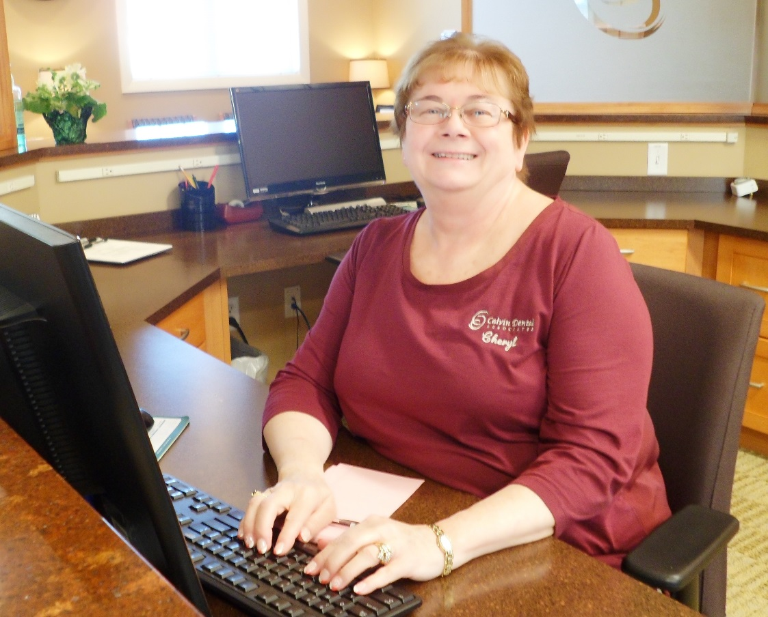

Cheryl – Receptionist

I have been a receptionist and part of the Calvin Dental team since 2011. I enjoy interacting with our patients and making sure that every one is greeted with a warm welcome. I’m always available to answer patients’ questions and help them with their dental treatment planning.

In my time out of the office, I enjoy spending time with my husband, children and grandchildren.