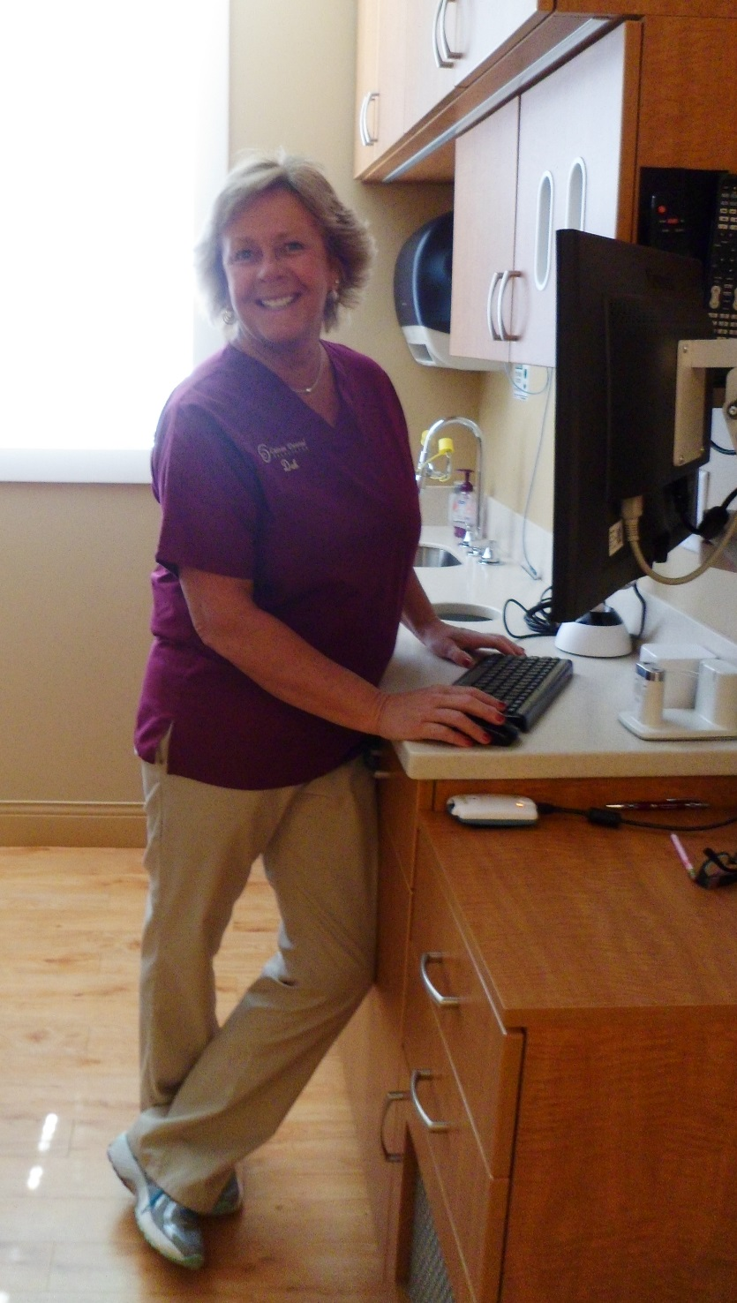

Deb – Dental Assistant

I have been a team member of Calvin Dental Associates since 2008 and obtained my assisting degree from NE School of Dental Assisting. I find enjoyment in getting to know my patients and meeting their individual needs while working with Dr. Calvin.

In my spare time, I enjoy traveling and spending time at the beach with my family and friends.