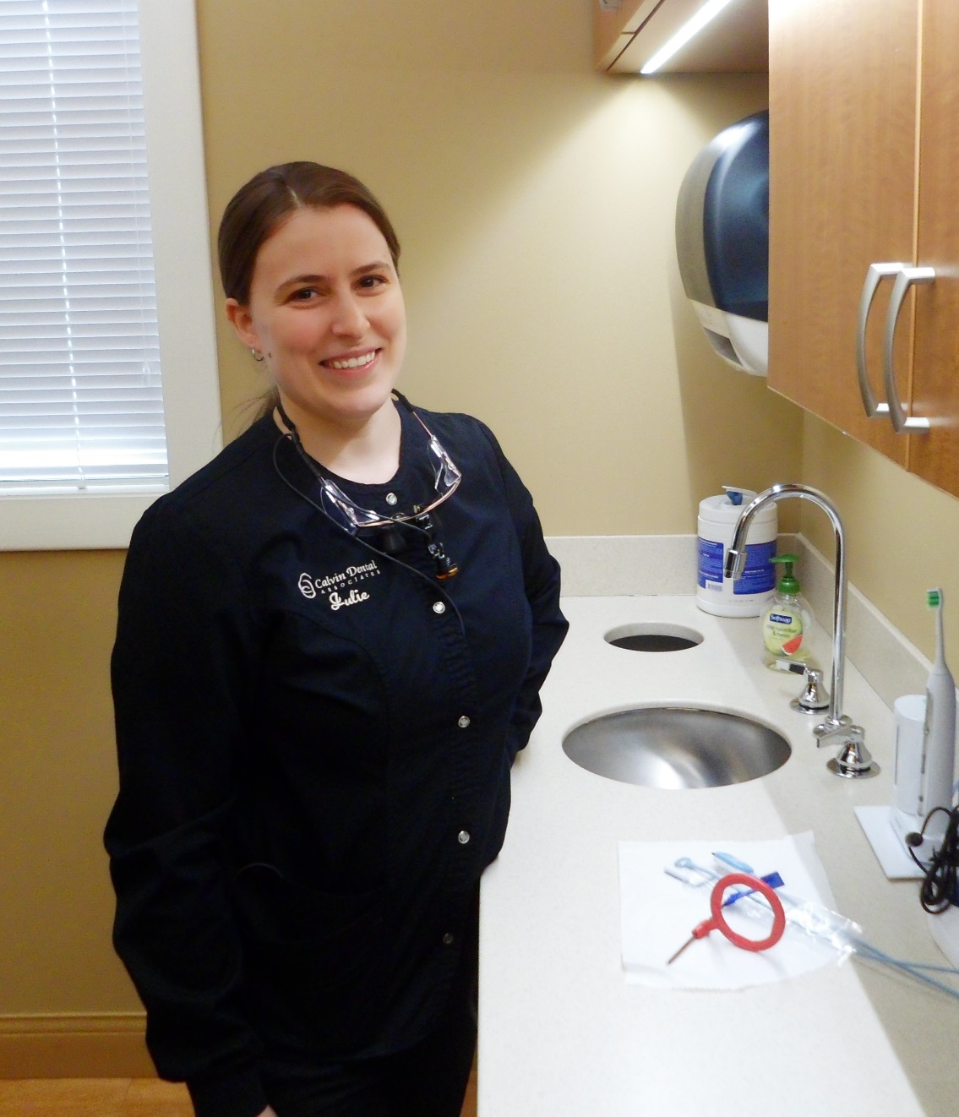

Julie – Dental Hygienist

I have been a team member at Calvin Dental since 2014 and am registered with the NH Dental Board to administer local anesthesia. I truly enjoy being a team member at Calvin Dental Associates where I get to form great relationships with my patients as I help them with their oral health.

I am originally from Michigan but have spent time living in California, Florida and Iowa. Outside of the office, I like to travel, attend hockey games with my family and work on home renovation projects.