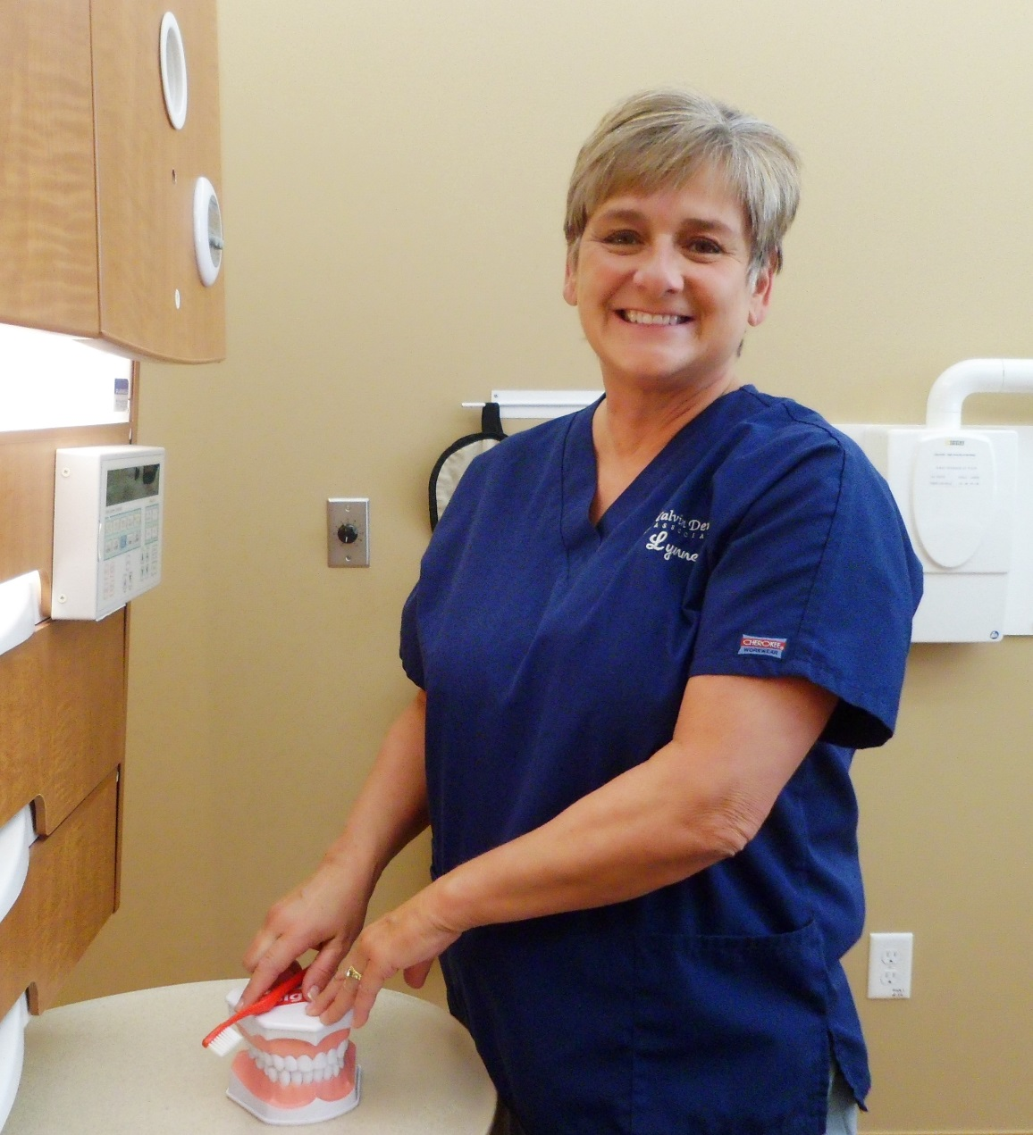

Lynne – Dental Hygienist

I obtained my Dental Hygiene Degree in 1977 from Middlesex Community College and joined Calvin Dental 15 years ago. I take pride in knowing my patients individually and providing high quality dental care in a relaxed and comfortable environment.

In my spare time I enjoy spending time with my grown children, granddaughter and large family at their beach house or in ski country.