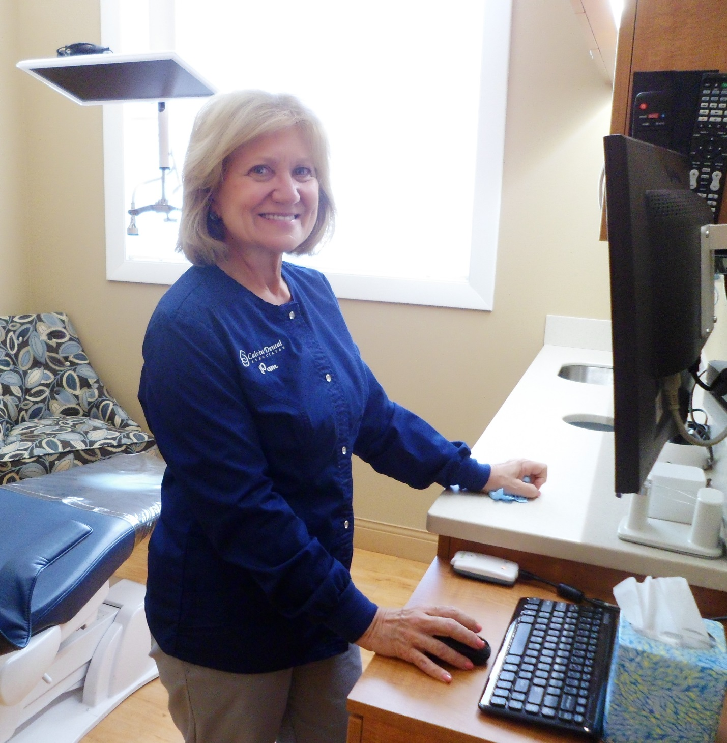

Pam – Dental Hygienist

I joined the team in December 2016 and am qualified and registered with the New Hampshire Board of Dental Examiners to administer dental anesthesia. I have completed many post graduate courses involving periodontal disease, aesthetic and neuromuscular dentistry and am happy to share my knowledge with my patients. In my free time, I enjoy spending time with my family and taking my labordoodle, Bailey, on long walks.