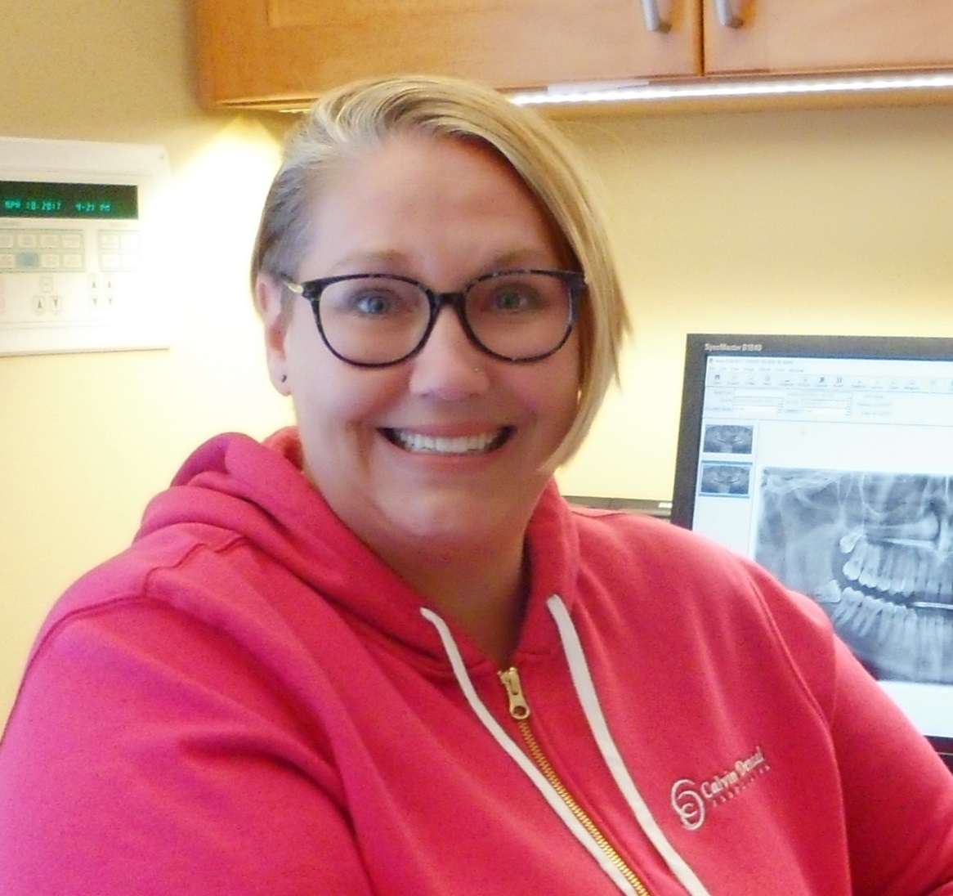

Wendy – Dental Assistant

I have been working in the dental field since 1986 and thoroughly enjoy working with people and our wonderful dental team. The advanced technology in our office is what I love most as it allows us to provide the absolute best care for our patients. Dr. Calvin’s passion for dentistry is outstanding and our patients adore him for the care that he provides.

In my spare time, I enjoy Boston sports teams and going to games. I love traveling, spending time with my cat Leo and soaking up the sun in my happy place – the beach.