Practical Documentation

* The app is .NET Core Console application following SOLID ENGINEERING principles
* Divided the classes to be handling single responsibility, Isolated Classes and methods including the test methods so then they test the single feature which is vital to for the entire system.
* Also the code is reusable and making changes to a component do not effect the other as according to the solid engineering principles.

1. Can run the application by navigating to \CodingAssessment\bin\Release\net5.0 NameSorter(Application)

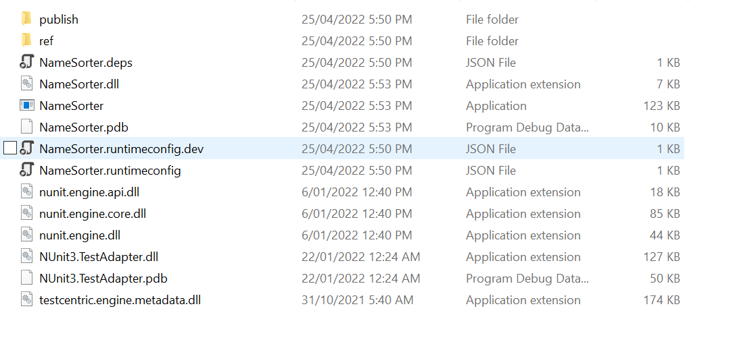

Note that not to move .exe file because reading ‘unsorted-names-list.txt’ file would fail because of the path setup in the code.

1. Unit Tests all written using NUnit and could be run as usual in the visual studio from

Test > Run All Tests

1. Have added comments to code as to give explanation on what and why I have coded that way.
2. Make sure to have the “unsorted-names-list.txt” file should be in the parent directory as shown below.

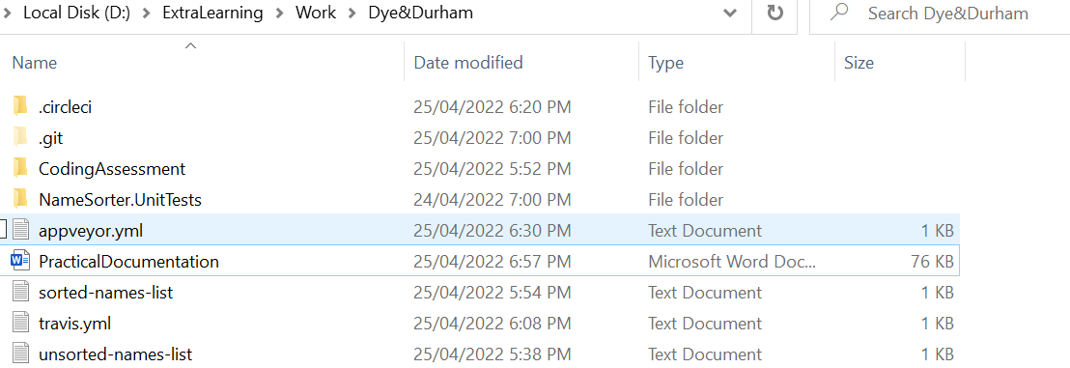

1. With “sorted-names-list.txt” if it exists content would be overwritten and if not it will be created and contents would be written so not to worry about it.

Tried my best to build pipelines with Travis, Appveyor and even CircleCi but throwing out errors couldn’t build a successful pipleline but have attached the configuration .yml files in the repository.