CHAPTER 3: SYSTEM DESIGN

3.1 OBJECTIVES OF THE DESIGN

The objectives of pure inventory management are to provide the desired level of customer service, to allow cost-efficient operations, and to minimize the inventory investment in terms of material, employees, space and time

Pure inventory management system is designed to make work easier in entering data into the system accurately in a short period of time. It also automatically generates receipt to clients, show reports of all the purchases, stock available, business statements, e.t.c

3.2 FILE DESIGN

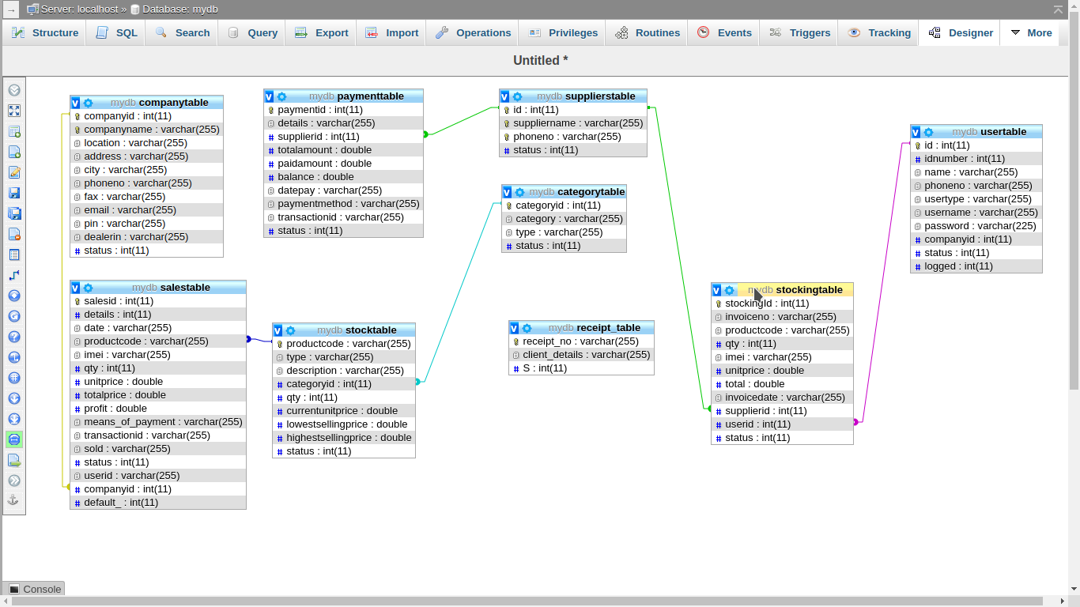
The above diagram illustrates the ERD shows entity relationship
The database that stores all the record of Pure inventory system is called mydb and conprises of the following tables

1. The usertable is the table that keeps all the data of the users who are to access the system.
usertable
 | ATTRIBUTE | DATATYPE | WIDTH
1 | id | int | 11
2 | idnumber | Int | 11
3 | name | varchar | 40
4 | phoneno | varchar | 15
5 | usertype | varchar | 10
6 | username | varchar | 10
7 | password | varchar | 255
8 | companyid | int | 11
9 | status | int | 11
10 | logged | Int | 11

2. The supplierstable is the table that keeps data of the details and information of all the suppliers that supply mobile phones to the business.

supplierstable
 | ATTRIBUTE | DATATYPE | WIDTH
1 | id | int | 11
2 | suppliername | varchar | 20
3 | phoneno | varchar | 20
4 | status | int | 11

3. The stockingtable is the table that holds all the information of the items/mobile phones purchased.

stockingtable
 | ATTRIBUTE | DATATYPE | WIDTH
1 | stockingid | int | 11
2 | invoiceno | varchar | 30
3 | productcode | varchar | 40
4 | qty | int | 11
5 | imei | varchar | 15
6 | unitprice | double | -
7 | total | double | -
8 | invoicedate | data
9 | supplierid | int | 11
10 | userid | Int | 11
11 | status | int | 11

4. The stocktable is the table that holds all the mobile phones that are currently in stock. As the stockingtable is enters, by purchases, the stocktable is updated

stocktable
 | ATTRIBUTE | DATATYPE | WIDTH
1 | productcode | varchar | 40
2 | type | varchar | 40
3 | description | varchar | 40
4 | categoryid | int | 11
5 | qty | int | 11
6 | currentunitprice | double | -
7 | lowestsellingprice | double | -
8 | highestsellingprice | double | -
9 | status | int | 11

5. The categorytable is the table that keeps all the types of categories of the phones that are sold in the business
categorytable
 | ATTRIBUTE | DATATYPE | WIDTH
1 | categoryid | int | 11
2 | category | varchar | 30
3 | type | varchar | 30
4 | status | int | 11

6. The companytable is the table that keeps all the company details. These details are mostly stored for reporting purposes

companytable
 | ATTRIBUTE | DATATYPE | WIDTH
1 | companyid | int | 11
2 | companyname | varchar | 40
3 | location | varchar | 12
4 | address | varchar | 40
5 | city | varchar | 15
6 | phoneno | varchar | 15
7 | fax | varchar | 15
8 | email | varchar | 40
9 | pin | varchar | 15
10 | dealerin | varchar | 10
11 | status | int | 11

7. The salestable is the table that keeps all the transactions of sales and receipting in the business.

salestable
 | ATTRIBUTE | DATATYPE | WIDTH
1 | salesid | int | 11
2 | details | varchar | 40
3 | date | varchar | 12
4 | productcode | varchar | 40
5 | item | varchar | 40
6 | qty | int | 11
7 | unitprice | double | -
8 | totalprice | double | -
9 | profit | double | -
10 | means_of_payment | varchar | 10
11 | transactionid | int | 11
12 | sold | int | 11
13 | status | int | 11
14 | userid | int | 11
15 | companyid | int | 11
16 | default_ | int | 11

8. The paymenttable is the table that keeps data of all the payments the business has done to the suppliers. This shows the business the balances and also helps in the generation of supplier statements.

payementtable
 | ATTRIBUTE | DATATYPE | WIDTH
1 | paymentid | int | 11
2 | details | varchar | 40
3 | supplierid | int | 11
4 | totalamount | double | -
5 | paidamount | double | -
6 | balance | double | -
7 | datepay | varchar | 15
8 | paymentmethod | varchar | 40
9 | transactionid | varchar | 15
10 | status | int | 11

File organization

File organization refers to the way data is stored in a file. File organization is very important because it determines the methods of access, efficiency, flexibility and storage devices to use. There are four methods of organizing files on a storage media. This include:
- sequential,
- random,
- serial and
- indexed-sequential

- Sequential file organization
- Records are stored and accessed in a particular order sorted using a key field.
- Retrieval requires searching sequentially through the entire file record by record to the end.
- Because the record in a file are sorted in a particular order, better file searching methods like the binary search technique can be used to reduce the time used for searching a file .
- Since the records are sorted, it is possible to know in which half of the file a particular record being searched is located, Hence this method repeatedly divides the set of records in the file into two halves and searches only the half on which the records is found.
- For example, of the file has records with key fields 20, 30, 40, 50, 60 and the computer is searching for a record with key field 50, it starts at 40 upwards in its search, ignoring the first half of the set.
Advantages of sequential file organization
- The sorting makes it easy to access records.
- The binary chop technique can be used to reduce record search time by as much as half the time taken.
Disadvantages of sequential file organization
- The sorting does not remove the need to access other records as the search looks for particular records.
- Sequential records cannot support modern technologies that require fast access to stored records.
- The requirement that all records be of the same size is sometimes difficult to enforce.
- Random or direct file organization
- Records are stored randomly but accessed directly.
- To access a file stored randomly, a record key is used to determine where a record is stored on the storage media.
- Magnetic and optical disks allow data to be stored and accessed randomly.
Advantages of random file access
- Quick retrieval of records.
- The records can be of different sizes.
- Serial file organization
- Records in a file are stored and accessed one after another.
- The records are not stored in any way on the storage medium this type of organization is mainly used on magnetic tapes.
Advantages of serial file organization
- It is simple
- It is cheap
Disadvantages of serial file organization
- It is cumbersome to access because you have to access all proceeding records before retrieving the one being searched.
- Wastage of space on medium in form of inter-record gap.
- It cannot support modern high speed requirements for quick record access.
- Indexed-sequential file organization method
- Almost similar to sequential method only that, an index is used to enable the computer to locate individual records on the storage media. For example, on a magnetic drum, records are stored sequential on the tracks. However, each record is assigned an index that can be used to access it directly.
ACCESS METHODS

- Create – This is the method that is used in creating tables in the database of the Pure Inventory System
- Insert – This is the access method used in the insertion of data in the database of the Pure Inventory System
- Update – This is the access method used in the updating of the data that has already been inserted in the database of the Pure Inventory System
- Delete – This is the method that is used in the deletion of data from the database of the Pure Inventory System

3.3 INPUT DESIGN
User interfaces in form of data entry forms or screens should be designed.
The forms for data entry should be clearly captioned, easy to use, attractive and consistent. Some of the forms needed for Pure Inventory System are: shop details entry form, users registration details form, supplier registration entry form, products entry form, supplier payments form and categories entry form

a) Shop Details Entry Form
This is where the company/shop detail are entered and updated. These details mainly appear at the top of report showing all the details as registered in this form

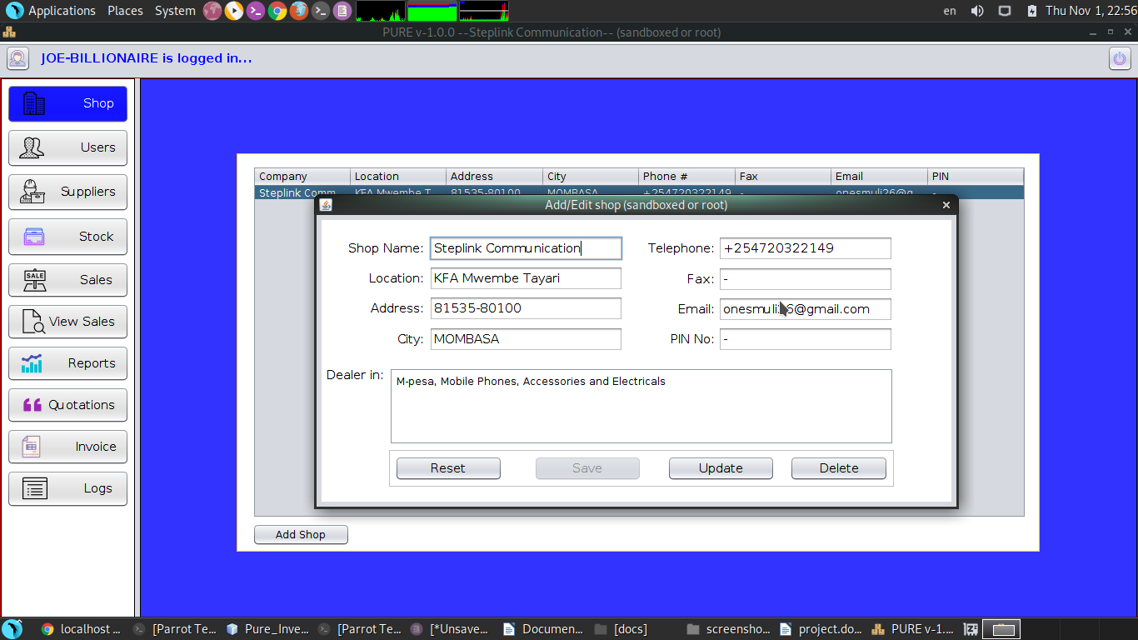

b) Users Registration Details Form
This form is designed for registering all the users who will access the system. This form is the one that provide privileges and assigns them to each user in the system.

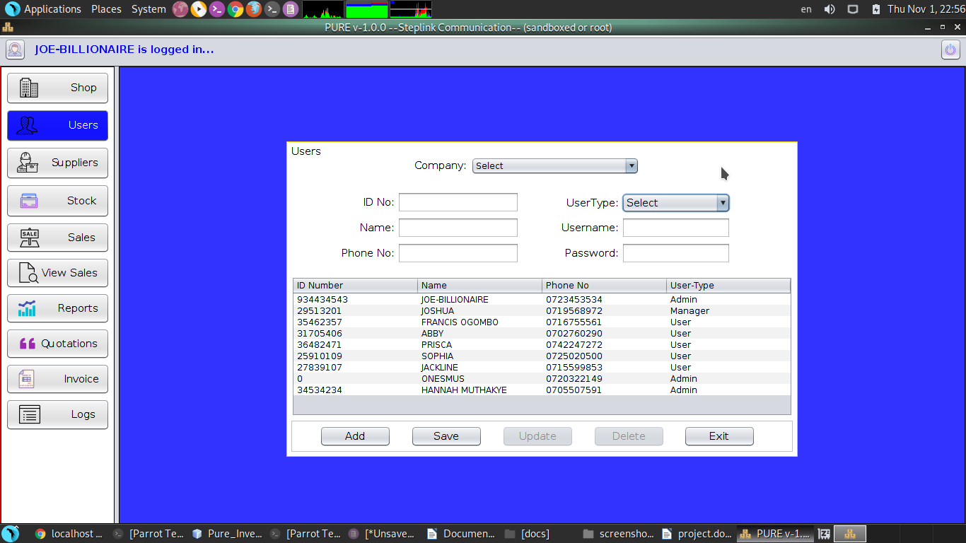
c) Supplier Registration Entry Form
This it the form that registers all the suppliers that supply mobile phones to the shop.

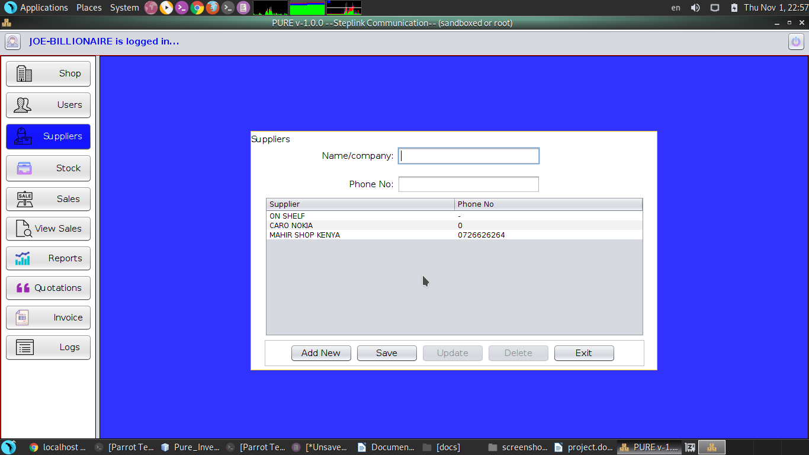

d) Products Entry Form
This is the form where all purchased products or mobile phones from the registered suppliers are entered in the system.

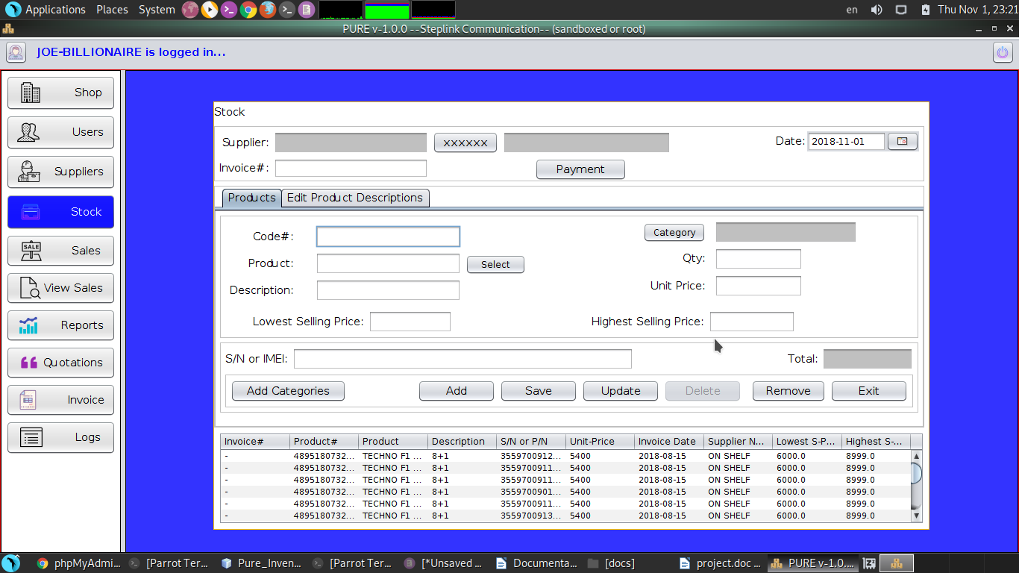
e) Supplier Payments Form
This is the form where all the payments to suppliers are done.

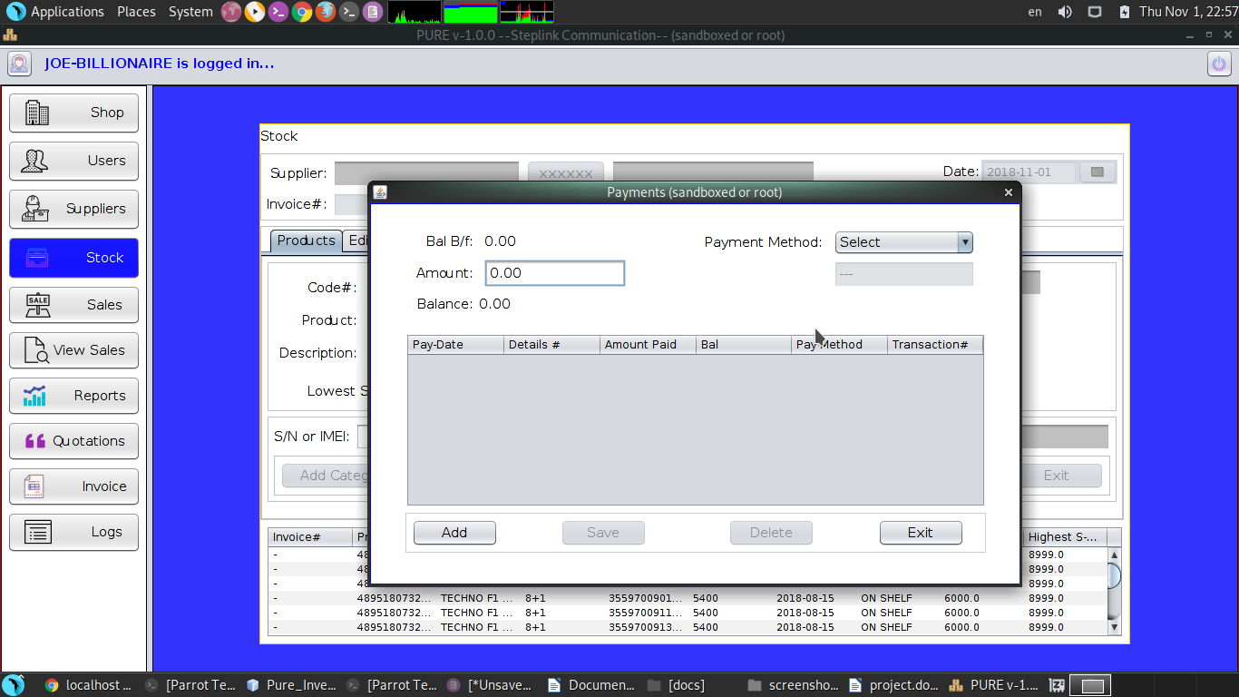

f) Categories Entry Form
This is the form where the user enters all the categories of the product he/she is to sell in the shop/company

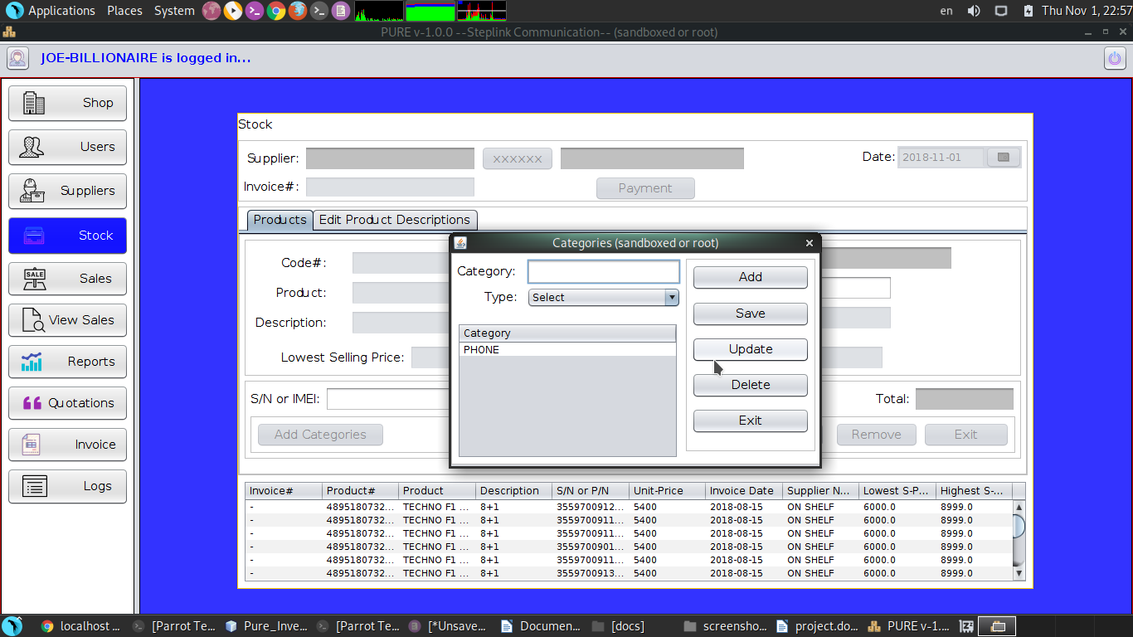
3.4 PROCESS DESIGN
User interfaces in form of data processing forms or screens should be designed.
The forms for data entry should be clearly captioned, easy to use, attractive and consistent. Some of the process needed for Pure Inventory System are: sales form, invoice processing entry form and quotation processing entry form

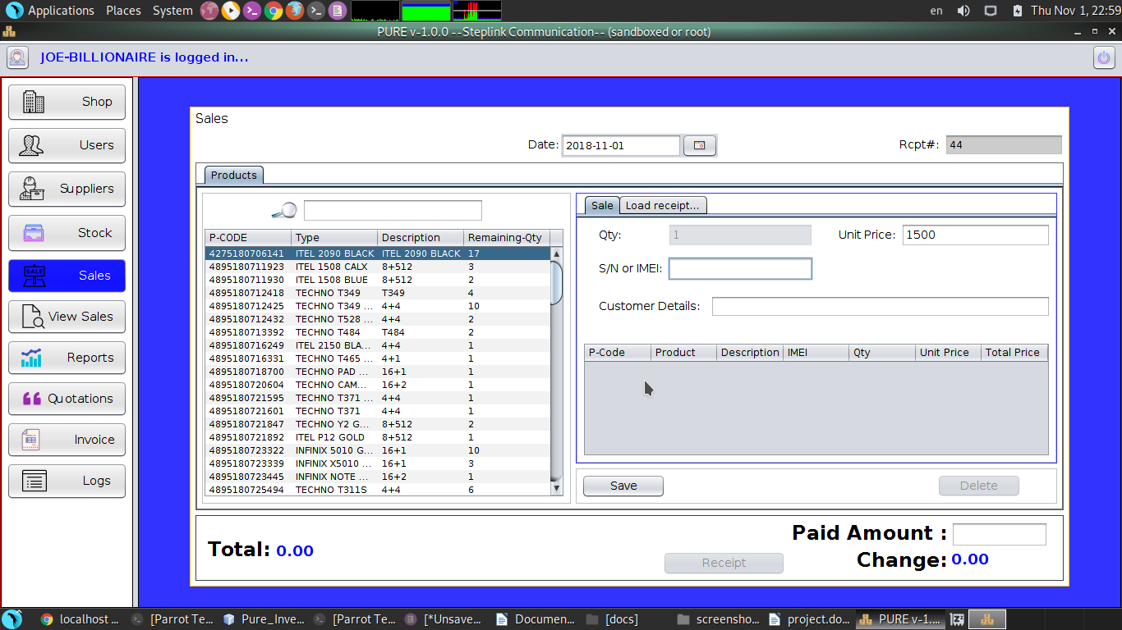
a) Sales Processing Form – This is where the user inputs the data during sales of a product. This is the form where sales and receipting done. It records all the transactions that took place.

Sales Receipt – This is the output result of the sales processing form, where a receipt is generated as shown below

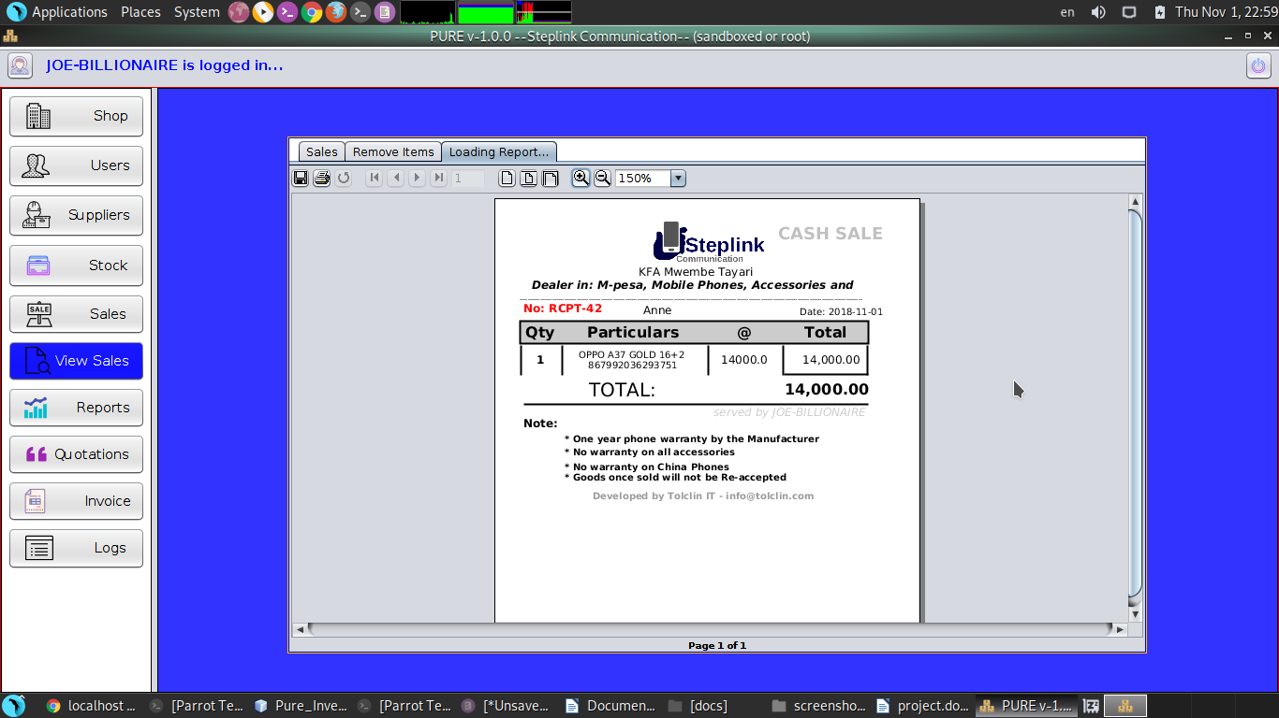

h) Invoice Processing Entry Form
This is the form where processing of invoices is done.

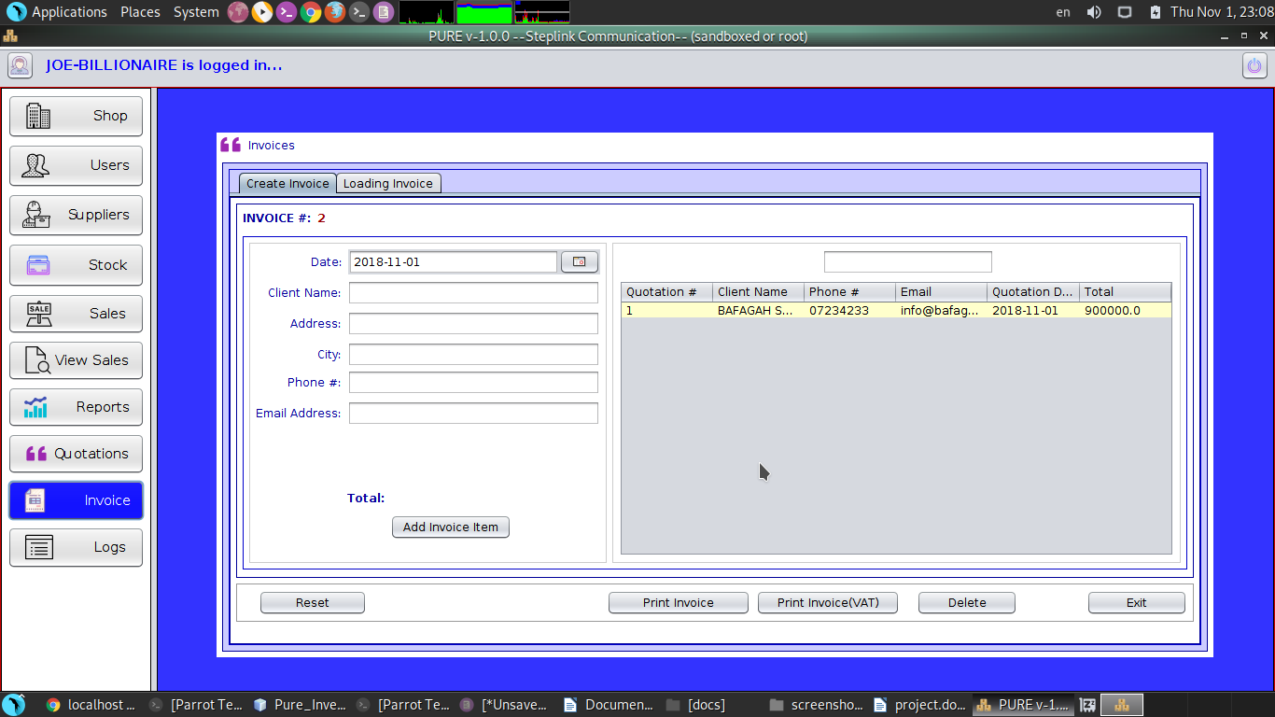

Invoice Generated – This is the output result of the Invoice processing form, where an invoice is generated as shown below

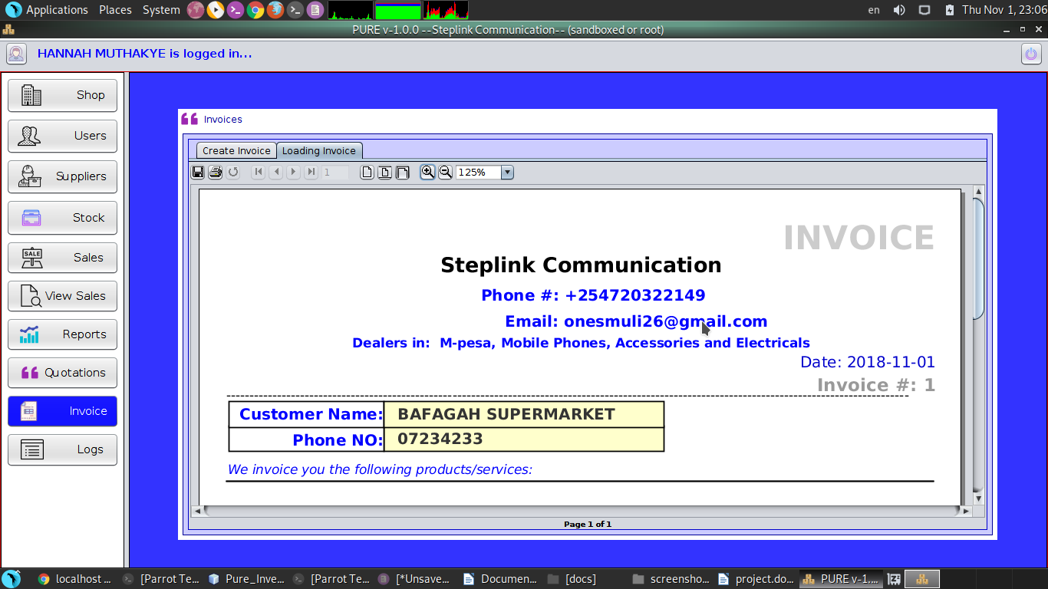
i) Quotation Processing Entry Form
This is the form where all quotation are being processed

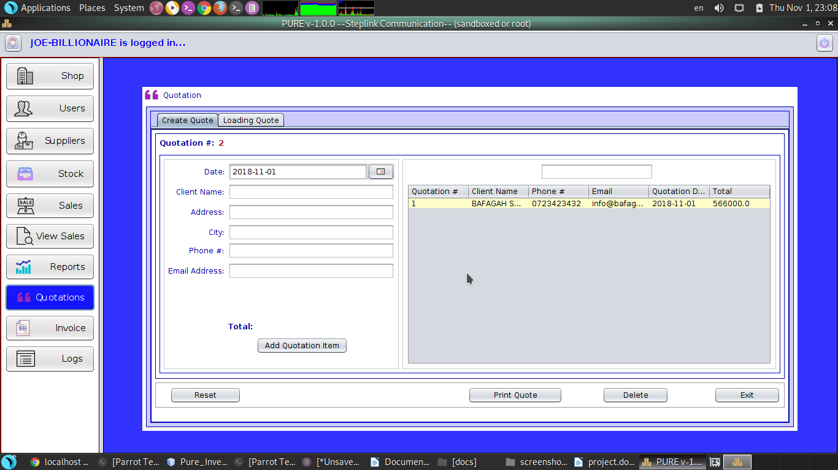

Quotation Generated – This is the output result of the quotation processing form, where a quotation is generated as shown below

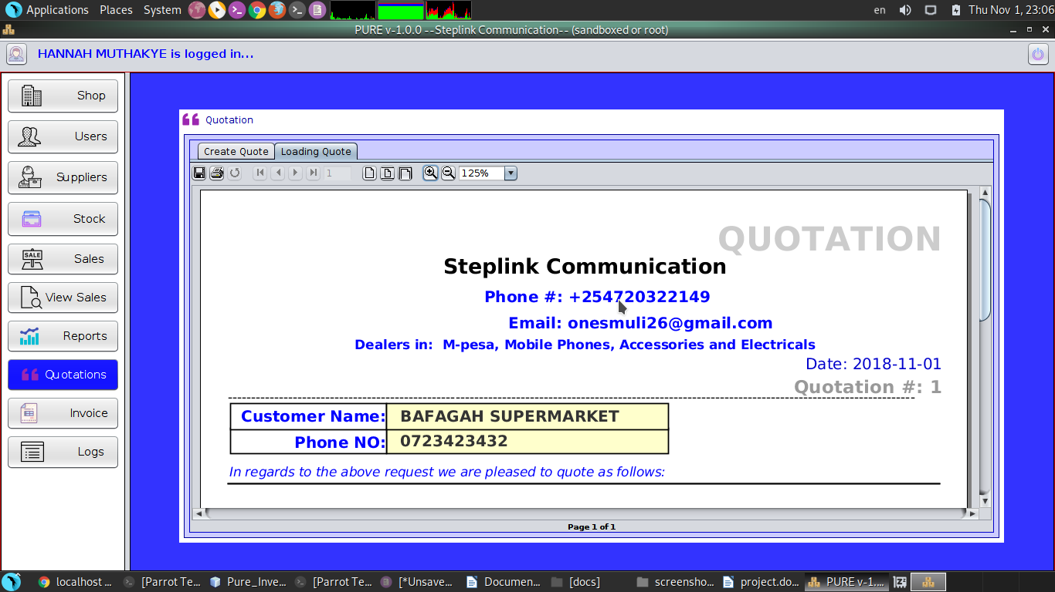

3.5 CONTROL DESIGN
This is where the system has been made secure and measures put in place to ensure that the system is secure and not subjected to abuse include Login, the log module and database authentication.

a) The Login – This is where authorized users are allowed to login in the system. They enter username and password which were registered by the administrator. The password is hashed into the database for security reason.

b) Logs Module – This module shows the administrators the activities performed by the users. If a user deletes or modifies data, the administrator could see which kind of data has been modified.

c) Database Authenication – This is the mysql database that is designed using xampp. To access the database, the only person allowed to access this is the system developer who has the only access to the database and that no one can access the database to destort data

3.6 TEST DESIGN

Individual system modules were tested using test data and found to work accurately and properly.
Sample test data and error messages that were encountered due to invalid data entry are given in the Appendix of this project report.

3.7 PROGRAM DESIGN

Specification:
- This software is designed to make the work of the business man easier in purchases to sales. It keeps records to the database for easy access and the system gives you perfect reports.

Analysis:
- Company Registration – This is where the company information is registered and used in the reporting purporses
- Users Registration – This is where the users details that are authorized to access the system are entered. The system identifies the users during the different operation of the system ie, the systems records every operation the user performs
- Suppliers Registration – This is where all the suppliers’ details are entered for easily access during entering of stock in the system
- Stock – This is the module that all purchases are registered
- Sales – This is the module where sales transactions are done
- Report – this is where all the reports are generated for the business
- Quotation – This is where the quotations are processed for clients
- Invoices – This is the module where the invoices are generated
- Logs – These are audit trails that show logs of the operation the users have been doing in the system

