SOFTWARE DEVELOPMENT LIFECYCLE (SDLC)
PROJECT TITLE: STUDENT GRADE MANAGEMENT SYSTEM
STUDENT NAME: ABIODUN JOEL ENIOLA
MATRIC NUMBER: 25/18070
DEPARTMENT: COMPUTER SCIENCE
INSTITUTION: CALEB UNIVERSITY

INTRODUCTION
The Software Development Life Cycle (SDLC) is a systematic process used in the development of software systems.
This project adopts the Waterfall Model because of its simplicity and suitability for small academic projects.

SDLC Model Used: WATERFALL MODEL
The Waterfall Model is a linear and sequential approach where each phase must be completed before moving to the next.

Reasons for Choosing the Waterfall Model:
- Easy to understand and implement
- Clearly defined phases
- Suitable for beginner-level projects
- Ideal for academic assignments
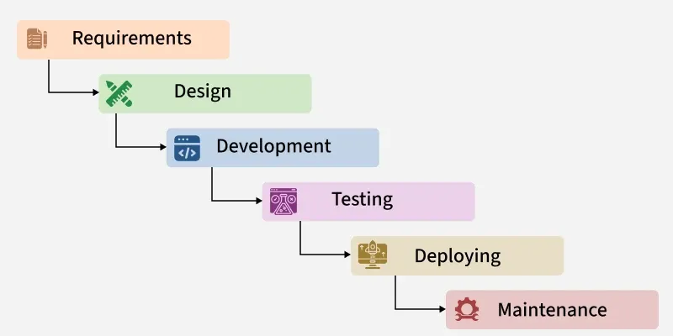

PHASE 1: REQUIREMENT ANALYSIS
At this stage, the requirements of the system were identified.
The system is required to:
- Accept student name
- Accept test and exam scores
- Calculate total score
- Assign grades
- Display student results

PHASE 2: SYSTEM DESIGN
In this phase, the structure of the system was planned.
Design decisions include:
- Use of Python programming language
- Console-based interface
- Use of functions for modularity
- Use of conditional statements for grading

PHASE 3: IMPLEMENTATION
This phase involved writing the actual Python code.
Implementation details include:
- Use of input() for user input
- Functions for calculations
- if-elif-else statements for grade assignment
- Clear variable naming

PHASE 4: TESTING
The system was tested using different inputs to ensure correctness.
Testing included:
- Valid score inputs
- Boundary values
- Verification of grade assignment

PHASE 5: DEPLOYMENT
After testing, the project was deployed.
Deployment involved:
- Uploading the project to GitHub
- Adding documentation
- Making the system available for execution

PHASE 6: MAINTENANCE
This phase involves future updates and improvements.
Possible improvements include:
- Adding support for multiple students
- Saving records to files or databases
- Developing a graphical user interface

CONCLUSION
The Waterfall Model provided a clear and structured approach for developing the Student Grade Management System.

