NAMA:

Before working on this Midterm, please have a look at the grading. Try to do your best, and I will value your efforts.

Grading**:**

**Correct answer**: 3/3 of the points

**Correct dictions**, **small mistake** in grammar: 2/3 points

Wrong grammar, **correct dictions** 1/3

Wrong grammar, wrong diction: 0

**正確答案**：3/3分

**正確的詞彙**，語法上的**小錯**誤：2/3分

錯誤的語法，**正確的詞典** 1/3

錯誤的語法，錯誤的詞彙： 0

1. **Listen and anwer by writing 請依據所聽到的內容寫出答案:**

2 points

* 1. _______

3 points

* 1. ___kamu berapa bersaudara_(or)__kamu punia berapa bersaudara_

3 points

* 1. ___kamu suka apa____

5 points

* 1. _________

1. **Please answer the question 請回答以下問題:**

5 points

* 1. Mereka **dari mana**?



rumah

1. **Please write down tenses of each sentence and change it to the assigned tenses (you can add adverb of time)**

**請針對每個句子寫下對應的文法並改寫成指定的文法。**

**（加上時間副詞 +2分）**

3 points

|  |  |
| --- | --- |
| Adik mau tidur | Change to **past tense**改寫成**過去式**:  Add the past tense word |
| **What tense is this? 這是什麼時態?**  present |

|  |  |
| --- | --- |
| Papa akan minum kopi | Change to **present continuous tense現在進式**: |
| **What tense is this? 這是什麼時態?** |

3 points

3 points

|  |  |
| --- | --- |
| Allen sudah makan es krim | Change to **future tense未來式**: |
| **What tense is this? 這是什麼時態?** |

|  |  |
| --- | --- |
| Elvis mau beli ayam goreng | Change to **past tense**改寫成**過去式**: |
| **What tense is this? 這是什麼時態?** |

3 points

3 points

|  |  |
| --- | --- |
| Xavier mau main bola basket besok | Change to **present tense 現在簡單式**: |
| **What tense is this? 這是什麼時態?** |

1. Namaku Maria, aku asalnya dari Medan. Umurku dua puluh empat tahun. Aku jurusan Geografi. Aku suka main bola. Aku suka makan mi goreng. Senang kenalan denganmu!

**Please answer this question in** Bahasa **請以印尼語回答此問題**:

2 points

* 1. Maria, umurnya berapa tahun?

**Answer**:

2 points

* 1. Dia suka apa?

**Answer**:

2 points

1. **Answer this question 請回答此問題:** Kamu punya agama?

**Answer:**

1. **Write down the number of 寫出此數字**:

3 points

Enam ratus dua ribu, delapan puluh lima. 🡪 _______________

1. **Write down the Bahasa Indonesia** for: 104.307 🡪

5 points

**請以印尼語（文字）寫出此數字**

1. **Translate these words 請翻譯以下單字:**

6 points

|  |  |  |  |  |  |
| --- | --- | --- | --- | --- | --- |
| No | Indo.Word | Meaning |  | Indo.word | Meaning |
|  | Pacar |  |  |  | How 怎嚒 |
|  | Samping / sebelah |  |  |  | Study (University) 讀大學 |
|  | Makan |  |  |  | Month 月 |
|  | Minum |  |  |  | You guys 你們 |
|  | Pergi |  |  |  | Like 喜歡 |
|  | Jumat |  |  |  | No 不/沒 |
|  | Sabtu |  |  |  | Home / house 家 |
|  | Kami |  |  |  | Buy 買 |
|  | Restoran |  |  | Mba (Rini) | Ms. / Miss 姐/小姐 |
|  | Apa kabar? | Hi |  |  | Not yet 還沒 |
|  | Saudara |  |  |  | Let me introduce 讓我節紹 |
|  | punya |  |  |  | Holiday假期 |
|  | Sini |  |  |  | Not bad 不錯 |
|  | Minggu |  |  |  | Excuse me 不好意思 |
|  | Hari |  |  |  | People 人 |

1. **Write down the Indonesian words** for 請寫出以下圖片的**印尼語單字**:

10 points

Apel ada di__________________kotak (box)

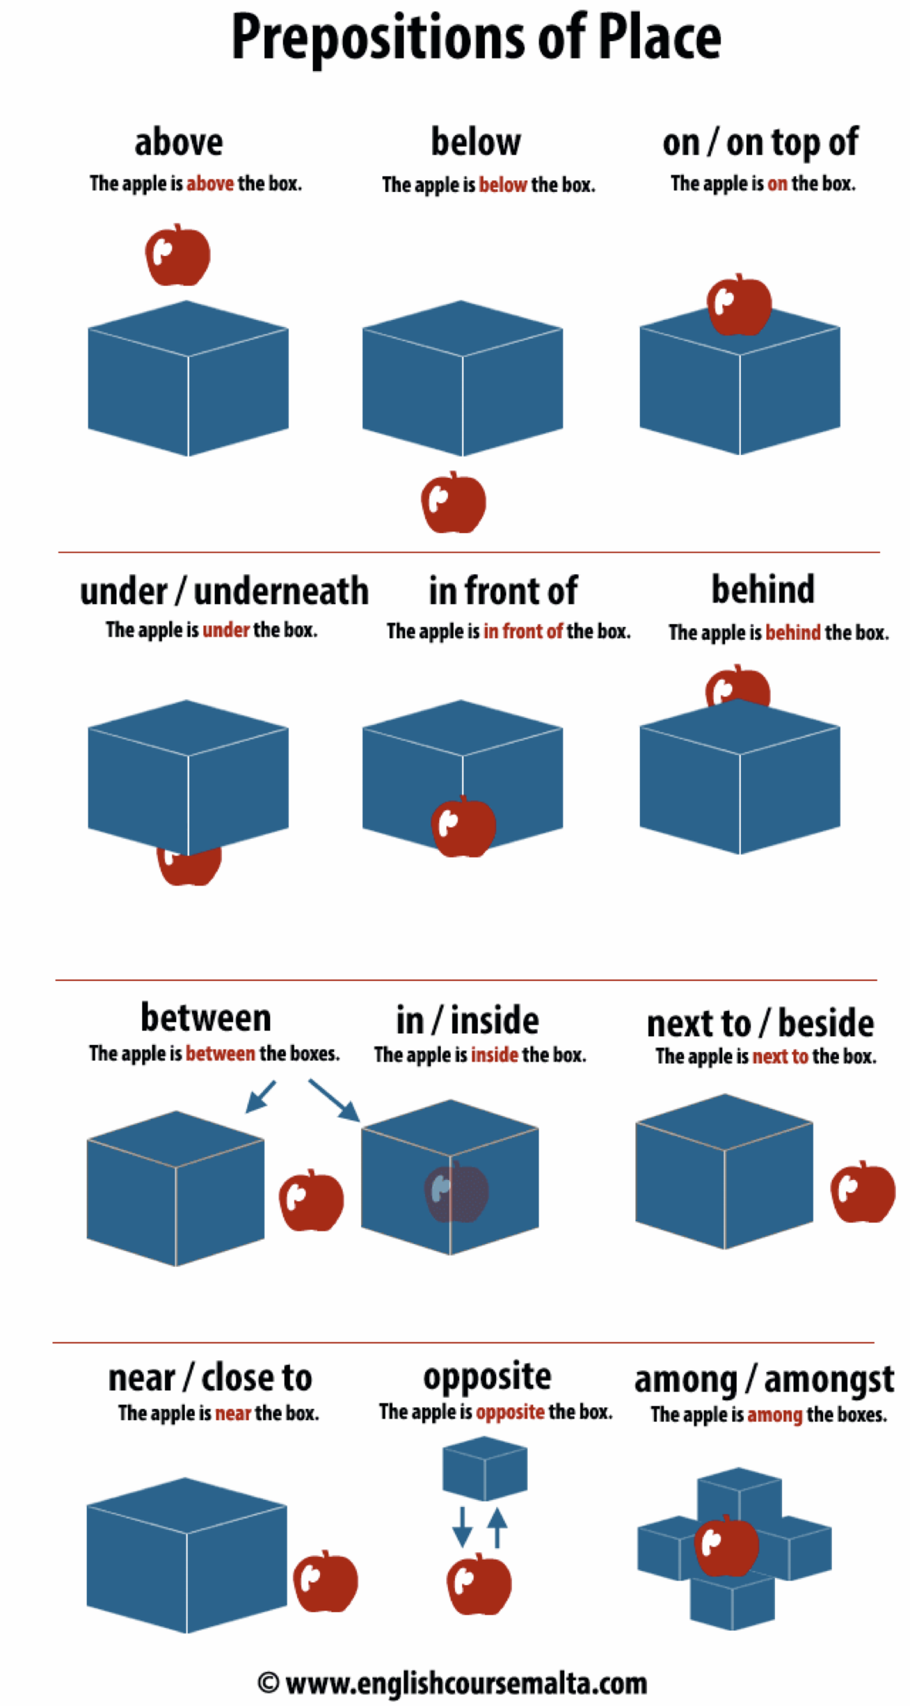





Apel ada di_____________kotak (box)

Apel ada di______________kotak (box)



Apel ada di__________kotak (box)



Apel ada di__________kotak (box)

Apel ada di__________kotak (box)

1. **Answer the question 請回答此問題**:

5 points

Kamu biasanya sarapan jam berapa?



5 points

1. **Answer the question** **請回答此問題**: Ini jam berapa?

5 points

1. **Please translate using Indonesian *words*請翻譯成*印尼語***: It’s 23.30

1. **Please guide me 請引導我**:

2 points

* 1. Kalau saya sedang di Halte bus, gimana caranya (pergi) ke toko alat tulis?

4 points

* 1. Kalau saya sedang di Rumah Sakit Umum (RSU), bagaimana caranya (pergi) ke toko buah?

6 points

* 1. kalau saya dari toko buah, gimana caranya (pergi) ke kafe?

10 points

* 1. Kalau saya sedang di SD, gimana caranya ke toko sepatu?

Jl. Kartini Jalan Kartini

Halte Bus

Toko kue

Rumah Sakit Umum

(RSU)

Sekolah Dasar

(SD)

Salon

kafe

Mesin ATM

Toko alat tulis (stationery)

Apotek

Mie ayam Pak Anto

Bakso Mataram

Jalan Sudirman Jalan Sudirman

Jalan Ksatria Jalan Ksatria



Jalan A.H. Yani Jalan A.H. Yani



Ayam Penyet

Toko sepatu

Toko Buah



Mesin ATM