**Name: JOEL JOHN JOSEPH**

**Roll No: 08**

**Batch: S2MCA**

**Date: 08/04/2022**

**ADVANCED DATABASE MANAGEMENT SYSTEM LAB**

**Experiment No.: 2**

**AIM**

To familiarize with selecting data from table

**PROCEDURES**

1. List all data from table deposit

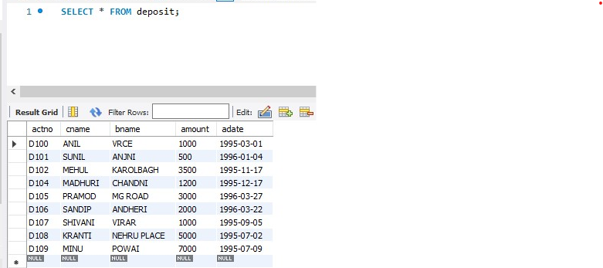

1. List all data from borrow

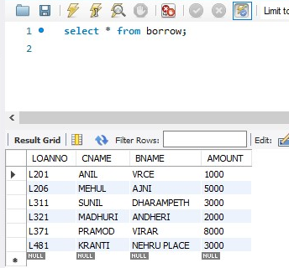

1. List all data from customer

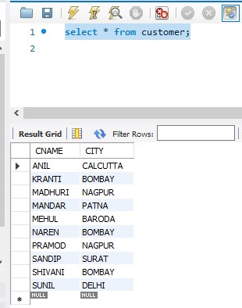

1. List all data from branch

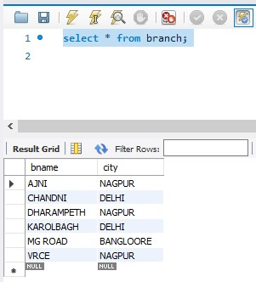

1. Give account no and amount of deposit

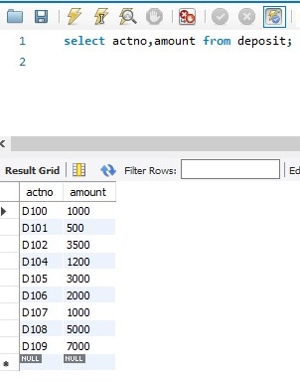

1. Give customer name and account no of depositors

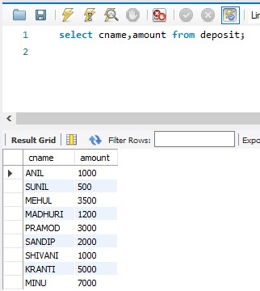

1. Give name of customers

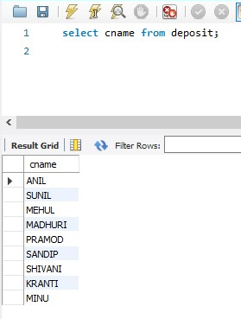

1. Give name of branches

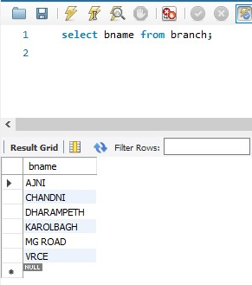

1. Give name of borrows

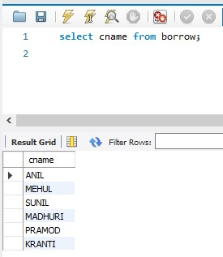

1. Give names of customer living in city Nagpur

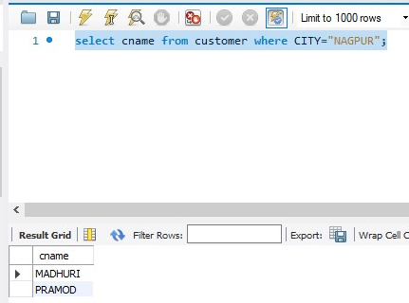

1. Give names of depositors having amount greater than 4000

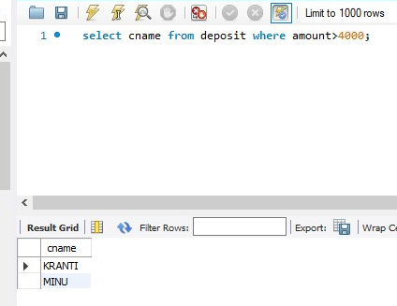

1. Give account date of Anil

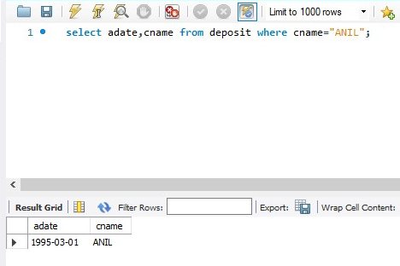

1. Give name of all branches located in Bombay

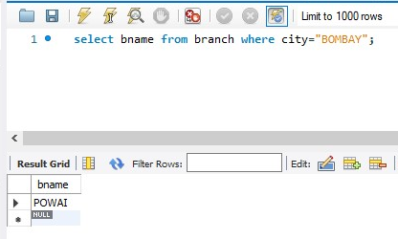

1. Give name of borrower having loan number l206

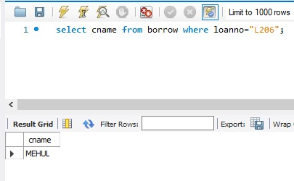

1. Give names of depositors having account at VRCE

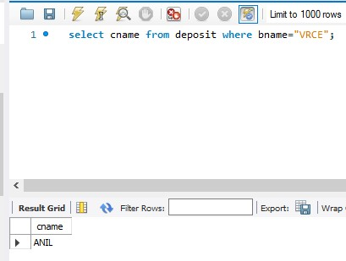

1. Give names of all branched located in city Delhi

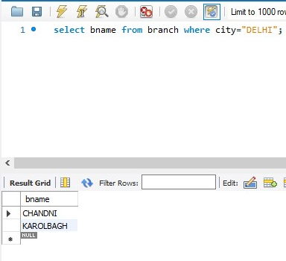

1. Give name of the customers who opened account date ‘1-12-96’

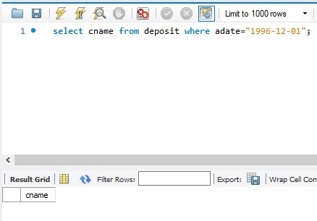

1. Give account no and deposit amount of customers having account opened between dates ‘1-12-96’ and ‘1-5-96’

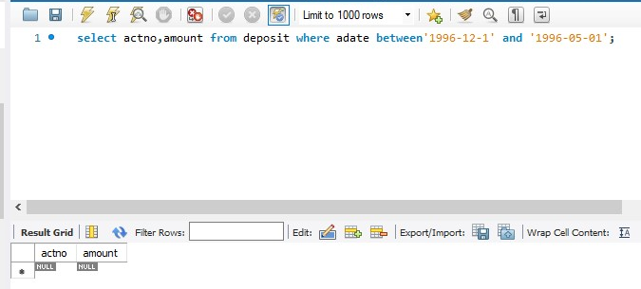

1. Give name of the city where branch KAROLBAGH is located

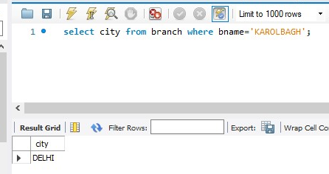

1. Give details of customer ANIL

