**Name: JOEL JOHN JOSEPH**

**Roll No: 8**

**Batch: RMCA S2B**

**Date: 5-4-22**

**NETWORKING & SYSTEM ADMINISTRATION LAB**

**Experiment No.: 2**

**Aim**

Familiarization of Hardware Components in a Computer.

**Procedure**

**1. Motherboard**

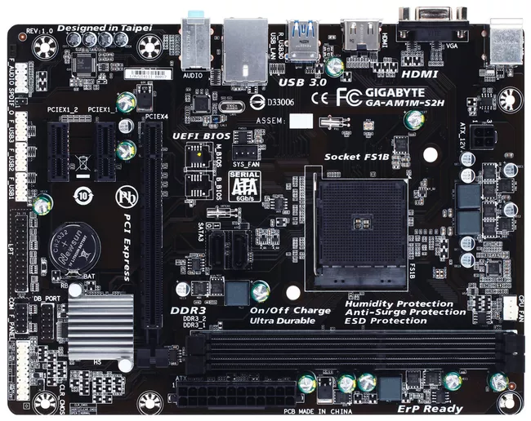

The motherboard is the piece of computer hardware that can be thought of as the "backbone" of the PC, or more appropriately as the "mother" that holds all the pieces together.

Phones, tablets and other small devices have motherboards, too, but they're often called logic boards instead. Their components are usually soldered directly onto the board to save space, which means there aren't expansion slots for upgrades like you see in desktop computers.

The IBM Personal Computer that was released in 1981, is considered to be the very first computer motherboard (it was called a "planar" at the time).

A motherboard comes with following features −

* Motherboard varies greatly in supporting various types of components.
* Motherboard supports a single type of CPU and few types of memories.
* Video cards, hard disks, sound cards have to be compatible with the motherboard to function properly.

Popular motherboard manufacturers include ASUS, AOpen, Intel, ABIT, MSI, Gigabyte, and Biostar.

**2. Power supply unit**

A power supply unit (PSU) converts mains AC to low-voltage regulated DC power for the internal components of a computer. Modern personal computers universally use switched-mode power supplies. Some power supplies have a manual switch for selecting input voltage, while others automatically adapt to the mains voltage.

Most modern desktop personal computer power supplies conform to the ATX specification, which includes form factor and voltage tolerances. While an ATX power supply is connected to the mains supply, it always provides a 5-volt standby (5VSB) power so that the standby functions on the computer and certain peripherals are powered. ATX power supplies are turned on and off by a signal from the motherboard. They also provide a signal to the motherboard to indicate when the DC voltages are in spec, so that the computer is able to safely power up and boot. The most recent ATX PSU standard is version 2.31 as of mid-2008.

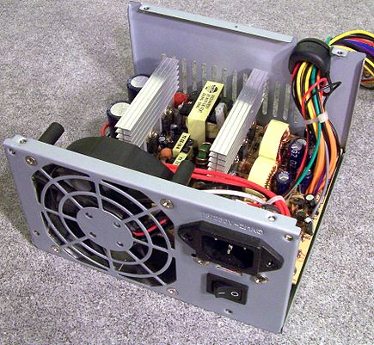

**3. Optical Drive**

Optical Drives are used in PCs to read and write CDs and DVDs.The optical drive reads the data from the disc, which can then be transformed into a digital file that is readable by the computer.This makes it easy to backup files, play music or movies, or copy data from one disc to another.

The term "CD" refers to Compact Discs, which are the most common type of optical drive on modern computers.They are often used for installing software on your computer, moving data between computers, or writing new programs.

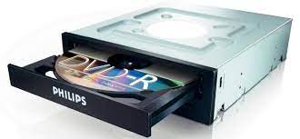

**4. Sound Card**

A sound card is a computer chip that processes and amplifies sounds.It produces a signal to the speakers, headphones, or other output devices.The sound card can also be called a "sound card" or "audio card."Computers with sound cards are capable of playing digital music files and videos, as well as speech synthesis.

Sound cards were originally provided as an external device for home computers in the 1980s.With the development of microprocessors, sound capabilities were integrated onto motherboards during the 1990s.

Sound functionality can also be integrated onto the motherboard, using components similar to those found on plug-in cards. The integrated sound system is often still referred to as a sound card. Sound processing hardware is also present on modern video cards with HDMI to output sound along with the video using that connector; previously they used a S/PDIF connection to the motherboard or sound card.

Typical uses of sound cards or sound card functionality include providing the audio component for multimedia applications such as music composition, editing video or audio, presentation, education and entertainment (games) and video projection. Sound cards are also used for computer-based communication such as voice over IP and teleconferencing.

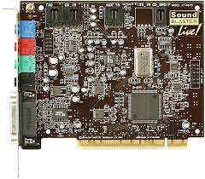

**5. Hard Disk Drive**

A hard disk drive is a piece of hardware inside a computer that stores information.It's used to store software and data in a safe place, which can be accessed when needed.  
With magnetic storage, there are no moving parts - unlike a CD or DVD player in which you need to move a disk in order to access data.You can think of it as "a closet" where all your stuff is stored safely.As long as you have power, you can get to your things when you need them.

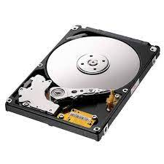

**6. RAM Memory**

A computer's RAM is a type of computer memory that stores information so the CPU can access it directly.Computer systems use main memory to store both data and programs.The more RAM you have, the more data your system can process at one time.This will lead to more efficient operations on your computer, which translates into better performance for the user.

RAM contains multiplexing and demultiplexing circuitry, to connect the data lines to the addressed storage for reading or writing the entry. Usually more than one bit of storage is accessed by the same address, and RAM devices often have multiple data lines and are said to be "8-bit" or "16-bit", etc. devices.[clarification needed]

In today's technology, random-access memory takes the form of integrated circuit (IC) chips with MOS (metal-oxide-semiconductor) memory cells. RAM is normally associated with volatile types of memory (such as dynamic random-access memory (DRAM) modules), where stored information is lost if power is removed, although non-volatile RAM has also been developed.[3] Other types of non-volatile memories exist that allow random access for read operations, but either do not allow write operations or have other kinds of limitations on them. These include most types of ROM and a type of flash memory called NOR-Flash.

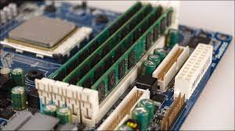

**7. ROM Memory**

ROM stands for a type of memory chip that can be read from but not written to.In other words, it's a form of data storage that can't be changed after being programmed.It's sometimes called "non-volatile" memory because the stored information will remain even when not powered up or in use.

ROM is often used to store a computer's basic start-up instructions and certain types of data, such as your car's onboard computer system and a calculator's data tables.

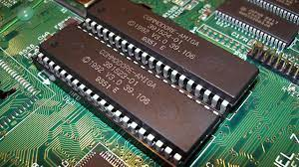

**8. CPU**

A CPU, or central processing unit, is the brain of a computer. The CPU processes information and runs programs.It functions as a control unit that executes programs according to instructions in its program memory.The CPU contains elements such as registers, an arithmetic logic unit (ALU), and control logic for sequencing instructions.

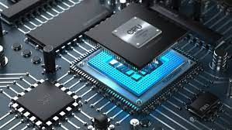

The term central processing unit originated way back in the mists of computer time when a single massive cabinet contained the circuitry required to interpret machine level program instructions and perform operations on the data supplied. The central processing unit also completed all processing for any attached peripheral devices. Peripherals included printers, card readers, and early storage devices such as drum and disk drives. Modern peripheral devices have a significant amount of processing power themselves and off-load some processing tasks from the CPU. This frees the CPU up from input/output tasks so that its power is applied to the primary task at hand.