**Name: JOEL JOHN JOSEPH**

**Roll No:8**

**Batch:RMCA(B)**

**Date:21-04-2022**

**NETWORKING & SYSTEM ADMINISTRATION LAB**

**Experiment No: 6**

**Aim**

Familiarization of linux commands

**Procedure**

1. **$read: :** This command is used to read the content of a line of a variable

**Output:**



1. **$locate:** This command is used to locate a particular file or directory

**Output:**



1. **$find :** This command is used to search and locate the list of files in the current directory.

**Output:**



1. **$locate -i filename:**This command is used to perform case insensitive search.

**Output:**



1. **$grep:**This command will let you search through all the text in a file.

**Output:**



1. **$grep -i**:This command filter output in a case insensitive way.

**Output:**



1. **$grep -v:**This command displays lines not matching to the specified word.

**Output:**



1. **$grep -A1:**This command is used to display line after result

**Output:**



1. **$grep -B1:**This command is used to display the line before the result.

**Output:**



1. **$grep -C1:** This command is used to display the line before and after the result

**Output:**



1. **$df:** This command is used s used to show the amount of free disk space available

and to understand the filesystems that have been mounted.

**Output:**

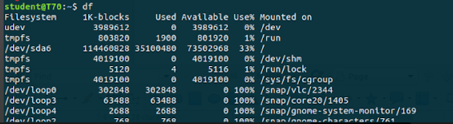

1. **$du:** The du command is used to gain disk usage information quickly.It is applied to current working directory.

**Output:**

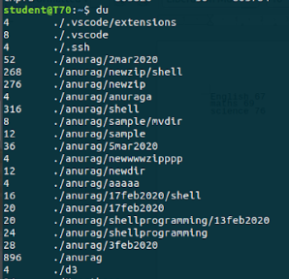

1. **$wc**: This command is used counting purpose.It is used to find the number of lines ,the number of words ,number of charcters and number of bytes.
2. **$wc** -l: Count number of lines

**Output**:



1. **$wc -w:**Count number of words

**Output**:



1. **$wc -c:**Count number of characters

**Output:**



1. **$wc-m:**Count number of lines.

**Output:**

