**Name: JOEL JOHN JOSEPH**

**Roll No: 8**

**Batch: RMCA 2021-23 S2(B)**

**Date:**

**NETWORKING & SYSTEM ADMINISTRATION LAB**

**Experiment No.: 4**

**Aim**

Familiarization of the Linux commands.

**Procedure**

**1. cat -n**

This command return contents with line numbers.

**Syntax**:- $ cat -n filename

**Output**:-

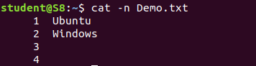

**2. cat -b**

This Returns contents with line numbers but excludes the empty lines

**Syntax**:- $ cat -b filename

**Output**:-

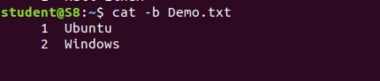

**3. touch**

This command is used to create a empty file

**Syntax**:- $ touch filename

**Output**:-



**4. echo command >> filename**

This command helps to add lines on the empty file

**Syntax**:- $ echo command>> filename

**Output**:-



**5. head**

This command returns first 10 lines in the file

**Syntax**:- $ head filename

**Output**:-

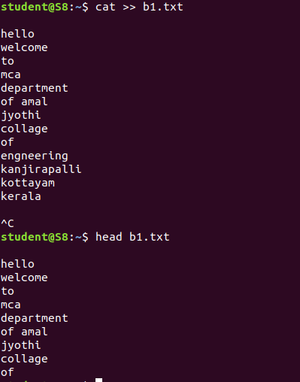

**6. head – (No. of lines)**

This will return beginning lines specified in the command

**Syntax**:- $ head -4 filename

**Output**:-



**7. tail**

This returns the last 10 lines in the file

**Syntax** $ tail filename

**Output**:-

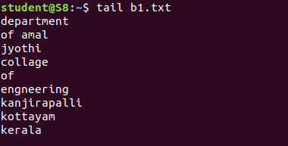

**8. tail – (No. of lines)**

This will return last no of lines specified in the command

**Syntax**:- $ tail -4 filename

**Output**:-



**9. cut -f2**

This commands in Linux allows you to select the second part of the content that split by ‘ - ‘ delimiter.

**Syntax**:- $ cut -d- f2 filename

**Output**:-

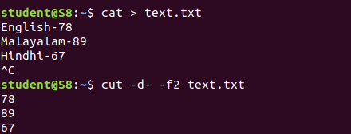

**10. cut -f1**

This commands in Linux allows you to select the First part of the content that split by ‘ - ‘ delimiter.

**Syntax**:- $ cut -d- f1 filename

**Output**:

