**Name: JOEL JOHN JOSEPH**

**Roll No:08**

**Batch:S2MCA**

**Date:4/04/22**

**NETWORKING&SYSTEM ADMINISTRATION LAB**

**Experiment No.: 6**

**Aim**

**Familiarization of basic linux commands**

**Procedure:**

1.cp – cp command used to copy

**syntax:**

**$**cp

**output:**

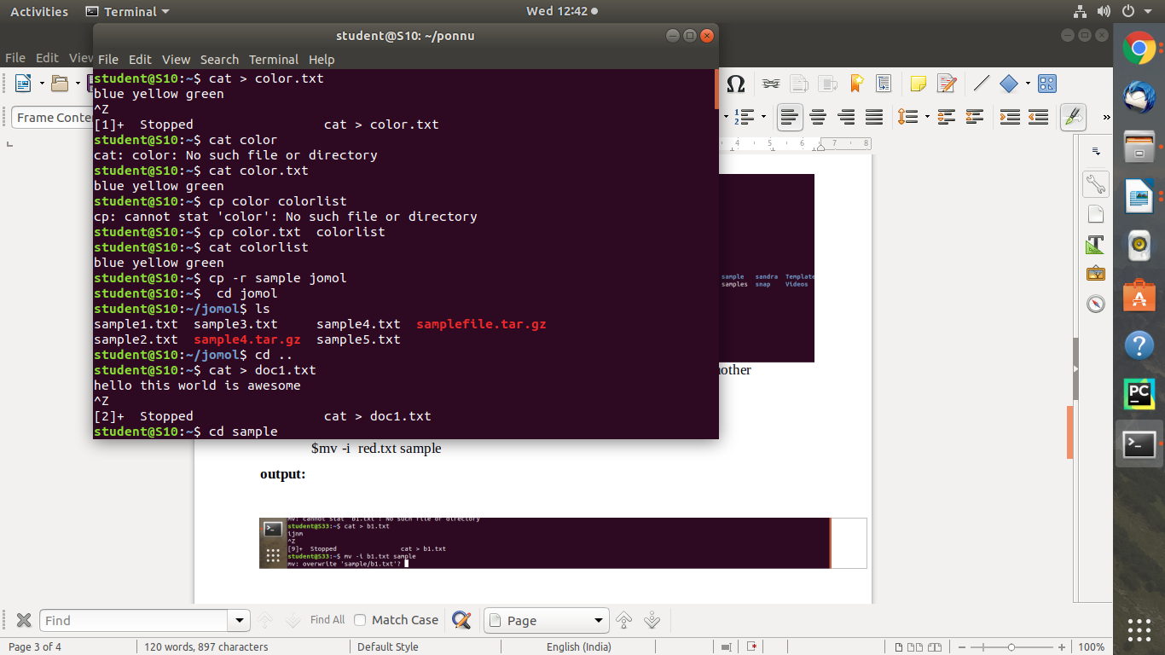

2. **cp -r**  - cp -r command is used to copy entire directory.

**Syntax:**

$cp -r –

**output:**



3. **cp -i** – this command is used to ask permission to overwrite

**syntax:**

cp -i doc1.txt sample

**output :**

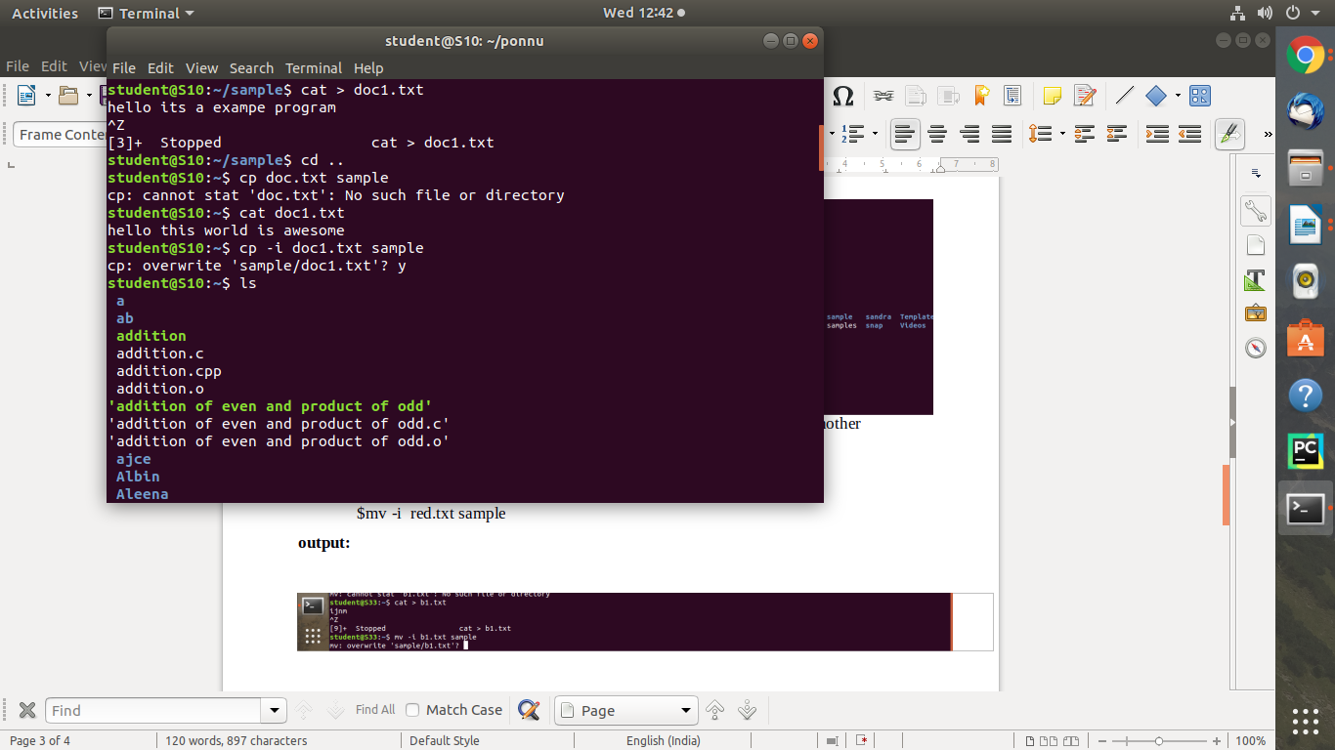

4.**mv** – mv command is used to move a file to another directory

**syntax:**

**$**mv b3.txt doc

**output:**

