**Name: Joel John Joseph**

**Roll No: 08**

**Batch: B**

**Date: 05/05/22**

**NETWORKING & SYSTEM ADMINISTRATION LAB**

**Experiment No.: 8**

**Aim**

To find sum of two numbers.

**Procedure**

#/bin/bash

echo "Enter the first number"

read num1

echo "Enter the second number"

read num2

sum=$(($num1+$num2))

echo "the sum of $num1 and $num2 is:"$sum

**Output**

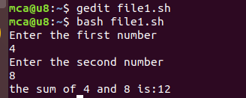

**Aim**

To find largest of three numbers.

**Procedure**

#/bin/bash

echo "enter the first number"

read n1

echo "enter the second number"

read n2

echo "enter the third number"

read n3

if [ $n1 -gt $n2 -a $n1 -gt $n3 ]

then

echo $n1 "is greater"

elif [ $n2 -gt $n3 ]

then

echo $n2 "is greater"

else

echo $n3 "is greater"

fi

**output**

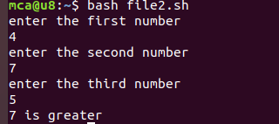

**Aim**

To find largest of two numbers.

**Procedure**

#/bin/bash

echo "enter the first number"

read n1

echo "enter the second number"

read n2

if [ $n1 -gt $n2 ]

then

echo $n1 "is greater"

else

echo $n2 "is greater"

fi

**output**

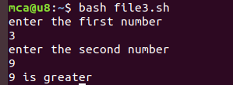

**Aim**

To find whether a number is odd or even.

**Procedure**

echo "Enter the number:"

read a

rem=$(( $a % 2 ))

if [ $rem -eq 0 ]

then

echo "the number is even."

else

echo "the number is odd."

fi

**output**

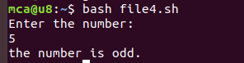

**Aim**

To print basic details.

**Procedure**

echo "Enter your name :"

read name

echo "Enter your department :"

read dep

echo "Enter your college name :"

read col

echo "--DETAILS--"

echo $name

echo $dep

echo $col

**output**

