**Name: JOEL JOHN JOSEPH**

**Roll No: 08**

**Batch: RMCA 2021-23 S2(B)**

**Date: 9-5-22**

**NETWORKING & SYSTEM ADMINISTRATION LAB**

**Experiment No.: 1**

**Aim**

Write a shellscript to display current date and calender.

**Procedure**

echo "Today is $(date)"

echo ""

echo "Calendar :"

cal

**Output Screenshot**

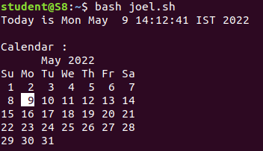

**Experiment No.: 2**

**Aim**

Write a shell script to check the number is greater than , less than, equalto another number.

**Procedure**

echo "Enter the First Number:"

read a;

echo "Enter the Second Number:"

read b;

if [ $a -gt $b ]

then

echo "First number ($a) is greater than second number ($b)."

elif [ $a -lt $b ]

then

echo "first number ($a) is lesser than second number ($b)."

else

echo "first number ($a) is equal to second number($b)."

fi

**Output Screenshot**

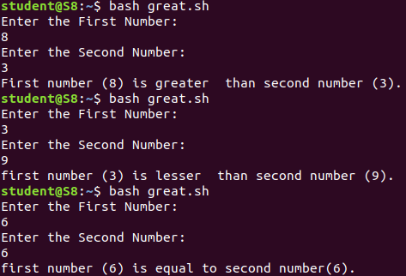

**Experiment No.: 3**

**Aim**

Write a shell script program to find sum of first 10 numbers.

**Procedure**

echo "Enter Size(N)"

read N

i=1

sum=0

echo "Enter Numbers"

while [ $i -le $N ]

do

read num

sum=$((sum + num))

i=$((i + 1))

done

echo $sum

**Output Screenshot**

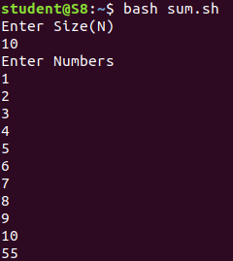

**Experiment No.: 4**

**Aim**

Write a shell script program to find sum avg and product of 4 numbers.

**Procedure**

echo "enter four integers"

read a b c d

sum=$(echo "$a + $b + $c + $d" | bc -l)

average=$(echo "$sum / 4" | bc -l)

product=$(echo "$a * $b * $c * $d" | bc -l)

echo "sum = $sum"

echo "Average = $average"

echo "Product = $product"

**Output Screenshot**

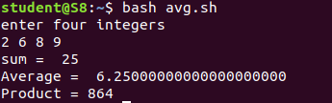

**Experiment No.: 5**

**Aim**

write a shell script to find a factorial of a number

**Procedure**

echo "Enter a number"

read num

fact=1

while [ $num -gt 1 ]

do

fact=$((fact * num)) #fact = fact * num

num=$((num - 1)) #num = num - 1

done

echo $fact

**Output Screenshot**

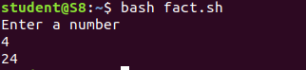

**Experiment No.: 6**

**Aim**

write a shell script to find a number is palindrome or not

**Procedure**

echo "Enter the number: "

read a

s=0

r=0

temp=$a

while [ $a -gt 0 ]

do

s=$(( $a%10 ))

a=$(( $a/10 ))

r=$(( ${r}${s} ))

done

if [ $temp -eq $r ]

then

echo "Number is pallidrome."

else

echo "Number is not pallidrome."

fi

**Output Screenshot**

