**Name: JOEL JOHN JOSEPH**

**Roll No: 08**

**Batch: RMCA 2021-23 S2(B)**

**Date: 12-5-22**

**NETWORKING & SYSTEM ADMINISTRATION LAB**

**Experiment No.: 1**

**Aim**

find leap year in shell script

**Procedure**

echo "LEAP YEAR SHELL SCRIPT"

echo -n "Enter a year:"

read year_checker

if [ `expr $year_checker % 4` -eq 0 ]

then

echo "$year_checker is a leap year"

else

echo "$year_checker is not a leap year"

fi

**Output Screenshot**





**Experiment No.: 2**

**Aim**

Write a shell script program to find sum of all digits in a number

**Procedure**

echo "Enter the number"

read num

sum=0

while [ $num -gt 0 ]

do

mod=$((num % 10))

sum=$((sum + mod))

num=$((num / 10))

done

echo $sum

**Output Screenshot**

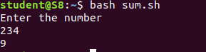

**Experiment No.: 3**

**Aim**

Let’s write a shell program to find average of n numbers.

**Procedure**

echo "Enter Size(N)"

read N

i=1

sum=0

echo "Enter Numbers"

while [ $i -le $N ]

do

read num

sum=$((sum + num))

i=$((i + 1))

done

echo "SUM"

echo $sum

echo "AVERAGE"

avg=$(echo $sum / $N |bc -l )

echo $avg

**Output Screenshot**

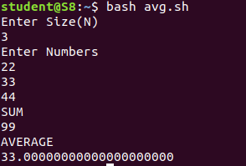

**Experiment No.: 4**

**Aim**

Create A Shell Script Calculator using Switch Case

**Procedure**

echo "Enter Two numbers : "

read a

read b

echo "Enter Choice :"

echo "1. Addition"

echo "2. Subtraction"

echo "3. Multiplication"

echo "4. Division"

read ch

case $ch in

1)res=`echo $a + $b | bc`

;;

2)res=`echo $a - $b | bc`

;;

3)res=`echo $a \* $b | bc`

;;

4)res=`echo "scale=2; $a / $b" | bc`

;;

esac

echo "Result : $res"

**Output Screenshot**

