**Name: JOEL JOHN JOSEPH**

**Roll No:8**

**Batch:MCA -R S2B**

**Date:22 – 3 - 22**

**NETWORKING & SYSTEM ADMINISTRATION LAB**

**Experiment No.: 1**

**Aim**

Install the latest version of Ubuntu on an Oracle VM VirtualBox.

**Procedure**

**Step 1:** Install VirtualBox, then click "Next".

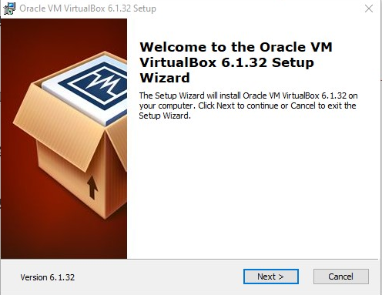

**Step 2:** Open VirtualBox and select features.

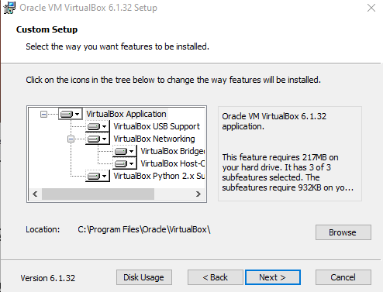

**Step 3:** Choose the options.

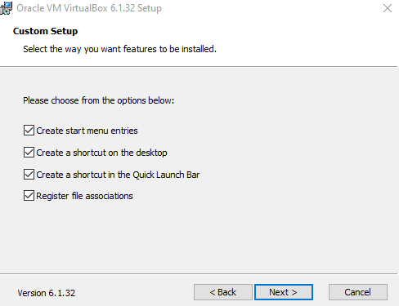

**Step 4:** Proceeding installation.

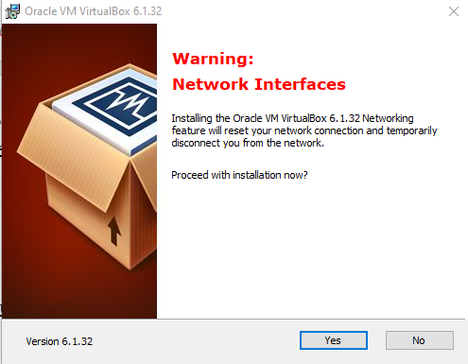

**Step 5 :** Ready to install.

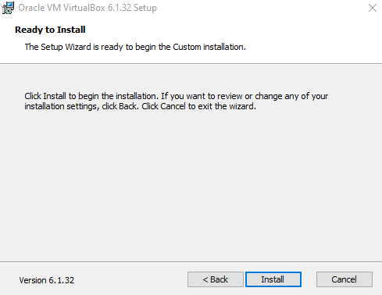

**Step 6:** Installing the Oracle vm virtualBox.

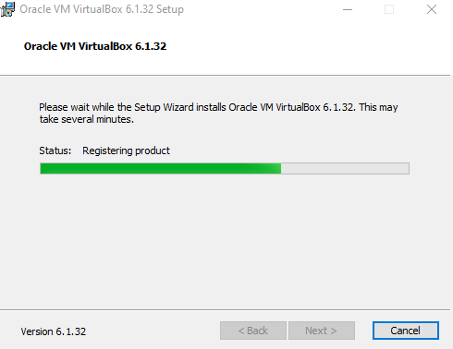

**Step 7:** Installation finished.

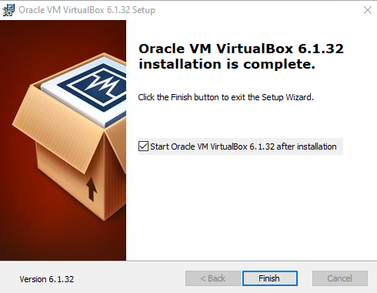

**Step 8:** Open VirtualBox, then click "New" to create a virtual machine.

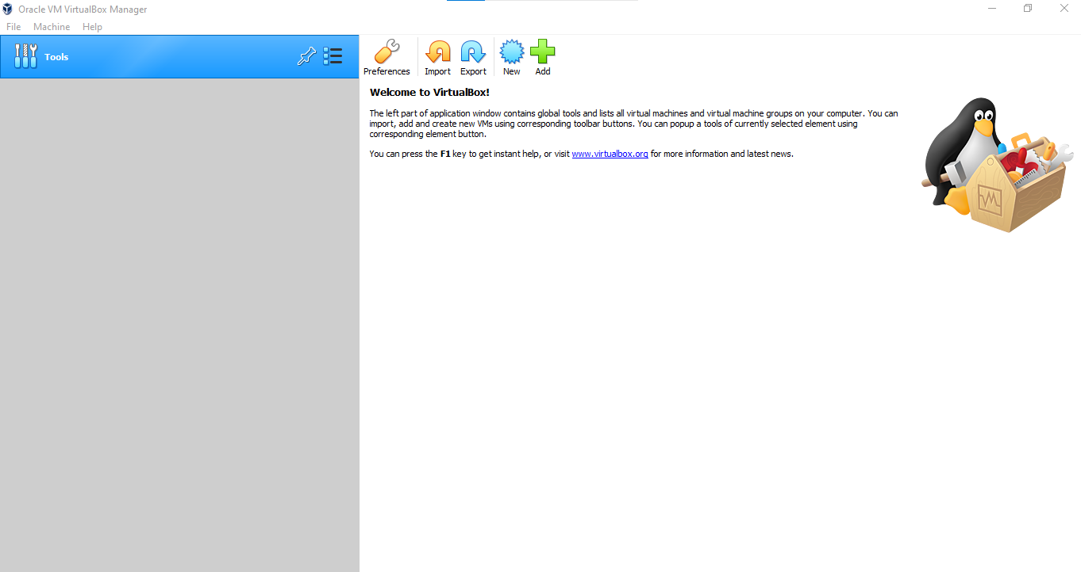

**Step 9:** Give VM a name, choose Linux and then choose Ubuntu as the Version and select Next.

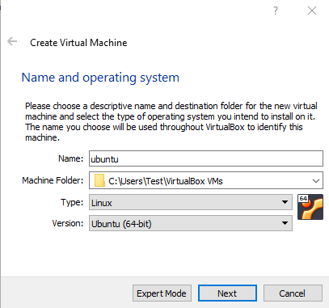

**Step 10:** We want to specify Memory size

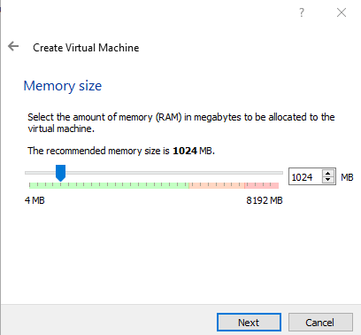

**Step 11:** Check the "Create a virtual hard disk now" option so we can later define our Ubuntu OS virtual hard disk size.

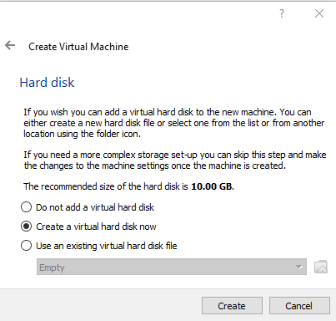

**Step 12**: Now, we want to select "VHD (Virtual Hard Disk)".

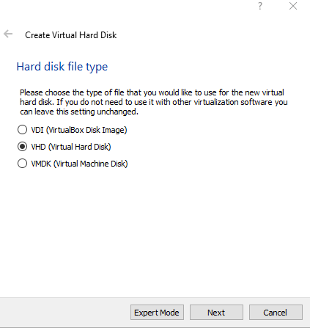

**Step 13:** Next, we'll dynamically allocate storage on our physical hard disk.

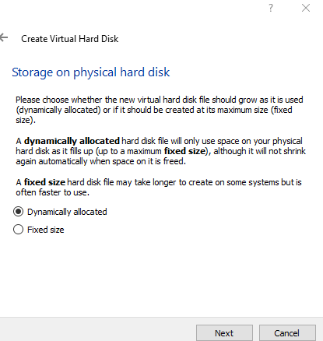

**Step 14:** We want to specify our Ubuntu OS's size. The recommended size is 10 GB, but you can increase the size if you wish.

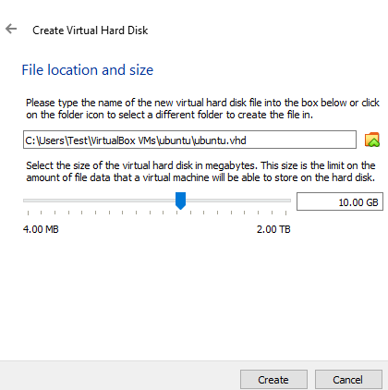

**Step 15:** After creating a virtual hard disk, you'll see Ubuntu in your dashboard.

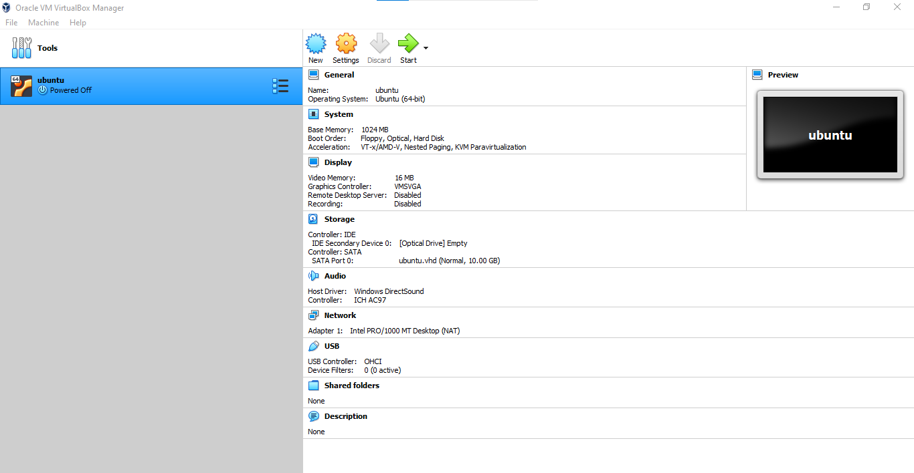

**Step 16:** Select virtual disk image. The Ubuntu disk image file can be downloaded here: Ubuntu OS download. To set up the Ubuntu disk image file, go to settings and follow these steps: Click "Storage".

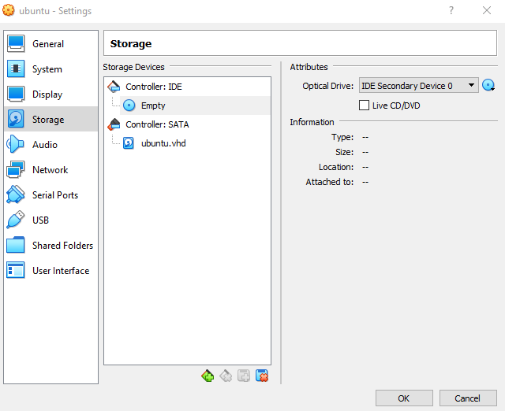

**Step 17:** The name of your virtual machine will now appear on the left side of the VirtualBox manager. Select Start in the toolbar to launch your VM.

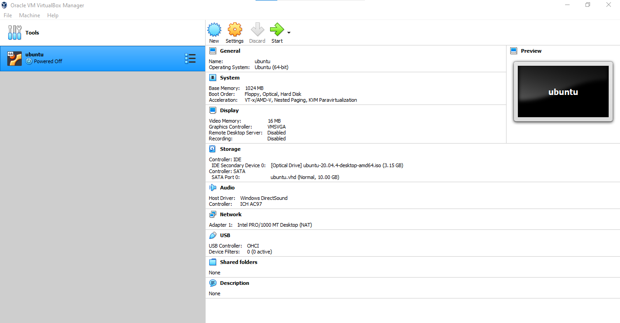

**Step 18:** Click Install Ubuntu.

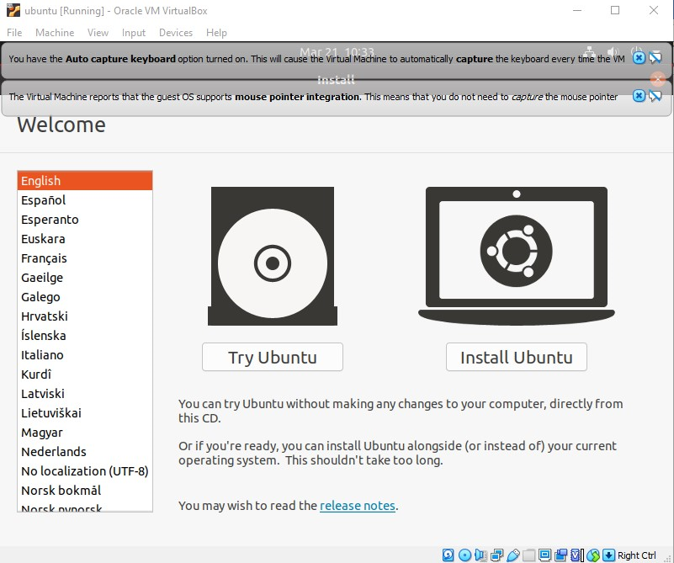

**Step 19:** Select your keyboard layout.

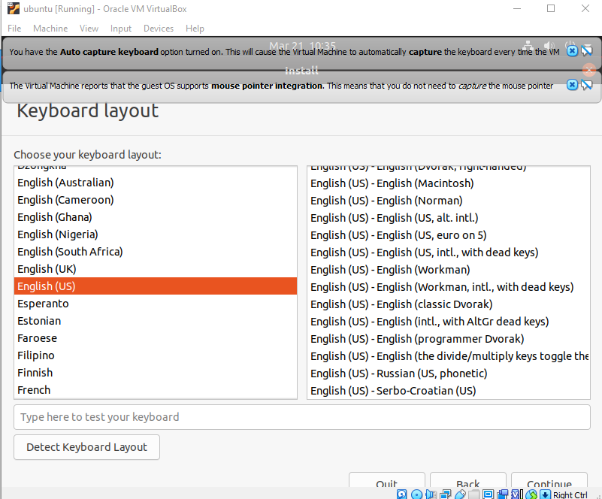

**Step 20:** In the "Updates and other software" section, check "Normal installation" and continue.

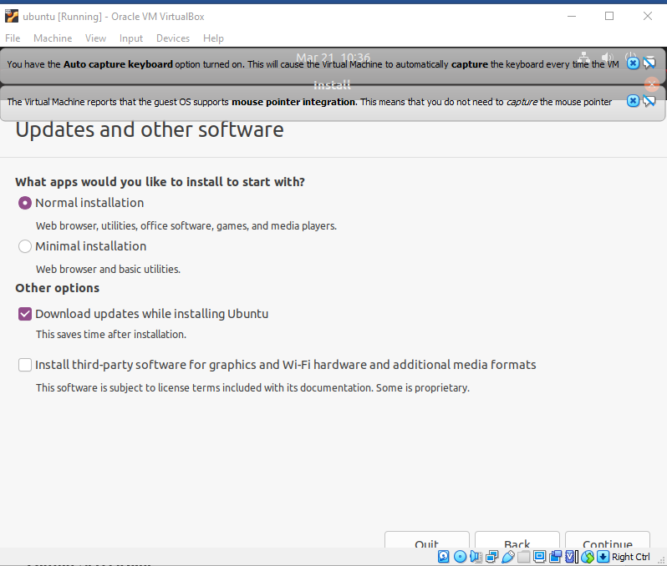

**Step 21:** In "Installation type", check "Erase disk and install Ubuntu"and Click

"Continue".

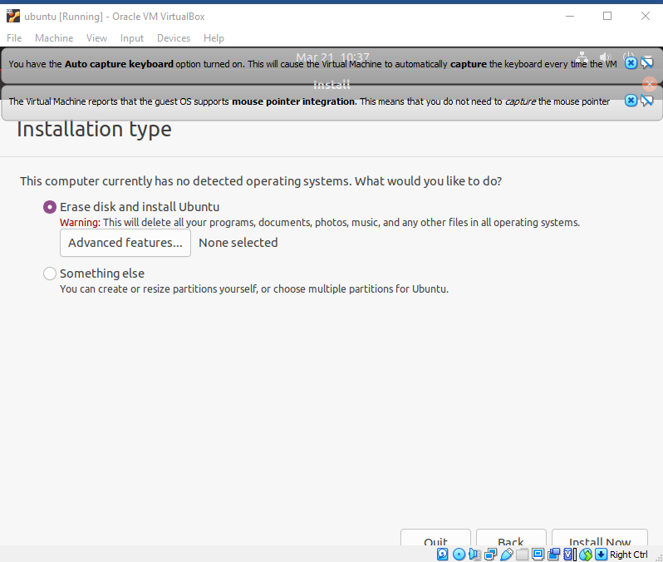

**Step 22:** Choose your time zone on the map, then select Continue.

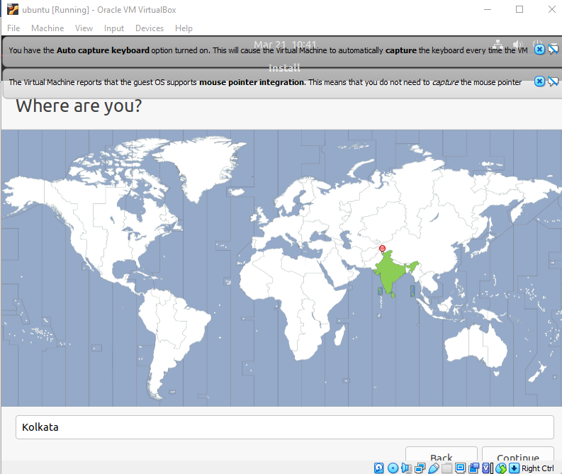

**Step 23:** Set up your user account and select Continue.

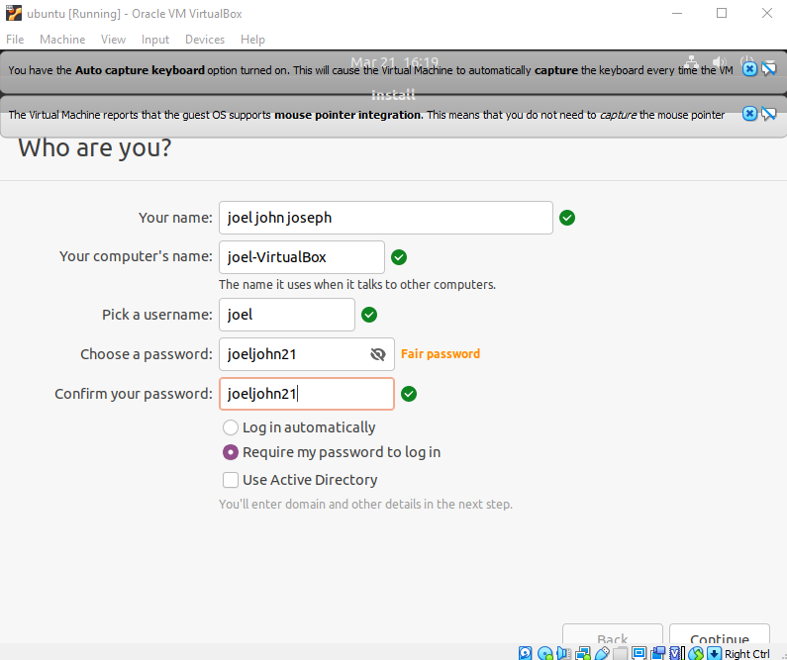

**Step 24:** Installation completed.

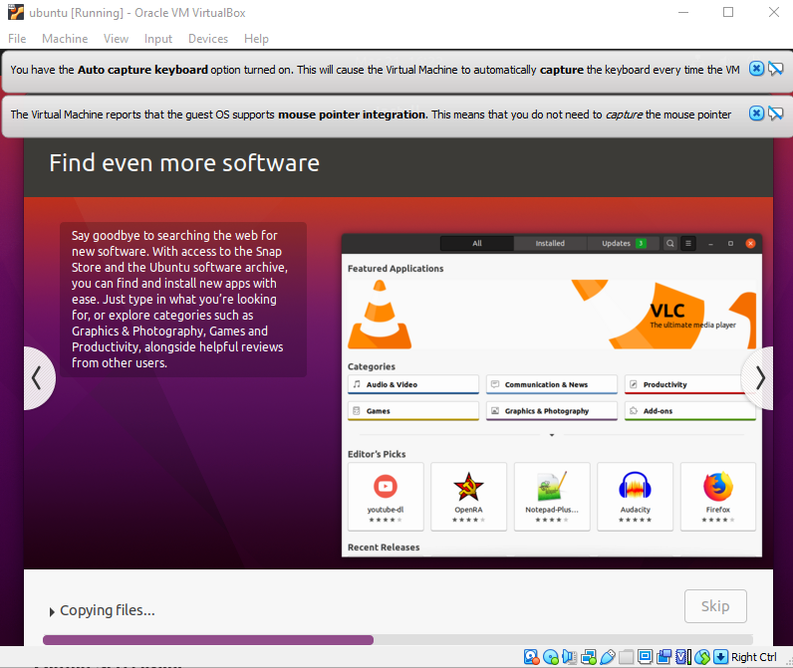

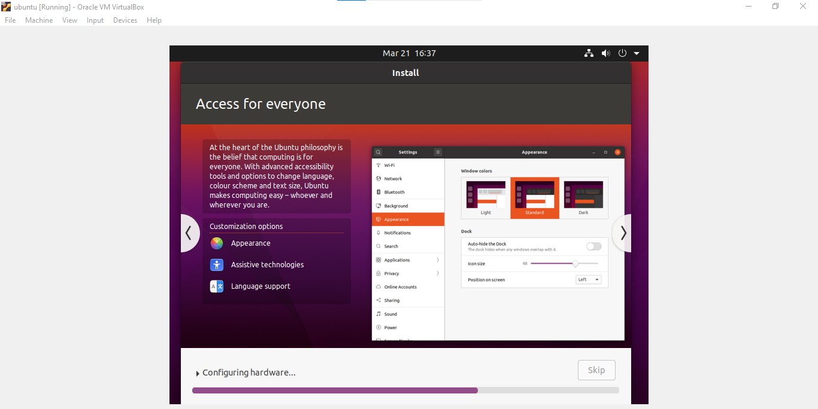

**Step 25:** Restart your System

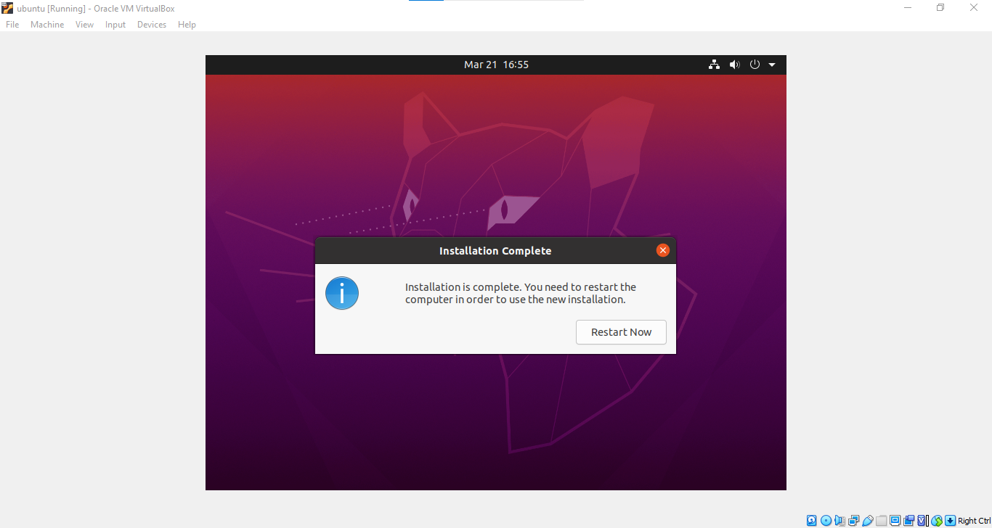

**Step 26:** After logging in, you'll see the Ubuntu desktop.

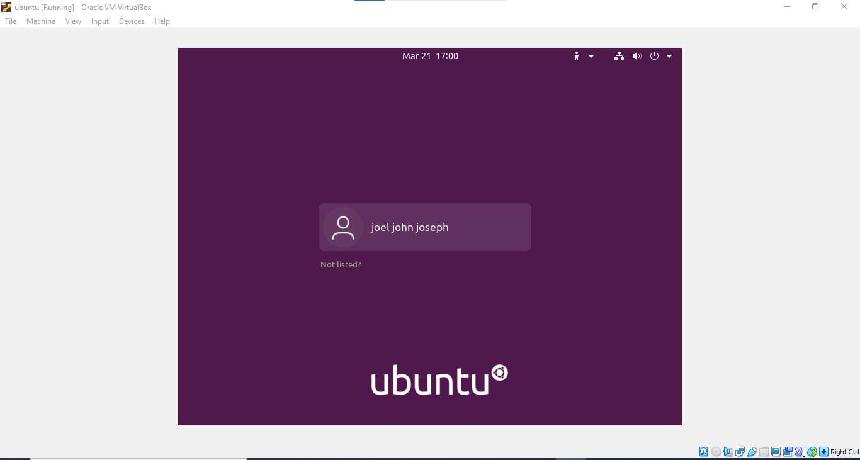

**Output Screenshot**

