My Health by JBoss – Installation Guide

My Health by JBoss – Installation Guide 1
Installation Prerequisites 1
Hospital Information System Installation 2
Install the MySQL Connector 2
Create the Databases 2
JBoss Fuse Service Works 6.0 Beta download and installation 2
Configure the JBoss Fuse Service Works 6.0 Beta Server 4
Start the JBoss Fuse Service Works 6.0 Beta Server 5
Build and deploy the HIS application 5
Patient Care Facility Installation 5
JBoss Fuse 6.0 download and installation 5
Configure the Server 6
Build the pcf feature 7
Start the JBoss Fuse 6.0 Instance 7
Install the pcf feature 7
Laboratory Information System Installation 8
JBoss Fuse 6.0 download and installation 8
Configure the Server 9
Build the lis feature 9
Start the JBoss Fuse 6.0 Instance 10
Install the lis feature 10
Android Client Installation 11
Install the Android SDK 11
FuseIDE setup 12

Installation Prerequisites
Before beginning the installation process, the items in the list below should be installed.
- Redhat Enterprise Linux 6 is the preferred OS (other Linux distributions may work)
- Java JDK (1.6_18 or better)
- Fuse IDE (the most recent version)
- Git
- MySQL Community Server
- Apache Maven 3.0.5 (later versions may not play well with the Android build)
- The settings.xml file from the <base_dir>/myHealth folder should be copied to Maven's ~/.m2 folder.
Go ahead and clone (git clone) this repository into the directory of your choice. Throughout this document this directory will be referred to as <base_dir>.

Hospital Information System Installation

Install the MySQL Connector
Before running the FSW installer, the MySQL Connector should be downloaded. Extract the connector jar to any folder.

Create the Databases
From the mysql prompt, enter the following:
mysql> CREATE DATABASE HIS;
mysql> CREATE DATABASE HIS_DATA;

JBoss Fuse Service Works 6.0 Beta download and installation
Download a copy of Fuse Service Works 6.0 Beta

Run the installer (java -jar jboss-eap-6.0.0.fsw.ci-installer.jar) and take all of the defaults throughout the installation process. Install into the <base_dir>/myHealth/fuseServiceWorks folder.

On the "Post-Install Configuration" screen select the option to "Perform additional post-install configuration". Choose "Install JDBC driver".

On the "JDBC Driver Setup" screen choose "MySQL" as the driver vendor and click the "Browse" button to add the MySQL connector jar that was installed earlier.

On the "Database Configuration" screen enter the credentials of the MySQL user. Enter the following in the Url text field:
jdbc:mysql://localhost:3306/HIS?transformedBitIsBoolean=true
In the end, there should be a new server directory named <base_dir>/myHealth/fuseServiceWorks/jboss-eap-6.1

Configure the JBoss Fuse Service Works 6.0 Beta Server
In the <base_dir>/myHealth/fuseServiceWorks/jboss-eap-6.1/standalone/configuration/standalone-full.xml file, disable hornetq security by adding <security-enabled>false</security-enabled> to the <hornetq-server> element.

In the <base_dir>/myHealth/fuseServiceWorks/jboss-eap-6.1/standalone/configuration/standalone-full.xml file, create the HISDS data source by adding the element shown below to the datasources element. The "user" and "password" values should be replaced with the credentials of the MySQL user.
<datasource jndi-name="java:jboss/datasources/HISDS" pool-name="HISDS" enabled="true" use-java-context="true">
<connection-url>jdbc:mysql://localhost:3306/HIS_DATA</connection-url>
<driver>mysql</driver>
<security>
<user-name>*user*</user-name>
<password>*password*</password>
</security>
</datasource>

Open port 5455
su -c “iptables -I INPUT -p tcp ––dport 5455 -j ACCEPT”
su -c “/sbin/service iptables save”

Start the JBoss Fuse Service Works 6.0 Beta Server
From a terminal, enter the following:
cd <base_dir>/myHealth/fuseServiceWorks/jboss-eap-6.1/bin
./standalone.sh -c standalone-full.xml

Build and deploy the HIS application
From a terminal, enter the following:
cd <base_dir>/myHealth/fuseServiceWorks/his
mvn clean package
mvn jboss-as:deploy

Patient Care Facility Installation

JBoss Fuse 6.0 download and installation
Download a copy of JBoss Fuse 6.0

Extract the contents of jboss-fuse-full-6.0.0.redhat-024.zip into <base_dir>/myHealth/fuse

This should result in a new server directory named <base_dir>/myHealth/fuse/jboss-fuse-6.0.0.redhat-024

Configure the Server
Copy all of the files from <base_dir>/myHealth/fuse/etc/ into the <base_dir>/myHealth/fuse/jboss-fuse-6.0.0.redhat-024/etc folder replacing any existing files. The pcf.cfg file is the configuration file for the pcf feature. If the Hospital Information System is to be installed on a different machine then this file will need to be modified accordingly. The activemq.xml file configures the embedded broker.

Update the /etc/hosts file adding the name given to the local machine as a synonym of 127.0.0.1 For example, if the local machine name is my.rhel.machine (use the hostname command to get the name of the local machine) then the hosts file would need an entry that looks similar to the one below.
127.0.0.1 localhost localhost.localdomain localhost4 localhost4.localdomain4 my.rhel.machine

Open ports 8888 and 1883
su -c “iptables -I INPUT -p tcp ––dport 8888 -j ACCEPT”
su -c “iptables -I INPUT -p tcp ––dport 1883 -j ACCEPT”
su -c “/sbin/service iptables save”

Build the pcf feature
From a terminal, enter the following:
cd <base_dir>/myHealth/fuse/
mvn clean install
This will build the feature and install it to the local maven repository.

Start the JBoss Fuse 6.0 Instance
From a terminal, enter the following:
cd <base_dir>/myHealth/fuse/jboss-fuse-6.0.0.redhat-02
./bin/fuse
Once the server has started, ensure that there are no errors by entering the following command into the Karaf console
JBossFuse:karaf@root>log:display

Install the pcf feature
Enter the following commands into the Karaf console
JBossFuse:karaf@root> features:addUrl mvn:com.sparc.myHealth/pcf-features/1.0.0-SNAPSHOT/xml/features
JBossFuse:karaf@root> features:install pcf
Ensure once again that there are no errors by entering the following command into the Karaf console
JBossFuse:karaf@root>log:display
Ensure that all bundles are installed by entering the following command into the Karaf console
JBossFuse:karaf@root> osgi:list
The end of the list should show that the 7 required bundles are installed:
[ 240] [Active ] [ ] [ ] [ 60] The Netty Project (3.2.4.Final)
[ 241] [Active ] [ ] [ ] [ 60] wrap_mvn_org.hornetq_hornetq-core_2.2.7.Final (0)
[ 242] [Active ] [ ] [ ] [ 60] wrap_mvn_org.hornetq_hornetq-core-client_2.2.7.Final (0)
[ 243] [Active ] [ ] [ ] [ 60] wrap_mvn_org.hornetq_hornetq-jms-client_2.2.7.Final (0)
[ 244] [Active ] [ ] [Started] [ 60] HL7-in (1.0.0.SNAPSHOT)
[ 245] [Active ] [ ] [Started] [ 60] Android-in (1.0.0.SNAPSHOT)
[ 246] [Active ] [ ] [Started] [ 60] Android-out (1.0.0.SNAPSHOT)

Laboratory Information System Installation

JBoss Fuse 6.0 download and installation
Download a copy of JBoss Fuse 6.0

Extract the contents of jboss-fuse-full-6.0.0.redhat-024.zip into <base_dir>/myHealth/fuse

This should result in a new server directory named <base_dir>/myHealth/fuse/jboss-fuse-6.0.0.redhat-024

Configure the Server
Copy all of the files from <base_dir>/myHealth/fuse/etc/ into the <base_dir>/myHealth/fuse/jboss-fuse-6.0.0.redhat-024/etc folder replacing any existing files. The lis.cfg file is the configuration file for the lis feature. If the Hospital Information System is to be installed on a different machine then this file will need to be modified accordingly. The activemq.xml file configures the embedded broker.

Update the /etc/hosts file adding the name given to the local machine as a synonym of 127.0.0.1 For example, if the local machine name is my.rhel.machine (use the hostname command to get the name of the local machine) then the hosts file would need an entry that looks similar to the one below.
127.0.0.1 localhost localhost.localdomain localhost4 localhost4.localdomain4 my.rhel.machine

Build the lis feature
From a terminal, enter the following:
cd <base_dir>/myHealth/fuse/
mvn clean install
This will build the feature and install it to the local maven repository.

Start the JBoss Fuse 6.0 Instance
From a terminal, enter the following:
cd <base_dir>/myHealth/fuse/jboss-fuse-6.0.0.redhat-02
./bin/fuse
Once the server has started, ensure that there are no errors by entering the following command into the Karaf console
JBossFuse:karaf@root>log:display

Install the lis feature
Enter the following commands into the Karaf console
JBossFuse:karaf@root> features:addUrl mvn:com.sparc.myHealth/lis-features/1.0.0-SNAPSHOT/xml/features
JBossFuse:karaf@root> features:install lis
Ensure once again that there are no errors by entering the following command into the Karaf console
JBossFuse:karaf@root>log:display
Ensure that all bundles are installed by entering the following command into the Karaf console
JBossFuse:karaf@root> osgi:list
The end of the list should show that the 5 required bundles are installed:
[ 240] [Active ] [ ] [ ] [ 60] The Netty Project (3.2.4.Final)
[ 241] [Active ] [ ] [ ] [ 60] wrap_mvn_org.hornetq_hornetq-core_2.2.7.Final (0)
[ 242] [Active ] [ ] [ ] [ 60] wrap_mvn_org.hornetq_hornetq-core-client_2.2.7.Final (0)
[ 243] [Active ] [ ] [ ] [ 60] wrap_mvn_org.hornetq_hornetq-jms-client_2.2.7.Final (0)
[ 244] [Active ] [ ] [Started] [ 60] HL7-Handler (1.0.0.SNAPSHOT)

Android Client Installation

Install the Android SDK
Download a copy of the Android SDK

Extract the contents of the compressed sdk folder into <base_dir>/myHealth/android

This should result in a new server directory named <base_dir>/myHealth/android/android-sdk-linux

Open the <base_dir>/myHealth/android/redHatRA/pom.xml file and set the android.sdk.path property as shown below (replace BASE_DIR appropriately) and save it.
<android.sdk.path>BASE_DIR/myHealth/android/android-sdk-linux</android.sdk.path>

Update the Android SDK
<base_dir>/myHealth/android/android-sdk-linux/tools/android update sdk --no-ui --obsolete --force

Install 32 bit libraries if necessary. For RHEL6:
su -c "yum install glibc.i686 glibc-devel.i686 zlib-devel.i686 ncurses-devel.i686 libX11-devel.i686 libXrender.i686 libXrandr.i686"
su -c "yum upgrade libstdc++"
su -c "yum install libstdc++.i686"

FuseIDE setup
Open the Fuse IDE.
Right click anywhere in the Package Explorer View.
Import...
Maven -> Existing Maven Projects
Browse to <base_dir>/myHealth/android/redHatRA
On the "Setup Maven plugin connectors" screen, click "Resolve All Later"

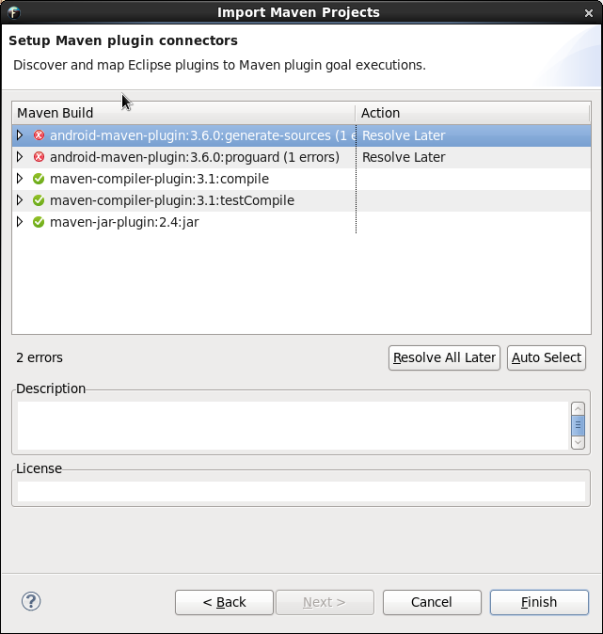

After the project is imported, install the Android Connector for M2E and Developer Tools by going to Help -> Install New Software...

In the "Work With" text field, enter http://rgladwell.github.com/m2e-android/updates/ and select the first two items.

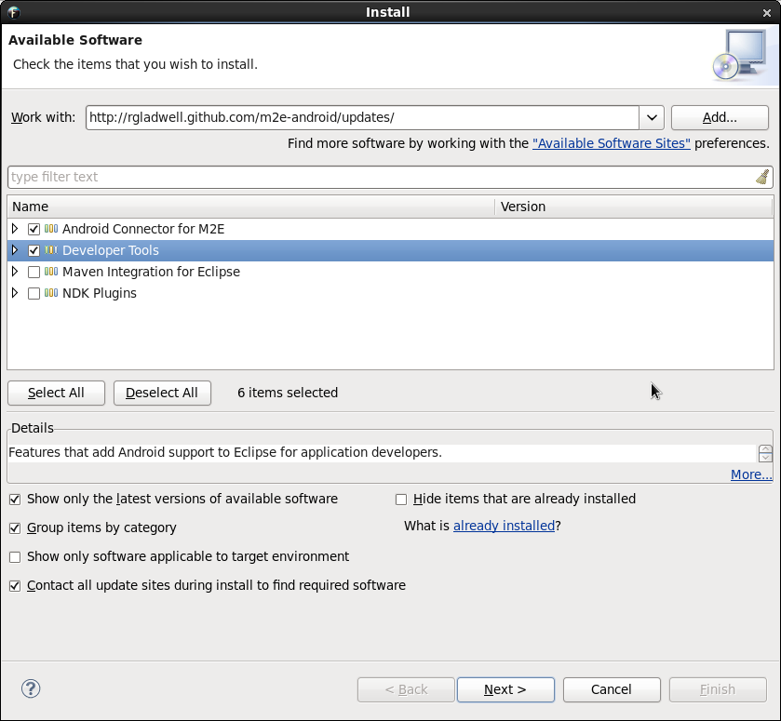

Set the Android SDK location by going to Window -> Preferences -> Android

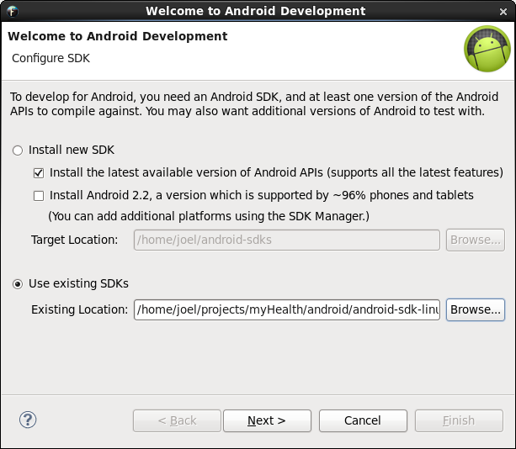

Set the Android target platform by going to Window -> Preferences -> Android

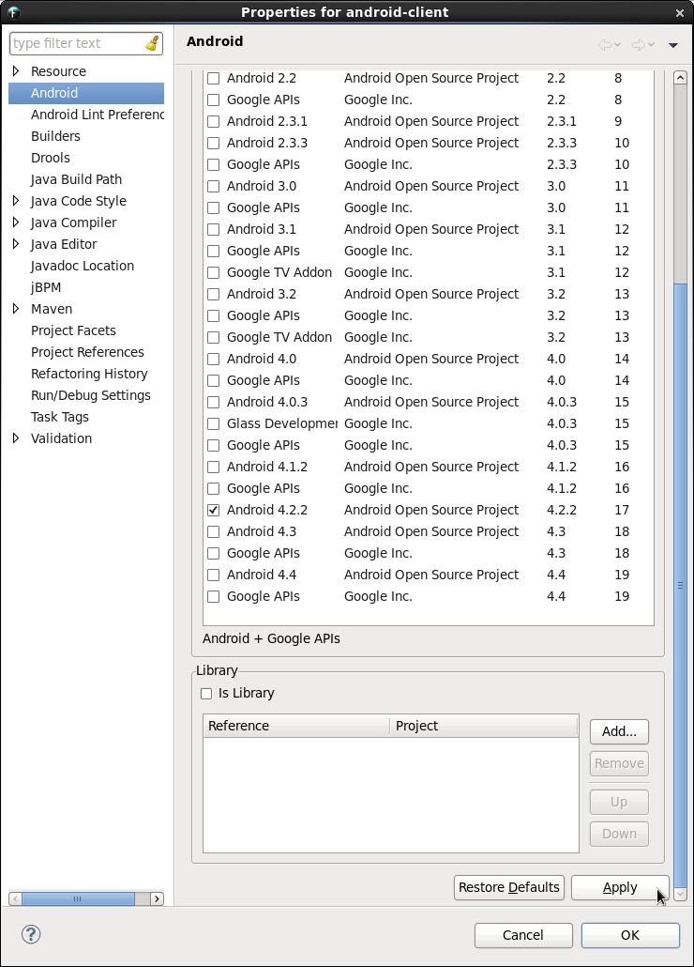

Be sure to click the apply button and then click ok on all open dialogs

To set up a virtual device, click on Window, then Android Virtual Device Manager
Click on New
Name the Android Virtual Device anything you want
In the Device drop down, select a device:
Nexus 4 (for example)
In the Target drop down, select Android 4.2.2 - API Level 17
In the CPU/ABI drop down, select ARM
Click on OK
Close the Android Virtual Device Manager window

Installation is complete. The client application should be up and running.

*Note for NVIDIA users: If an NVIDIA card is in use with the open source nouveau drivers then a libGL error may show up:
libGL error: failed to load driver: nouveau
The solution to this problem is to install the proprietary NVIDIA drivers. For RHEL6:
su -c "rpm --import http://elrepo.org/RPM-GPG-KEY-elrepo.org"
su -c "rpm -Uvh http://elrepo.org/elrepo-release-6-5.el6.elrepo.noarch.rpm"
su -c "yum install nvidia-detect"

