My Health by JBoss – Technical Guide

Application Overview 1
Use Case 1 1
Use Case 2 2
Message Types 2
HL7 Messages 2
AHE Messages 3
The Hospital Information System 3
The Patient Care Facility 3
The “HL7 In” Bundle 3
The “Android In” Bundle 4
The “Android Out” Bundle 4
The Laboratory Information System 5
The Android Client 5
A Note About ActiveMQ and HornetQ 5

Application Overview
The purpose of this application is to provide a reference architecture that demonstrates some features of Fuse 6, Fuse Service Works, and MQTT on Android. A medical setting was chosen for this demonstration and use cases were designed to exercise cooperation between medical facilities and caregivers. The diagram below outlines the major components and the basic relationships between them.
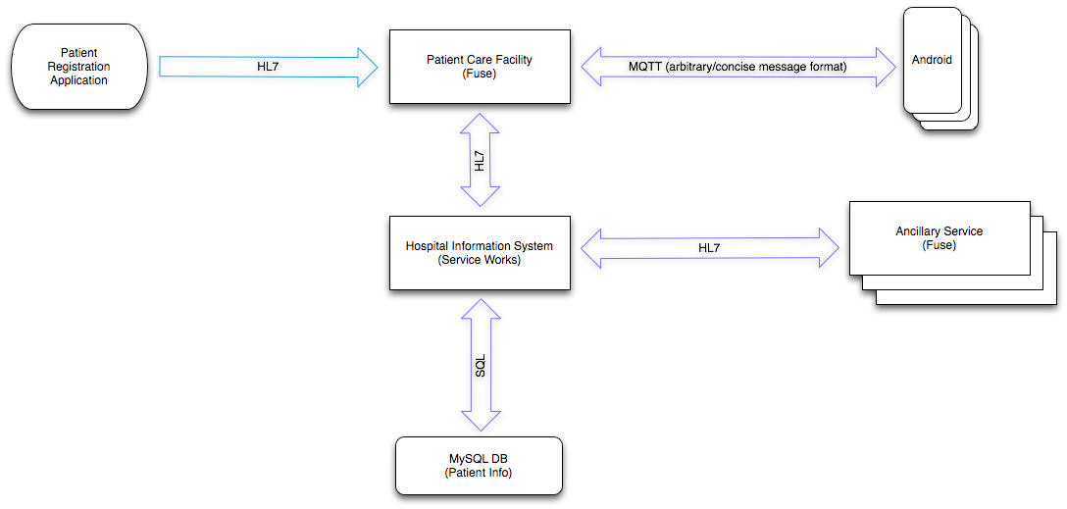
The Hospital Information System is the central management application that coordinates the flow of information between Ancillary Services and Patient Care Facilities.
The Patient Registration Application represents the software application that provides a way to enter information about newly admited patients into the Hospital Information System. In this architecture, the Patient Registration Application is hosted by the Patient Care Facility and employees of that facility are responsible for patient data entry.
The Patient Care Facility represents a hospital-affiliated medical practice. This could be a family medical practice or a pediatric practice, for example. In real-world applications, multiple Patient Care Facilities would likely be connected to a network of one or more Hospital Information Systems.
The Ancillary Service represents a specialized service provider. This could be a pharmacy or a laboratory, for example. In real-world applications, multiple Ancillary Services would likely be connected to a network of one or more Hospital Information Systems.
Android clients represent the smart devices that are used by doctors and nurses to place orders and request information.

Use Case 1
In the first use case, a patient is admitted to the Patient Care Facility. As shown in the diagram below, patient information is submitted to the Patient Care Facility via a HAPI test panel (which is used to simulate a Patient Registration Application), stored by the Hospital Information System, and finally forwarded to the laboratory. The "lab" in the diagram is a "Laboratory Information System" and is used in this architecture to provide an example ancillary service.
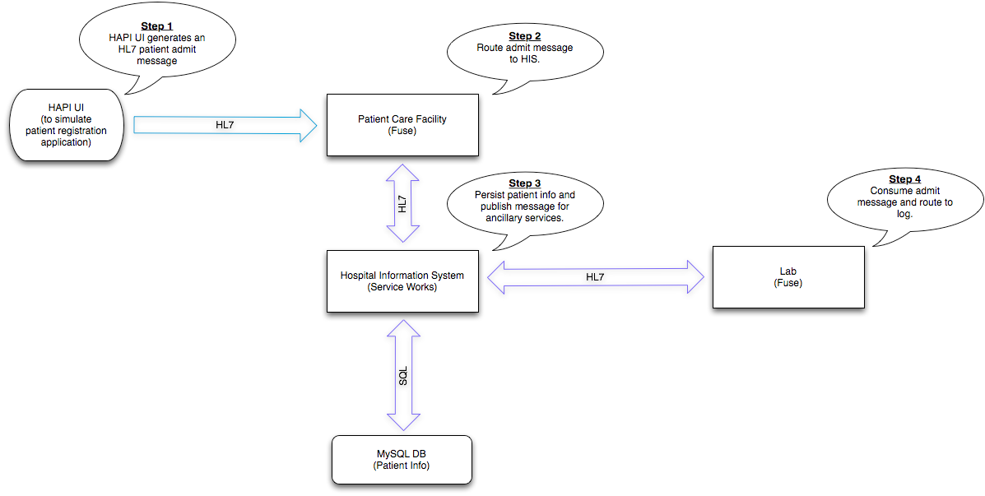

Use Case 2
In the second use case, a caregiver requests a test from the lab. The request comes in to the Patient Care Facility from the Android client and is ultimately processed by the lab. Once the test has been performed, test results are sent back to the client. In order to build a more complete request, the Patient Care Facility calls upon the Hospital Information System's patient lookup service to provide additional patient information. In this demonstration, that additional patient information is simply the patient's last name which was stored in the database as part of the first use case.
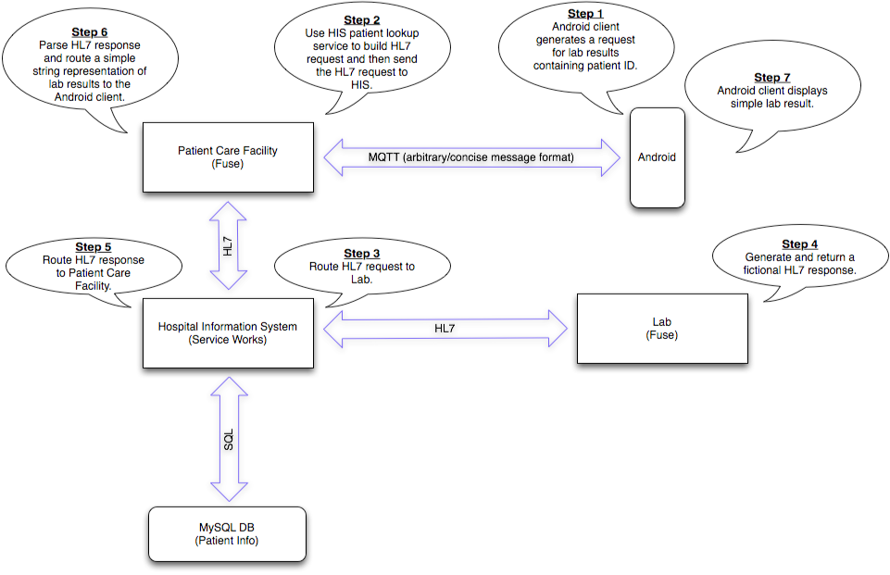

Message Types

HL7 Messages
HL7 messages carry information between major system components. HL7 Patient Admit messages that are generated by the HAPI Test Panel come into the Patient Care Facility via MLLP. Throughout the rest of the architecture, HL7 messages are passed between system components as JMS text messages. The list below describes each of the five HL7 messages that are used.

ADT-A01
The Patient Admit message indicates that a new patient has been admitted. This message is generated by the Patient Registration Application (simulated with the HAPI test panel).

A19-QRY
The Patient Query message used to gather patient information. The Patient Care Facility sends this message to the Hospital Information System as part of the process of building an ORM-O01 message.

A19-ADR
The Patient Query Response message contains requested patient information. The Patient Care Facility receives this message from the Hospital Information System in response to the A19-QRY message.

ORM-O01
The Observation Request message used to order a lab test. The Laboratory Information System receives this message and responds with an ORU-R01 message.

ORU-R01
The Observation Result message contains the lab test results. The Laboratory Information System sends this message in response to an ORU-R01 message.

AHE Messages
For Android clients, a more concise message format was needed. The chosen format has been arbitrarily named "AHE" (Abbreviated HL7 Exchange). An AHE message looks like a URL path followed by a query string. The path part establishes the HL7 message type and trigger event while the query string contains the properties that provide context. See the format definition below.
<message type>.<trigger event>?<properties>
…and an example:
ORU.R01?code=87880&text=Negative&patient.surname=Smith
The example above is an observation result (the results of a lab test). The code is the LOINC identifier associated with a particular type of strep test. The text property contains the actual results ("Negative" indicates that no strep bacteria were detected). The patient.surname property contains the last name of the patient.

The Hospital Information System
The Hospital Information System is a Switchyard application. A patient lookup service is exposed via JMS to support patient queries. Incoming observation requests are forwarded to ancillary services. Incoming patient admit messages are stored in the database and forwarded to ancillary services.
- The HISBean represents the Hospital Information System and acts as a central hub, delegating tasks and passing information to the other components. HIS functionality is exposed to the outside world via the "HospitalInformationSystem" service which contains all of the necessary JMS bindings.
- The AncillaryBean represents ancillary services. The AncilllaryBean offers an ability to send information to ancillary services. In practice, this sending of information is done by publishing to the virtual topic to which ancillary services are subscribed (VirtualTopic.OUT.HL7..).
- The PCFBean represents patient care facilities. The PCFBean offers an ability to send information to patient care facilities. In practice, this sending of information is done by publishing to the virtual topic to which patient care facilities are subscribed (VirtualTopic.OUT.HL7.PATIENT.*).
- The PatientDataBean represents stored patient data and implements the CRUD operations that are needed by the HISBean.
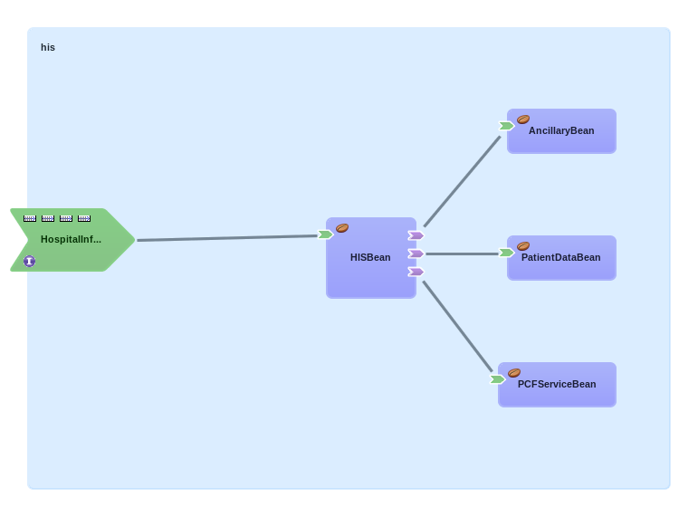

The Patient Care Facility
The Patient Care Facility is a feature that consists of the following three bundles:
- HL7 In - Handles all incoming HL7 messages
- Android In - Handles AHE messages that come in from Android clients
- Android Out - Delivers AHE messages to Android clients
A technical overview of each bundle is provided in the following three sections.

The “HL7 In” Bundle
The patient admit message (ADT-A01) is the only HL7 message that is currently supported by the Patient Care Facility. The Patient Registration Application publishes admit messages to the Patient Care Facility's VirtualTopic.IN.HL7.ADT.A01 topic and the HL7 In bundle routes them to the Hospital Information System which has a topic that shares the same name.
For convenience, an MLLP protocol adaptor is included - this allows admit messages to be sent in from the HAPI Test Panel.
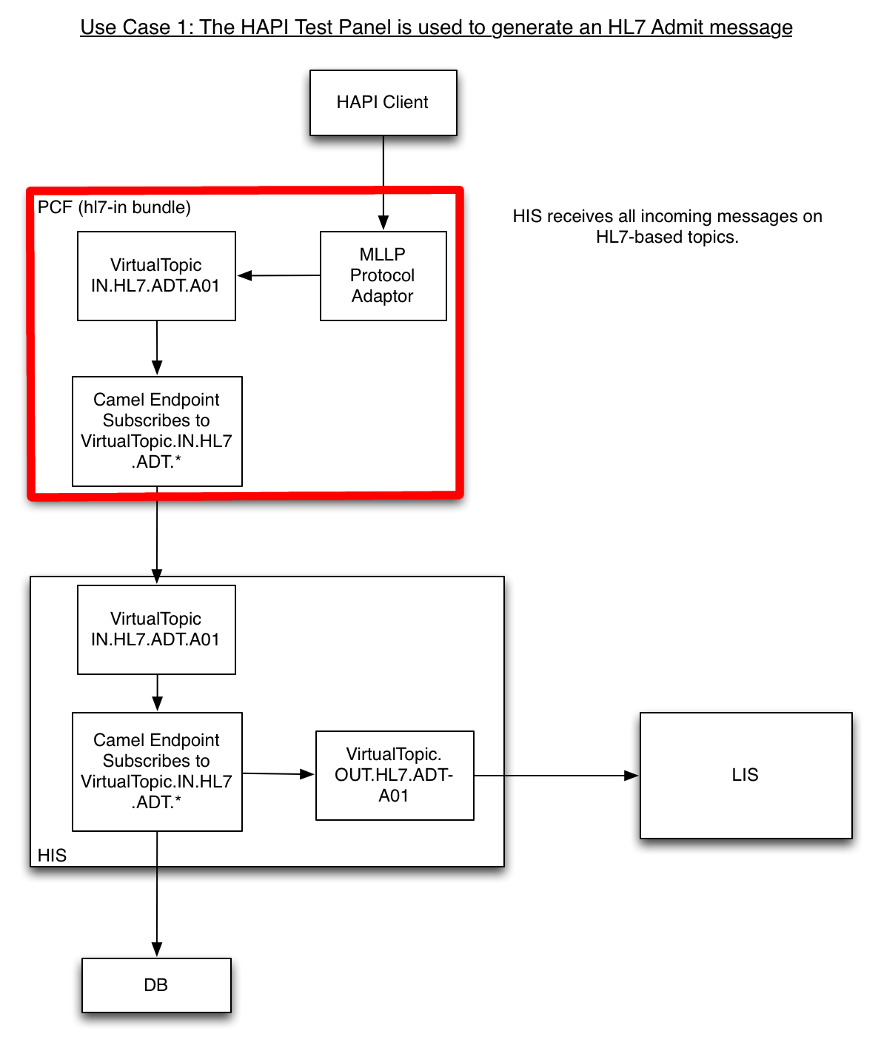

The “Android In” Bundle
The Android client publishes an AHE order request. The "Android In" bundle then parses that request, uses a camel enricher to build a proper HL7 ORM-O01 message with the results of a patient lookup request, and finally sends the ORM-O01 message to the Hospital Information System for processing.
Notice that the Android clients will publish and subscribe to patient-based topics instead of HL7 based topics. This makes sense for the use cases but it also provides scalability because each patient would be associated with a very manageable number of caregivers and each topic would therefore have a manageable number of publishers and subscribers.
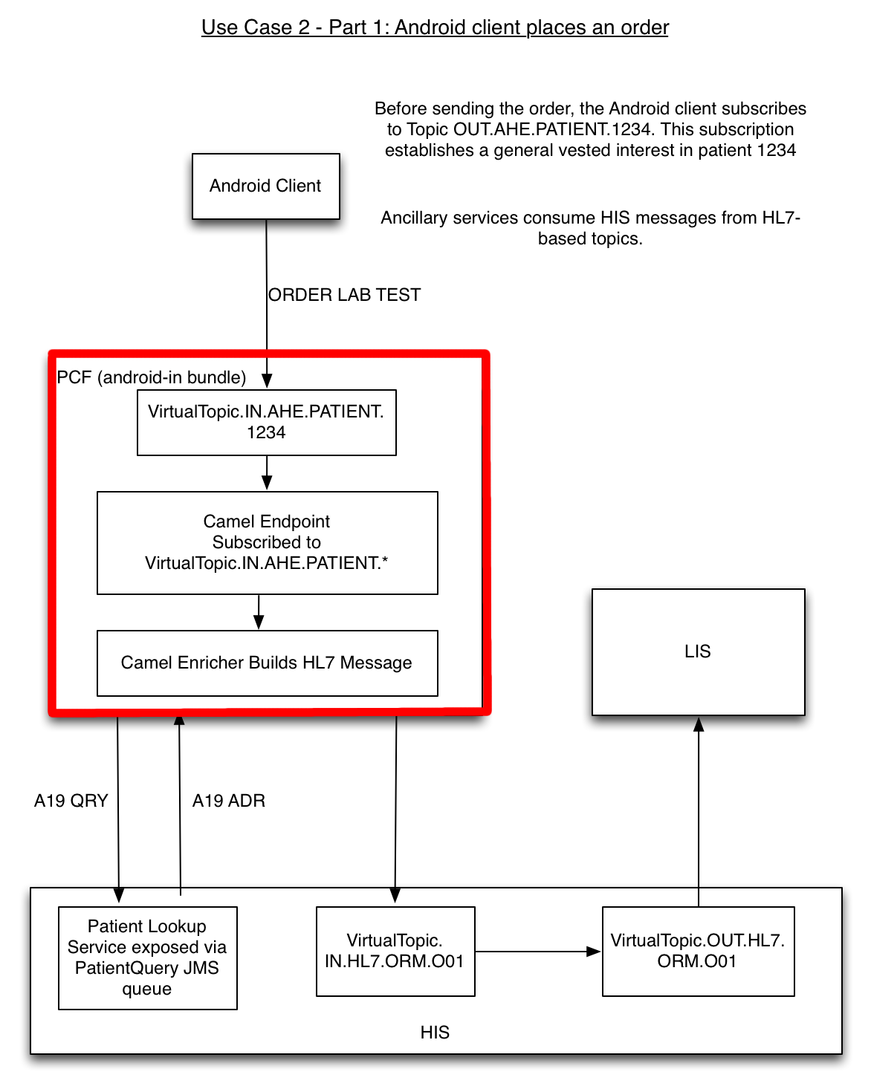

The “Android Out” Bundle
The "Android Out" bundle receives the HL7 ORU-R01 messages from the Hospital Information System and converts them to AHE for Android clients to consume.
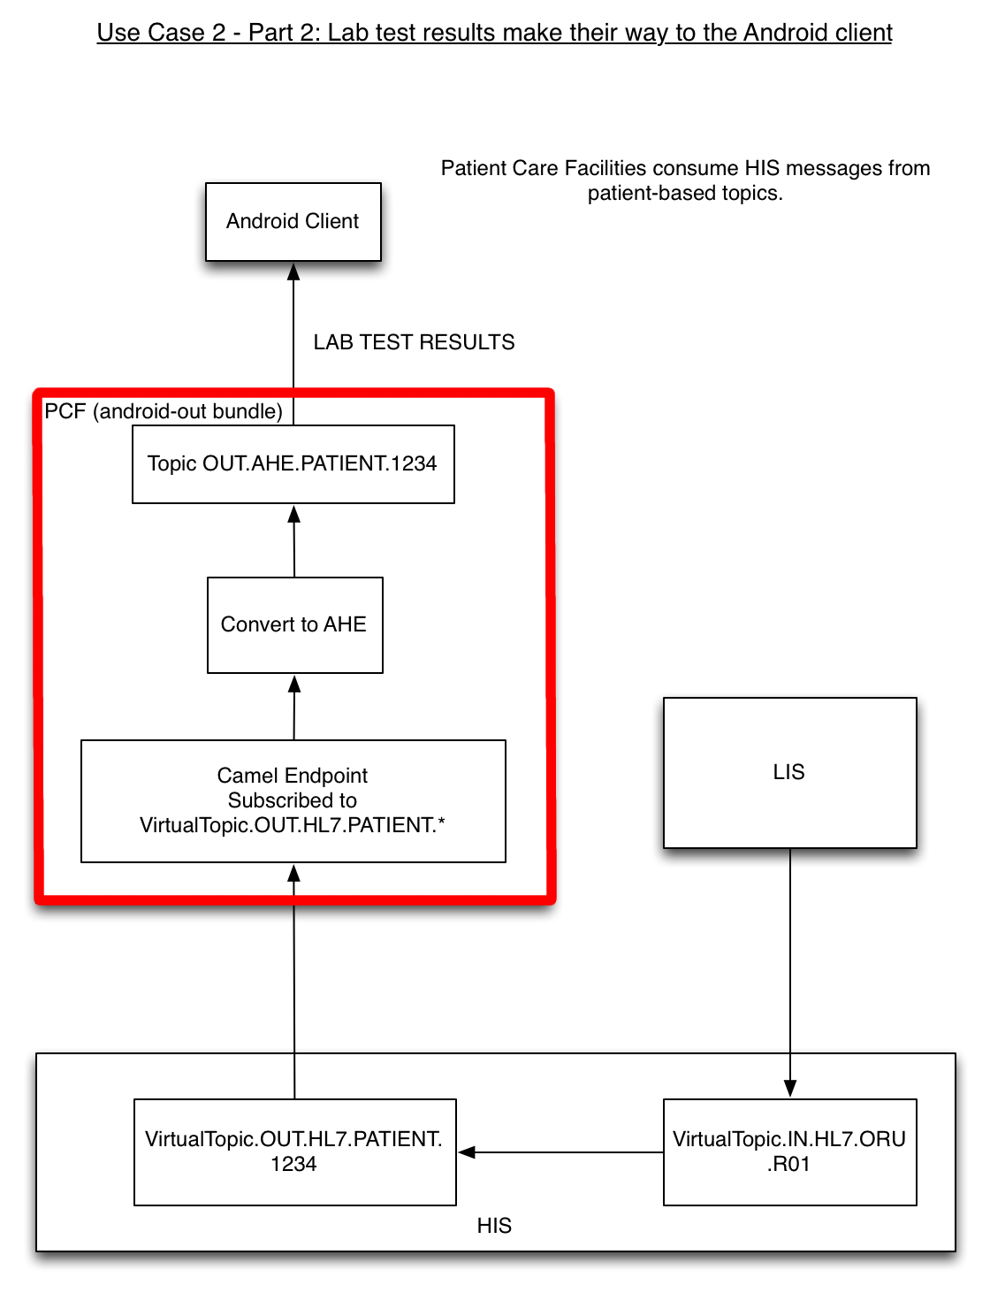

The Laboratory Information System
The Laboratory Information System is a feature that contains a single "HL7 Handler" bundle.. The "HL7 Handler" bundle is responsible for processing all incoming HL7 messages. Two types of HL7 messages are currently handled:
- Patient Admit (ADT-A01) - Patient Admit messages are routed to the log.
- Observation Request (ORM-01) - A fictional response is generated for each incoming Observation Request message. The HL7 Handler currently supports one type of Strep Test and Complete Blood Counts (CBC).

The Android Client
The Android client is a small application that sends observation requests for the lab and listens for incoming results.
The user clicks a connect button to start the "Result Receiver" thread and subscribe to the Patient Care Facility's OUT.AHE.PATIENT.* topic. Any incoming result message will cause the "results screen" to display immediately showing the results. In a real-world application incoming results would likely be stored in a list somewhere.
A "Place Order" button kicks off an "Order Sender" task that publishes the observation request to the Patient Care Facility's VirtualTopic.IN.AHE.PATIENT.* topic.
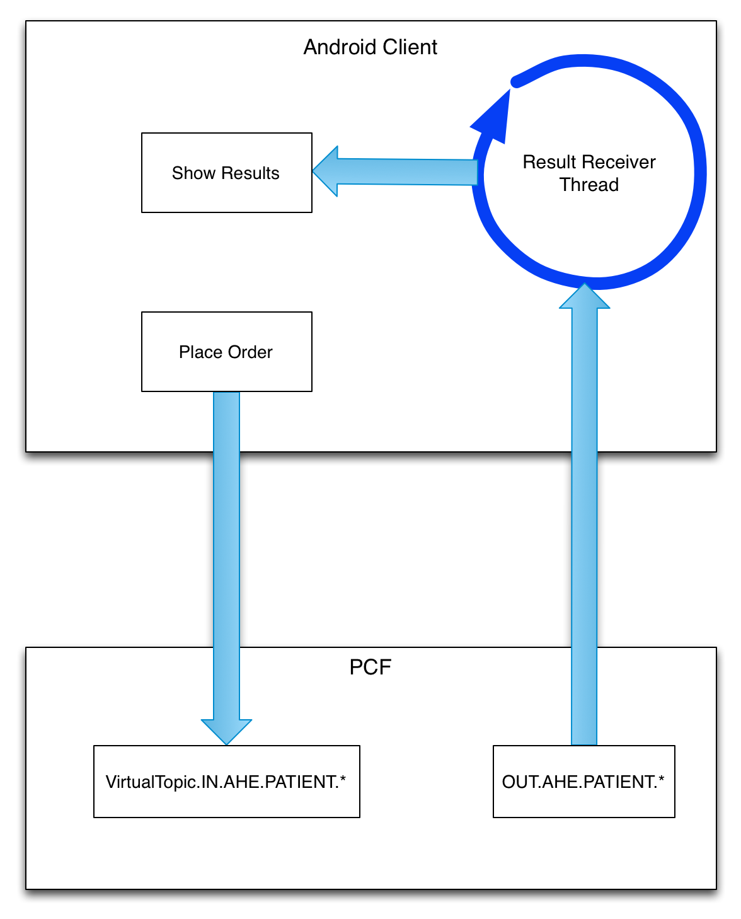

A Note About ActiveMQ and HornetQ
This reference architecture was designed to work with ActiveMQ as the message broker on the Patient Care Facility, the Hospital Information System, and ancillary services. However, the Beta version of JBoss Fuse Service Works 6.0 includes support for HornetQ exclusively and, as a result, the Hospital Information System currently uses HornetQ. This architecture was designed to make heavy use of virtual topics which are not directly supported by HornetQ. There are currently a few workarounds within the architecture that allow the original design to remain relevant while HornetQ is in use on the Hospital Information System. This is all temporary - the plan is to move the Hospital Information System to ActiveMQ when support for ActiveMQ comes to Fuse Service Works 6.0.

