Project Title:
Accessibilator
Project Summary:
Accessibilator is envisioned as a website with the primary goal to assist individuals with a range of learning disabilities, such as dyslexia, dyscalculia, oral/written language disorders, and specific reading comprehension deficits along with physical disabilities, including color blindness and visual impairment by transforming and optimizing the contents of their documents.
What are you doing?
Accessibilator focuses on converting a variety of documents including PowerPoint presentations, Word documents, and Excel spreadsheets, into highly accessible formats. We seek to optimize content for users with various accessibility requirements by combining conventional techniques like font adjustments, color correction etc and machine learning techniques to develop features such as image labelling and text summariser.
Why are you doing it?
In the current digital era, we understand the vital importance of universal accessibility. Many people struggle to understand and interact with common document formats as they are not designed by taking into consideration the different accessibility requirements of different users. By improving accessibility, we intend to level the playing field and make sure that everyone can access and use the information provided. Institutions are under increased pressure to develop accessible products not just for PR purposes but also to better engage with the community.
Financially speaking, Software that places a high priority on meeting accessibility standards has a good chance of winning grants in the current environment where accessibility research is a hot topic.
There is a substantial body of legislation surrounding accessibility, including acts like the Americans with Disabilities Act (ADA), European Accessibility Act, and United Nations Convention on Rights of Persons with Disabilities and IT organizations need individuals who are familiar with these laws. Through our project, we aim to gain a deeper understanding of these legal frameworks and their implications for accessibility in the digital realm.
Who will use it?
Accessibilator is designed for a broad spectrum of users. The primary users are individuals with disabilities and those who work closely with them, such as caregivers, therapists, and special educators. We are also looking closely at working with Dyslexia Association of Ireland and other such government and private agencies that work with people with disabilities. Input from these stakeholders will help us improve the quality of the application and its useability.
Secondary users encompass professionals, educators, and students who aim to make their standard documents more adaptable to these specific accessibility needs. Government and private agencies working on accessibility issues will also benefit from using Accessibilator.

How will they use it? (Example use case)
- Once on the website, the user can choose an accessibility format such as dyslexic-friendly, color-blind-friendly etc.
- Users have the option to customize their format or proceed with a predefined accessibility template. Customization includes selecting font styles, sizes, color corrections, summarization, and more.
- Once the format is chosen, User will be able to upload their document (supported doc types, word, ppt, excel) by clicking on the upload option on the website.
- Once a document is uploaded user can proceed to click on the modify option.
- The system will then apply the chosen accessibility features to the document.
- The user can download the optimized document.
Project Development:
A description of your first minimal viable product (MVP) including what you will learn from deploying this and what you would measure to learn it. (Even if you are not taking a lean approach to managing your project you should be able to articulate an MVP.)
Our first Minimal Viable Product (MVP) will focus on developing the core functionality of Accessibilator. This version will allow users to upload documents (of type Word) and apply predefined accessibility templates, specifically targeting dyslexic-friendly formats. Users will be able to customize font styles, sizes, and color corrections. This initial version will not incorporate machine learning-based enhancements. Following the Feature-Driven Development approach, the project will be divided into manageable features or functionalities. Each feature will be developed and integrated incrementally, ensuring a structured and iterative development process.

How will you build your system?
- Front-end: The user interface will be built using Next.js, a framework based on the React UI library, which allows advanced production-ready features such as server-side rendering and SEO benefits. This will ensure optimal client-side performance and make our application easier to discover on the web. Some of the UI components will include:
  - Accessibility Format Selector: This component will feature a dropdown menu or a button grid, allowing users to easily choose from predefined accessibility formats like "Dyslexic-Friendly" or "Color-Blind-Friendly."
  - Document Upload Interface: A drag-and-drop area will be the focal point of this component, complemented by file type icons to indicate the supported document formats like Word, PPT, and Excel.
  - Document Review Interface: This component will serve as an interactive preview pane where users can review the optimized document before downloading. It will offer zoom-in and zoom-out features, as well as page navigation controls for multi-page documents like PDFs or PowerPoint presentations.
  - Customization Panel: Implemented as a sidebar or modal, this panel will offer interactive sliders and checkboxes for users to fine-tune settings such as font size, color schemes, and additional features like text summarization.
  - User Dashboard: This component will include sections for profile information and document history, allowing users to view and manage their previously uploaded and processed documents for easy re-download or further modification.
  - Feedback Form: A small form widget will be included at the bottom of the review interface, encouraging users to provide feedback on the optimization process and the final output, which can be invaluable for future development.

- Back-end and ML:
  - AWS Amplify for AWS Cloud Hosting and Management: Amplify will serve as an integrated development platform, streamlining both front-end, back-end and ML services. Amplify provides managed cloud hosting and deployment as well as a unified management console for integrating the various AWS services that the application will utilize. Top of Form
  - AWS Lambda with Express.js: We'll use AWS Lambda to run serverless Express.js applications for handling RESTful API requests. This architecture is cost-effective and scales automatically with the number of requests, making it ideal for a variable load.
  - AWS API Gateway for Request Routing: API Gateway will serve as the entry point for all API requests, routing them to the appropriate Lambda functions. It also provides features like rate limiting, caching, API key validation, enhancing security and performance.
  - Amazon S3 for Document Storage: Amazon S3 will be used to temporarily store the uploaded documents and the processed, accessible versions. S3 offers high durability and availability, ensuring that user files are safe and readily accessible.
  - Amazon SageMaker for Machine Learning: Custom machine learning models for text summarization, color correction, and font adjustments will be trained and deployed using Amazon SageMaker. It provides a complete set of tools for ML development, from data labeling to model deployment.
  - AWS Step Functions for Workflow Coordination: Given the multiple steps involved in document processing (upload, ML-based optimization, storage, etc.), AWS Step Functions will be used to coordinate these workflows, ensuring a smooth and error-free process.
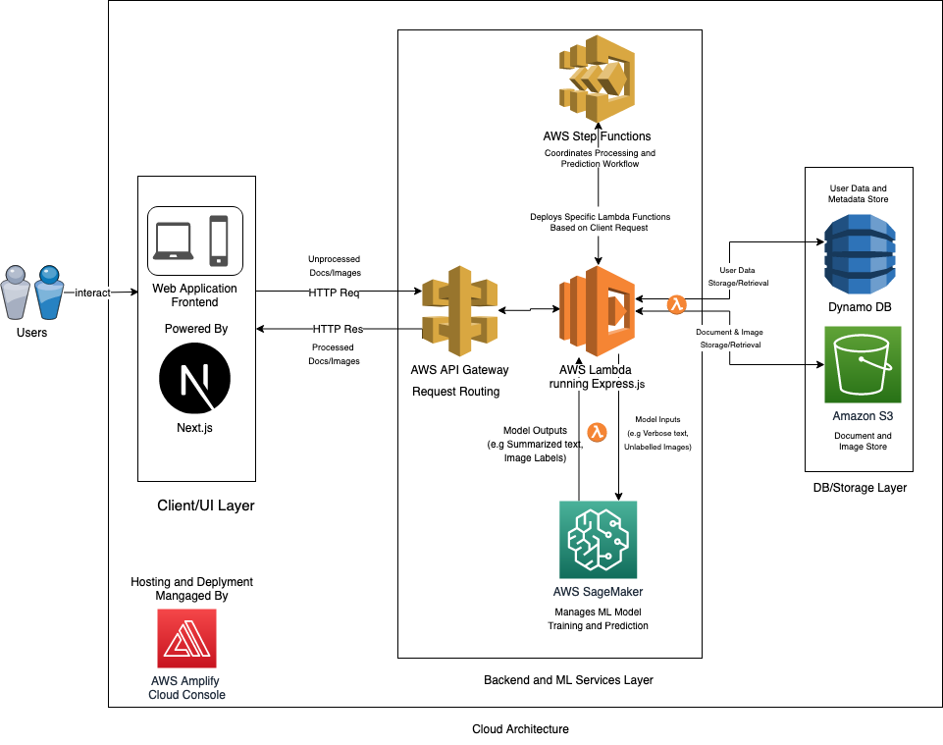
  - Amazon DynamoDB for User Data and Preferences: User-specific data like preferences, history, and annotations will be stored in Amazon DynamoDB. It's a NoSQL database service that offers quick and consistent performance, making it ideal for storing user profiles and session states.
Accessibilator System Diagram

- Data sources: What data will you use and how will you access it?
The data is collected from various sources and meticulously prepared for our machine learning model. Our goal is to provide both complex and simplified text versions to the model. As a result, the model can effectively summarize and convert complex document files into simple English. This strategy aims to improve content accessibility for people with learning disabilities, making it easier for them to understand and grasp the information.
We intend to obtain raw data from a variety of sources, including Google Datasets, Wiki large, and News Articles that include concise summaries that serve as simplified versions. Web scraping, downloading datasets, and possibly utilizing APIs provided by these sources are all part of the data collection process.
In terms of image labelling, we will collect many images along with their corresponding labels. The goal is to teach our model how to describe and categorize images in documents. This image data can be sourced from Google Datasets or other image databases through similar data acquisition methods.

Evaluation:
- How will you evaluate your system?
User Testing and Feedback: Conduct usability testing with a diverse group of users, representing various demographics and accessibility needs to adequately test our solution. Gather feedback on their experience, including ease of use, effectiveness of customization options, and overall satisfaction.
Accessibility Metrics: Employ automated testing tools to assess the accessibility of modified documents. Evaluate against established accessibility standards (e.g., WCAG) to ensure compliance.
Comparative Analysis: Evaluate the modified documents against their original versions to assess enhancements in accessibility, particularly for individuals with specialized needs such as dyslexia. Measure the time users take to read through the document both before and after applying the customizations.
Machine learning Evaluation: We will evaluate the performance of our machine learning model using various metrics such as accuracy, error rate, F1 score, precision, recall, confusion matrix, mean absolute error (MAE), mean squared error (MSE), root mean squared error (RMSE), R-squared, area under the ROC curve (AUC-ROC), and hinge loss. A careful analysis of our model's use case will be used to select specific metrics or a combination of metrics. This method ensures that we select the most appropriate evaluation measures to effectively assess our results.

- How will the evaluation inform your future development?
User choices and requirements will help prioritize accessibility features and customization possibilities in upcoming iterations. User feedback may also reveal any undetected issues, which will be addressed to enhance system performance.
Since scrum is an Agile methodology, evaluation and feedback will help us to adjust priorities for future development in the upcoming iterations helping us make the application more relevant and useable.
The evaluations can also help us make sure that proper precautions are taken to achieve data security and privacy.
This will also help us in being able to automate the process of making the document more accessible to users without much input from the user.
In the future, we are looking at creating extensions for Word and Excel, Powerpoint that users can use as plug-ins on the system.

Project Management:

- How will you run the project?
The SCRUM methodology will be employed to manage the project. The development process will be organized into sprints for 2 weeks long, allowing for focused and iterative progress. Tasks for each sprint will be collaboratively determined by the team. As part of project management, we will be using Azure DevOps. This will help us integrate our GitHub, our source repository and Slack, our team collaboration platform for seamless CI/CD.
Sprint Planning: During sprint planning, the team's primary objectives are to define clear sprint goals, select user stories, estimate and break down tasks, plan according to team capacity, identify and address dependencies, prioritize tasks if needed, set the sprint schedule, promote team alignment and communication, and assess and mitigate risks. Every sprint the role of scrum master and product owner will be rotated between the team members.
Daily Stand-ups: Brief daily meetings will occur, providing updates on individual progress, any issues faced, and tasks planned for the day.
Sprint Review and Retrospective: In person meetings will be scheduled on Fridays to address any issues, review completed work, and gather feedback. During the retrospective, the positives, negatives and how to improve on the negatives will be discussed. Additional ad-hoc meetings may be organized if required.
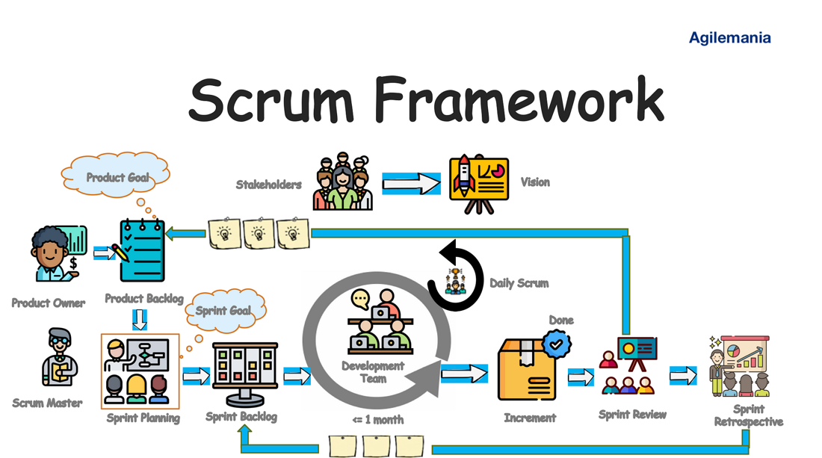
Scrum Framework
Kumar Singh, N. (2021, June 6). Essential elements of Agile Scrum. Google.com. https://www.google.com/url?sa=i&url=https%3A%2F%2Fmedium.com%2Fagilemania%2Fessential-elements-of-agile-scrum-d5d5d8cafe8d&psig=AOvVaw2GVE1noaGkOvtJoOhkbdRb&ust=1695977762044000&source=images&cd=vfe&opi=89978449&ved=0CBMQjhxqFwoTCKj5ttL3zIEDFQAAAAAdAAAAABAT

- What deadlines will you set?
The project is planned to span 13 weeks, with key milestones and deadlines carefully set to ensure timely completion. The first week is dedicated to project kick-off activities, including finalizing the scope and setting up the initial development environment. Weeks 2 and 3 are allocated for research and planning, where we'll finalize the technology stack and architecture based on market research and user personas.
By the end of Week 5, we aim to complete the initial development phase, which includes setting up AWS services and databases, as well as beginning front-end and back-end development. Week 6 marks our first internal review, where the team will assess the project's progress and make any necessary adjustments.
The interim demo is scheduled for Week 6 as well. This is a critical milestone where we'll showcase the Minimum Viable Product (MVP) to stakeholders and gather initial feedback. Feature development will continue in weeks 7, 8 and 9, influenced by the feedback received during the interim demo. This phase will also include the training of machine learning models.
A second internal review is planned for Week 10 to make final adjustments and finalize the machine learning models. Weeks 11 and 12 are earmarked for user testing and evaluation. We'll implement any last-minute adjustments based on user feedback during this period.
Finally, Week 13 is reserved for the final review and submission. This includes completing all project documentation and preparing for the final demo. These deadlines serve as the backbone of our project plan report, ensuring that we meet our objectives within the allocated 13-week timeframe.

- What is success?
Success for this project encompasses:
- Completion of planned tasks within each sprint, in accordance with sprint objectives.
- High-quality code with few errors or flaws.
- Positive feedback on Accessibilator's functionality and usability.
- User-customizable accessibility features were successfully integrated.
- User feedback and evaluation metrics drive continuous improvement.
- Meeting project timelines and deadlines.
- We aim to efficiently progress through the development phases while prioritizing user needs and ensuring product excellence by adhering to the SCRUM methodology, dividing the project into manageable sprints, and utilizing tools like Azure boards for task tracking.

Team Name: ByteTheBarrier

Team Members:

Name | Student Number | Contact Number
Joel Felix Quadras | D22125093 | 0894373029
David Ayang | D22127639 | 0852226909
Mountdenyraj Chelladurai Nadar | D22124430 | 0892404418
Cheril Mariam John | D22124272 | 0851368585

Team Meetings:
For our group we have planned online Team meeting at 10 pm occurring from Monday to Friday each week and in person meeting after the session at university from 12 pm to 2 pm. Currently the online meeting is set to 1 hour owing to the project being in the nascent stages which leads to figuring out a lot of things together. Once we have the stories and tasks set up, this will be a standup call of about 20 min where people can share their updates on what they are working on and discuss any issues they are facing. On Fridays we will discuss the feedback we have received from the Professors and make necessary updates to the next week’s plan. It is mandatory for everyone to attend the meetings, exceptions may be made on a case-by-case basis, with advance notice. With respect to decision making, we will decide things together considering everyone’s input. If a situation calls for expertise, we'll trust the person with the most knowledge in that area.
Team Conflict:

We have had open conversations on what is expected from each of us as team members taking into consideration everyone’s needs and preferences. This helps in fostering a collaborative spirit and encourage members to take ownership of different tasks smoothly and effectively. Unresolved issues will be discussed among the team members to find a solution. When not able to arrive at a solution, we will choose the support of our project supervisor in identifying the best possible way to move forward. Conflicts will be discussed in meeting outside of daily standup calls with all members present. The problems will be discussed without judgement and criticism to hopefully arrive at a resolution. We believe having clear and open communication among all the team members will prove helpful in preventing conflicts to a certain degree. We will delegate to the team member with the greatest expertise in the relevant area to make the final choice.

