- pwd command
- mkdir command

Practical 1
Working with Directories & Files
- cd & cd .. command
- ls & ls -l command
- man command
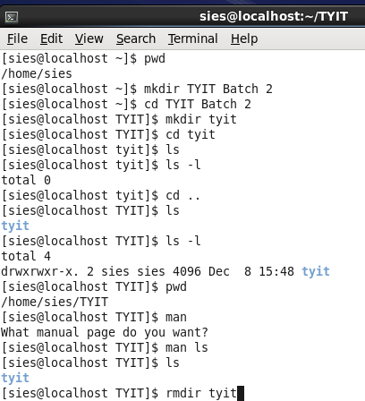
- rmdir command

- cat > & cat command
- cp command
- mv command
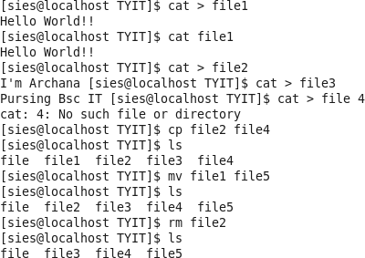

- history command
- cal command
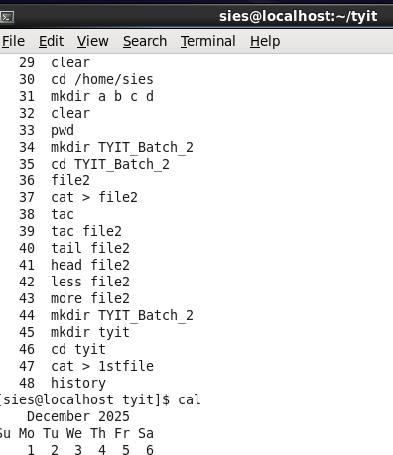
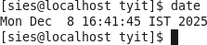
- date command

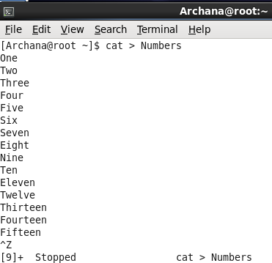

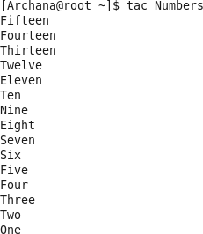
- tac

- tail
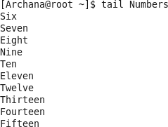
- head
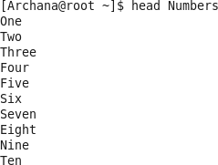

- less
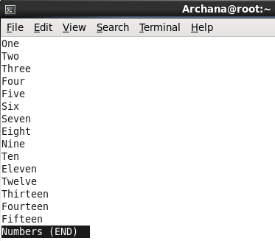

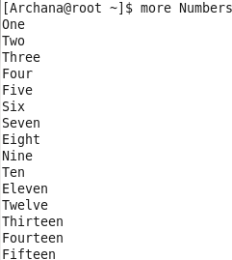
- more

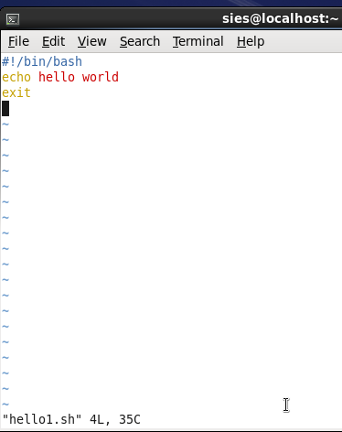
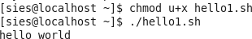
  - hello world

  - Even Odd Number

Practical 2
if else & case

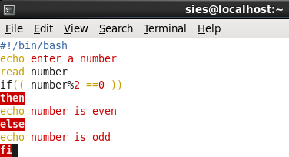
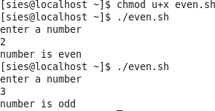

  - Positive Negative Number
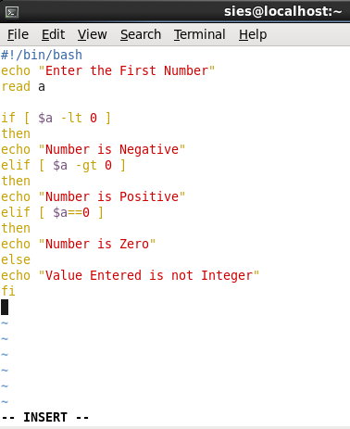
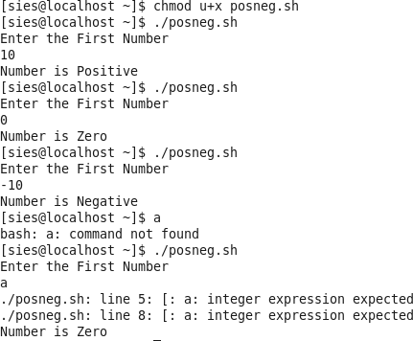

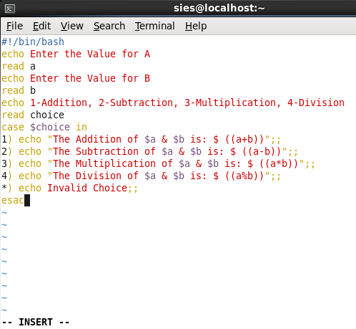
  - Case
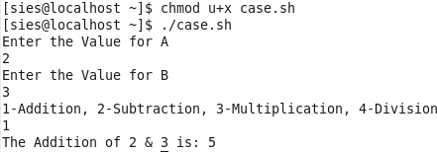
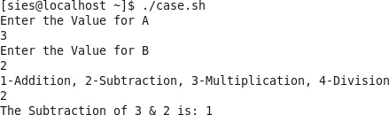
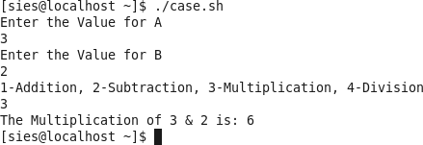
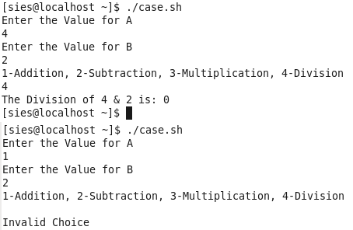

  - Find a Month
[7
sies@localhost:~
.Eile .Edit Y:iew _Search Jerminal .!:::!_elp
#!/bin/bash
echo Enter a Number From 1-12 to Find a Month read n
case $n in
11 echo This Month is January;;
2) echo This Month is February;; 3] echo This Month is March;; 41 echo This Month is April;; 5] echo This Month is May;;
6] echo This Month is June;;
7) echo This Month is July;; 8] echo This Month is August;;
9] echo This Month is September;;
- echo This Month is October;;
- echo This Month is November;;
- echo This Month is December;;
1 echo Invalid number;; esac

:wql
[sies@localhost -]$ chmod u+x year.sh [sies@localhost -]$ ./year.sh
Enter a Number From 1-12 to Find a Month
7
This Month is July [sies@localhost -]$ ./year.sh
Enter a Number From 1-12 to Find a Month 12
This Month is l)eceimber [sies@localhost -]$ ./year.sh
Enter a Number From 1-12 to Find a Month
4
This Month is April [sies@localhost -]$ ./year.sh
Enter a Number From 1-12 to Find a Month
3
This Month is March

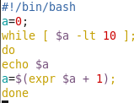
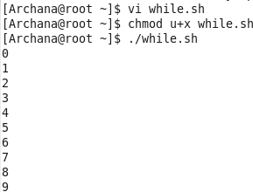
- While Loop

- Until Loop

Practical 3
While Loop, Until loop and for loop

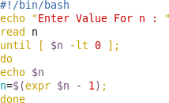
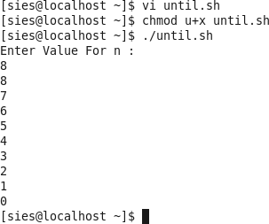
- For loop
  - In command prompt/terminal
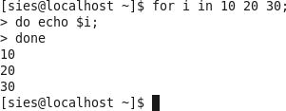

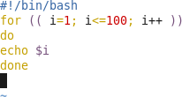
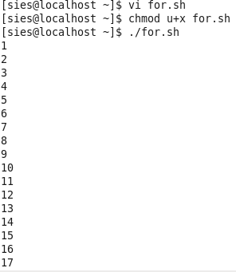
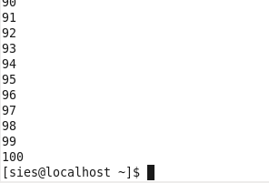
  - In shell script

Practical 4
Process Management , Creating Links, Creating Backups Commands for Process Management
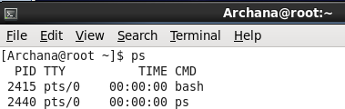
- ps command

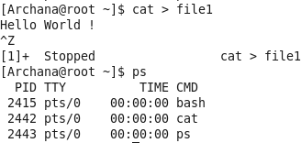
Using ps command after creating a file

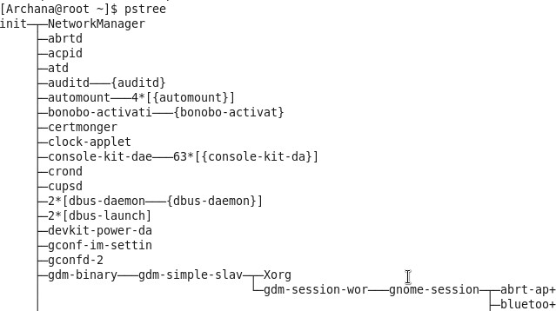
- pstree command

- kill command
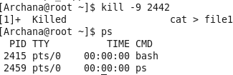

- top command
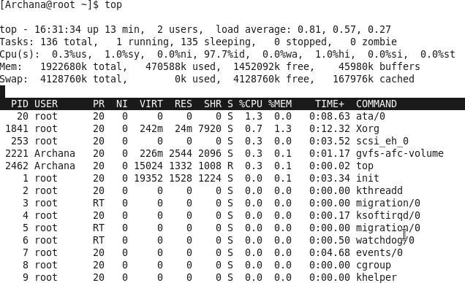

Creating links
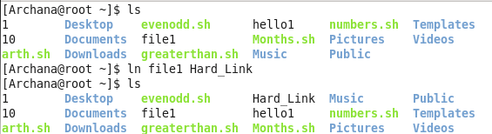
- Creating Hard Link (ln command)

- Creating Symbolic Link (ln -s command)
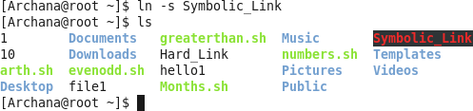

Creating Backups
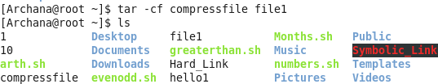
- Tar -cf command

- Create a new directory (backupfile) and create (3 files inside it) then execute tar -cf command
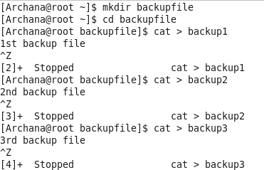
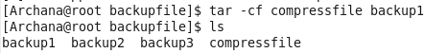

- Decompressing the backup file using –xvf command

Practical 5
Creating a new user & adding password for that user (Inside root ie. admin)
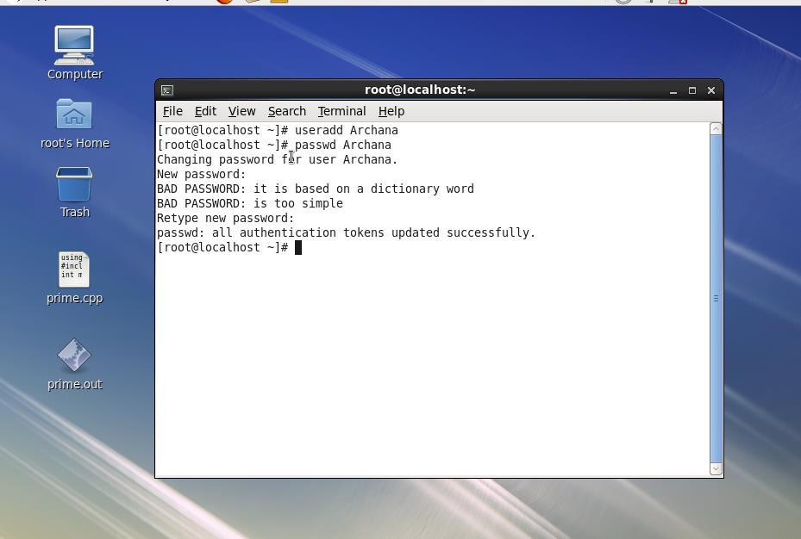
Trying to create new user inside a existing account , but its not allowed as only root/admin can create or add an user.
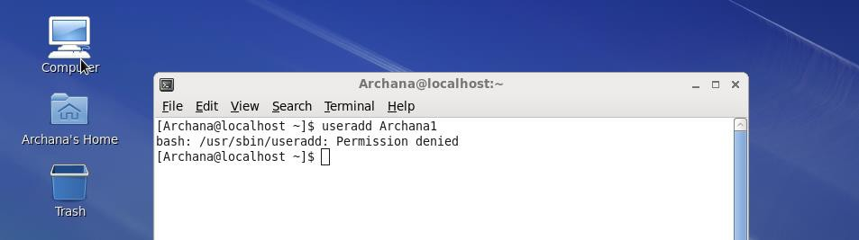
Rpm commands
- rpm -qa
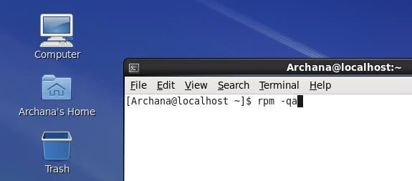
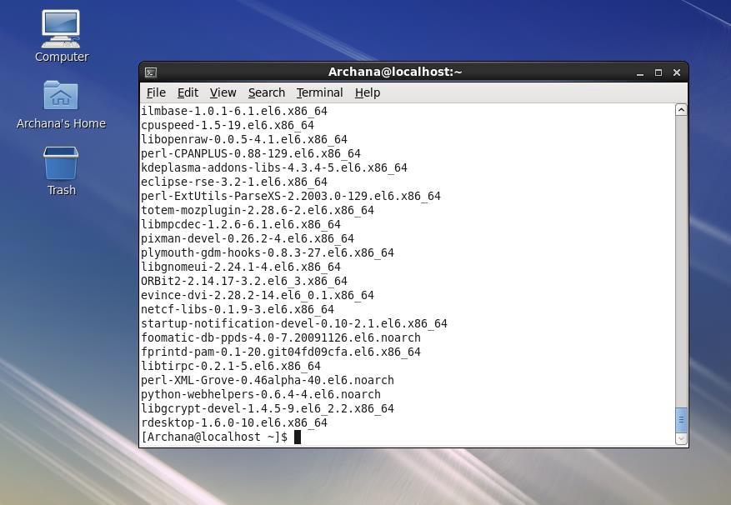

- rpm -ql command (here select any one packagename from the above (rpm
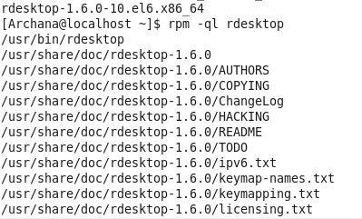
-qa command’s output)

- rpm -qc & rpm -qd commands

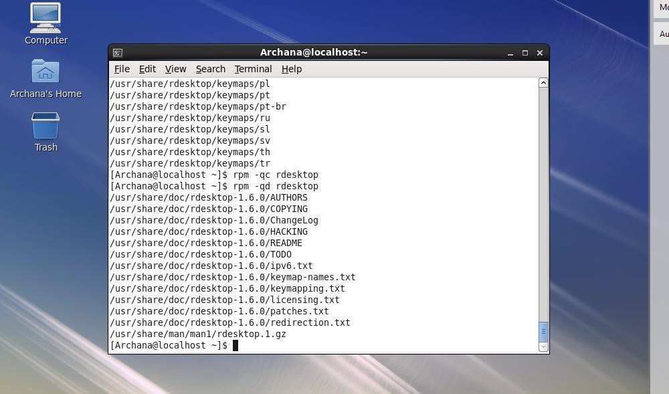
Locking user
- passwd -l command
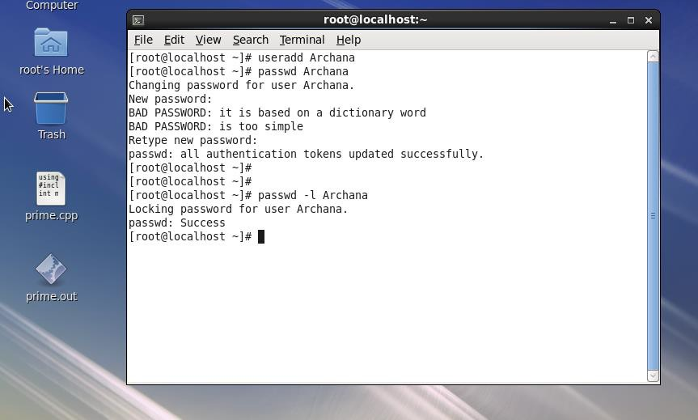

Unlocking User
- passwd -u command
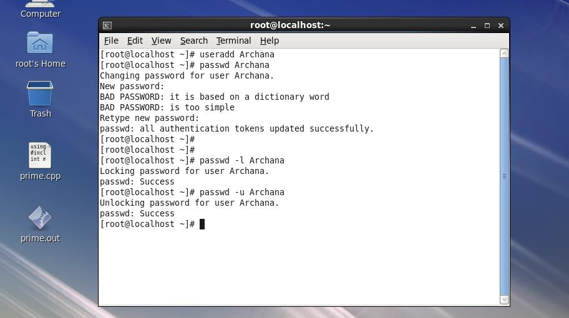

Creating Groups
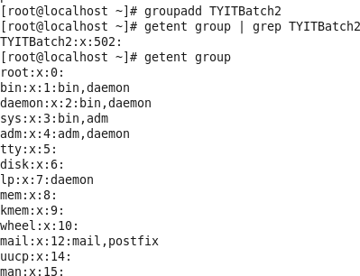
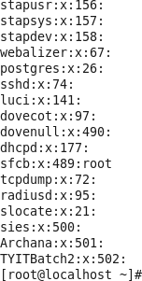

Adding one more user in the same group
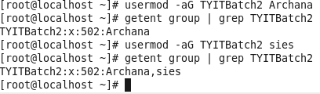
Creating a file and change the mode of it
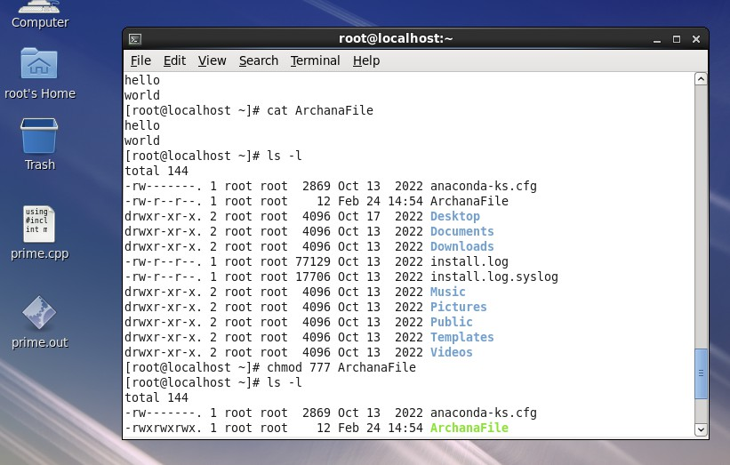
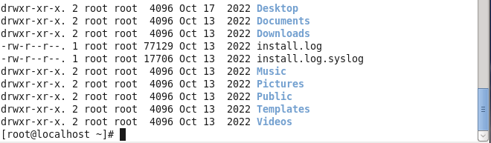
Changing ownership of the file
