Joel Chavali

Vistas In Advanced Computing

11 August 2017

Traffic Flow 1: Single Lane, Velocity Dependent Flow

Abstract:

Equations:

General Traffic Flow Equation:

|  |  |
| --- | --- |
| Legend of Symbols | |
|  | Acceleration of the jth vehicle |
|  | Constant that user defines |
|  | Real Time Speed of Previous Car |
| (t) | Real Time Speed of Current Car |

In this model, the acceleration of the jth vehicle (current vehicle) is based on the difference in velocity of the jth and j-1 vehicle (current and immediately previous vehicle in the line of traffic). The model is designed to use real time velocities. As the difference in velocity increases, the acceleration follows suit to always try to match the vehicle in front of it. Since the equation does not take into consideration the position of the vehicle, crashes can occur if vehicles are near each other but vary greatly in velocity.

Optionally, the equation can be simplified to eliminate the term by altering .

Discretized Forms of Equations:

Discretizing the equation requires two considerations. First the time and when things are happening as well as which vehicle in the line is having their velocity changed.

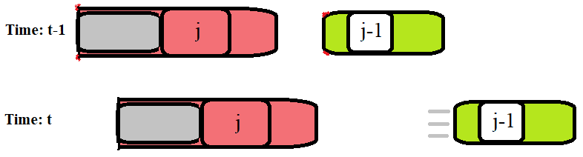

General Discretization:

However this has an error of order O(dt). Therefore I used the 4th order Runge Kutta.

4th Order Runge-Kutta:

Description of Numerical Methods with Pseudocode:

The 4th Order Runge-Kutta is a versatile beast that uses a center weighted average of the slopes at various points along the discrete interval in which it is given. Using 4 instead of 1 approximation values allows it to get much closer to the actual solution.

Implementing the Runge-Kutta ran into an interesting but simple problem. Evaluation of

Results:

Graphs and conclusions.

**Technical Specifications of Computer Used**:

Processor: Intel® Core™ i5 CPU M 560 @ 2.67GHz

Installed RAM: 4.00 GB

Local Storage: 297 GB

System Type: 64-bit operating system, x64-based processor

Windows Edition: Windows 10 Pro Insider Preview

Windows Version: 1703

OS Build: 16251.0