**17CS2064– Open Source Technologies URK17CS117**

**Ex no: 3 Compiling from the source**

**Date 29/08/2020**

**Aim:**

To perform compiling from the source code.

**Description**

**To transform a program written in a high-level programming language from source code into object code. Programmers write programs in a form called source code. Source code must go through several steps before it becomes an executable program. Table of commands:**

**S n. Command Meaning Description**

**1 make utility for building and maintaining groups of programs**

**The purpose of the make utility is to determine automatically which pieces of a large program need to be recompiled, and issue the commands to**

**recompile them**

**2 Gcc Gnu compiler collection Using for compile c and c++ program**

**3 -lm This command link math This** Command **will use the c11 version of**

**standards for compiling**

**the source**

**4 cmake Configure scripts It may be used for  configure project scripts**

**Openttd project configuration**

Ex. No. 3 |OPEN SOURCE TECHNOLOGIES 1

**17CS2064– Open Source Technologies URK17CS117**

**Step1: To download oppenttd project**

**Step2: unzip**

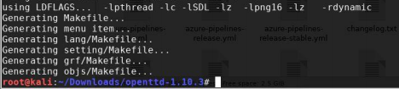

**Step3: Run make command**

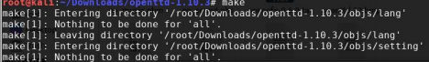

**Step4: Run make install command**



**Step5: Run cd bundle and type ./openttd**

****Ex. No. 3 |OPEN SOURCE TECHNOLOGIES 2

**‘**

**17CS2064– Open Source Technologies URK17CS117** 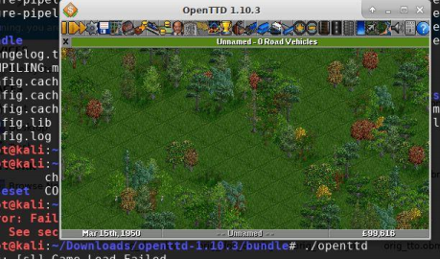

**To compile using cmake**

**Cmake version**

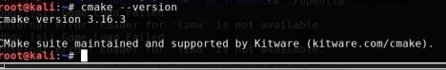

**Write the c program and use makefile to compile the program**

Ex. No. 3 |OPEN SOURCE TECHNOLOGIES 3

**17CS2064– Open Source Technologies URK17CS117 **

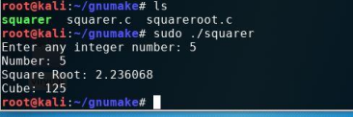

**Results: Output are successfully compiled and excuted.**

Ex. No. 3 |OPEN SOURCE TECHNOLOGIES 4