18CS2064 - Open Source Technologies Lab | URK17CS117 EX 4 Virtualization 01/09/2020

Aim: To learn the Virtualization setup with QEMU system and installing FreeDos in virtual machine.

Description: Virtualization is creation of Virtual Machines which can emulate hardware in software or in other words it is the creation of virtual version of something such as a hardware platform, operating system, storage device, or network resources

When you are running an OS over the top of another on your machine the whole environment acts like a HOST and GUEST OS. The real operating system acts as a HOST and the OS run by virtualization software acts as a GUEST OS.

QEMU is a generic and open source machine emulator and virtualizer.

FreeDOS (formerly Free-DOS and PD-DOS) is an operating system for IBM PC compatible computers. FreeDOS is made up of many different, separate programs that act as "packages" to the overall FreeDOS Project.

Types of Virtualization

■Full virtualization

■OS level virtualization

■Para virtualization

XEN is a free open source software virtual machine monitor for Intel / PowerPC architectures. It is software that runs on a host operating system and allows several guest operating systems to be run on top of the host on the same computer hardware at the same time.

18CS2064 - Open Source Technologies Lab | URK17CS117

`sl n.

command

Meaning

Description

1 Qemu For botting and creating disk image

2 Qemu-img For creating image directory

3 Pwd To find current directory

-h Display help and exit

-machine

type=]*name*[,prop=*value*[,...]]

Select the emulated machine by *name*. Use - machine help to list available machines.

Step 1 Preparing the base system for virtualization Install the required packages for virtualization using the following command.

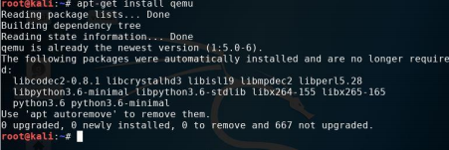

• Step 2 Check whether qemu is installed.

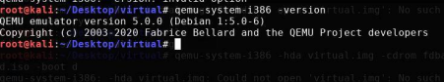

18CS2064 - Open Source Technologies Lab | URK17CS377 Steps to install FreeDOS or any other operating system 1.Create a directory named virtual #mkdir virtual



2.Move the downloaded iso file of freedos into the directory virtual e.g. mv source destination

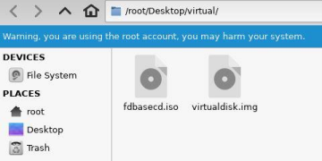3.Create a virtual disk space of 100MB for installing free dos #qemu-img create virtualdisk.img 100M

4.Boot the iso file from cdrom for installing #qemu –hda virtualdisk.img –cdrom fdbasecd.iso –boot d

18CS2064 - Open Source Technologies Lab | URK17CS117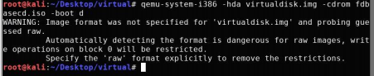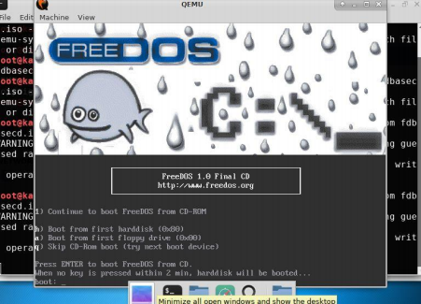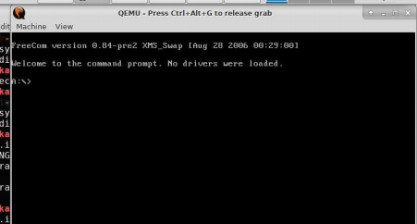

18CS2064 - Open Source Technologies Lab | URK17CS117

Result: Freedos os is successfully installed in virtual environment.