**Naan Mudhalvan**

**Data Analytics with Cognos**

**Phase-3**

**Team: Joel Ananth A, Monish R, Karthi M, Neelanand R**

**Route Mapping and Geographic Insights:**

One of the primary objectives is to gain geographic insights from the public bus transportation data. Visualization techniques will be employed to illustrate the routes and distribution of bus stops across different regions, cities, or states. By using color-coded maps or interactive GIS tools, we can depict the density of bus stops in various areas. This analysis will help identify areas with high and low accessibility to public bus transportation, shedding light on geographic trends in transportation infrastructure.

**Peak Hours Analysis:**

The public bus transportation data will be used to investigate peak hours of ridership. Visualization tools such as line graphs or heatmaps can be utilized to showcase the fluctuations in passenger counts throughout the day. This analysis will provide insights into the busiest hours for public transportation, helping in optimizing schedules and resources. It will assist in understanding whether there are variations in ridership based on time of day.

**Route Efficiency and Stops Comparison:**

The data will be employed to compare the efficiency of different bus routes and the number of stops on each route. Visualization techniques like bar charts, stacked bar charts, or radar charts can be used to represent route characteristics. This analysis will offer insights into the most and least efficient routes and help in making informed decisions regarding route optimization and stop consolidation.

In summary, the visualization of the public bus transportation data based on route mapping, peak hours, and route efficiency aims to provide valuable insights into the public transportation system. These visualizations will assist in identifying patterns, trends, and variations within the data, contributing to informed decision-making in the context of improving public bus transportation services and infrastructure.

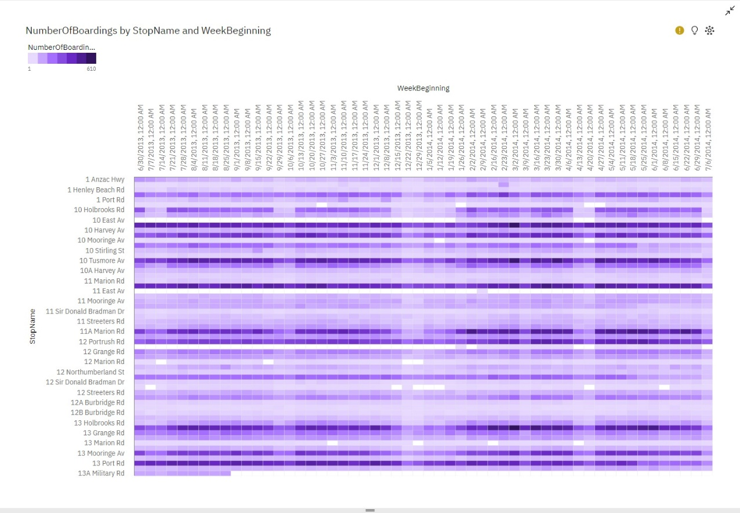

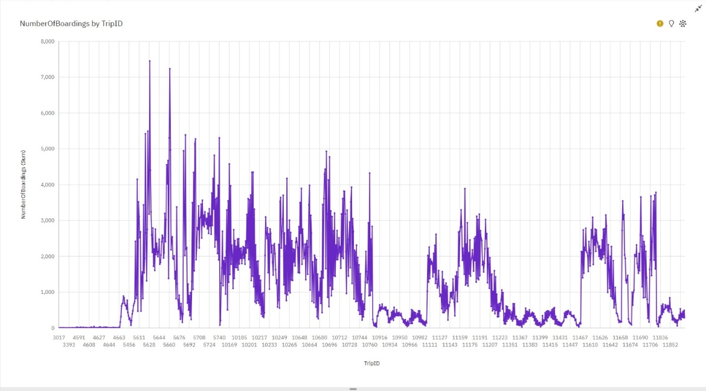

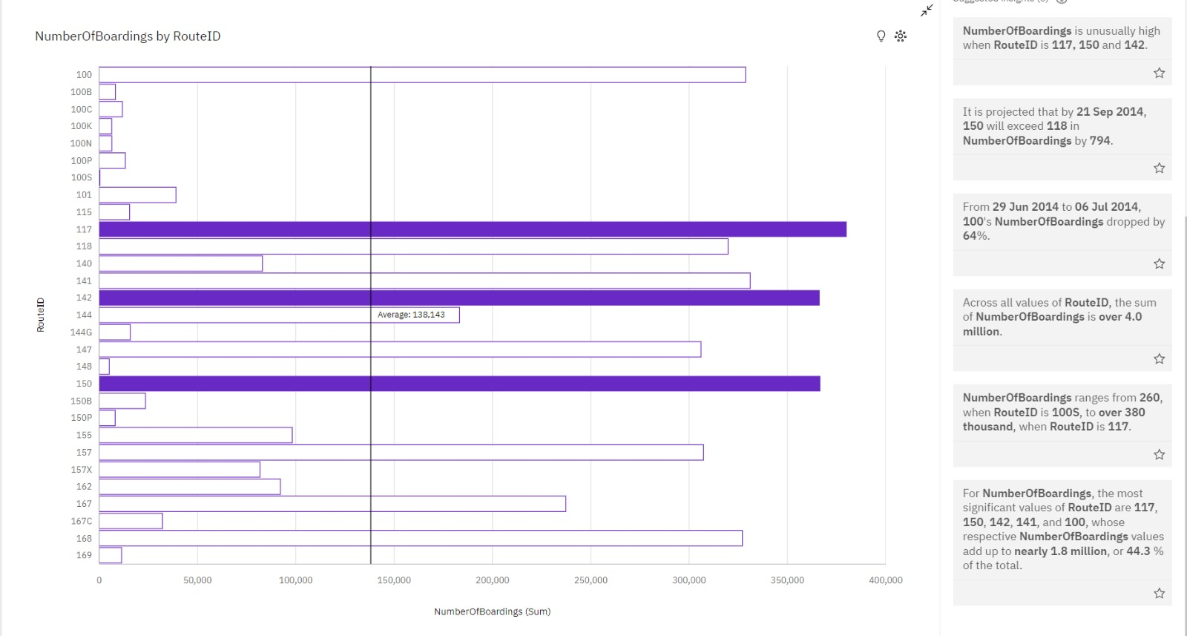

* **NumberOfBoardings** is unusually high when **RouteID** is 117, 150 and 142.
* It is projected that by 21 Sep 2014, 150 will exceed 118 in **NumberOfBoardings** by 794.
* From 29 Jun 2014 to 06 Jul 2014, 100's **NumberOfBoardings** dropped by 64%.
* Across all values of **RouteID**, the sum of **NumberOfBoardings** is over 4.0 million.
* **NumberOfBoardings** ranges from 260, when **RouteID** is 100S, to over 380 thousand, when **RouteID** is 117.
* For **NumberOfBoardings**, the most significant values of **RouteID** are 117, 150, 142, 141, and 100, whose respective **NumberOfBoardings** values add up to nearly 1.8 million, or 44.3% of the total.

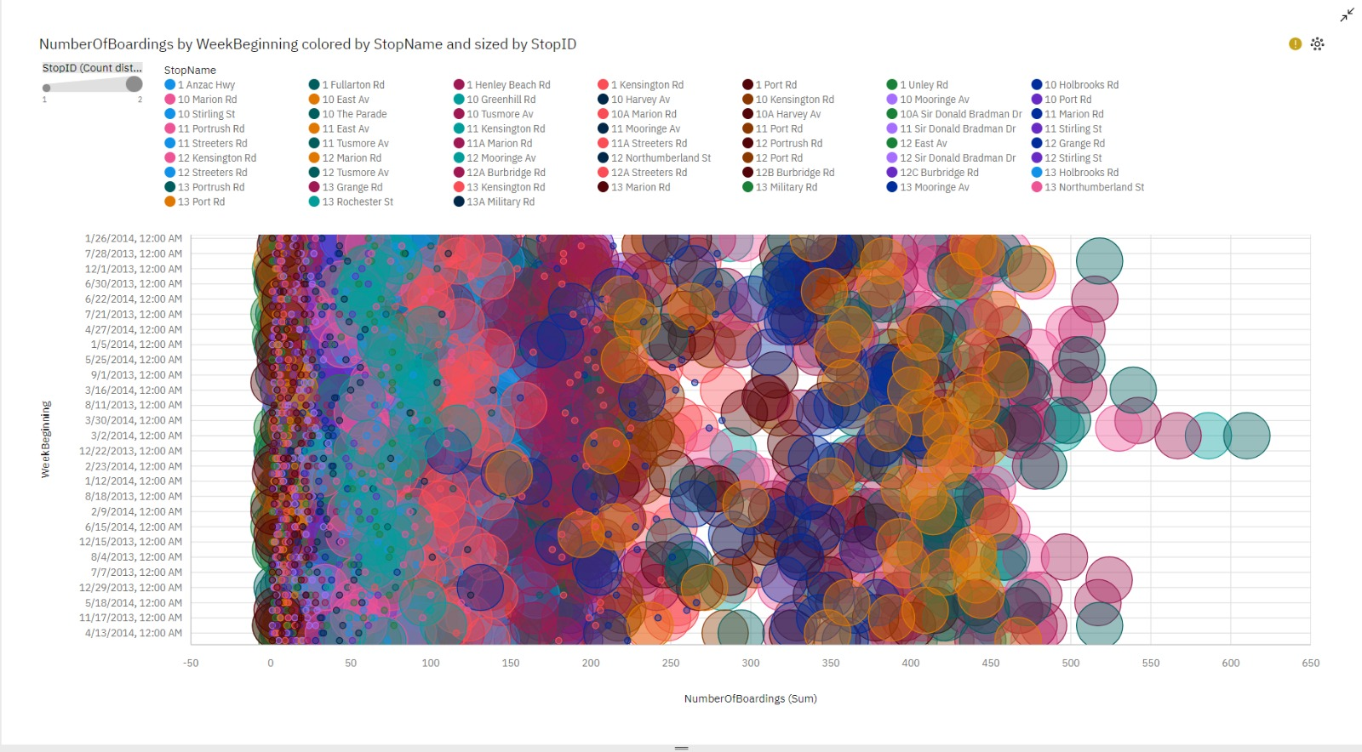

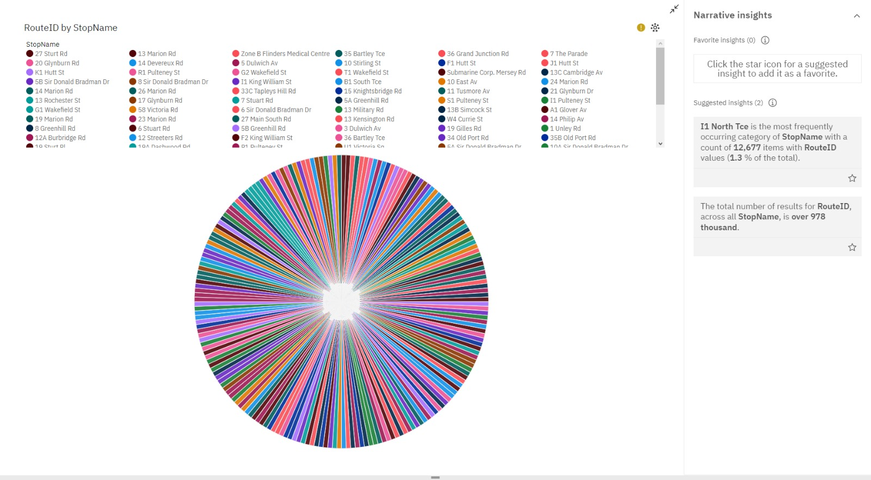

* 11 North **Tce** is the most frequently Occurring category of **StopName** with a count of 12,677 items with **RouteID** values (1.3% of the total).
* The total number of results for **RouteID**, across all **StopName**, is over 978 thousand.

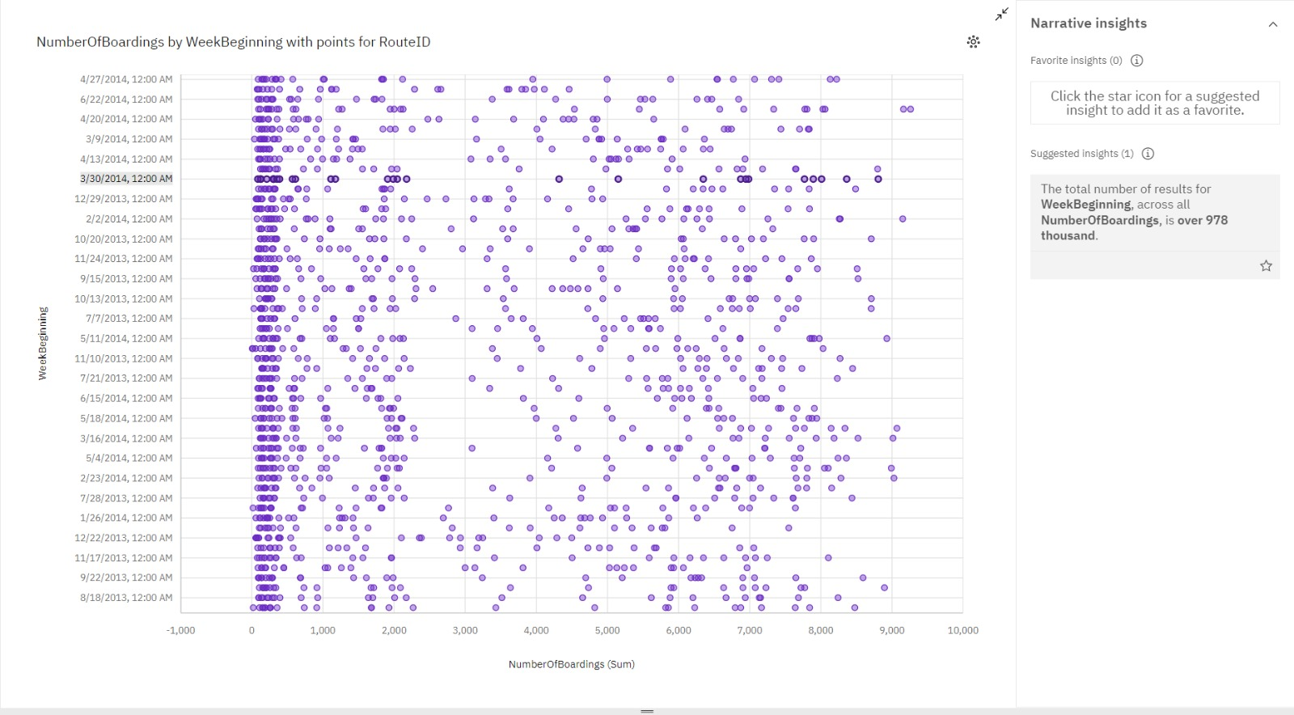

* The total number of results for **WeekBeginning**, across all **NumberOfBoardings**, is over 978 thousand.

The given dataset is pre-processed and cleaned using python libraries like numpy, pandas using Jupyter Notebook and then uploaded to IBM Cognos for Dashboard Visualization

About the Dashboard:

1. Boardings by Stop Name and Week Beginning: Analyzes weekly boarding patterns at each stop.
2. Boardings by Trip ID: Breaks down boardings by unique trip IDs for trip performance assessment.
3. Boardings by Route ID: Examines the popularity and efficiency of different routes.
4. Boardings by Week Beginnings (Color by Stop Name, Size by Stop ID): Visualizes boardings weekly, using color-coded stop names and stop ID sizes for insights.
5. Route ID by Stop Name: Displays the connection between route IDs and stop names.
6. Boardings by Week Beginning (Points for Route ID): Tracks boardings over time, pinpointing trends with route ID data points.
7. Preventive Measures Administered: Indicates the availability and utilization of special treatments or services within the public bus transportation system.