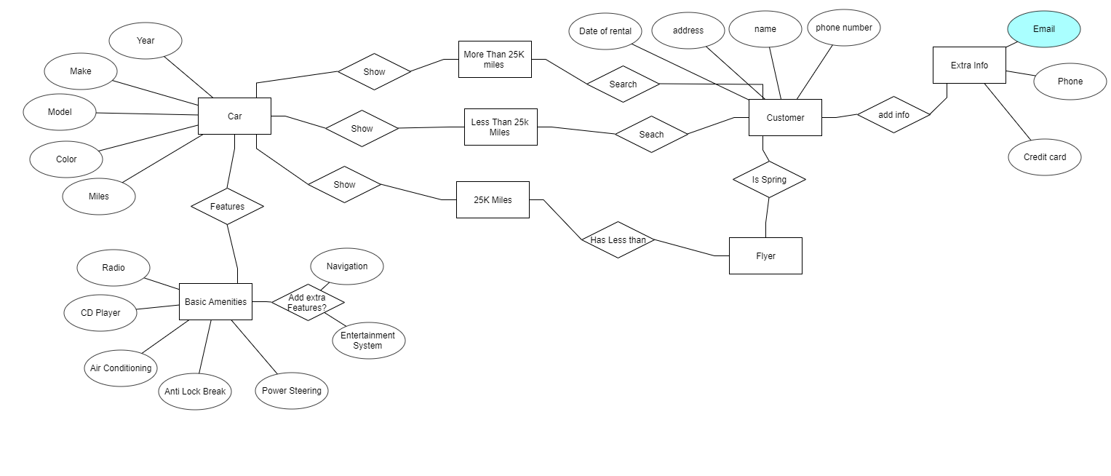

Car:

Make

Year

Model

Color

Miles

Customer:

Date of Rental

Address

Name

Phone Number

Basic Amenities:

Radio

Cd Player

Air Conditioning

Anti Lock Brake

Power Steering

Navigation

Entertainment System

Extra Info:

Email

Phone

Credit Card

More Than 25k:

Less than 25k:

25k miles: