Firebase

Firebase Site: https://console.firebase.google.com/u/0/

Using Firebase in an ngApp (FireStore framework):

Installation tutorial: https://github.com/angular/angularfire2/blob/HEAD/docs/install-and-setup.md

You need to create first a Firebase project + WebApp
Then to start a project locally:

ng new [project]
ng add @angular/fire

Follow the steps to select the project and features to add.
It will automatically open a Chrome tab to log in, when asking the authentication key.

The old version had to be done manually with:
npm i firebase @angular/fire
ng add @angular/fire

Add the FireBase key to the environment.ts (get it from the console):  /src/environments/environment.ts | Add Angular Fire Modules to the main module of the app (app.module.ts):  /src/app/app.module.ts
export const environment = {  production: false,  firebase : {  apiKey: 'AIzaSyHmdY5T2qXo_VyhmRePnT-VilV0CM',  authDomain: 'jb-tg.firebaseapp.com',  databaseURL: 'https://jb-tg.firebaseio.com',  projectId: 'jb-tg',  storageBucket: 'jb-tg.appspot.com',  messagingSenderId: '71600346',  appId: '1:795516003:web:93aa979d7833b12a'  }  }; | import { environment } from '../environments/environment';  import { AngularFireModule } from '@angular/fire';  import { AngularFirestoreModule } from '@angular/fire/firestore';  import { AngularFireStorageModule } from '@angular/fire/storage';  import { AngularFireAuthModule } from '@angular/fire/auth';  @NgModule({  declarations: [AppComponent],  imports: [  BrowserModule,  AppRoutingModule,  AngularFireModule.initializeApp(environment.firebase, 'jb-mtg'), // imports firebase  AngularFirestoreModule, // imports firebase/firestore, only needed for database features  AngularFireAuthModule, // imports firebase/auth, only needed for auth features,  AngularFireStorageModule // imports firebase/storage only needed for storage features  AngularFireDatabaseModule, // imports fire store  ],  providers: [],  bootstrap: [AppComponent]  })

Usage example:
/src/app/app.component.ts
import { AngularFirestore } from '@angular/fire/firestore';

@Component({...})
export class AppComponent {
items$: Observable<any[]>;
constructor(db: AngularFirestore) {
this.items$ = db.collection('cards').valueChanges();
}
}

Cloud DB

Firebase offers 2 cloud-based DB solutions that support real time data syncing: FireStore & RealTime DB (docs):

FireStore: Sets of collections  It is Firebase's newest database for mobile app development. It builds on the successes of the Realtime Database with a new, more intuitive data model. Cloud Firestore also features richer, faster queries and scales further than the Realtime Database. | Realtime DB: A JSON file  It is Firebase's original database. It's an efficient, low-latency solution for mobile apps that require synced states across clients in realtime.
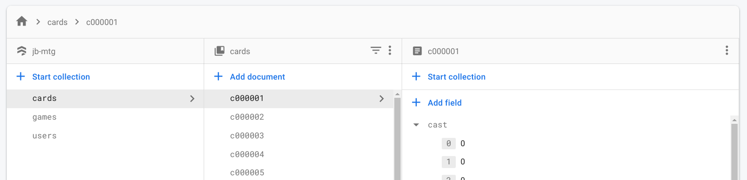 | 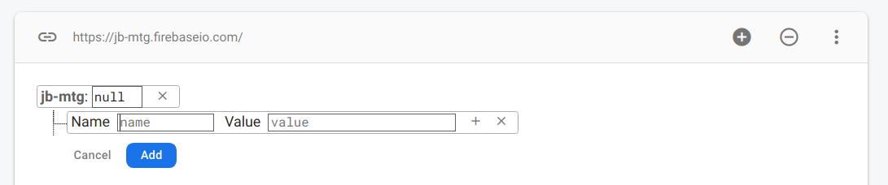

New Cloud Firestore

To use Firestore you should first add it with: ng add @angular/fire: (here the package doc).

Then you can use it in 2 ways:
- Directly injecting Firestore
- Injecting the angular wrapper: AngularFirestore

Firestore | AngularFirestore
import { provideAuth,getAuth } from '@angular/fire/auth';  import { initializeApp,provideFirebaseApp } from '@angular/fire/app';  import { provideFirestore, getFirestore } from '@angular/fire/firestore';  import { AngularFirestoreModule } from '@angular/fire/compat/firestore/';  @NgModule({  declarations: [AppComponent],  imports: [  BrowserModule,  AppRoutingModule,  AngularFirestoreModule,  provideFirebaseApp(() => initializeApp(environment.firebase)),  provideFirestore(() => getFirestore()),  provideAuth(() => getAuth()),  ],  providers: [],  bootstrap: [AppComponent],  })  export class AppModule { } | import { AngularFireModule } from '@angular/fire/compat';  import { AngularFirestoreModule } from '@angular/fire/compat/firestore';  @NgModule({  declarations: [AppComponent],  imports: [  BrowserModule,  AppRoutingModule,  AngularFireModule.initializeApp(environment.firebase),  AngularFirestoreModule,  ],  providers: [],  bootstrap: [AppComponent],  })  export class AppModule { }
import { Firestore, collection, doc, getDoc, getDocs, query, where, onSnapshot } from '@angular/fire/firestore';  @Component({  selector: 'app-root',  templateUrl: './app.component.html',  styleUrls: ['./app.component.scss']  })  export class AppComponent {  usersRef;  usersDocs;  usersSnapshot;  constructor(private firestore: Firestore) {}  async ngOnInit() {  this.usersRef = collection(this.firestore, 'users');  // Get a collection snapshot with filters  const q = query(this.usersRef, where('name', '!=', 'Joel'));  this.usersDocs = await getDocs(q);  this.usersSnapshot = this.usersDocs.docs.map((user) => user.data());  // Get a document snapshot  const docRef = doc(this.firestore, 'users', 'y5YzN30wrF5ZVKCoDK1x');  const docSnap = await getDoc(docRef);  if (docSnap.exists()) { console.log("Document data:", docSnap.data()); }  // To get updates every time the document changes  const unsub = onSnapshot(docRef, { includeMetadataChanges: true }, (doc) => {  console.log("Current data: ", doc.data());  });  }  } | import { AngularFirestore } from '@angular/fire/compat/firestore';  interface IUser { name: string }  @Component({  selector: 'app-root',  templateUrl: './app.component.html',  styleUrls: ['./app.component.scss']  })  export class AppComponent {  users$ = this.af.collection<IUser>('users');  // list$ = this.users$.valueChanges({ idField: 'id' });  constructor(private af: AngularFirestore) {}  }

FireStore

Angular FireStore is a set of collections, each of which contains a set of documents, each of which contains fields of different types. One of these types can also be a collection, nesting data down.

Collection manipulation: https://github.com/angular/angularfire2/blob/7108875fb8811aaebc5b986696ec1b84762650a0/docs/firestore/collections.md
Document manipulation: https://github.com/angular/angularfire2/blob/7108875fb8811aaebc5b986696ec1b84762650a0/docs/firestore/documents.md

Quick example:
View | Controller
Items: {{ items$ | async | json }} | interface Item { user1: string, user2: string, }  public myColRef: AngularFirestoreCollection<Item>;  public items$: Observable<Item[]>;  constructor(private afs: AngularFirestore) {  this.myColRef = afs.collection<Item>('games');  this.items$ = this.myColRef.valueChanges();  }

Methods:

.collection(colName) | Reference to a collection. Returns an instance of type AngularFirestoreCollection | this.gamesCol = afs.collection<Item>('games');
.doc(docName) | Reference to a collection. Returns an instance of type AngularFirestoreDocument | this.gameDoc = this.afs.doc<IGameDoc>('games/' + game.id);
col.valueChanges({idField?: string})  doc.valueChanges({idField?: string}) | Returns an observable that emits the array of the collection data / document.  (no metadata is added here).  Optionally, you can pass an options object with an idField key containing a string. If provided, the returned JSON objects will include their document ID mapped to a property with the name provided by idField. | this.games$ = this.gamesCol.valueChanges();  {{ games$ | async | json }}
col.snapshotChanges({idField?: string})  doc.snapshotChanges({idField?: string}) | Same as valueChanges() but with the metadata.  It wraps the collection in an object with the metadata DocumentChangeAction.  A good practice is to map the stream and return it into every document. | this.gamesCol.snapshotChanges().pipe(  map(actions => actions.map(a => {  const data = a.payload.doc.data() as IGameDoc;  const id = a.payload.doc.id;  return { id, ...data };  }))  ).pipe(take(1)).subscribe(games => { ... });
col.add(newDocument) | Create a new document in a collection | this.gamesCol = this.afs.collection<IGameDoc>('games');  this.gamesCol.add({  player1: this.profile.user.id,  player2: null,  });
doc.update(item) | Update an existing document

this.userDoc = this.afs.doc<User>('/users/' + this.userId); // ← Reference to the user document

this.user$ = this.userDoc.valueChanges(); // ← Provides an observable with just the raw data (no metadata)
this.user$ = this.userDoc.snapshotChanges(); // ← Provides an observable with all data (id, references, ect)

To add documents in a collection:
const newGame = { id: 'xxx', ...fields };
user1Ref.collection('games').add(newGame); // <--- Auto generates an ID: /games/999/{}
user1Ref.collection('games').doc(newGame.id).set(newGame); // <--- Set the same ID: /games/xxx/{}

Rules (permissions)
To prevent access to the FireStore data, you can use rules (Rules tab). The syntax of these consist in a document matcher (by path levels) and a permission - condition key:
Full doc here: https://firebase.google.com/docs/firestore/security/get-started

Structure | Example
rules_version = '2'; (should always be 2)  service cloud.firestore {  match /databases/{database}/documents {  match /<some_path>/ {  allow read, write: if <some_condition>;  }  }  } | rules_version = '2';  service cloud.firestore {  match /databases/{database}/documents {  match /{document=**} {  allow read: if true;  }  match /games/{game} {  allow read, write: if request.auth != null;  }  }  }

service cloud.firestore → scopes the rules to Cloud Firestore, preventing conflicts between Cloud Firestore Security Rules and rules for other products such as Cloud Storage.

/databases/{database}/documents → specifies that rules should match any Cloud Firestore database in the project. Currently each project has only a single database named (default).

All match statements should point to documents, not collections. A match statement can point to a specific document, as in match /games/rFja7XKbVyRbr2K1v5gG or use wildcards to point to any document in the specified path, as in match /games/{game}.

Rules in a document match are not inherited by their subcollections (no access by default). You have to next a match to give permissions to the subcollections.
You can specifically tell a match to be applied recursively with the recursive wildcard syntax: {name=**}.

Data Structure = /games/{game}/landmarks/{landmark}  match /games/{game} {  allow read, write: if <condition>;  match /landmarks/{landmark} {  allow read, write: if <condition>;  }  } | Recursive wildcard (applies to /landmarks too)  match /games/{game=**} {  allow read, write: if <condition>;  }

When multiple matches are met, it adds up all the rules (so if any is granting access, it'll has access)

In general permissions are "read" and "write", but you can be more granular and break them down in:
- read → get, list
- write → create, update, delete

To check user authentication conditions, use request.auth. You can also use the request.auth object to check the data belongs to the authenticated user.
It is also possible to set a condition based on the data of the document you access with request.resource.data:

match /users/{userId} {
allow create: if request.auth != null;
allow update: if request.auth != null && request.auth.uid == userId;
allow delete: if request.resource.data.population > 0
&& request.resource.data.name == resource.data.name;

}

Realtime DB

This is the old version of the cloud DB, but it can be useful if you just want to store plain JSONs.
Quick example:

private afd: AngularFireDatabase,

const itemsRef = this.afd.list('games/-LkenjwC9yrodtnv_cuB');
const items = itemsRef.valueChanges().subscribe(val => {
console.log(new Date(), 'Game changed', val);
});

Remember to import the module: AngularFireDatabaseModule

DOC to use AngularFire with realtime DB: https://github.com/angular/angularfire2/tree/master/docs/rtdb

Tricks

When having this error:

Error: node_modules/@angular/fire/compat/firestore/interfaces.d.ts:13:18 - error TS2430: Interface 'DocumentSnapshotExists<T>' incorrectly extends interface 'DocumentSnapshot<DocumentData>'.
The types returned by 'data(...)' are incompatible between these types.
Type 'T' is not assignable to type 'DocumentData | undefined'.
Type 'T' is not assignable to type 'DocumentData'.

13 export interface DocumentSnapshotExists<T> extends firebase.firestore.DocumentSnapshot {
…

add the following in tsconfig.json: { "compilerOptions": { "skipLibCheck": true, } }

fsd

