Pricing American Options by Simulation: A Comparison of Methods
Joel Braun, James Ly, Avinash Sharma

Overview

A Brief Introduction to Stock Options
In finance, an option is a contract which gives the buyer (the owner or holder of the option) the right, but not the obligation, to buy or sell an underlying asset or instrument at a specified strike price on a specified date, depending on the form of the option. (Wikipedia). For the intent of this paper, an underlying asset or instrument will be considered to be a simple equity (or “stock”, “share”, etc.) in a firm.
There are two types of options that will be priced as part of this simulation. The first, the Call option, allows an investor to secure purchase of an asset at a certain prespecified price. The second, the Put option, allows an investor to secure sale of an asset at a certain prespecified price. These prespecified prices are referred to as the ’strike’ prices of the option. An option is considered worth exercising (buying or selling) in circumstances where it is in the money. An option is in-the-money for a call when the strike price is below the underlying asset’s value. It is in-the-money for a put when the strike price is above the market price of the asset. Typically, in options trading, a call option is used when investor sentiment on a stock is positive, while a put option is used when sentiment on a stock is negative.
The style of option being bought or sold adds additional complexity to the situation. Each stock option being bought or sold is given an expiry date. An expiry date is the date at which an option expires and a final decision must be made as to whether to exercise. There are two commonly traded types of options, however- American-Style and European-Style. American-Style stock options may be exercised at any point prior to the expiry. European-Style stock options may only be exercised at the time of expiry. This paper will solely explore American-Style options pricing as it relates to actual US market values.

Simulation of Options
With the advent of the modern financial services industry, high frequency trading, and computational data analytics it is now common practice to determine via computer simulation the estimated future prices of stock options. Numerous methods have been developed which address the idea of option estimation, the most notable being the Black-Scholes (sometimes Black-Scholes-Merton) method. The Black-Scholes method, introduced in 1983, is largely considered the standard for options pricing. A deep discussion of Black-Scholes is beyond the scope of this paper, but there are several points worth covering.
The Black-Scholes model makes several key assumptions. The first is that there are two possible asset categories, the stock itself and an alternate lower-risk asset. The second is that the return of the stock can be estimated by a random walk with drift. This random walk is based on geometric Brownian motion, and is most simply a random path up and down the value of an asset might take. The random walk for equities is dictated by volatility, a concept which will be discussed shortly.
It’s also worth noting the original design of the Black-Scholes pricing model focused on pricing of European-Style options, but future refinements and iterations provided additional methods for the pricing of American-Style options. Two of these will be explored in the simulation, the Barone-Adesi and Whaley method and the Bjerksund-Stensland method. Both of these are approximation methods.
In order to model an option price, the Black-Scholes model requires several set variables. These are as follows:
Current underlying price:
The current market price of the equity.
Option strike price:
The price at which the shares will be bought or sold.
Time to expiry:
Time left until the option expires.
Implied Volatility:
The size of the shifts the asset may make during the random walk.
Risk-free interest rate:
The rate the asset would appreciate at in a lower-risk investment.
Another commonly used model for estimating stock option prices is the binomial model. A binomial model formulates a random option pricing curve based on a number of time intervals. The stock price is simulated to move up or down at each step by an amount relating to volatility and time to expiry. It is somewhat analogous to the Black-Scholes model, but is a discrete-time model as opposed to a continuous one. The result of binomial method options calculations resembles a tree, as the decision is made to exercise or hold at each point.
Luckily, the binomial method requires exactly the same inputs as the Black-Scholes model. As such, we can luckily maintain a similar testing framework for both. We will explore the following binomial methods as part of this simulation:
- Cox-Ross-Rubenstein
- Jarrow-Rudd
- Equal Probabilities
- Trigeorgis
- Tian
- Leisen-Reimer
Binomial methods are less commonly used in professional options simulation[???]. However, their ability to progressively price-in the value of an early option exercise makes it ideal for American options.

Volatility
The asset’s implied volatility is worth some discussion. Because volatility dictates the shifts of the random walk in the model, it has the potential to dictate the accuracy of the model altogether. There is some discussion as to whether historical volatility should be used in lieu of implied volatility. One of the simplest methods for calculating implied volatility is a guess-and-check approach involving repeated simulation volatility values. These values are calibrated until a result similar to the current option price is attained[??]. This is less than ideal for our analysis, as it is not quantifiable. It also does not take into account whether current options are reasonably priced or are outliers.

The GARCH Model
A model commonly used in academia for quantitative finance volatility calculations is the GARCH model. The GARCH model is an autoregressive conditional heteroskedasticity method that is used to model time series[]. In this case, we specifically will be using the GARCH(1,1) model for calculations.
The GARCH model produces an and value, as well as an value which represent the time series of stock prices. It assumes that the volatility value is mean reverting, or that it will always stay close to a specified value. Typically, and are less than 1, which indicates that we can calculate the volatility as the standard deviation of the unconditional variance. This is represented by

As is commonly known, the variance can be reduced down to the standard deviation by taking its square root.

Intent of Analysis
The intent of our analysis on these topics was to try and answer several key questions on the models:
Black-Scholes vs. Binomial
Which options pricing class provides better accuracy?
Short term accuracy
Which options pricing model is the most accurate in the short term?
Long term accuracy
Which options pricing model is the most accurate in the long term?
Patterns
What patterns do we see in the accuracies/inaccuracies of these models?
Our analyses of these questions will be based on several datasets. The first will be a short-dated expiry set of puts and calls expiring one calendar week from the test. The second will be a long-dated expiry set of puts and calls expiring one 30-day month from the test. The third test will be the longest-dated expiry set of puts and calls expiring six 30-day months from the test. This will provide an effective cross-section of estimation methods over both the short and long-term time periods.

Simulation Design

Tools
For this simulation, we relied on several open-source libraries and publicly accessible financial data. A testing framework was developed in Python 2.x for which accessed financial data and performed simulations based on current option availability and parameters.
The cornerstone of this effort was the open source C++ library QuantLib, which provides tools for quantitative finance. QuantLib is a comparatively massive library, taking several hours to compile and measuring several GB in size. It contained a complete options-pricing simulator incorporating all pricing equations being tested. This was integrated with a Python 2.x wrapper framework that is also part of the QuantLib project.
Also used was the pip package python-google-options-chain, which downloads and converts Google finance data from its JSON endpoints.
To calculate the volatility values used, historical data from Yahoo! finance (provided as part of the pandas library) was used. This was integrated in with the pyflux package, which provided GARCH calculation functionality for the simulation.

Simulation Method
For the purposes of our simulation, it was determined that options prices would only be compared for the Dow Jones Industrial Average, a set of thirty shares that is a price-weighted aggregation of the largest corporations in America. This scope limitation was designed to keep data measurable- it is likely the S&P 500 would provide a better cross section of American industry.
For each of these listings on the index, simulations were run in all situations where a current option price was available. Two separate datasets were collated for the shares on the index; one for call options and another for put options. This method was used for the one week, one month, and six month tests.
The GARCH method requires historical financial data. Typically, closing-day prices are used. Our model aggregated closing day prices from 1990 on in order to generate values. Volatility values were then calculated for each stock price and used in the simulation.

Simulation Framework
The framework under which these tests were conducted was developed in Python 2.x for compatibility purposes with available QuantLib Python libraries. These were based off of samples provided by the QuantLib project for options simulation[???]. The testing framework itself merely served to facilitate connection between real data procured from Google Finance and the generated valuations for each option. Once an option for one of our symbols was found to have a present value, our simulation pulled additional data on underlying asset price and calculated a volatility value. This volatility value, the critical part of the simulation, was then used in conjunction with other parameters to formulate an options price.
After a price was formulated, all data was written in rows to a CSV file for later analysis. This data generation isolated puts and calls for further analysis as to the accuracy of the pricing of each. Each CSV file was then analyzed and the results prepared in Python using various additional libraries.
to .8 Column & Value
Symbol & AAPL
Tag & AAPL160610P0009950
Strike & 100
Real & 2.72
Barone-Adesi Whaley & 2.364
Bjerksund-Stensland & 2.364
Jarrow-Rudd & 2.367
Cox-Ross-Rubenstein & 2.367
Equal Probabilities & 2.367
Trigeorgis & 2.367
Tian & 2.367
Leisen-Reimer & 2.367
The data in table 2.1 is representative of a single row in a CSV file. Depending on the amount of price data, individual runs for options yielded around 14,000 row entries (including both put and call valuations). From this CSV format, data could be reloaded back in to a separately designed Python analysis library for further investigation. Depending on machine speed, individual runs could take as many as several minutes to complete. Simulations were not time dependent and no performance improvements or modifications (such as multiprocessing, etc) were made to the original framework.

Notes on Computational Performance
While in the case of our simulations no tangible performance issues were experienced, it is important to consider that these pricing models vary in complexity. The binomial method, while boasting a higher perceived accuracy, is typically less computationally performant than a Black-Scholes implementation. Likewise, some of the models tested (such as Barone-Adesi Whaley) are actually approximation models. Thus, they are designed to be more performant and provide for quicker price calculations. Various research papers are available on this subject, but they are beyond the scope of our analysis.

Results Analysis

Short Dated Puts and Calls
The first test we performed involved all priced short-dated puts and calls for stocks on the Dow. Our test was run one business week prior to the expiry of the puts and calls and exported for analysis. For each of these, the simplest test we could use to determine the differences from actual values was a Sum Squared Error (SSE) test. The results are shown in table 3.1.
to .8 Method & Combined SSE (Puts + Calls)
Barone-Adesi Whaley & 1633.569682
Bjerksund-Stensland & 1633.67047532
Cox-Ross-Rubenstein & 1634.02600139
Jarrow-Rudd & 1634.02313417
Equal Probabilities & 1634.140215
Trigeorgis & 1634.02323538
Tian & 1634.02877159
Leisen-Reimer & 1633.9644903
As shown in the table, for the one-week test there is a very small difference observed between the estimation methods. This indicates that, at least for the one week dated options, no method has a guiding advantage over the other. This is not unexpected; due to the very small time to expiry, the potential values of each method?s random walk are less inclined to deviate heavily.
Diving further into the analysis, we elected to perform a threshold accuracy test which would give us a better idea of the values closeness to their intended value. For a threshold accuracy of 1 (that is, estimations were within $1 of the actual price value, we saw that for put options each test typically 86% of results fell within our expected range. This is quite good. Call options were less accurately priced, with roughly 75% of modeled options falling within $1 of expected price value. Still, neither were particularly poor representations.
We then elected to plot the actual prices versus the estimated model’s results. This gave us a better indication of the model’s tendencies in estimation. The following graphs were produced for the one week puts and calls of an AAPL (Apple Inc.) stock.
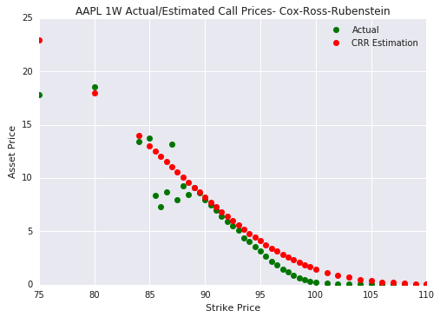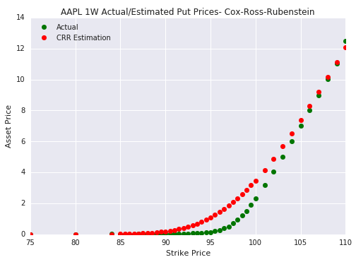
Both put and call charts indicate that our model seems to overestimate values. This is not necessarily unexpected, as results are generated entirely upon volatility. As we can see, however, in line with our previous threshold prediction values put prices are clearly more accurately priced. We also see that options with strike prices closer to the price of the share are much harder to predict. During these tests, AAPL shares were priced around $98.
With this test, however, no clear leading model in options pricing has made itself apparent. There also appears to be little difference experienced in using the binomial model as opposed to Black-Scholes and its variants.

Long Dated Puts and Calls
Since option prices vary more widely as times extend out further, tests also had to be run for longer times in order to determine their accuracy. An exipry date approximately six months in the future (January 2017) was selected. The analysis was then rerun for both sum squared error and threshold accuracy.
to .8 Method & Combined SSE (Puts + Calls)
Barone-Adesi Whaley & 41813.4995377
Bjerksund-Stensland & 41838.2751664
Cox-Ross-Rubenstein & 41777.9329279
Jarrow-Rudd & 41777.7318535
Equal Probabilities & 41817.923815
Trigeorgis & 41778.030902
Tian & 41776.6236091
Leisen-Reimer & 41775.6888507
Once again, though, we see very little difference in the values considering the six month expiry date. This is unexpected. The values deviate by less than one hundred in range. Looking at a threshold accuracy value, we see a pattern of decreased accuracy, at least when pricing calls. Only 17% of calls were within $1 of their actual values. Sixty-eight percent of puts were accurate within $1. When increasing the threshold to $5, the results were far better at 73% of calls and 90% of puts. Still, is a very wide margin of error considering the prices of individual options contracts.
Expanding our analysis out, we’ll once again look at our estimated prices for AAPL’s six-month calls versus their real values.
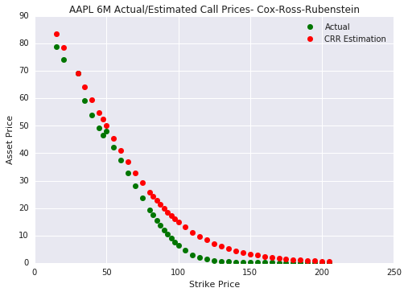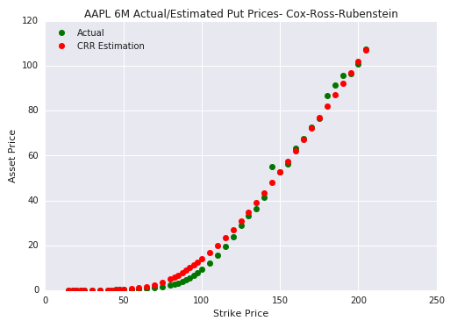
These graphs indicate very fair valuations in the case of put options, and much poorer accuracy for call options. This was indicated early on by the SSE values for puts and calls. Typically, SSE values for all call option tests were around 24,000, while put options had SSE values of around 18,000. Returning to the graphs, we see greater inaccuracy for options with strike prices around the underlying asset values.
Surprisingly, in these tests there is once again no model which clearly leads in accuracy. SSE values for each of the models were all grouped closely, and the only discernable difference in accuracy that could be found was the pricing of put or call options.

Very Long Dated Puts and Calls
After observing little difference in the accuracies of the models for six-month expiry puts and calls, we decided to attempt to price options with expiries almost one and a half years away from the current date. Pricing options for January 19, 2018, we saw the following SSE results:
to .8 Method & Combined SSE (Puts + Calls)
Barone-Adesi Whaley & 92095.2212736
Bjerksund-Stensland & 92034.9437455
Cox-Ross-Rubenstein & 91944.8014098
Jarrow-Rudd & 91940.288989
Equal Probabilities & 92143.5437267
Trigeorgis & 91943.2074004
Tian & 91929.01258
Leisen-Reimer & 91940.5065844
Even at a time to expiry of 1.5 years we still observe that the models remain relatively closely grouped in their accuracies. In fact, we observe a standard deviation in SSE values of around 83.8, which is very close grouping for numbers as high as these values are. This seems to suggest that in most cases we will see little variance in the results of our estimation methods. Not only that, it also seems to suggest that there is no particular reason to use the Black-Scholes model over the binomial (or vice-versa).
Observing threshold accuracy, we see that 42% of calls fall within one dollar of the actual values. Forty-five percent of puts fall within one dollar of their actual value. SSE values varied widely between puts and calls once again. In this case, however, SSEs for call values were six times those of put values, equating to around 79,000. Put values averaged SSEs of around twelve thousand.
Graphing the data, we observe a picture similar to what we have seen in the two previous estimations. Note the difference between the estimated call prices and the actual call prices.
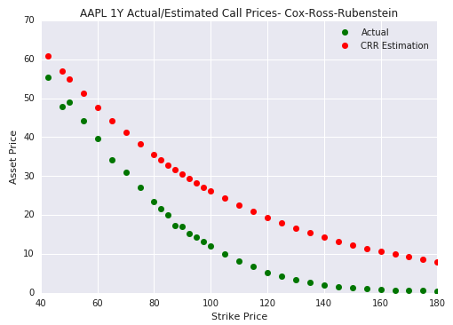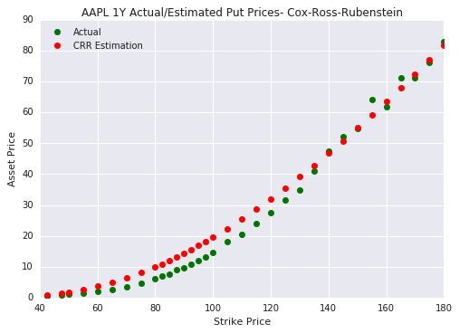
In this situation, the AAPL put prices remain fairly stable and sensible. The call prices are off by very large amounts, as was suggested by our SSE calculations. This in turn seems to suggest that in the long run, both Black-Scholes and the Binomial method may overestimate the value of call returns.

Conclusions
0.9

