ADHESIVES RESEARCH
Oracle EBS Inventory Item Creation
Item Verification Report - CSV Values vs. Screenshot Evidence
Prepared for | Caron Wills
Verification Date | September 8, 2026
Source File | test data(Data)(1).csv
Items Reviewed | F-5412-991, EL-94916-990, CV-8345-990, W-12005-990, R-13141-97

1. Verification Basis
Every nonblank value in the supplied CSV is evaluated. Blank CSV cells are excluded. The expected-value text is reproduced exactly as supplied, including capitalization and apparent source typographical values.
MATCH is used only when the corresponding value can be read in a current Oracle EBS screenshot. Truncated values and fields outside the supplied screenshots are classified as NOT VISIBLE. A visibly different value is classified as NOT MATCH.
Confirmed project mappings used in the comparison are: Requested By to INITIATOR, Batch Size to AVERAGE CONTAINER SIZE, PDR to PDR NUMBER, Shelf Life From to Lot Expiration Control, Weight Per Gallon to the CONSTRUCTION text, Sellable to Shippable, and Eng / Mfg = Engineering to the Engineering Item indicator. Part Status is not treated as Oracle Item Status, and the CSV Item Type is not treated as Oracle User Item Type unless a direct mapping is supplied.
MATCH | NOT MATCH | NOT VISIBLE | NOT APPLICABLE

2. Verification Summary
Item Number | Item Type | MATCH | NOT MATCH | NOT VISIBLE | Overall Result
F-5412-991 | Adhesives | 12 | 0 | 7 | PARTIALLY VERIFIED
EL-94916-990 | Adhesive Coating | 10 | 0 | 4 | PARTIALLY VERIFIED
CV-8345-990 | Converting | 11 | 0 | 10 | PARTIALLY VERIFIED
W-12005-990 | Liner Coating | 5 | 1 | 6 | ACTION REQUIRED
R-13141-97 | Raw Material | 4 | 0 | 21 | PARTIALLY VERIFIED
Overall results: 91 populated CSV values were evaluated: 42 MATCH, 1 NOT MATCH, and 48 NOT VISIBLE.

3. Item F-5412-991
CSV Item Type | Adhesives
Populated CSV Values | 19
Result Counts | 12 MATCH | 0 NOT MATCH | 7 NOT VISIBLE
Overall Result | PARTIALLY VERIFIED

Item Descriptive Flexfield
CSV Attribute | Expected Value from CSV | Oracle EBS Value | Result
Weight Per Gallon | 7.5 | 7.5 LBS/GAL (stored in CONSTRUCTION) | MATCH
HIMS | 230 | 230 | MATCH
Percent Solids | 31.6 | 31.6 | MATCH
Lead Time Days | 20 | 20 | MATCH
Batch Size | 350 | 350 (AVERAGE CONTAINER SIZE) | MATCH
PDR | 26-16 | 26-16 (PDR NUMBER) | MATCH
Requested By | Christina Wilson | Christina Wilson (INITIATOR) | MATCH
UOM | POUND | POUND (visible behind the flexfield window) | MATCH

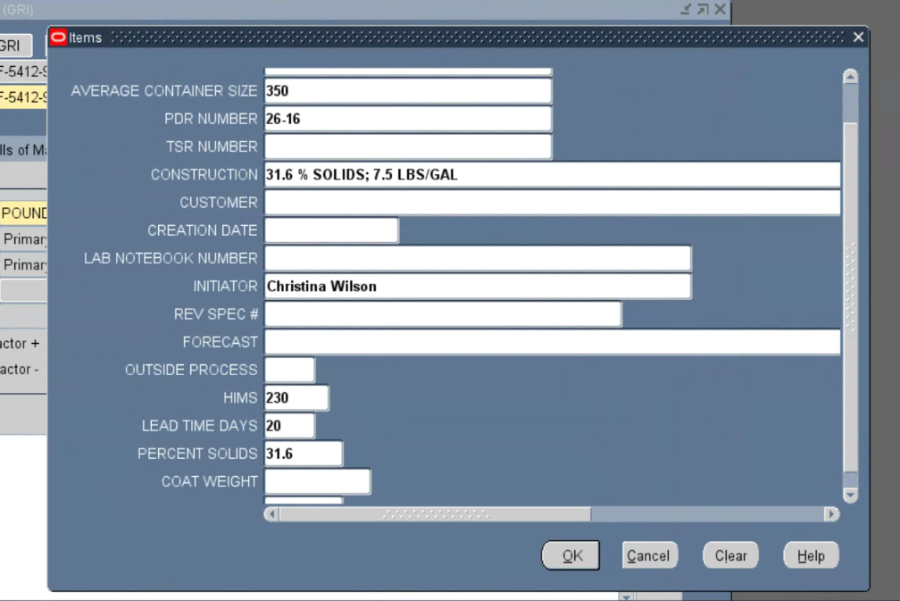
Figure 1 - Oracle EBS Item descriptive flexfield for F-5412-991 showing the CSV-supplied batch size, PDR, HIMS, lead time, percent solids, weight-per-gallon construction value, and Requested By value stored as Initiator.

F-5412-991 - Continued

Inventory - Shelf Life
CSV Attribute | Expected Value from CSV | Oracle EBS Value | Result
Item Number | F-5412-991 | F-5412-991 | MATCH
Shelf Life Days | 90 | 90 | MATCH
Shelf Life From | Shelf life days | Shelf life days (Control) | MATCH
ORG | GRI | GRI - Glen Rock Inventory | MATCH

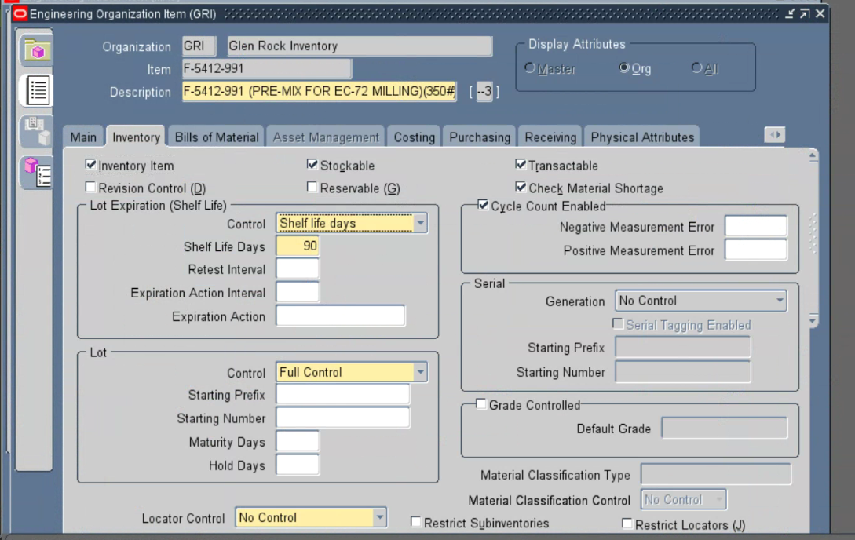
Figure 2 - Oracle EBS Inventory tab for F-5412-991 showing the item, GRI organization, Shelf Life Control = Shelf life days, and Shelf Life Days = 90.

F-5412-991 - Continued

Category Assignments Not Visible
CSV Attribute | Expected Value from CSV | Oracle EBS Value | Result
Division | ARcare | Category Assignments not displayed | NOT VISIBLE
Business Unit | Electronics | Category Assignments not displayed | NOT VISIBLE
Engineering | PDR | Category Assignments not displayed | NOT VISIBLE

Evidence status: No current Oracle EBS screenshot supplied for these populated CSV values; the results remain NOT VISIBLE.

F-5412-991 - Continued

Other CSV Values Not Visible
CSV Attribute | Expected Value from CSV | Oracle EBS Value | Result
Item Type | Adhesives | Source business item type not displayed | NOT VISIBLE
Part Status | New | Not displayed in current screenshots | NOT VISIBLE
Eng / Mfg | Engineeirng | Not displayed in current screenshots | NOT VISIBLE
Description | F-5412-991 (PRE-MIX FOR EC-72 MILLING)(350#) | Header text is truncated; full value cannot be confirmed | NOT VISIBLE

Evidence status: No current Oracle EBS screenshot supplied for these populated CSV values; the results remain NOT VISIBLE.

4. Item EL-94916-990
CSV Item Type | Adhesive Coating
Populated CSV Values | 14
Result Counts | 10 MATCH | 0 NOT MATCH | 4 NOT VISIBLE
Overall Result | PARTIALLY VERIFIED

Main Tab
CSV Attribute | Expected Value from CSV | Oracle EBS Value | Result
Item Number | EL-94916-990 | EL-94916-990 | MATCH
Description | ARCARE 94916 (60")(59.5" MIN ADHESIVE WIDTH) | Visible text is truncated after the description prefix | NOT VISIBLE
ORG | GRI | GRI - Glen Rock Inventory | MATCH

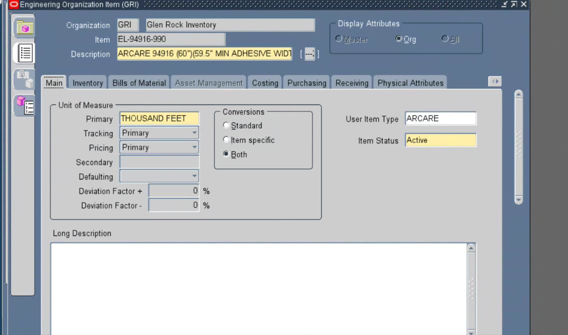
Figure 3 - Oracle EBS Main tab for EL-94916-990 showing the item in GRI; the description field is truncated and therefore is not treated as a complete match.

EL-94916-990 - Continued

Item Descriptive Flexfield
CSV Attribute | Expected Value from CSV | Oracle EBS Value | Result
PDR | 26-09 | 26-09 (PDR NUMBER) | MATCH
Requested By | Jilian Thoman | Jilian Thoman (INITIATOR) | MATCH

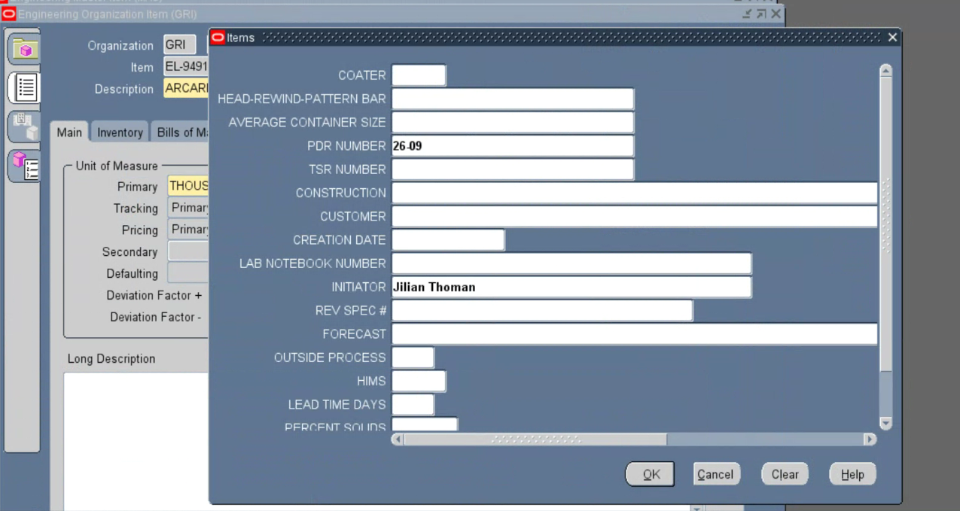
Figure 4 - Oracle EBS Item descriptive flexfield for EL-94916-990 showing PDR NUMBER = 26-09 and Requested By stored as INITIATOR = Jilian Thoman.

EL-94916-990 - Continued

Inventory - Shelf Life
CSV Attribute | Expected Value from CSV | Oracle EBS Value | Result
Shelf Life Days | 360 | 360 | MATCH

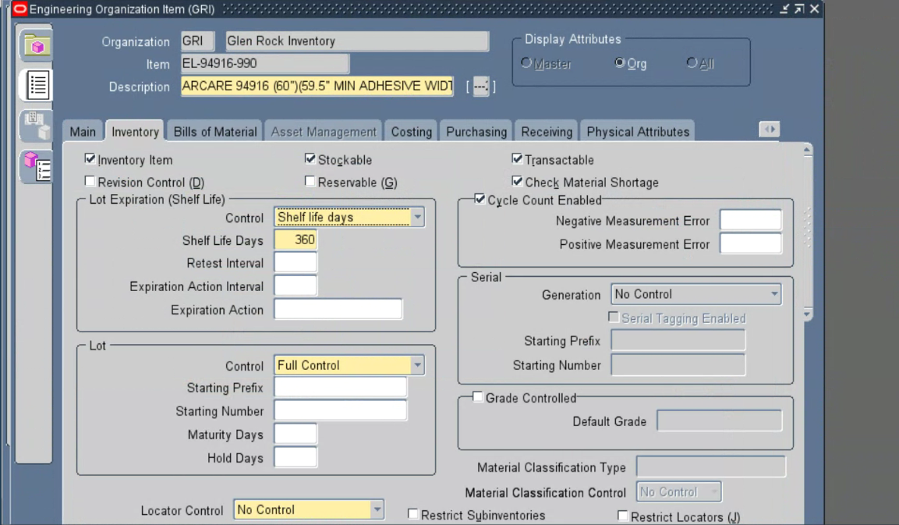
Figure 5 - Oracle EBS Inventory tab for EL-94916-990 showing Shelf Life Days = 360.

EL-94916-990 - Continued

Purchasing - Outside Processing
CSV Attribute | Expected Value from CSV | Oracle EBS Value | Result
Outside Processing | No | Outside Processing Item unchecked (No) | MATCH

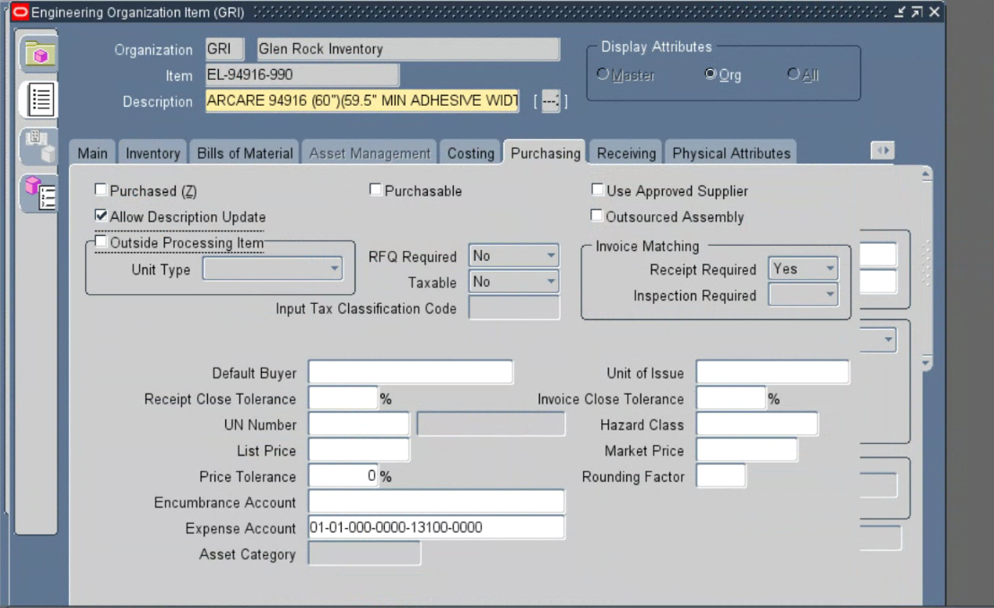
Figure 6 - Oracle EBS Purchasing tab for EL-94916-990 showing Outside Processing Item unchecked, which represents No.

EL-94916-990 - Continued

Bills of Material - Engineering Indicator
CSV Attribute | Expected Value from CSV | Oracle EBS Value | Result
Eng / Mfg | Engineeirng | Engineering Item checked (Yes) | MATCH

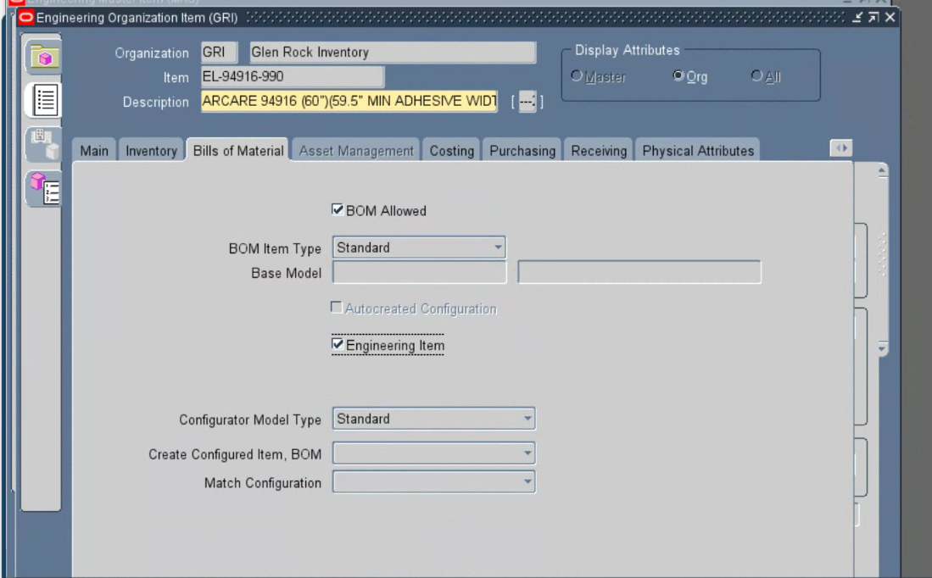
Figure 7 - Oracle EBS Bills of Material tab for EL-94916-990 showing Engineering Item checked, supporting the CSV Eng / Mfg value.

EL-94916-990 - Continued

Category Assignments
CSV Attribute | Expected Value from CSV | Oracle EBS Value | Result
Division | ARcare | ARCARE | MATCH
Business Unit | Electronics | ELECTRONICS | MATCH
Engineering | PDR | PDR | MATCH

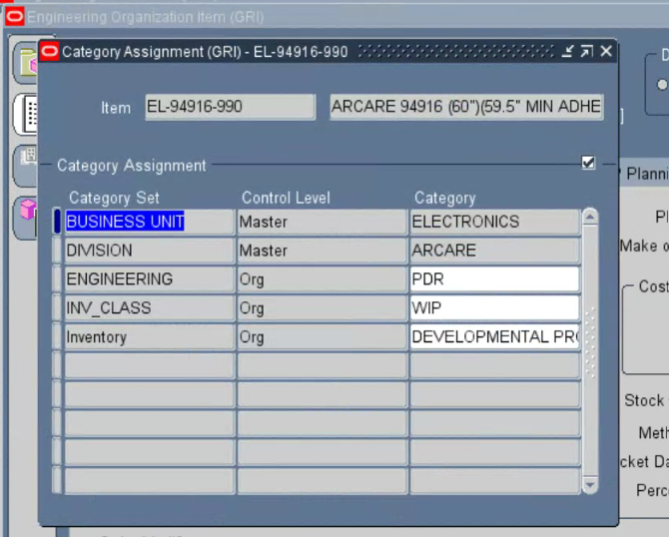
Figure 8 - Oracle EBS Category Assignments for EL-94916-990 showing Business Unit = ELECTRONICS, Division = ARCARE, and Engineering = PDR.

EL-94916-990 - Continued

Other CSV Values Not Visible
CSV Attribute | Expected Value from CSV | Oracle EBS Value | Result
Item Type | Adhesive Coating | Source business item type not displayed | NOT VISIBLE
Part Status | New | Not displayed in supplied screenshots | NOT VISIBLE
Cost Roll Up | No | Costing evidence not supplied | NOT VISIBLE

Evidence status: No current Oracle EBS screenshot supplied for these populated CSV values; the results remain NOT VISIBLE.

5. Item CV-8345-990
CSV Item Type | Converting
Populated CSV Values | 21
Result Counts | 11 MATCH | 0 NOT MATCH | 10 NOT VISIBLE
Overall Result | PARTIALLY VERIFIED

Main Tab
CSV Attribute | Expected Value from CSV | Oracle EBS Value | Result
Item Number | CV-8345-990 | CV-8345-990 | MATCH
UOM | ROLL | ROLL | MATCH
Description | ARCLAD 8345 (1.50" x 180')(38.1 MM x 55 M) | ARCLAD 8345 (1.50" x 180')(38.1 MM x 55 M) | MATCH
ORG | GRI | GRI - Glen Rock Inventory | MATCH

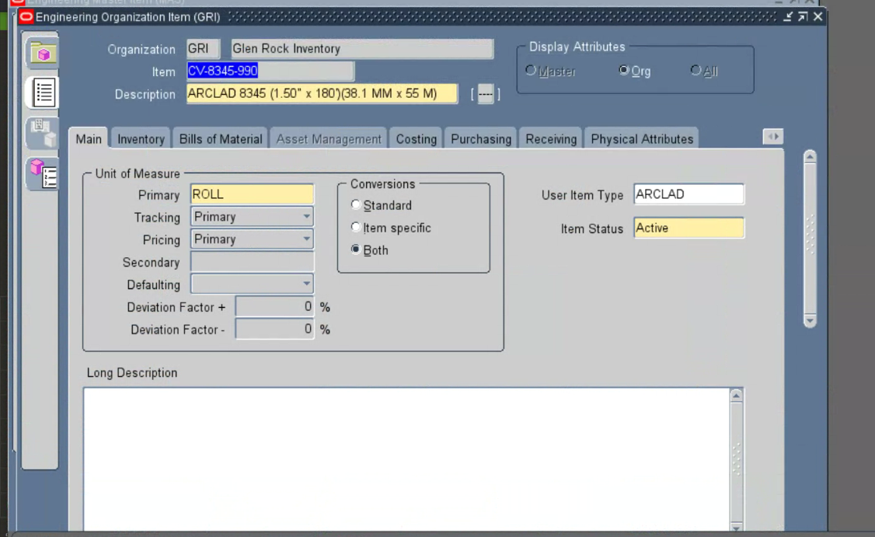
Figure 9 - Oracle EBS Main tab for CV-8345-990 showing the item number, ROLL primary UOM, complete description, and GRI organization.

CV-8345-990 - Continued

Item Descriptive Flexfield
CSV Attribute | Expected Value from CSV | Oracle EBS Value | Result
Lead Time Days | 50 | 50 | MATCH
Requested By | Vitaly Falevich | Vitaly Falevich (INITIATOR) | MATCH

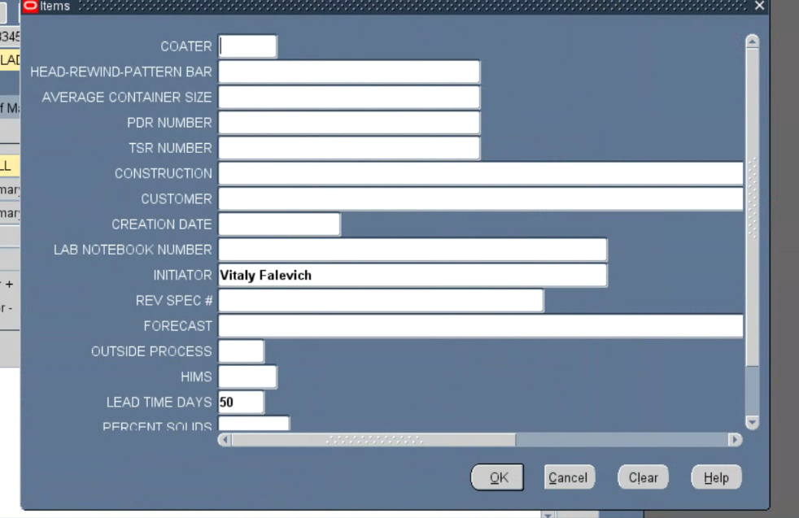
Figure 10 - Oracle EBS Item descriptive flexfield for CV-8345-990 showing Lead Time Days = 50 and Requested By stored as INITIATOR = Vitaly Falevich.

CV-8345-990 - Continued

Inventory - Shelf Life
CSV Attribute | Expected Value from CSV | Oracle EBS Value | Result
Shelf Life Days | 360 | 360 | MATCH

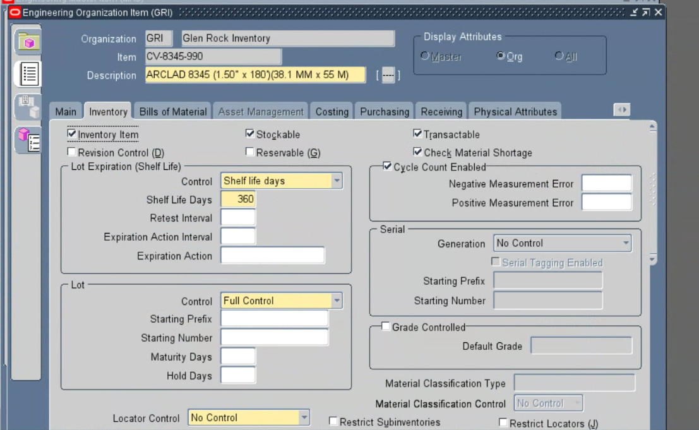
Figure 11 - Oracle EBS Inventory tab for CV-8345-990 showing Shelf Life Days = 360.

CV-8345-990 - Continued

Bills of Material - Engineering Indicator
CSV Attribute | Expected Value from CSV | Oracle EBS Value | Result
Eng / Mfg | Engineeirng | Engineering Item checked (Yes) | MATCH

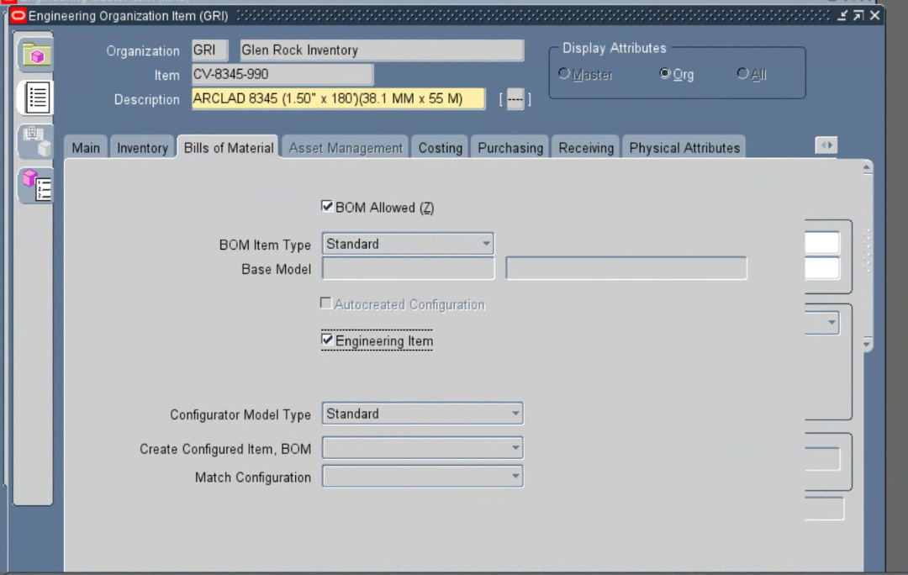
Figure 12 - Oracle EBS Bills of Material tab for CV-8345-990 showing Engineering Item checked, supporting the CSV Eng / Mfg value.

CV-8345-990 - Continued

Purchasing
CSV Attribute | Expected Value from CSV | Oracle EBS Value | Result
Purchasable | No | Purchasable unchecked (No) | MATCH
Outside Processing | No | Outside Processing Item unchecked (No) | MATCH

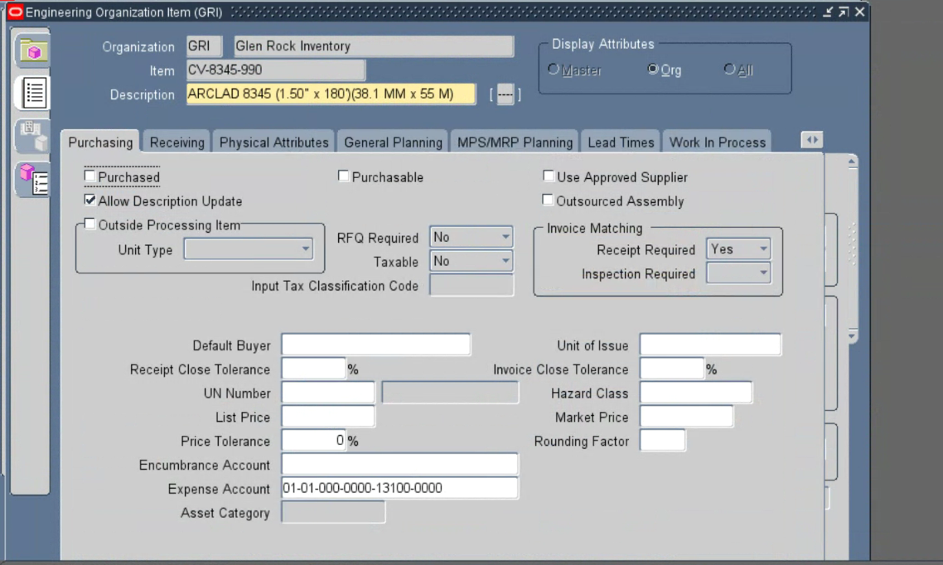
Figure 13 - Oracle EBS Purchasing tab for CV-8345-990 showing Purchasable and Outside Processing Item unchecked, which represents No for both CSV values.

CV-8345-990 - Continued

Order Management
CSV Attribute | Expected Value from CSV | Oracle EBS Value | Result
Sellable | Yes | Shippable checked (Yes) | MATCH

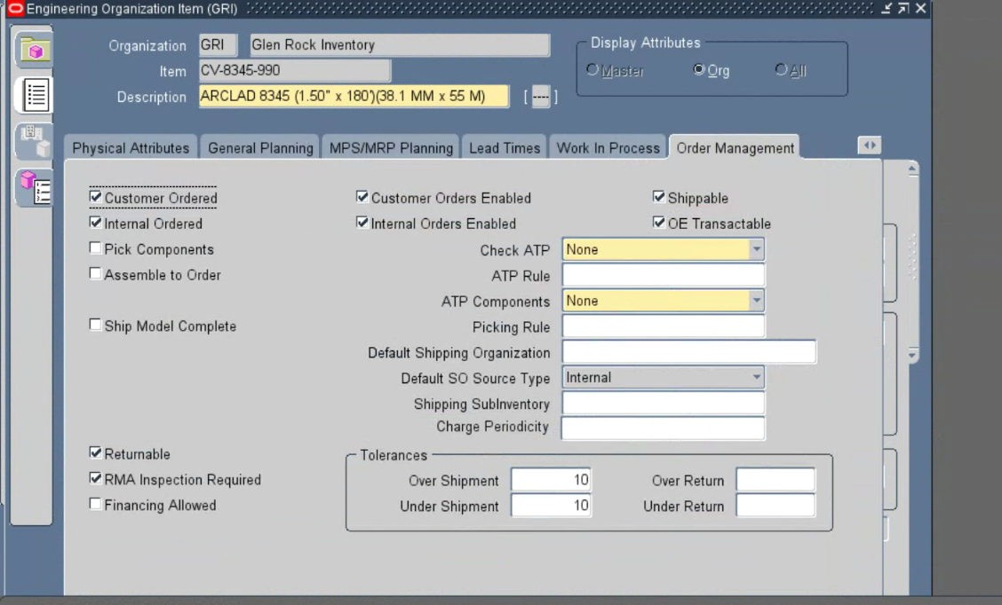
Figure 14 - Oracle EBS Order Management tab for CV-8345-990 showing Shippable checked, supporting Sellable = Yes.

CV-8345-990 - Continued

Category Assignments Not Visible
CSV Attribute | Expected Value from CSV | Oracle EBS Value | Result
Division | ARclad | Category Assignments not displayed | NOT VISIBLE
Business Unit | Converting | Category Assignments not displayed | NOT VISIBLE
Engineering | OPS | Category Assignments not displayed | NOT VISIBLE

Evidence status: No current Oracle EBS screenshot supplied for these populated CSV values; the results remain NOT VISIBLE.

CV-8345-990 - Continued

Other CSV Values Not Visible
CSV Attribute | Expected Value from CSV | Oracle EBS Value | Result
Item Type | Converting | Source business item type not displayed | NOT VISIBLE
Part Status | New | Not displayed in supplied screenshots | NOT VISIBLE
HTS Code | 3919.10.2055 | Relevant Oracle EBS field not displayed | NOT VISIBLE
Cost Roll Up | No | Costing evidence not supplied | NOT VISIBLE
Notify CS | Mo | Not displayed in supplied screenshots | NOT VISIBLE
Notify Planning | No | Not displayed in supplied screenshots | NOT VISIBLE
Platform | Custom Construction | Not displayed in supplied screenshots | NOT VISIBLE

Evidence status: No current Oracle EBS screenshot supplied for these populated CSV values; the results remain NOT VISIBLE.

6. Item W-12005-990
CSV Item Type | Liner Coating
Populated CSV Values | 12
Result Counts | 5 MATCH | 1 NOT MATCH | 6 NOT VISIBLE
Overall Result | ACTION REQUIRED

Main Tab
CSV Attribute | Expected Value from CSV | Oracle EBS Value | Result
Item Number | W-12005-990 | W-12005-990 | MATCH
Description | W-12005-990 (POLYIMIDE FILM)(2 MIL)(12003-0 IN)(25") | Visible text is truncated after the description prefix | NOT VISIBLE
ORG | GRI | GRI - Glen Rock Inventory | MATCH

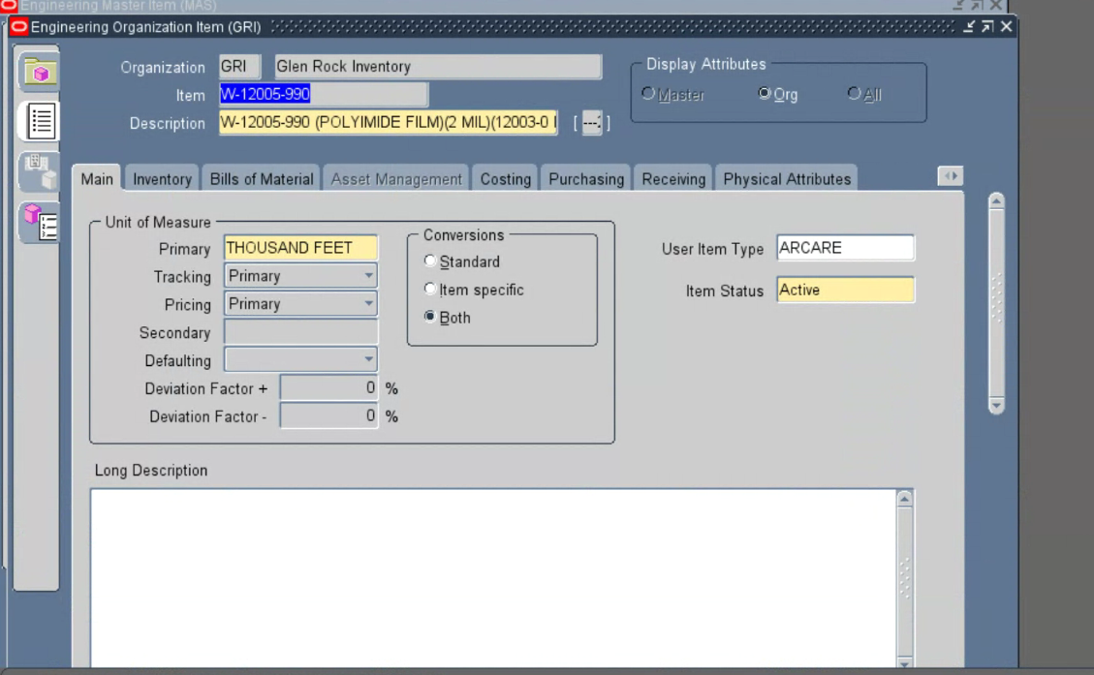
Figure 15 - Oracle EBS Main tab for W-12005-990 showing the item in GRI; the description field is truncated and therefore is not treated as a complete match.

W-12005-990 - Continued

Item Descriptive Flexfield
CSV Attribute | Expected Value from CSV | Oracle EBS Value | Result
PDR | 26-10 | 26-10 (PDR NUMBER) | MATCH
Construction | Single Face with Single Side Primed Substrate (Preferred) | Blank | NOT MATCH
Requested By | Christina Wilson | Christina Wilson (INITIATOR) | MATCH

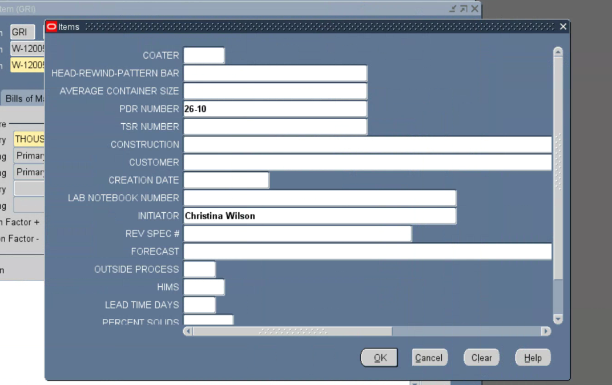
Figure 16 - Oracle EBS Item descriptive flexfield for W-12005-990 showing PDR NUMBER = 26-10, INITIATOR = Christina Wilson, and CONSTRUCTION blank.

W-12005-990 - Continued

Bills of Material - Engineering Indicator
CSV Attribute | Expected Value from CSV | Oracle EBS Value | Result
Eng / Mfg | Engineering | Engineering Item checked (Yes) | MATCH

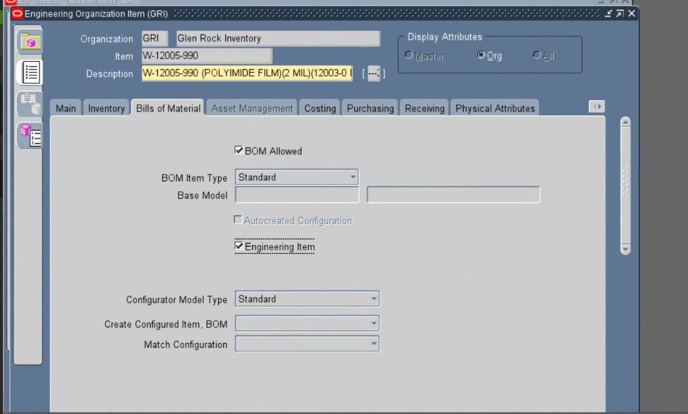
Figure 17 - Oracle EBS Bills of Material tab for W-12005-990 showing Engineering Item checked, supporting the CSV Eng / Mfg value.

W-12005-990 - Continued

Category Assignments Not Visible
CSV Attribute | Expected Value from CSV | Oracle EBS Value | Result
Division | ARcare | Category Assignments not displayed | NOT VISIBLE
Business Unit | Electronics | Category Assignments not displayed | NOT VISIBLE
Engineering | PDR | Category Assignments not displayed | NOT VISIBLE

Evidence status: No current Oracle EBS screenshot supplied for these populated CSV values; the results remain NOT VISIBLE.

W-12005-990 - Continued

Other CSV Values Not Visible
CSV Attribute | Expected Value from CSV | Oracle EBS Value | Result
Item Type | Liner Coating | Source business item type not displayed | NOT VISIBLE
Part Status | New | Not displayed in supplied screenshots | NOT VISIBLE

Evidence status: No current Oracle EBS screenshot supplied for these populated CSV values; the results remain NOT VISIBLE.

7. Item R-13141-97
CSV Item Type | Raw Material
Populated CSV Values | 25
Result Counts | 4 MATCH | 0 NOT MATCH | 21 NOT VISIBLE
Overall Result | PARTIALLY VERIFIED

Inventory - Shelf Life
CSV Attribute | Expected Value from CSV | Oracle EBS Value | Result
Item Number | R-13141-97 | R-13141-97 | MATCH
Description | Single Face with Single Side Primed Substrate (Preferred) | Visible text is truncated after the description prefix | NOT VISIBLE
Shelf Life Days | 720 | 720 | MATCH
Shelf Life From | User-defined | User-defined | MATCH
ORG | GRI | GRI - Glen Rock Inventory | MATCH

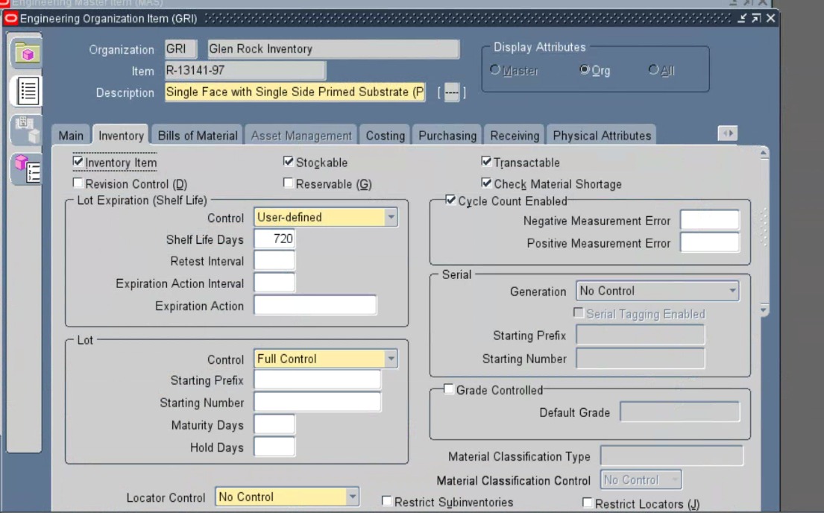
Figure 18 - Current Oracle EBS Inventory tab for R-13141-97 showing the item in GRI, Shelf Life From / Control = User-defined, and Shelf Life Days = 720; the description is truncated.

R-13141-97 - Continued

Category Assignments Not Visible
CSV Attribute | Expected Value from CSV | Oracle EBS Value | Result
Division | ARcare | Category Assignments not displayed | NOT VISIBLE
Business Unit | Medical | Category Assignments not displayed | NOT VISIBLE
Engineering | OPS | Category Assignments not displayed | NOT VISIBLE

Evidence status: No current Oracle EBS screenshot supplied for these populated CSV values; the results remain NOT VISIBLE.

R-13141-97 - Continued

Other CSV Values Not Visible
CSV Attribute | Expected Value from CSV | Oracle EBS Value | Result
Item Type | Raw Material | Source business item type not displayed | NOT VISIBLE
Part Status | New | Not displayed in the current screenshot | NOT VISIBLE
Eng / Mfg | Engineering | Not displayed in the current screenshot | NOT VISIBLE
UOM | ROLL | Not displayed in the current screenshot | NOT VISIBLE
Lead Time Days | 50 | Item descriptive flexfield not displayed | NOT VISIBLE
Customer Purchased Raw | No | Relevant Oracle EBS field not displayed | NOT VISIBLE
Vendor | ABI Tape | Relevant Oracle EBS field not displayed | NOT VISIBLE
Contact Name | Sam Veitz | Relevant Oracle EBS field not displayed | NOT VISIBLE
Address | same as in Oracle | Relevant Oracle EBS field not displayed | NOT VISIBLE
Phone | same as in Oracle | Relevant Oracle EBS field not displayed | NOT VISIBLE
Price Per UOM | 221 | Relevant Oracle EBS field not displayed | NOT VISIBLE
Food Grade | No | Relevant Oracle EBS field not displayed | NOT VISIBLE
Medical Grade | No | Relevant Oracle EBS field not displayed | NOT VISIBLE
Hazard Class | OK | Relevant Oracle EBS field not displayed | NOT VISIBLE
Storage Conditions | None | Not displayed in the current screenshot | NOT VISIBLE
Notify CS | No | Not displayed in the current screenshot | NOT VISIBLE
Requested By | Vitaly Falevich | Item descriptive flexfield not displayed | NOT VISIBLE

Evidence status: No current Oracle EBS screenshot supplied for these populated CSV values; the results remain NOT VISIBLE.

